
it,k4,no es un proyec un esfuerzo colectivo de estudiantes y profeso para facilitar el acceso a los materiales necesa educación de la mayor cantidad de gente posi editar en formato digital libros que por su alt porque ya no se consiguen en bibliotecas y li accesibles para todos.

Invitamos a todos los interesados en participa sugerir títulos, a prestarnos los textos para su ayudarnos en toda la labor técnica que implic El nuestro, es un proyecto colectivo abierto a cualquier persona y todas las colaboraciones

Society of Actuaries' Texthook
ON
LIFE CONTINGENCIES

BY
CHESTER WALLACE JORDAN, Jr.
Fellow of the Societ y o/ Actuaries Pro/ essor o/ Mathematics Williams College

SECOND EDITION

Published by
T H E S O C I E T Y O F A C T U A R I E S

1991

Copyright 1967
The Society of Actuaries Chicago, Illinois
Library of Congress Catalog Card Number 67-31240

. !

PREFACE FOR THE SOCIETY OF ACTUARIES

The first edition, published in 1952, has admirably served the purpose for which it was commissioned-to provide a modern text on Life Contingencies, applicable to the benefits commonly offered by life insurance companies in the United States and Canada. That it has served so well is due to the fortunate combina­ tion of technical ability and expository talent of the author, C. Wallace Jordan, Professor of Mathematics at Williams Coliege and Feliow of the Society of Actuaries, and to the members of the Society's Education and Examination Committee who assisted him, particularly Morton D. Miller, who determined in large measure the scope of the first edition and persuaded Professor Jordan to be its author, and David H. Harris, who devoted much time and thought to the organization and preparation of the text. When it became evident that an updated "textbook was desirable, Paul T. Rotter, then General Chairman of the Society's Education and Examination Committee, prevailed upon Professor Jordan to revise his book. Once again, Professor Jordan has applied to the task hu; many talents which, with his unfailing good humor, were so successful in producing the first edition. Zehman I. Mosesson, F.S.A., made a painstaking review of the revised manuscript and page proofs and worked closely with the author, as did John A.
Fibiger, F.S.A.
The Board of Governors of the Society of Actuaries is most appreciative of the great amount of work and talent contributed by Professor Jordan toward the education of actuarial students, both past and to come. The usefulness of the second edition not only to those studying lífe contingencies but also to those engaged in actuaria!practice will be a source of gratification to all con­ cerned.

HAROLD R. LAWSON
President
Society of Actuaries
JULIUS VoGEL
Genera/, Chairman Education and Examination Committee

BERT A. WINTER
Chairman
Advisory Committee on Education and Examinations

August, 1967
V

EXCERPTS FROM THE AUTHOR'S PREFACE TO THE FIRST EDITION

This book was prepared for the Society of Actua.óes as a text for students of life contingencies. The material included forms a survey of the fundamental principles of lif e contingencies with applications to American lif e insurance practice.
In designing the pedagogic approach, the author has been mindful of the needs of those many actuaria.l students who must acquire their knowledge of life contingencies without the assistance of an instructor. Since the text is their only teacher, these students deserve particularly full discussions of the basic concepts. Accord­ ingly, a special effort has been made to give careful and meaningful explanations of such fundamental ideas as the mortality table, the force of mortality, reserves, and the various multiple-life statuses. Emphasis is constantly placed oti a relatively small number of primary principles, and attention is drawn to the unity inherent in the different branches of the subject.
lt is important for the student to test his comprehension of the text at frequent intervals by solving problems. Collections of exer­ cises are placed at the end of each chapter, and the student should turn to the exercises as he completes each section of a chapter. Answers are given for all the exercises, either on the same page when the form of the answer gives no clue as to the method of solution, or at the end of the book.
The mathematical symbols used in the book are based on the International Actuaria! Notation. A few new symbols are intro­ duced; in particular, the following new usages should be noted: (ia)z and ( lA)z for the present values of a continuous increasing
annuity and insurance, P1 1 for an apportionable premium payable
"'
m times a year, and Sz:nl for the value of a foreborne annuity-due in place of the older symbol tluz • No previous knowledge of the lnternational Code is assumed here; each symbol is defined at its first appearance, and an Index to Notation shows the page on which each definition is given.
The material in this book has been obtained from many sources, including the author's own experience in practica} actuarial work and in teaching. The author was first introduced to life contin­
vii

viii EXCERPTS FROM THE AUTHOR'S PREFACE TO THE FIRST EDITION

gencies through the textbook of the British Institute of Actuaries written by George King and revised by E. F. Spurgeon, and his present task has been greatly simplified by the existence of this excellent text. The importance of King's work in systematizing the subject of life contingencies cannot be overemphasized. Another writer whose work has been a more recent influence is Ernst Zwinggi.
The preparation of the new text has afforded the opportunity of consolidating in a single volume a large body of material which has previously been available to students only through scattered papers in the actuaria!journals. The author thus counts as his col­ laborators a large and distinguished company of actuaries upon whose published contributions he has drawn. These original sources are listed in the appended bibliography. The names of the various actuaria} journa.ls are abbreviated as follows:
TSA Transactions of the Society of Actusries
TASA Transactions of the Actuaria! Society of America RAJA Record of the American Institute of Actuaries
JIA Joumal oí the Institute of Actuaries (Great Britain) Many persons have assisted in the preparation of the manuscript.
The major contribution has been that of Mr. David H. Harris, F.S.A., who served as editorial consultant for the whole project on behalf oí the Society of Actuaries. During the past three years, he has generously devoted many hours to a careful reading of each successive draft of the entire manuscript. His critical comments and creative suggestions have contributed greatly to the improve­ ment of the literary style, the clarity of the exposition, and the forro of the mathema.tical demonstrations. The author considers himself most fortunate to have had the assistance of so able a collaborator.
The author is also indebted to Mr. Harry Walker, F.S.A., and to Mr. Robert D. Acker, F.S.A., both of whom read the whole manuscript. Their valuable criticisms resulted in conspicuous im­ provements in the original text.
Finally, the author wishes to express his sppreciation to the members of the Education and Examination Committee, and espe­ cially to Mr. F. Bruce Gerhard, Mr. Morton D. Miller, Mr. Charles
A. Spoerl, and Mr. Bert· A. Winter, not only for their efficient
handling of many administrative details, but also for their warm interest and encouragement while the work was in progress.

AUTHOR'S PREFACE TO THE SECOND EDITION

The general plan of the first edition has been retained, but there has been sorne rea.rra.ngement of the material together with the addition of a new chapter on pension plans and disability benefits (Chapter 16). The chapter on population problems has been com­ pletely rewritten and expanded, and it is now included in Pa.rt I as Chapter 8. In Part 11, the two short chapters on the Last-Sur­ vivor Status a.nd the Genera.lized Multiple-Life Status have been combined and now appear as Chapter 10. In the other chapters, changes were made wherever it seemed possible to clarify the ex­ position and improve the form of the mathematical demonstra­ tions. The exercise sets were also revised and expanded.
The Bibliography has been enlarged and up-dated to include the relevant literature of the past fifteen years. In order to avoid inter­ rupting the text with references and footnotes, a section has been added at the end of each chapter which cites the more useful sources and relates them to the context of the chapter.
The task of reviewing the manuscript for the Society of Actuaries was undertaken by Zehman l. Mosesson, F.S.A., and it is a great pleasure to acknowledge the special contributions which he has made. His helpful suggestions and wise counsel are reftected in countless improvements throughout the book.
Va.lua.ble help was also received from John A. Fibiger, F.S.A., who worked closely with Mr. Mosesson in reviewing each succes­ sive draft of the entire manuscript. His comments, particularly on style and nomenclature, were an important inftuence.
Many other members of the Society of Actuaries were helpf ul either in reading drafts of individual chapters or in suggesting im­ provements in the treatment of certain topics. The following were particularly generous in their assistance: Dwight K. Bartlett, Murray L. Becker, M. David R. Brown, Edward F. Dalton, Carl
H. Fischer, Harry Gershenaon, Harold G. lngraham, Jr., John H. Miller, James J. Olsen, Robert B. Sha.pland, Charles L. Trow­ bridge, Charles B. H. Watson, and Howard Young.
Thanks are due a.lso to those members of the Education and Examination Committee who handled the administrative details.
Paul T. Rotter, F. S. A., was inftuential in getting the project
ix

X AUTHOR'S PREFACE TO THE BECOND EDITION

started. Robert J. Johansen, F.S.A., and Julius Vogel, F.S.A., 88Sisted in many ways while the work was in progresa. Their en­ couragement, support, &nd cooperation were important fe.ctors in the completion of the work.

Williamstown, Massaehusetts May 1, 1967
C. WALLACE JORDAN

TABLE OF CONTENTS
Preface for the Society of Actuaries. v
Author's Pref ace to the Second Edition. . . . . . . . . . . . . . . . . . . 1x
Part I. Single-Life Functions
l. The Measurement of Mortality. 3
- Life Annuities. 37
- Life Insurance. 65
- Net Annua.l Premiums. 81
- Net Level Premium Reserves. 96
- The Expense Factor 132
- Special Topics. 150
- Population Theory 170
Part II. Multi-Life Functions
- The Joint-Life Status 191
- Last-Suivor a.nd General Multi-Life Statuses 210
- Contingent Functions 225
- Compound Contingent Functions 246
- Reversionary Annuities 255
Part III. Multiple-Decrement Functions
- Multiple-Decrement Tables 271
- Tables with Secondary Decrements 291
- A Generalized Model. 305
Appendix l. Tables
  - The Commissioners 1958 Standard Ordinary Mortality Table 333
  - Life Table for White Males: United States, 1959-61 . . . 346
Appendix 11. Derivatives of Actuaria! Functions 349
Answers to the Exercises 351
Bibliography 375
lndex to Notation. 379
General Index 387
xi

Part I
SINGLE-LIFE FUNCTIONS

CHAPTER 1
THE MEASUREMENT OF MORTALITY

l. lntroduction
The systematic analysis of the contingencies of human life fonns the foundation of an actuary's work. In the solution of problems involving these contingencies, he requires sorne type of quantita­ tive measure of their effects;- and, in financial problems, he requires also a set of principies by which the measurements may be com­ bined with interest functions to produce monetary values.
The actuary's first concern is with the contingencies of death and survival. In this chapter, the problem of giving quantitative expression to observed mortality patterns will be considered, and the various functions which have been used for this purpose will be defined and examined. In the chapters that follow, formulas will be developed in which mortality functions and interest functions are combined to produce monetary values for Iife annuities and insurances.
2. The survival function
The normal mortality pattern observed among human lives is generally familiar. The elimination of individual lives by death, rather rapid in infancy, slows down during childhood, then in­ creases throughout adolescence and middle-life, accelerating as the end of the life-span is approached. mg a numerical measure of the extent of these effects, we begin by defining a fundamental probability function.
Let x represent the age in years of a human life. Then x may have any value from O to the upper limit of the life-span.
Consider now the probability that a new lif e, aged O, will sur­ vive to attain age x. We may regard this probability as a function of x, and will refer to it as the survival f unction, s (x ).
What properties may we attribute to this function from our general knowledge of the normal mortality pattern described above? In the first place, it is clear that s (x ) is a decreasing func­ tion as x increases, since the probability of surviving to age x is
greater than the probability of surviving to age x + t, for t > O.
3

4 THE MEASUREMENT OF MORTALITY (CH. 1

Secondly, since we are confining our attentio to normal pa.tterns of mortality, it is convenient and reasonable to assume that s (x)
is a continuous function of x. In addition, we know two specific values of s (x). When x = O, s (x ) has the value 1, and at the upper end of the life-span, s (x ) = O. If we denote by the symbol w the
smallest value of x for which s (x) vanishes, we can express this last condition as s ( w ) = O, where w is sorne value probably nea.r
100. Summarizing, s (x ) is a continuous function of x, defined on the interval O x w, which decreases from the value s (O) = 1 to the value s(w) = O.
The student should realize that the designation of a terminal a.ge w is merely a convenient simplifying device. No fact of experi­ ence supports the asswnption that a life can survive for n years but not for n years and one second. On the other hand, the proba­ bilities of survival to advanced ages are extremely small, and in practical work it is helpful to be able to assume that these proba­ bilities become negligible at a certain specified age. It would there­ fore be more realistic to state that the values of s (x ) are negligible for x w. However, we shall retain the more precise condition
s (w) = O because of its convenience in the mathematical analysis
that follows.
A typical s (x ) curve, derived from experience, is shown in Figure
l. It is difficult to find a mathemátical expression, involving a small number of parameters, which will fit this curve closely over its entire range. If, however, we sacrifice the requirement of close fit, we can find ma.ny simple functions which satisfy the conditions on s (x ) summarized above. Let us then, for purposes of illustration, regard as a survival function any mathematical expression that satisfies the above analytic conditions, whether or not its graph closely follows the typical s (x) curve oí Figure 1. Our objective here is not so much to reproduce the normal mortality pattern as to illustrate through the use of simple functions the manner in which quantitative measurements .of mortality ma.y be obtained when a particular mathematical law of survival is assumed.
The simplest type of expression satisfying the required condi­ tions on s (x) is a linear function. Consider, for example,

a(x) = 1 - 105 , 0 X 105.
X

SEC. 2)

S(r)
THE SURVIVAL FUNCTION 5

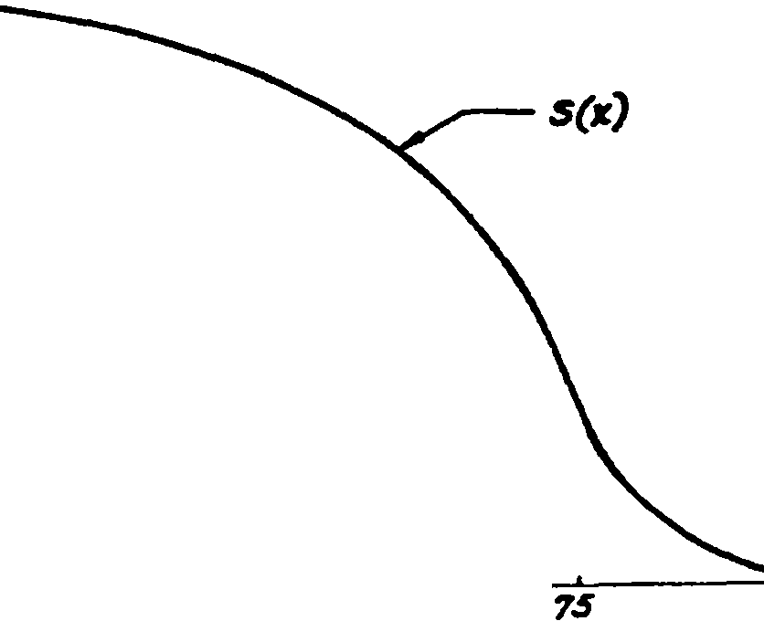JOO
l
o
2S
so

Frn. 1

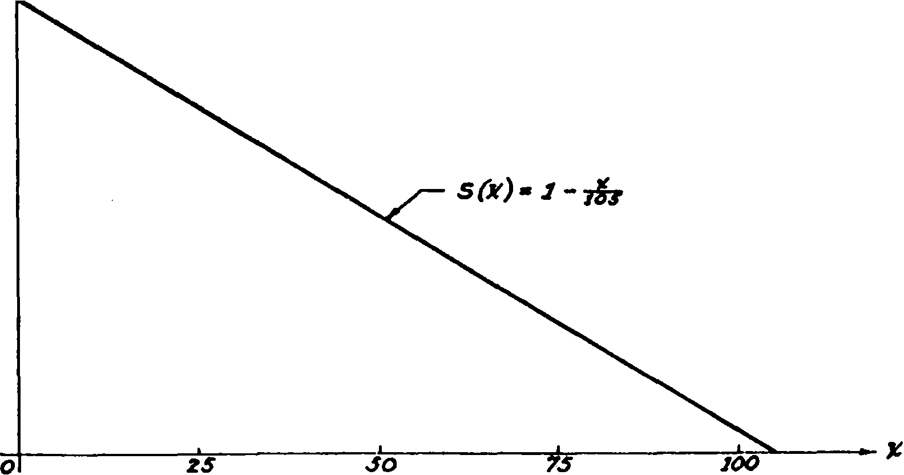#)
t
Frn. 2

We note first that the conditions for a survival function are satis­ fied, since this expression is continuous and decreasing, and has the value 1 for x = O and the value O for x = 105. The upper limit of life w is thus 105 in this case. The graph is shown in Figure 2.
We proceed to obtain sorne sample mortality measurements from the abovc function. The probability that a life aged O will

6 THE MEASUREMENT OF MORTALITY [CH. 1

survive to age 15 is
s (15) = 1 - 1%os = 1 - H = %.
The probability of surviving from birth to age 42 is s(42) = 1 - 4Yios = 1 - % = %,
Then the probability that a life aged O will die between age 15 and
age 42 will be
,7 -
s(15) - s (42) = % = %s,
What is the probability p that a life aged 15 will survive to age 42? The probability of surviving from birth to age 42 is equal to the probability of the c<>poq_nd event of surviving to age 15 and then surviving from age 15 to age 42. Hence,
s(42) = s(15) ·p,
d - 8(42) - u
an p - s(I5) - 710·
Then the probability that a life aged 15 will die before ttaining age 42 is 1 - Yio = fo.
As a second example, let
s (x) = HovIOO - x , 0 X 100.
See Figure 3. Sorne sample probabilities computed from this func­ tion follow.
The probability of surviving from birth to age 36 is
s (36 ) = HovIOO - 36 = .Vio = %,
The probability of surviving from birth to age 64 is s(64) = Hov'IOO - 64 = %o = %.
The probability that a life aged 36 will survive to age 64 is
s(64) _ 3/.
s (36) - 74·
The probsbility that a life aged O will die between ages 36 and
64 is % - % = }&.
The probability that a life aged 36 will die before attaining age o-4 is 1 - % :::z H.

SEC. 3) THE MORTALITY TABLE 7

It should be clear from these cxamples that numerical measures oí the probabilit.ies of living nd dying are readily calculated in any instance where a survival function is known or can be assumed.

- The mortaJity table
Suppose that we wish to exhibit the effect of the survival func­ tion
s (x ) = tfoV100 - X

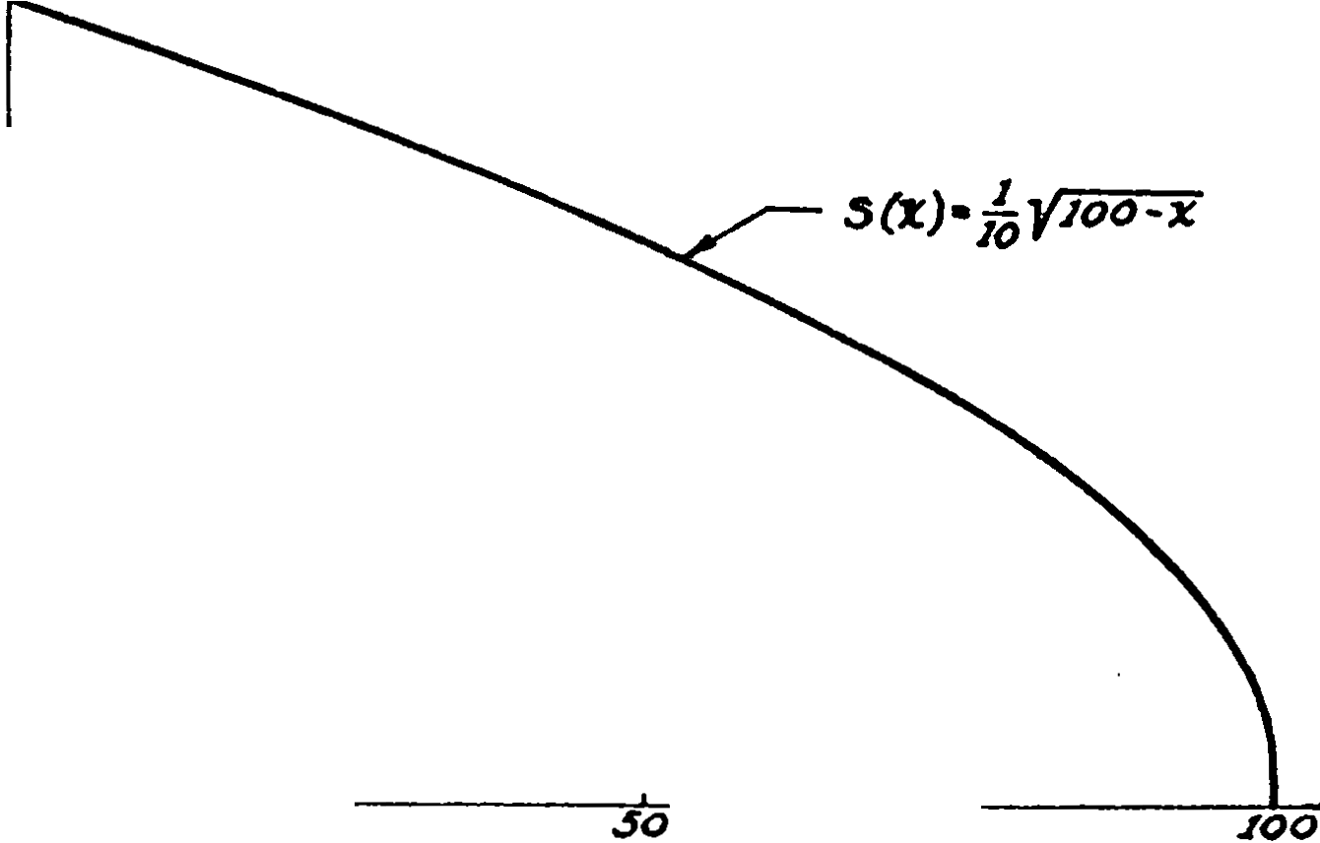S{x.)
I
o
25
7.5
FIG. 3

on an assumed group of 100,000 newly-born Iives. Now the number X 1 of lives surviving to age 1 is a random variable with expected value
E( Xi) 100,000 s( 1)
= 100000 ·v99
' 10
= 99,499. _ .
We denote this expected number of survivors by l1 . We can now compute the expected number of lives dying in the first year of life as 100,000 - 99,499 = 501. 8imilarly, the expected number of

8 THE MEASUREMENT OF MORTALITY rca.1

lives surviving to age 2 is

l2 = 100,000 &(2) = 1

v'98 == 98,995,

00,000·--ro-

and the expected number of lives dying in thc sccund year of life is 99,499 - 98,995 = 504. Continuing this proccss, we have Table 1, where the figures in the l:i column can be thought of as represent­
ing survivors at each age x and the d:i figures as representing deaths in the year of e.ge x to x + l.
TABLE 1
SECTION OF HYPOTBETICAL MoRTALITY TABLE WITH s(x) = Hov'IOO - z,
k == 100,000
Ase • | ,. | d,, | Ap s | ,. | "'
o | 100,000 | 501 | 6 | 96,954 | 517
1 | 99,499 | 504 | 7 | 96,437 | 520
2 | 98,995 | 500 | 8 | 95,917 | 523
3 | 98,489 | 509 | 9 | 95,394 | 526
4 | 97,980 | 512 | 10 | 94,868 | 528
5 | 97,468 | 514

This device for exhibiting mortality data is known as the mor­ tality table or the lije table. The l:i and d:ii functions have the follow­ ing definitions :
l:i = k·s (x ), where k is a positive constant, {1.1)
d:i .= ls - l:i+l . {1.2)
The value of k is called the radix of the table. It corresponds to the value lo and is generally taken to be some large round number. The interpretation of l:i as a "number living" or "number sur­ viving" and of d. as a "number dying" is a convenient aid in vis­ ualizing many of the relations that follow. It should be borne in
mind, however, that neither z. nor dz has any absolute meaning;
the values of both are dependent on the value of thc radix chosen in the construction of the table. It should also be remembered that l:c , from definition {1.1), is a continuous function of x , although ta.bulated values appear in mortality tables only for integral ve.lues of x.

SEC, 3] THE MORTALITY TABLE 9

Probabilities of death and survival may be obtained directly from the lz and dz columns of the mortality table, and the relations exhihited below may be readily verified on the basis of elementary probability concepts. The symbol (x) is used hereafter to denote "a life aged x."
The proba.bility that (x ) will survive at least 1year, that is, to attain age x + 1, is denoted by Ps , and
ls+i

Ps = -¡;·
(1.3)

The probability that (.'t) will survive to age x + n is denoted by raPs , and
.p. = l-s+¡a;· ( 1.4)
The probability that (x) will die within 1year is denoted by qs ,
and
qs = 1 _ Ps == l _ l.+1 = l. - l.+1 = da • ( l.S )
ls l. lz
The probability that. (x) will die within n years is denoted by
,,q. , and
l l - l 1 •+1t-l
.+.. :E
,.q. = 1 - ,,p. = 1 - .l+,a = • l = l- <4 . ( 1.6)
a a a ,-is
The probability that (x) will survive for n years and die in the
(n + 1)-th year is denoted by ,.1q. , and
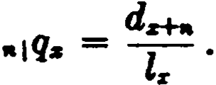 ( 1.7)
The probability that (x) will die between ages x + n and
x + n + m is dcnotcd by •l111qz , and
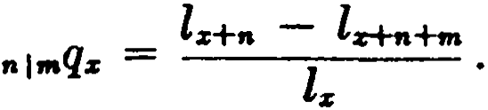 ( 1.8)
In formula (1.4), when x = O, nPz becomes the survival function:
nPo = s(n). ·
It should be notc<l t.hat the above probabilities can be evaluate<l f rom thc morta.lit.y table only if x, n, and m havc inf<'gml values.

10 THE MEA5UREMNT OF MORTALITY [CH. 1

Probabilit ies like 2¡p24 and 1q21t can be computed exactly from the survival function, but they can only be estimated from mortality table data.
Although we have defined the mortality table in tenns of its underlying s (x ) law, in practice these tables are usually constructed on a purely empirical basis from statistical studies of mortality dat a. When this is done, the values of qz are developed from a mortality investigation, and these values are used to construct the lz and dz columns of the mortality table by the following process.
An arbitrary value is chosen for lo .
T'hen

and generally,
do :o: lo ·qo ,
l1 := lo ..... do ,
d1 = l1 ·q1 ;
ls = l1 - di ,

d., = l:z .qz '
lz+l == lz ..... d:i ,

It oftcn happcns in such studies that therc is iusufficiellt data to define qz reliably for thc younger ages, and in many iwstances thc purpose for which the table is being prepared is such that thcrc
·is no need to include values for these ages even if available. In such cases, it is cust.omary to start the table at the earliest signifi­ cant agc, perhaps 10 or 20, and the arbitrarily chosen value of lz at that age will be called the radix of the table.
When mortality tables are constructed in this way, it is not. usually possible to find a simple mathematical expression for s (x ), and the mortality table itself then constitutes the entire definition of the mortality pattern. We shall nevertheless find it convenient in the further development of the theory to keep in mind thc exist­ ence of an underlying continuous s(x), even when wc do not know its exact mathematical fonn.
An example of a table constructed from expcrience with s (x ) unknown is given in Table 2. This table is based on t.he mortality during the years 1959-61 of white male lives residcnt in the United

TABLE 2
s  -- | •• | Is | ,. |  | s | fa |  | ls
o | .00592 | 100,000 | 2,592 |  | 40 | .00032 |  | 92,427 | 306
1  2  3 | .0015.1  .00101  .00081 | 97,403  97,259  97,160 | 149  99  78 |  | 41  42  43 | .OOJ68  .00409  .004M |  | 92,121  91,782  91,406 | 339  376  415
4 | .00069 | 97,082 | 67 |  | 44 | .00604 |  | 90,991 | 4li8
5 | .00062 | 97,015 | 60 |  | 45 | .00558 |  | 90,5.13 | 505
6  7  8  9 | .00057  ,(XX)53  .<XX>49  .<XX>45 | 96,955  96,900  96,848  96,801 | 55  52  47  43 |  | 46  47  48  49 | .00617  .00686  .00766 |  | 90,028  89,472  88,859  . 88,178 | 556  613  681  754
10  11  12  13  14 | .00042  .00042  .00047  .00059  .()()(115 | 96,758  96,718  96,678  96,632  96,576 | 40  40  46  56  73 |  | 50  51  52  s.,  54 | .00955  .01058  .01162  .01264  .01368 |  | trl,424  86,589  85,673  84,678  83,607 | 835  916  995  1,071  1,144
15  16  17  18  19 | .<XM>93  .00111  .00126  .00139  .00149 | 96,503  96,413  96,306  96,185  96,051 | 90  107  121  134  143 |  | 55  56  57  58  59 | .01475  .01593  .01730  .01891  .02074 |  | 82,463  81,247  79,952  78,569  77,083 | 1,216  1,295  1,383  1,486  1,598
21  22  23  24 | .00159  .00169  .00174  .00172  .00165 | 95,908  95,755  95,593  95,426  95,263 | 15.1  162  167  163  157 |  | 60  61  62  63  64 | .02271  .02476  .02690  .02912  .03143 |  | 75,485  73,771  71,944  70,009  67,970 | 1,714  1,827  1,935  2,039  2,136
25  26  27  28  29 | .00156  .00149  .00145  .00145  .00149 | 95,106  94,957  94,816  94,679  94,542 | 149  141  137  137  141 |  | 65  66  67  68  69 | .00389  .03652  .03930  .04225  .04538 |  | 65,834  63,603  61,280  58,trll 56,384 | 2,231  2,323  2,409  2,487  2,559
30  31  32  33  34 | .00156  .00163  .00171  .00181  .00193 | 94,401  94,254  94,100  93,939  93,7G9 | 147  154  161  170  180 |  | 70  71  72  73  74 | .04trll  .05230  .05623  .06060  .06542 |  | 53,825  51,204  48,526  45,797  43,022 | 2,621  2,678  2,729  2,775  _2,81
35  36  37  38  39 | .00207  .00225  .00246  .00270  .00299 | 93,589  93,395 | 194  210 |  | 75  76 | .07006  .07636 |  | 40,207  37,3f>6  34,513  31,658  28,814 | 2,841  2,853  2,855  2,844  2,821
 |  | 93,185  92,956  92,7().5 | 1  1 | 229  251  278 | 77  78  79 | 1 | .08271  .08986  .09788

MORTALITY TABLS l'OB u. s. WBITlll MALES 1959-61
"'

11

12 THE MEASUREMENT OF M.ORTALITY (CH. 1

States. It is one of a series of tables constructed in connection with the nationa.l census of 1960. Although the original table includes data through a.ge 109, the values are shown in Table 2 only up through age 79. A mortality table covering the entire range of ages, the Commissioners 1958 Standard Ordinary Mortality table
for male lives, may be seen in Table A of Appendix l. In referring to this table, we shall usually abbreviate the na.me to 1958 eso
table. The ,complete published table shows values for fema.le lives also, but only the values for male lives are shown in Table A. We shall, unless otherwise specified, assume male mortality when reference is made, in the text or in the exercises, to either of the mortality tables described in this paragraph.
- The force of mortality
The probability functions defined in the preceding section are useful for measuring mortality over specified intervals of time. The function qz , for example, which measures the probability of dying within one year, may be regarded as an index of the average ·mor­
tality effective over the year of age x to x + 1. In this sense, q. is
commonly known as the annual rate of mortality.
It is evident, however, that the intensity of mortality is varying at each moment of age, and it is important to ha.ve sorne way of measuring this instanlaneous variation. The graph of Figure 1, with a change in the vertical sea.le, may be thought of as an Zs curve. Now the slope of such a curve at any point is related to the number of deaths near that point, for the steeper the curve the greater the numbcr of deaths. The slope is measured by the deriva... tive of the function, and it is therefore natural to study next the derivative of lz .
We take first a concrete case with a k nown s (x ) so that the diff er­ cntiation can be actually carried out.
Let s (x ) = Hov'100 - x and let the radix be 10,000 so that
lz = 1000,VlOO - x.
Denoting the derivative of lz with respect to x by Dl;,; , we ha.ve
500
Dl. = - 'VIOO - X '
and this mcasures the rate of decrease of l;,; with respect to x. At

SEC. 4) TBE l'ORCE 01' MORTALITY . 13

age 51, for example,
500
DI.]_ =
'\1100 - 51 = - 71
'
to the nearest integer. This means that at age 51l. is decreasing at the rate of 71 lives per year.
As a measure of the .death rate, this figure is unsatisfe.ctory since it dependa upon the number of lives which are subject to the risk
of death at age 51, namely,' l61 = 7000. By dividing 71 by 7000, we obtain at age 51 a mortality index of 7Hooo = .0101, a result
which is independent of the number of Iives attaining a.ge 51.
The mortality index just described is known as the force of mortaUty and is denoted by the symbol µ• • Its definition is
Dl.
"·= - T.. (1.9)
An equivalent expression is
Da( x )
,,.. = - 1(%) .
The following properties should be kept in mind: (1) ,,..is a meas­
. ure of the mortality al, the precise moment of at,t.aining age x ; (2) P.z
expresses this mortality in the form of an annual rate.
The values of are not confined to the interval O ,,. 1, in the way that probability functions are restricted, but may assume any positive value. It can be seen from fonnula (1.9) that ,,.. will exceed unity whenever the numerical value of the slope of the l. curve exceeds the corresponding value of z• • This nonnally occurs at both ends of the life-span, in the first few days following birth, &nd again in the year of age preceding age w. In fact, as x approaches
age w, l. approaches O and "*• becomes infinite.
It is now possible to write an exprion for the value of l. at a particular age y in terms of the function ,,.. . It will be seen from formula (1.9) that an altemative expression for is
µ. = -D log z.. (1.10) 1
Replacing x by y and integrating both sides between the limits O
1 The symbol log is used here to denote a natural logarithm. Common
logarithms will be denoted by 10110 .

14 THE MEASUREMENT OF M9RTALITY (CH. 1

and x,
f "'dy = - f D log Z,, dy
= -log 4JTo' = -log z¡; ,

and hence we have

z. = -fo -."•. ( 1.11)

It is now easy to obtain an expression for ,.pz . From (1.11), we ha.ve

Then

.p. =
ls+ta = loe-r.·"•"".
l 1_-r.·,,,, ,,, r.+•
l. = -r.,.,, ,,,, = e •
s+ta -

,.., ""•

In the definite integral, the values of µ.., are needed only on the interval x y x + n, a.nd this suggests the change of variable y = x + t, O t n. We thus ha..ve

'
tiPs - e-fo J&s+c di• '
-
( 1.12)

The probability ,.q:r may then be expressed as
.,.q. = 1 - e-J: 11•+' "1
. ( 1.13)
An altemative expression may be derived for this probability from formula (1.9). Writing the formula as
4JJ.w = -DJ,,¡ ,
and integrating between the Jimits x and x + n, we obtain
ls+tt l,,µ,, dy = - lª+tt Dl,, dy
s %
= -1.r··= l._ 1.....
or, with a change of variable,
la - ls+ta = l.,. lr+t Jls+I dt. ( 1.14 )

SEC. 4) THE FORCE 011' MORTALITY 15

Dividing by l:ic , we ha.ve the proba.bility ,.qs :
r· r·
ls - lrl,t 1
"q:ic = l =-l J,, l""'"""' dt = J,, ,P.P.rl-c dt.
o o
- s

( 1.15)

The proba.bility •1 ,.q. me.y similarly be expressed in definite inte­
gral fonn as
.L
11+.
1
- t1 f:1t ;; · tPsP.s+e dt. ( 1.16}
•
The form of the integrand in formulas (1.15) and (1.16 ) is easily
remembered sincc the differential cxpression tPzllz+t dl may be thought of as the probability that (x ) will survive for t years and
then die at the instant of attaining age x + t. When this expres­
sion is integrated between limits for t, it gives the probability of dying within the corresponding period of time.
The role played by the force of mortality in the mathematics of lif e contingencies is analogous to that played by the force of inter­ est in compound interest theory. Thís wíll be apparent in the duality exhibited below.

lnterut
An original sum of A o is subject to the incremental effect of the vary­ ing (or constant) force of interest .
Let A , be the amount of the sum at time t.
The rate of change of A , is given
by
ddAt, = Ac&, .
The total increment to A produced in a year is
J.' A.&, dt = A.J:
= A1 - Ao = I,
and the annual increment per unit of
Mortality
An original group of lz lives is subject to the decrementa! effect of the varying force of mortality µ.
Let lz+1 be the number of lives in the group at time t.
The rate of change of lz+t is given
by
ddlz+t1 = -lz+ll':z+I •
The total decrement from lr pro­ duced in a year is
J.' i.......dt = -1...J:
= -Zz+t + l,r = dz ,
and the annual decrement per unit

. I
A o
18 -
A o
= i.
. dz
Of lz 18 == qz .
¡;

Just as i represents the effective rate of interest corresponding

16 THE MEASUEMENT OF MORTALITY (cn. 1

to the operation of the varying (or constant) force throughout a yearly period, so q:z: may be interpreted as the effective annual rate of mortality corresponding to the operation of the varying force µ
throughout the year of age x to x + l.
Further insight into the nature of the force of mortality may be gained by analyzing formula (1.9) in terms of the definition of the derivative. The derivative of l:z: may be expressed as
Dl :,; = 1· lz+h - l:,: '
Im h
h-+11

and P.:z: , from (1.9), may then be written

p.:z: = lim l:z: - l:z:+h
1· 1iq:z:
1m -.
=

(1.17 )

h-+O h ·l:z: A-+O h

Now the expression '/a!:z: may be regarded as an annal rate of mor­
tality based upon the mortality during the age interval x to x + h.
For example, if h =l, 11t becomes 2·¡q:z: , which represents ·twice
the probability that (x) will die within half a year. As h approaches O, the limit of this expression, the force of mortality, may be de­ scribed as the nominal annual rate of mortality based upon the intensity of mortality at the instant of attaining age x.
It is now easy to see why the values of P.:z: normally exceed 1 at the beginning and end of the mortality table. Infant mortality is high in the period immediately following birth. Considering the first 24 hours of life, for example, the value of :sl,qº may exceed
H65 so that the ratio "t exceeds 1. As shorter intervals of time are
taken, the ratio may increase still more. Now consider the upper end of the mortality table. Since there are no survivors at age w, we may write .,_:z;q:z: = 1, which is true for all x. Now if x is such an age that w - x is less than 1, it will follow that
,,,_:,:q:,: > 1,
w - x
and hence values of P.:z: exceeding 1 will occur in the year of age
w - 1 to w.
Values of P.:z: greater than 1 are occasionally encountered when

SEC. 5] ESTDlATION OF JJ,a 17
we a.re dea.ling with hypothetical survival functions not closely rela.ted to the normal pa.ttem of mortality. For example, if

l. = (100 - X )
, 0 X 100,

191

it is easy to verify tha.t µ. is gres.ter than 1 at a.ll a.ges.
S. Estimation of JJ,s from the mortality table
When l. is defined in terms of a mortality table and the under­ lying mathematica.l law is unknown, values of µ.. can be determined only approxima.tely.
From formula {1.12) with n = 1,
p.= e-f l"•+t de '
o
whence, taking logarithms, we ha.ve

log p. = - f J.&:n-e dt.

( 1.18)

The definite integral represents the mea.n value of µ. between the ages x and x + 1. If we approximate this mean value by µ:i:+t , we
have2

l'z+t =: -log p• .
If we integrate Jl.z+e between t = -1and t = 1,we find
L: P:i:+e dt = -log Pz-1 - log p.
(1.19a)

and this is twice the mean valuc of µ between the ages x - 1 and
x + 1. This leads to the following approximation:
J.&z =; -t (log P:i:-1 + log Pz )

= !(logl:i:-1 - logl:i:+1).
(1.19b)

Other approximations for J.&:i: can be derived by the use of numerical methods. A simple approximation for DJ. is
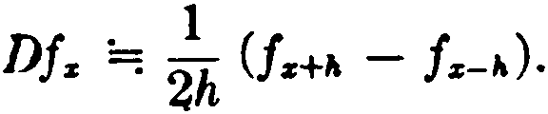

1 The sign ="! is used to denote an approximation.

18 THE MEASUREMENT OF MORTALITY [CH. 1
Using h = 1,

P.z = _!Dlz == lz-1 - lrH = dz-1 + dz .
l. · 2ls 2lz

( 1.20)

The formula. is exact if lz is a polynomial of the second degree. If we assume that lz is a polynomial of the fourth degree, the follow­ ing formula can be derived:
. 8(lz-1 - ls+-1 ) - (f-2 - ls+-2 )

1/,:c =: . 12la. .
( 1.21)

Othcr formulas may be obtained by using the relation connect­ ing the diff erential opcrator with the finite diff erence operator A:
2 3
A tl
D = log ( 1 + A ) = A - 2 + 3 -
For example,

1 Dl 1 ( l 1 2l 1 L ªl l¡ Í'/)1
= - i = - i: A - iA + 7
/Jz z s 73A z

= Í1: (dz - ! z + HA2dz - ··' ) •

( 1.22)

6. Methods for ·fractional ages
Consider the problem of evaluating the probability l/3Pao that a life aged 30 will survive at least 4 months. If the mathematical law for lz is known, we can readily compute l3') and lao t/3 , and hence
determine the required probability exactly as la;13• Howe;er, if lz
is defined only by a mortality table, it becomes necessary to ob­ tain a value for lao 11a by sorne approximation method. Using the data of Table 2, we note that lao = 94,401 and 131 = 94,254. The simplest solution is to interpolate linearly between these two val­
ues, obtaining l30 11a =: lao - } (l30 - la1) = 94,352.
It is of course possible to improve this estímate by examining
the differences of lz in the neighborhood of lao and adopting an appropriate numerical formula. The linear interpolation is widely used, however, and is considered to be sufficiently accurate for many practica} purposes. Since we shall have frequent use for it in our later theory, let us examine the nature of the assumption that it involves.

SEC. 6] METHODS FOR FRACTIONAL AGES 19

The approximation which it produces may be expressed ana-
lytically as ·
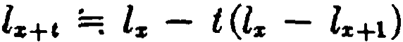
. for integral x
and O t l. (1.23a)
Graphically, the as.5umption involves the replacement of the lz curve by a polygonal graph consisting of straight-line segments joining the points at integral a.ges.
Ir' we write (1.23a) as
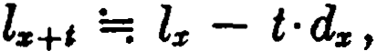 O t 1, (1.23b)
it is apparent that a t-th part of the total deaths dz in the year of a.ge
x to x + 1 are assumed to occur in a Hh part of that year. In other
words, we are making the assumption of a unif orm distribution of deaths throughout the year of age. Actually, of com'Se, the deaths in any year of age are not spread evenly throughout the year, and in any case where close accuracy is important, the size and direction of the error introduced by this assumption should be considered.
1t is important to note the approximations for certain other func­ tions that result from this assumption. The following relations fol­ low directly from (1.23b):

and
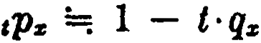 (1.23c)

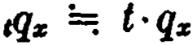
for O t l. (1.23d)

A consistent approximation for the force of mortality at frac­ tional ages may also be derived. We first write
Dln-c
P.n-c · = --- .
la+i
Now under our assumption the derivative Dl:i:+i has the constant value -dz for O < t < 1, as may be seen by differentiating (1.23b) with respect to t. Then
( 1.24a)
This approximation for 1,&z+t is not uniformly good for all values of t in the interval O < t < l. It produces a good estimate when applied in the middle portion of the year of age where the slope

20 THE MEASUREKENT 01' MORTALITY [CH. 1

of the &8SUIIled straight-line segment does not cliffer materially from the slope of the true lz curve, but yields only a rough esti­ mate near the ends of the interval where the slope of l. is more greatly distorted by the nature of the underlying assumption. In fa.et, as t approaches O in (1.24a), we find that J.&s+c a.pproaches q• • The expression 1PzJ.&z+1 occurs frequently, a.nd from (1.24a) we
ha.ve
tPzJ.&z+I =; qz for O < t < l. (1.24b) Another a.ssumption wh1ch has proved valuable in dealing with
·nortality functions at fractional ages is the a.ssumption that the reciproca.!of la+• is a linear function of t for O t 1:

l, =; i - t l: - l1 ' o t l.
1 . 1 (1 1 )
Under this a.ssumption, the proba.bility 1_,q•+c takes on a. particu­ larly simple form:
n.2s)
Formula (1.25) is known as the Ba.lducci hypothesi. . It is espe­ cially useful in the theory underlying the constfuction of mortality tables. Its properties will be explored further in the exercises.
The student should realize that ali the formulas of this section, although written as approximations, are exact mathematical rela­ tions under the assumptions specified. They have been designated as approximations beca.use the assumptions themselves are only approximate descriptions of the usual behavior of mortality data.
7. Sorne famous laws oí mortality
The ma.thematical expressions that we ha.ve been using as sur­ vival functions are admittedly artificial. Mathematicians ha.ve long been intrigued with the problem of constructing ana.lytic functions which closely reproduce the typica.l l. curve. It is a twisted, de­ scending curve, a.nd the presence of at lea.st two points of inflection makes it a difficult curve to fit with a.ny simple formula.. We ex­ amine here sorne of the more importa.nt solutions that have been proposed.
The earliest and simplest proposal was that of Abraham de Moivre (1724 ) who suggested that l. be represented by a straight

SEC. 7] SOME FAMOUS LA.WS OF MORTALITY 21
line. De Moivre recognized that this was a very rough approxima­ tion. His objective, however, was the practical one of simplifying the calculation of life annuity values, which in those days was an arduous task. He recommended that his assumption be used only for the range of ages from about 12 to 86. The fo1mula met with ready acceptance and was widely used for th purpose intended. It may be expressed as
l:r: = k (w - x ). (1.26)
Figure 2 is based upon this law, with w = 105.
In 1825, Benjamín Gompertz, in a celebrated actuaria! paper, examined the eff ect of assuming "the average exhaustion of a man's power to avoid death to be such that at the end of equal infinitely small intervals of time he lost equal portions of his rc­ maining power to oppose destruction which he had at the com­ mencement of these intervals." Thus he assumed that man's power to resist death decreases at a rate proportional to itself . Since µ.z is a measure of man's susceptibility to death, Gompertz used the
1
reciproca! -to measure man's resistance to death. His assumption
P.:r:
may be expressed as
D (!..) = -h· _!_
/Jz /J,:r:

whcrc h is thc com;taut of proportionality. lntegrating,

log (:.) = -hx - log B,

where -log B is thc constant of integration.
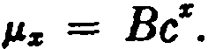
Then, with e"' = e,

(1.27 )

lt thus appears that Gompertz,s hypothcsis is equivalent to thc a.ssumption that the fotce of mortality increases in gcometric pro­ gression. We may now derive Gompcrtz':,; cxprcssion for lx , using formula (1.11).

22 THE- MEASUREMENT OF MORTALITY (CH. 1

First,
i•.P.. dy = ¡

- Be' dy =
·

Be• - B

where
o o log e log e
= -( e· - 1) log g = -log gcz-1,

log g = - . log e

Then Zz = 'loe-J: "" d,, = z1°s "cZ-1 = lofJcz-1.
This is usually written as

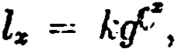
where k = l-o .
g

(1.28)

By suitable choice of the constants g and e, the formula can be made to follow closely the typical lz curve over a considerable. range of ages. In his original paper, Gompertz restricted the use of the formula to the ·period from about age 10 or 15 to age 55 or 60, and it is not possiblé to use the formula over the entire range of ages without making a change in the constants at sorne point, usually between ages 50 and 60. Indeed, it would not be expected that a single two-parameter formula would fit the twisted l:z curve over its entire range.
In presenting his formula, Gompertz stated, "It is possible -that death may be the consequence of two generally coexisting causes: the one, chance, without previous disposition to death or deteriora­ tion; the other, a deterioration, or increased inability to withstand destruction." In deriving his law of mortality, however, he took account of only the second of these causes. It remaincd for Make­ ham (1860) to combine the two causes. The eff ect of the first cause, chance, would be to make a constant addition to the Gom­ pertz force of mortality. Hence, Makeham's assumption may be written as

µz = A + Be•.
To derive the expression for lz , we first evaluate
(1.29 )

8EC. 7) SOIIE FAMOUS LAWS OF MORTALITY 23

where
s ,,.. dy = 1s ( A + Be• ) dy = Ax +
o o
1
= -log 3" -log ,r%-1,

Be"
--
1og e
-B
og e
1 -

log s = -A and log g = -
B .
log e

·Then l = loe-fo ,.,,,,, = toetoc •z+ ioc "c:S-1 = Lo.,sgcZ- 1.
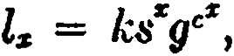
This is usually written as

(1.30)

w1.th k
=-lo .
g

Makcham's law turne<l out to be a rcmarkable improvement on Gompertz's assumption, and the formula, with proper choice of the constants. g, e, and s, can of ten be applied from about age 20 almost to the end of life.
Both Gompertz's and Makeham's laws possess properties which are of great practica!importance in the simplification of compound probabilities involving the survival of more than one lif e, and these will be noted later. Bccause of their practica! application in this connection, both laws continue to be uscd today. Gompertz's law was employed in the construction of thc 1937 Standard An­ nuity Table, and Makeham's law was used in connection with the Commissioners 1941 Standard Ordinary Mortality Table and also with the Annuity Table for 1949.
Each of thesc laws involves a certain number of unspecificd paramcters, and hence each gives rise to an infinite number of different survival functions. These laws of mortality thus define only the f orm of the mathcmatical functions to be assumed and do not yield numerical measurements of mortality until appropriate values are chosen for the parameters. It will be found that the values of each paramcter lie within a certain restrictcd range whcn thc survival function follows the usual mortality pattcrn closely. For example, with Makcham's law,
l'z = A +· Be\

24 THE MEASUREMENT OF MORTALITY [CH, l

the parameters are usually confined to the ranges shown below :
.001 < A < .003,
10-11 < B < 10-3,
1.08 < e < 1.12.
- Select mortality tables
The mortality of a group of insured lives exhibits certain dis­ tinctive characteristics which derive from the special nature of such a group. Before an insurance policy is issued, the insurer must be satisfied that the applicant meets certain underwriting stand­ ards. Sorne applicants, because of health conditions or other factors, will not be offered insurance on a standard basis, and some others may be considered uninsurablc. As a result of this selcction process, a group of lives insurcd on a standard basis <loes not constitute a random group, but rather a select group ali the members of which have initially satisfied certain criteria of insurability.
lt follows that the mortality in such a group will vary not only by age, but also by the duration of the insurance. Thus, a group of lives just insured on a standard basis at age 30 will be subject to a lower rate of mortality during the following year than anothcr group of lives aged 30 who were similarly insured a year ago and are now in the second year of insurance, and the mortalit.y of both of these groups will be lower than that among a third group agrd 30 who were insured two ycars ago at age 28.
If we write q¡zJ +n for the rate of mortality at attaincd age x + n
among a group of lives insured at age x, the tendency dcscríhed above may be expressed mathematicaJly by the series of inequali­ ties
q(z] < q¡z-1) +l < q¡z-2)+2 < ·' ' •
Normal1y the difference q1x-nJ+n - q¡x-n+ii+ n-1 dimiu ishes quite rapidly and becomes negligible for practica! purposcs af ter sorne years. Thus, there will probably be no appreciablc variat ion i n the mortality expcrienccd by insured groups of thc samc age which have been insured for durations greater thau 10 or 1!> years. Thr period of time during which thc cff ects of Relcction are st ill sign ifi­ cant is called thc select períod.
This feature of the mortality among insured livcs is onc t hat

SEC. 8] SELECT MORTA LITY T..\BLES 25

must often be recognized in the construction of mortality tables. Selecl mortality tabl,es, which show the mortality variation bot.h by age and duration, are therefore prepared.
A completely select table would consist of a set of mortality tables, one for each age at issue. It is not usually necessary to pre­ pare tables in this extensive form, however, since it is generally possible to assume a unifom1 select period for ali ages at issue, and condense the table into a select and ultimate form. If it can be assumed, for example, that the effects of selection disappear in 3 years, the table can be shown in the select and ultimate form illus­ trated in Table 3. The first column, headed lizJ , represents the number of lives insured at age x, the symbol [x] denoting a life newly insured at age x. The second column, Zczl+t , represents the
number of survivors at age x + I of the lczJ lives insured at age :r.
The columns headed l¡z1+2 and lz+3 represent the corresponding numbers of survivors of the original l¡zJ lives at the two succeeding years of age. The select symbol [xl is not used in the lz+a column, since the effects of selection do not carry over into the fourth year, and Zz+3 is therefore equally representative of the number of sur­ vivors of the l¡zJ lives insured 3 years previously, the liz-tJ lives in­ sured 4 years previously, and so on, and this column constitutes an ultimate mortality table. The value of lz-H is found directly below lz+3 in the ultimate column. The complete set of values for age at issue x is thus obtained by reading the select values horizontally starting with l¡;i;J and the ultimate values vertically from lz+3 . At age 21, for example, there are 944,710 lives insured. The number of survivors at age 23 is found by reading l121J +2 = 941,916 from the third column of the select portion of the table; and the number of survivors at age 25 is found by reading l'lb = 938,359 from the ultimate column. Note that this same value for [26 also represents the number of survivors at age 25 of the l1201 lives insured at age 20 and of the l¡2'lJ lives insured at age 22.
In order to construct a select table in this form, it is first neces­ sary_ to havc values of q¡zJ , q¡z1+1 , and q 1z1 +2 for each age at issue for the select portion, and a complete set of values of qz+a for the ultimate section (assuming a 3-year select period ). Suppose that the earliest age at issue is 20. A convenient radix is then assumed for lt201 , and the complete mortality table for this age at issue is constructed using the values of q 1201 , qt20J +1 , q¡20J +2 , q23 , q24 , etc.

26 THE MEASUREMENT OF 'MORTALITY [CH. 1
[x]  -- | l(z) | l¡.rJ+l | Z¡zJ+t | Z.+3 | x + 3
 | ---
20 | 946,394 | 945,145 | 943,671 | 942,001 | 23
21 | 944,710 | 943,435 | 941,916 | 940,202 | 24
22 | 942,944 | 941,652 | 940,108 | 938,359 | 25
23 | 941 ,143 | 939,835 | 938,265 | 936,482 | 26
24 | 939,279 | 937,964 | 936,379 | 934,572 | 27
25 | 937,373 | 936,061 | 934,460 | 932,628 | 28
26 | 935,433 | 934,123 | 932,507 | 930,651 | 29
27 | 933,467 | 932,151 | 930,520 | 928,631 | 30
28 | 931,488 | 930,156 | 928,491 | 926,560 | 31
29 | 929,476 | 928,119 | 926,421 | 924,429 | 32
30 | 927,422 | 926,040 | 924,290 | 922,220 | 33
(:e] | d1ir) | d1.1+1 | d¡irJ+2 | ds+a | x + 3
20 | 1,249 | 1,474 | 1,670 | 1,799 | 23
21 | 1,275 | 1,519 | 1,714 | 1,843 | 24
22 | 1,292 | 1,544 | 1,749 | 1,877 | 25
23 | 1,308 | 1,570 | 1,783 | 1,910 | 26
24 | 1,315 | 1,5&5 | 1,807 | 1,944 | 27
25 | 1,312 | 1,601 | 1,832 | 1,977 | 28
26 | 1,310 | 1,616 | 1,856 | 2,0'20 | 29
2i | 1,316 | 1,631 | 1,889 | 2,071 | 30
28 | 1,332 | 1,665 | 1,931 | 2,131 | 31
29 | 1,357 | 1,698 | 1,992 | 2,209 | 32
30  ---- | 1,382  -- | 1,750 | 2,070 | 2,306 | 33
 |  | -  q[z)+l | q12:J+2 | q,.+a | x + a
(:e] | q(:,;)
20 | .00132 | .00156 | .00177 | .00191 | 23
21 | .00135 | .00161 | .00182 | .00196 | 24
22 | .00137 | .00164 | .00186 | .00200 | 25
23 | .00139 | .001G7 | .00190 | .00204 | 26
24 | .00140 | .00169 | .00193 | .00208 | 27
25 | .00140 | .00171 | .00196 | .00212 | 28
26 | .00140 | .00173 | .00199 | .00217 | 29
27 | .00141 | .00175 | .00203 | .00223 | 30
28 | .00143 | .00179 | .00208 | .00230 | 31
29 | .00146 | .00183 | .00215 | .00239 | 32
30 | .00149 · | .00189 | .00224 | .00250 | 33

TABLE 3
8ECTION OF 8ELECT ANO ULTIMATE TABLE

-

SEC. 8] SELECT MORTALITY TABLES

This produces the entire ultimate colunm. The select values for ages at issue over 20 must now be filled in so that the ultimate values already obtained represent the correct number of survivors for each age at issue. This is done by working backwards from the ultimate values. To fill in the select values for age at issue 21, we
lu
compute p1211+2 and then obtain l1211 +2 = -- Similarly,
P1211+2

Z1211+2 l1211+1
l1211+1 = -- and 11211 = -- .
p (21) +l p [21)
When the complete Zr table has been constructed in this way. the dr table is fom1ed f rom the relations,
d ¡z] = lcrJ - l1r1+1 , dcr)+l = lcrJ +t - lcr) +2 ' d1r1+2 = lcr1+2 - Z:s+a ,
and in the ultimate column
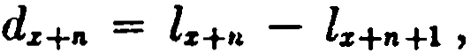 n > 2.
Table 3 is based on the actual experience of a group of insured lives. The degree of selection inherent in this table can be seen by inspection. At age 25, for example, the select ql26J is seen to be just 70 % of the ultimate rate qu . Similarly, q1u1 +1 is 84 % of q26 , and q!UJ+t is 94 % of q21 , and these ratios illustrate the way in which the influence of initial selection diminishes.
In evaluating probabilities of death or survival involving select lives, carc should be taken to relate all select functions to the cor­ rect age at entry. Note thc following examples based on the data of Table 3:
lc221+2 940,108
2Pcni = = 942,944
lu 938,359
•Pc201 = Zc201 = 946,394
ZcH1+2 936,379

241
p¡
+i = l¡24J +1 = 937,964
di& 1,910

21q¡n)+i = l1n1+1 = 939,835

28 THE IIEASUREMENT OF MORTALITY [CH. 1

Although the table we have used here for illustration involves a select period of three years, it should not be inferred that this · is the normal period during which the effects of selection are signifi­ rant. The length of the select period depends on the nature of the underlying data, and the effects of selection may persist noticeably for many years. A number of standard American tables havc 5-year select periods; one of the classical British tables was constructed with a 10-year select period ; and the continuous mortality inves­ tigation carried on by the Society of Actuaries maintains a 15-year select period.
Although the above discussion has been concerned with the mor­ tality of insured lives, the analysis is perfectly general and applies to any group in which mortality varíes by duration as well as by age. Select mortality is found in the same fonn among annuitants as among insured lives, although in this case the eff ect is produced by self-selection on the part of the annuitants themselves, since usually only those persons who think themselves to be in good health will consider the purchase of an annuity.
Values of the force of mortality at select ages may be estimated from mortality table data by using the methods of Section 5. Using the analogue of formula (1.21 ), for example,
. 8( lcs]+l - l1s1+a) - ( l¡s] - l¡s]H)
l"[z)+2 =; 12l
(zl +2
(assuming the select period to be greater than 4 years). Note that this formula could not b.e used to approximate J.ilzl+l , since it would then involve the meaningless symbol lizJ-1 . The analogue of for­ mula (1.22) could be uscd in this case.
A mortality table which is constructed from records of insured lives without rcgard to age at issue, all durations from zero on being included, and all lives of the same attained age being grouped togethcr, is called an aggregate table. Another type of mortality table is the ultimate table, which is constructed from records of insured lives with the experience of the first years after issue omitted in ordet to eliminate the eff ects of selection. The ultimate column of any select and ultimate table constitutes in itself an ultimate rnortality table. The American Experience table, one of the earliest tables to be used extensively for insurance purposes in the United States, is a well-known example of an ultimate table.

SEC. 9] THE INTERNATIONAL ACTUARIAL NOTATION 29

- The lnternational Actuarial Notation
The Intemational Congress of Actuaries adopted in 1898 a sys­ tem of notation for actuarial literature. In addition to prescribing definite symbols for the common actuaria! functions, this code indicates the notational principies to be followed in adopting sym­ bols for new functions that may be needed. In this way, it provides for the development of a consistent actuaria} notation that will always be intelligible to anyone familiar with the code.
At the end of each chapter the notational ideas first introduced in that chapter will be summarized. These summaries will consist of three parts: (1) the fundamental principies, (2) the application of these principies to the specific types of function discussed in the current chapter, (3) consideration of any exceptional points.
Fundamental rwtational principles used in Chapter 1
  - Actuaria} functions are represented by a principal symbol with associated prefixes and sujfixes which may be either subscripts or superscripts. The principal symbol expresses the general nature of the function. The prefixes and suffixes each limit sorne phase oí the generalization, so that the completed symbol constitutes a pre­ cise definition of the function.
- A sujfixed subscript (appearing at the lower right-hand comer of the principal symbol ) indicates the conditions relative to ages and the otder of succession of the events.
- A prefixed subscript (appearing at the lower lcft-hand comer) indicates the conditions relative to the duration of the operations and to their position with regard to time.
- A vertical bar with a prefixed subscript indicates a period oí defennent.
Application to mortality tab'le functions
  - The following principal symbols are used in this chapter:
l, a number living;
d, a number dying;
p, a probability of living;
q, a probability of dying;
µ., a force of mortality.
- With the above principal symbols, a suffixed subscript indi­ cates the age of the life involved (Principie B) ; e.g., l:r: . If the sub-

30 THE MEASUREMENT OJI' MORTALITY (CH. 1

script x is enclosed in square brackets, it indicates select mortality with duration measured from age x ; e.g., dczJ • To this may be added, outside the brackets, the number of years which have elapsed since age x, so that the total suffix denotes the attained
age; e.g., d1 1+e . The symbol w is used to indicate the first age at which there are no survivors; i.e., w is the smallest x for which
l.= o.
- With the principal symbols p and q, a prefixed subcript de­ notes the time interval over which the probability is taken (Prin­ cipies C and D); e.g., t1Pz and ml nqz . When n = 1 in these symbols, it is customarily omitted: Pz , ,n¡q.e .
- The special symbol (x ) denotes "a life aged x."
N of,e: The symbol s (x ) is not defined in the International '!\ota­ tion. In demographic literature, it is called the "survival factor" and is denoted by l (x) or p (x).
References
In addition to the general texts on life contingencies by King (1902), Spurgeon (1932), and Hooker and Longley-Cook (1953, 1957 ), there are numerous articles in the actuaria) journals which bear on the material of this chapter. A few of thesc will be cited as being of particular interest either as original sources or modem interpretations. The comments bclow are arranged according to the sections of this chapter to which thcy refer. The complete ref erence will be found in the Bibliography at thc end of the book. 1, 2. The biometric background, including thc survival function,
is given by Lotka (195.6), Chapter 9.
3. The data for Table 2 and for Table B in thc Appendix is taken from "Life Tables for 1959-61," Volume I, o. 1, National Center for Health Statistics, Public Health Service, U.S. Depart­ ment of Health, Education, and Welf are. The general character­ istics of these tables are discussed by Myers and Bayo (1964 ) . The Commissioners 1958 Standard Ordinary l\fortality Table is described in TSA 10 (1958), pp. f>86·-706. Thc tcchnical methods used in the construction of such tables are treated in the text by Spiegelman (1955).
4. A mathematical trC'atment of the force of mortality is given by Smith (1948) and by Ilrillingrr (19f>l ). Thc relationship hc­ tween the theories of compound intcrest and lifc contingencics is developed more fully by Allen ( 1907).

EXERCISES 31

5, 6. Techniques of numerical diff erentiation are treated in all standard texts on finite differences and numerical analysis; e.g., Freeman (1960), Froberg (1965). The approximations for frac­ tional ages are examined in detail by Mereu (1961 ).
7. The original papers on the laws of mortality are Gompertz (1825) and Makeham (1860, 1889). Other mathematical laws are surveyed by Elston (1923}. See also Wolfenden {1942 ), p. 77. A modern interpretation, from the point of view of statistical lifc testing, is given by Brillinger {1961) .
8. Discussions of the effects of selection may be found in Thomp­ son {1934), Williamson {1942), and Jenkins {1943).
9. An outline of the International Actuaria! Notation, with revisions, appears in TASA 48 (1947 ), p. 166. It is also given by Hooker and Longley-Cook {1953, 1957 ).
EXERCISES

l. Introduction; 2. The survival function

.
l. Venfy
h h . 20,000 - lOOx - xi . fi
e funct1on satis es
t at t
20,000

h d. .
1t10ns
t e con

on s(x). What is w?
Use the f unction to calcula.te the following probabilities:
- the probability of surviving from birth to age 20; (Ans. .88)
- the probability that a life aged 20 will survive to a.ge 40;
(Ans. %1)
(e) the probability that a life aged 20 will die between 30 and 40.
. (Ans. 1'.!-ú6)
- Given s(x) = Hov'lOO - x, O < x < 100.
  - Find the probability that a Iife aged O will die between age 19 and a.ge 36. (Ans. fo)
(b) Find the probability that a life aged 19 will die before a.ge 36.
(Ans. } )
- The mortality pattern of a certain population may be described as follows: Out of every 98 lives born together one dies annually until there are no survivors.
- Find a simple function that can be used as s(x ) for this population.
- What is the probability that a life aged 30 will survive to attain a.ge 35? (Ans. 6 %s)
d

- Given the function .p( x )
-- s(x.). Show that
dx

(a) {' .,(y) dy = l;

32 THE MEASUREMENT OF MORTALITY · [CH. 1

(b) [
s
+"
cp(y) dy is the probability that a life aged O will die between

age x and a.ge x + n;
(e) 8(:t) = 1 - [ ..,(y) dy.

(d) If 9'(z) = 4 x-111, find a(x). What is the value of w?
- Tbe mortality table
5..Given s(x) = 1 - .005x - .00005x2 , construct the lz and dz columna of the corresponding mortality table for a.ges 0-2, using a radix of 100,000.
  - The following values of qz ha.ve been derived from a mortality experi- ence:
"
o
1
2
fs
.011
.005
.003

Construct the corresponding lz and ds columns, using a radix of 10,000.
  - Use Table 2 to calculate the following probabilities (answers may be left in fractional form) :
    - that (35) will live at least 30 years;
    - that (35) will die within 30 yea.rs;
(e) that (35) will die in the tbirtieth year hence;
- that (35) will die between a.ges 55 and 65;
- that (35) will not die between 55 and 65.
  - Show that
(a) ,.¡,,,qz = nPz - "+"'Pz ;
(b) ,.,qs = •P• ·fs+t1 i
(e) "+"'Ps = •Ps ·"'P"+" ·
Justify ea.ch one by general reasoning.

4. 1'he force of mortality
9. Obtain an expression for /Jz if
lz = k. "w2,rs.
Is formula (1.9) or (1.10) more convenient in this case? 10. Obtain an expression for lz if
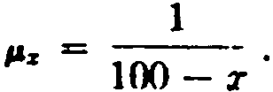

EXERCISES 33

- Show that
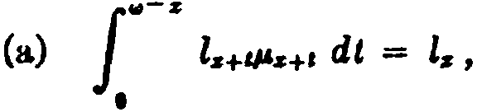
(b) ¡w-s tP*dt = 1,
o
(e) f
1
VA.r+t + &) dt = -log "Pz ,
o

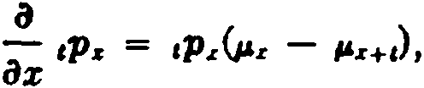
where & is the force of interest., (d)
a
(e) aL tP.r = -iP.rl'z+I •

- A life aged 40 is subject to an extra hazard during the year of age 40 to
41. lf the normal probability of survival from age 40 to 41 is .992 and if the extra risk may be expressed by an addition to the normal force of mortality which decreases uniformly from .06 at the beginning of the year to O at the end of the year, find the probability that the life will not survive to age 41.

S. Estim.ation of l'z from the mortality table
13. If Zs = lOOOylOO - :z:, compute µu exactly and compare with the value given by formula (1.20). (Ans. J8)
14. Show that (1.21) can be written as
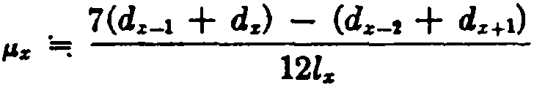

15. Would you expect (1.22) to produce a satisfactory value for µ0 ? Ex­ plain. What additional data would you require in order to produce a better estimate?

- Methods for fractional ages
  - The table below gives expressions for various mortality functions on the basis of two different assumptions. Verify the expressions in the table, assuming O < t < l.

34 THE MEASUREMENT OF MORTAL TY [CH. 1

tion of deaths Balducci hypothesis
Uniform distribu­
t·q.,

1 - (1 - t)q.,
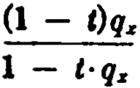
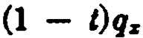

-
1 - t·qz
q,,

1 - (1 - t)qz
q.,(1 - 9z)

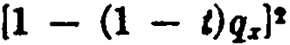

  - Assuming a uniform <list ribution of deaths, calculate from Table 2 thc values of
    - 11.qu ,
    - 1tP•o ,
(C) P.H 1/a •
  - For a certain value of x it is known that ,qz = kt over the i nterval O < t < 3, where k is a const ant. Express P.z+2 in terms of k.
19. Given l,o = 7,746 and lu = 7,681.
Compute µu 1/6

    - assuming a uniform distribution of deaths,
    - using the Balducci hypothesis,
(e) using the fact tha.t the given values a.re
lz = 1ooov100 - x.
(Ans. .00841)
(Ans. .00844)
obtained from (Ans. .00837)

7. Some famous laws of mortaJity
20. Show that under de Moivre's law the probability ,.,qz is independent of n.
21. For a mortality table based on Gompertz's law, evaluate

z+l /J.v 1'11+1 d y
l
z log P11
in terms of the parameters g and c.
- Makeham derived a Second Law from the assumption that the force of mortality consists of three elements, one constant, another increasing in arithrnetical progression throughout life, and the third increasing i n geometrical progression t hroughout life. Show that this implies t hn.t
µ., = A + H x + Be", and derive the expression l., = ks11w1gcz , givi ng t he
relations between the constants s , w, g, e and A , H , B.

- Find l z if P.z
Acz
1 + Bcz

EXERCISES 35

- Select mortality tables
  - Write an expression for 2¡ ,q¡10J+2 in terms of Z, assuming a select period of 5 years.
  - Explain why the following probabilities will differ on the basis of a select table:
    - the probability that a newly insured life aged 23 will die before attaining age 'Zl;
    - the proba.bility that a life aged 23 which was insured three years
ago will die before attaining age Zl .
Calculate both probabilities using Table 3.
  - Consider the three following mortality tables: Table A, a select and ultimate table;
Table B, an ultimate table cohsisting of the ultimate column of Table A; and
Table C, an aggregate table constructed from the data on which Table
A is based.
Wha.t will be the relative magnitudes oí the following f unctions on the basis of the three ta.bles?
    - nPlzJ in Table A compared with »Pz in B;
    - q¡zJ in Table A compared with qz in B and C;
(e) P.z •

- The lnternational Actuaria( Notation
Zl. Express ea.ch of the following by a single symbol:
- the probability that a life now aged 50, insured 3 years ago, will die in his 59th year, i.e., between a.ges 58 and 59 (assuming a 5-year select period) ;
- the probability that a new life aged O will die between ages 67 and 72;
(e) the number of deaths occurring between age 29 and age 30 in the third year of insurance (assuming a 3-year select period).

Miscellaneous problems
- qz has been defined as "the complement of the reciprocal of the anti­ log of the arithmetic mean oí the dea.th rates operating at each instant
throughout the age interval x to x + l." (Weck , 1947) Demonstrate mathe­
matica.lly the accuracy of the definition.
- The probability ,.qz may be expressed in the following different ways:

.q. = l z - lz+" (1.6)
lz
11
1 - e-f o"z +I di (1.13)
ln tPzP.s+C dt. {1.15)

36 THE MEASUREMENT OF MqRTALITY [CH. 1

Assuming the survival function s(x) = foo (100 - x), show tha.t ea.ch of
n
the a.hove formulas leads to the result ,.q,, = ---
100 - X
- From a standard mortality table, a second table is prepared by
doubling the force of mortality of the standard table. Is the rate of mor­ tality q; at a.ny given age under the new table more than double, less than
double, or exactly double tbe mortality rate Qz of the standard table?
31. Find µ.3s to four significant figures, given that

JJ,z = k log x ,
log 2 = .69315,
log •P2 = -.00536426, log 3 = 1.09861.

(Ans. .003584

ÜIAPTER 2
LIFE ANNUITIES

l. Pure endowments
The student will recall from bis study of probability that if p is the chance that a person will receive a certain payment of value K , the product Kp is said to be his expectation. If the payment is deferred for n years, the present value of thc expcctation is K ·vn ·p, where vn is the usual discount factor computed at an appropriatc rate of interest.
Suppose now that (x ) is to receive a payment of K at the end of n years if he is then living. It will be seen that this situation is similar to the one described above. In this case the probability in­ volved is the chance that (x ) will survive n years, nPz , and the present value can be expressed as K ·vn ·nPz . This typc of deferred payment is called an n-year pure endowment of K .
The present value at age x of an n-year pure endowment of 1
1·8 denoted by nEz . Sm· ee nE z = VnnPz = V-nylz;+-n , the vaJuc can bl'
calculated directly from mortality and interest tables. However, the computation involved in such calculations can be reduccd by the use of commut.ation functwns. We first write
nl z+nz
"Ez = V z+n =
lx vrz:,; •
This produces a symmetry in numerator and denominator which suggests the definition of a commutation function
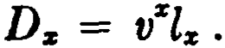

We can then write

"Ez

Dz . (2.1)
= Dz+n

Note that thc computation of ,.E:,; from the basic mortality data involves a multiplication and a division (v" ·l;+n), and that this
37

38 LIFE ANNUITIE [CH. 2

is reduced by the use of commutation functions to a single division
(Dn:"). lt will be found that commutation fundions produee
even greater simplifications when used to evaluate fuuctions which are more complex in form than n.Ez . Values of Dx , and of other commutation functions whieh will be dcfined as the nced for them arises, are tabulated for all values of x for all mortality tables that
form the basis of extensive monetary calculations.
The importance of commutation functions as a labor-saving de­ vice has been diminished to sorne extent by the wide-spread use of digital computers. When an entire series of calculations can be carried out automatically at high speed, the additional time savcd by the use of commutation functions is sometimes uniroportant. Aside from their computational advantagcs, however, concimtation functions are useful in simplifying the construction and manipula­ tion of actuaria! formulas.
nEx may be called the net single premium at age x for an n-year
pure endowment of l. It represents the single payment which (x ) should make in return for an insurer's promise to pay him the sum of 1 at the end of n years if he is then alive. The word net indicates that no provision is being made for the expense involved in the transaction.
Example
What is the net single premium at age 35 for a 20-year pure endowment of $1000 according to the Commissioners 1958 Stand­ ard Ordinary Mortality Table with 3 % interest?
Referring to the Dx columns for 3% in Table A of Appendix I,
we find
lOOO ,J¡¡ = 1000D" = 1000( 1,639,329.7)
D 36 3,331,295.4
= $492.10.
lt is illuminating to check this result from elementary prin­ cipies. Referring to the 1958 CSO table, we note that l» equals 9,373,807. Suppose that each of 9,373,807 lives at age 35 contributes
$492.10 to a fund which is left at 3 % interest until the end of 20 years, at which time the accumulation is divided equally among the

SEC. 2} LIFE ANNUITIES WITH ANNUAL PAYMENTS 39
survivors at a.ge 55. If our previous calculation is correct, the pro­ ceeds should be sufficient to provide $1000 for ea.ch of the sur­ vivors.

Original lives at age 35 . . . . . ... . . . . . . . . . . . . . . . . . . .
Contribution of eacb member . . . . . . . . . . . . . . . . . . . . .
9,373,8(17
X 492.10

Total amount of original fund . . . . . . . . . . . . . . . . . . . . . 4,612,850,425
20-year accumulation factor. . . . . . . . . . . . . . . . . . . . . . . X (1.03)10
Total amount after 20 years ... . . . . . . . . . . . . . . . . . . . . 8,331,319,894
Survivors at age 55. . . . . . . . . . . . . . . . . . . . . . . . . . . . . . . + 8,331,317
Share of each survivor . . . . . . . . . . . . . . . . . . . . . . . . . . . . 1,000. 00
This calculation illustrates what it means to accumulate a fund with benejit of survivorship. The share of each individual who sur­ vives to age 55 includes a portion of the shares which are forfeited by those who die before attaining age 55, so that the share of a survivor includes a greater increment than it would receive from interest alone. At 3% interest, a sum of $492.10 accumulates in 20 years to $888.79. With benefit of interest and survivorship, $492.10 at a.ge 35 accumulates in 20 years to $1000, using the 1958 CSO 3 % basis.
Generalizing, we may say that a sum of nEz at age x accumulates in n years with benefit of interest and survivorship to the amount ofl. This may be expred altematively by saying that nEz is the present value at age x of a payment of 1 at the end of n years discounted with interest and survivorship. Thus, we may use nEs as a discount factor for interest and survivorship, corresponding to
v" for interest alone. Similarly, we may use El as an accumulation

" :e
+
factor for interest and survivorship, corresponding to (1 i)n
for

interest alone.
2. Life annuities with annual payments
A lif e annuity of 1 payable annually to (x ) is a series of annual p&yments of 1 commencing at the end of one year if (x ) is then living and continuing throughout his lifetime. Its present value, denoted by a , may be expressed as the sum of a series of pure endowment values:

40 LJFE AN'NUITJE.<; [CH. 2
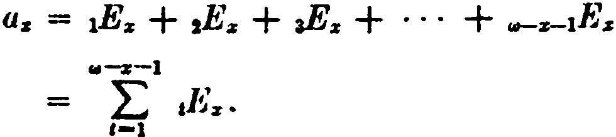
The swnmat ion may also he writteu in thc two fonns:
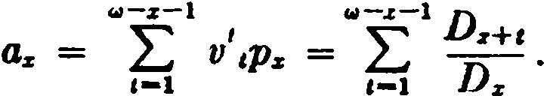
By defining a new commutation function,

the formula becomes
(11--1
Ns = L,-o

Ds+t ,

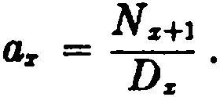
(2.2)

Commutation functions here confer a very real advantage, for without their use it would be necessary to compute the value of
..--1 'l
¿
az from the unwieldy expression az = v l.z+t . In formula
1-1 .z
(2.2 ), by thc use of commutation functions, this calculation is re­ duced to a single division. Complete columns of N z are easily tabulated for this purpose by summing the Dz values from the oldest age back to the youngest age. This convenient continued
process is based on the relation N z = N z+1 + D:z . Once this pre­
liininary tabulation has been perfonned, the value of a:z can
readily be determined for any desired age.
Another fom1of life annuity has payments limited to a specified maximum period. This is the n-year temporary life annuity, which provides payments at the end of each year for n years if (x) sur­ vives. If the annual payment is 1, its present value, denoted by az:;i (or by naz), may be cxprcsscd as follows:
.¿... n J)z+t
L
az:n] = LJ ,Ez = D .
t-1 t=l r

Since ¿"
,1

Dz+t is thc difference between N r+1 and Nz+n +1 , we have

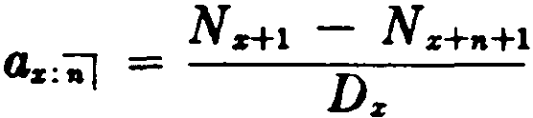
(2.3)

SEC. 2) LIFE ANNUITIES WITH ANNUAL PAYMENTS 41

A third type is the n-year def erred lif e annuity. This is a life annuity with the first n payments omitted. Thus, an n-year de­ ferred life annuity to (x ) provides payments commencing at age
x + n + l. Its present value, denoted by nlaz , may be expressed
as follows:
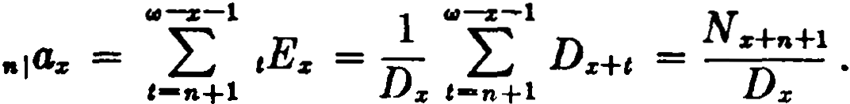 (2.4)
Formula (2.4) may be obtained in other ways. The series of payments provided by the n-year deferre<l life annuity is easily seen to be equivalent to the difference between the life annuity and thc n-year temporary life annuity. Hence,
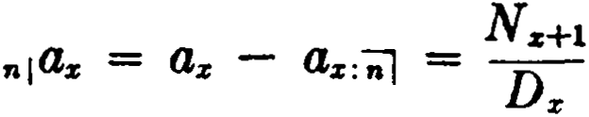
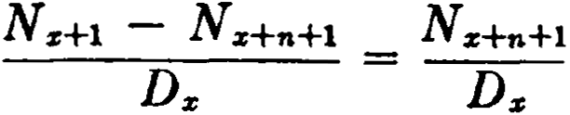
A third derivation of (2.4 ) depends on the use of nEz as a dis­ count factor. At age x + n, the series of payments under the n­
year deferred life annuity has the present value az+n . Discounting
to age x with interest and survivorship, we have
n¡az = nEz ·az+n = Dz+n .Nz+n+1 = N z+n+1
Dz Dz+n Dz
A series of annual payments to (x ) which commences at age
x + n + 1· and continues for rn ycars if (x ) survivcs is called an
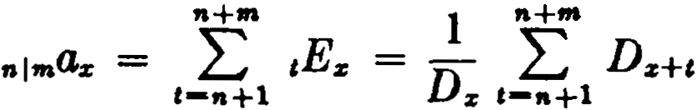
n-year deferred m-year lemporary lif e annuity. lts present value is denotcd by nlmaz , and

Nz+n+l Nz+n+m+l
Dx

( 2.5)

The life annuities defined thus far provide that the first payment he made at the end of a payment period. Any annuity of this type is callcd an immediate annuity. When the series of payments com­ menccs at thc beg-inning of the paymcnt pcriod, the annuity is calle<l an annuity-due, an<l its prcsent value is·distinguished by a
double dot (dicresis) over the a, for exam ple az .
Whcn paymcntH are ma<lc annually, the payments of the ain­ nuity-due conunence one year earlicr than those of the correspond-

42 LIFE ANNUITIES . (CH. 2

ing immcdiate aunuity. The following formulas may be readily verified:

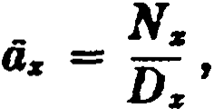
(2.6)

_ N11 - Nz+,.
az:i"f = Dz
_ Nz+.
,.,az = Dz '
.. Nz+• - Ns+.+-
•1•ª11 = Ds

( 2.7)

(2.8)

( 2.9)

Thc foJlowing relations between immediate annuities and an­ nuities-due will also be evident:
éi:r = 1 + a:r , (2.10)
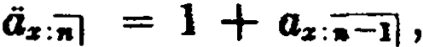 (2.11)
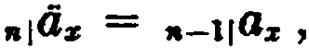
(2.12)

•I.Ó:r = •-11.<J.z •
(2.13)

Lifc unnuities are occasionally encountered which providc that payments be made at the end of a fraction of a year and annua11y thcreaftr. These may be regarded as annuities-due deferrcd for yean:;. The present value, 1/tidz , of such an annuity may be ap­
1
proximated by intcrpolating linearly between the prcscnt value á:z of the annuity-due (first payment deferred O years) and the present value az of thc immediate annuity (first payment deferred 1 year).
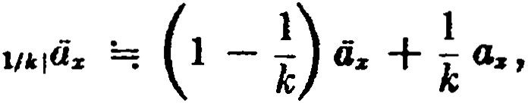
Thus,

or, since

az = - 1,

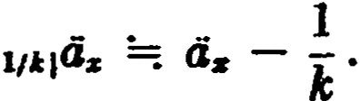

SEC. 2] LIFE ANNUITIES WITH ANNUAL PAYMENTS 43

Formulas for other types of life annuity may be obtained by a simi­ lar interpolation.
It is sometimes necessary to use a function which is obtained
by examining the temporary life annuity from a somewhat different point of view. Suppose that each member of a group of lives aged x agrees to make a payment of 1 into a fund at the end of each year, provided he is then alive. If these payments are accumulated in the fund for n years, the share of each survivor in the total fund at the end of that time is known as an n-year forborne life annuity, denoted by S:e:ñ'] .
A formula for Sz:-;-J may be derived by summing the amounts to
which each of the individual payments of 1 will accumulate at the end of n years with benefit of interest and survivorship. The first
payment of 1 made at age :r + 1 will accumulate to -E-- at age
1
n-1 z+l
x + n; the second payment will accumulate to -,¡- ; and so on.
1
n-2=z+2 ·
Thus, the total accumulation for a life surviving at age x + n is
Sz:-;i = t --1- = t D:e+t = Nz+l - N:e+n+l • ( 2.}4 )
t-1 n-tE:r+t t l Dz+n D:e+n
It will be seen that Sz:-;i represents the accumulated value at the end of n years of the series of payments for which ax: denotes the prcHcnt value at a.ge :r, and, if this present value is accumulated for n ycars, the value of Sx :-;;i is obtained.

S:z::-;i = a:z;;-;;i . E
1
,a X

N:e+J - N:z:+n+l Dx N:e+l - Nz+n+l
0

D:r
D:z:+n
Dx+n

The accumulated valuc of n annuity-<luc payments may be
similarly obtained. Thc formula is

N z - N:e+n
= ----­
Sr: -;;1
D..r:+n
( 2.15)

Thc oldcr syrnhol n1tz has bccn commonly uscd in place of Sz:;-J .
It shoul<l he notcd that all of thc annuity formulas derive<! m thi8 8edion are of the gen<'ral form

44 Lll"E ANN1JITl'ES

N ,, - N.+,.
Dz-
where y is the age at which the first payment is due,
n is the number of payments, and

(2.I6:)

x is the age at which the value of the payments is desircd.
It is thus unnecessary to memorize individual formulas for each different type. The present value, or net single premium, for- a 10- year deferred 15-year temporary life annuity to (36), for example, may be immediately written down by formula (2.16). Noting that
the first annuity payment will be due at age 47, we have y = 47,
n = 15, and x = 36, so that
N., - Ne
10116'131 =
If the accumulated valuc of the annuity at age 62 is required, wc simply write
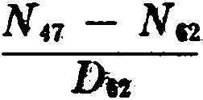
In <·alculating lifc annuity va}ucs from. select tables, it iti con­ venieut to use select commutation functions. The values of D can be computed in the U'.)Ual way. If the select period ís k yea.rs, th formulas are

and
D1%)H = vr+tl(zl+t
D,,+, = vz+i¡s+t
for
for
o . t < k,
t k.

Thc N columns are then obtained by summing thc D valucs for
each age at i&;ue:

.lr-1 tt-.1:-l
Nc:11l +t = L D[z}+r + Dz+r

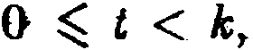
for

,-e .

and

N%+l =

1.,1-.:111-l
,._,

Dz+r

for t k .

Formulas for select annuity values may then he convenicntly expressed in commutation symbols. t'or cxamplc, consider an n­ year deferred Iife annuity to (xJ:

SEC. 3] ANNUITIES PAYABLE MORE THAN ONCE A YEAR 45

nlG(sJ

Nrs1+.+1 for n < k - 1
DrzJ
Ns+.+1 for n k - 1.
= D1s1

In the following pages, the word annuity will nonnally ref er to a life annuity. Whenever life contingencies are not involved, the tenn annuity-certain will be used.
- Annuities payable more frequently than once a year
In practice, life annuities are often payable on a semi-annual, quarterly, or monthly basis. The present value of an immediate lüe annuity of 1 paya.ble m time.s a year to a life aged x is denoted
by a! m> . This serie.s of payments, contingent on the survival of
. 1 1
+ -
(x), consists of a first payment of - at age x followed by
m m
1
similar payments at intervals of - years. The present value may
m
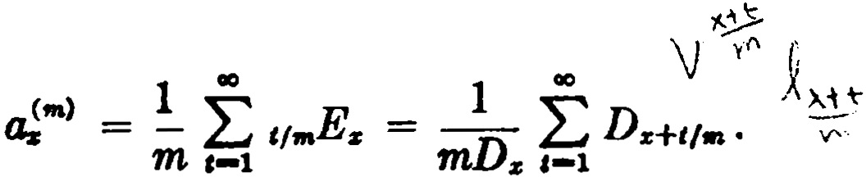
be written

r

The upper limit of m (w - x) has been written as oo . This is a con­ venient device which is often used to indicate that a summation extends to the upper limit of the life-span. The value of the sum­ mation is not affected, since Ds+tfm = O for t m(w - x).
If it is necessary to evaluate a!"'> in terms of mortality table data
for which the mathematical fonn of ls is unknown, as is usually the case in practice, a difficulty arises in that Ds+t/m is not defined
when x + .!_ is fractional. However, the expression L;°_1 Dz+t/m can
m
be approximated in severa} ways. Using Woolhouse's formula, for example, we may write
1 CIO
mDz ,-1Dz+t /m
1 [ m - 1 m2 - 1 dDz
··J
z ,-1 m m x

= D L.J D:i:+t + 2-Dz + 12 2·
d--

46 LIFE ANNUITIES . (CH. 2

To simplify the expression, we must find the derivative of Ds .
Using elementary calculus, ·
dDs = r dls + l dvs .
dx v dx z dx •
Since the derivative of lz is -lzP.s and the derivative of vz is
vr log v = -vrc5, we have
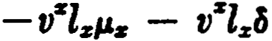
dD.
dx
-vzlz (µz + c5 )
- Dz (µz + c5 ). (2.17 )
With this substitution, the first three terms of the Woolhouse ex­ pression for a.!•> reduce to
(m) • m - 1 m2 - 1

a; =: as + -
m ( µz + ). (2.18)

12 2
In practice, the approximation given by the first two tenns of (2.18) is usually regarded as sufficiently accurate, and the result­ ing simple formula
a; =: az (2.19)
(m) . + m - 1
is almost universally used. Formula (2.19) can also be derived 1 under the simple assumption that Dz+t is a linear function for O t l.
In deriving formulas for deferred and temporary annuities pay­
able m times a year, we will consider only the practica} approxima­ tions which correspond to formula (2.19) for a"'> .
For the deferred annuity payable m times a year,
n<m> E <•> . E ( m - 1)
11!""% = 71 s·a.;+,. =: n S a.i:+n + ,
whence 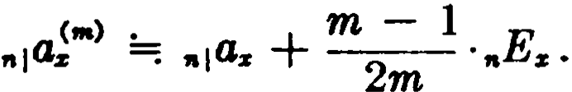 ( 2.20)
For the temporary annuity payable m times a year,
at;/¡ = tJ!•l - .,tJ!•l =; (a.+ m2 1) - (.,a, + m2 1..E,) '
1 See Exercise 9.

SEC. 3] ANNUITIES PAYABLE MORE THAN ONCE A YEAR 47

<•> •
whence a
s:i'J =:
a.r:;i +· m - 1 ( 1 - nEz ).
(2.21)

The corresponding annuity-due formulas may now be easily derived. The annuity-due paya.ble m times a year differs from the immediate annuity "'> only by the amount of the initial payment
of 1-.Thus, a...s(ffl) = a.s< m) +1- .=: az + m2+ 1 or, sm. ce az = dz -l,
m m -m -,

-Cm> • -
a.s
=: az.
.m - 1
, m -
- 2 .
(2.22)

For the deferred annuity-due paya.ble m times a year,
.14!•> = .E.·á!'i' =¡.E,(11.+. - :1 ,
)

whence
.;<•> . - m - 1 E
nlU.:Z =: 111Gz - n z •
2m · (2.23)

For the temporary annuity-due paya.ble m times a year,
A<•> _ -<•> -Cm) • (- m - 1) ( _ m - 1 E )

1.ts:il - Os - "'ªz =: az - 2m - "'ªz - ·n % '

ªz:•I =: as:il - - n i z • (2.24 )
whence ..<•> • . m - 1 ( 1 E )

In tenns of commutation functions, these formulas appear as
follows:

(2.19)
lmmediate Annuities

(2.20)
m - 1
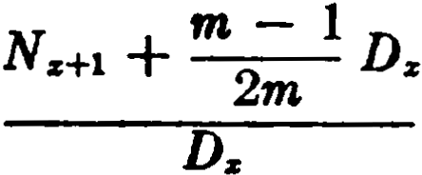
m
N.+w+1 +
2

Dz+n

•( ,n) :-.;- -Dz ---

(2.21)

<•> •
m - 1
N z+l - N s+n+l m
+
2

( Dz - Ds+n )

as:=: -----------------
Ds

48 un ANNlJJTIES (cu. 2

Aanuitie•-Due
Ns - m - 1

(2.22)
a!•> =:
--Ds
2m
Ds
m - 1

(2.23)
ñ(•) =-
N"" - 2m Ds+.

•1-..z ---
Ds ---

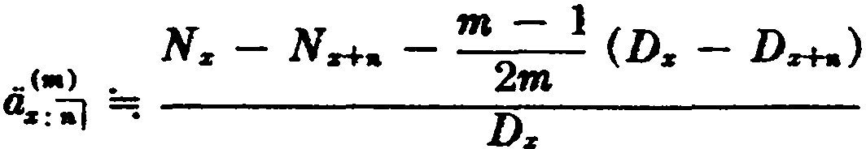
(2.24)

- Continuous annuities
When the frequency of payment m becomes infinite, the result­ ing annuity is called a continuous annuity. We define
tls = lim ->,
•-+ao

and call iis the present value of a continuous life annuity of 1 to (x ). We may regard the continuous annuity as being payable momently throughout the year in such a way that the total annual payment is l. This is admittedly an artificial concept. It has, how­ everi considerable theoretical interest, and is useful in affording an approximation to annuities payable as often as weekly or daily.

Since as =.li.m....,
a;•> , we may write
<is = lim !._ f, ,,,,.Es .
  - -+IO ffl t-1

Since the right-hand side is equivalent to a definite integral, we
have
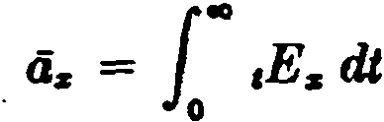 (2.25a)
and this may be written in the alternative forms

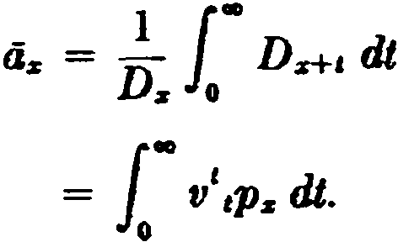
(2.25b)

(2.25c)

SEC. 4) CONTINUOUS ANNUITIES 49

It will be recalled that the upper limit of co is used to indicate that the summation extends to the end of the life-span. Thus the symbol oo is used as an abbreviation for a more complicated finite expression, and the integrals in such formulas as (2.25) need not be regarded as improper integrals.
The values of á:,: cannot be directly calculated from tlie above formulas unless we are given a survival function which is simple enough to permit the integration in {2.25c) to be carried out. This is not usually thc case, and an approximate method must be used. The simplest device is to let m become infinite in the formulas al­ ready derived for am> . From (2.18) and (2.19) we thus obtain
(2.26 )

and 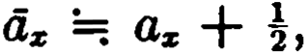
formula (2.27 ) being thc usual practical approximation.
(2.27 )

The calculation of continuous annuities is facilitated by the preparation of special commutation columns. We define
Dz·= f Dz+t dt (2.28)
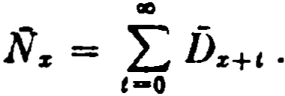
and (2.29a )

It will then be scen that l z = i«i Dz+t dt ,
so that we may write

(2.29b)

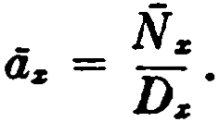
(2.30)

In computing the values of Ds and Ñ:,: , it is necessary to adopt an approximati<m for formula (2.28). If we assume that Dz+e is linear for O t 1, wc ha.ve
f Dz+i dt =: Drll/2 =: !(Dz + Dz+i ),
nnd 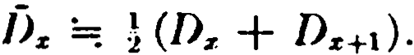
Then J\'z =: (Nz + Nz+d = N z -!Dz = Nz+1 +!Ds .
This assumption proclu<·C8 valucs of dz which are ronsistent with formula (2.27 ).

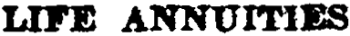
50 [CH. 2

The various types of continuous annuity can now be expressed in both integral and commutation fonn:

li:,:; = 1..,"t4>:s dt
1 e dt Ñ
= Ñ. ;
/):,:;
-

(2.31)

11
aa.i = v •Ps = z
D Ñ s+a ;
(2.32)

o z
•tª-• = 1·"'tP:s dt = Ñ1s)+. .
    - z

(2.33)

We shall frequently need the derivatives of actuaria! functions which are expressed as integrals. lt is helpful to recall the following caJcuJus principie:

If F( x ) = f J( y ) dy, then
•
If ;(x ) = [" f( y ) dy, then
z
dx ) = J( x).

dx ) = - f( x ).

( 2.34a)

(2.34b)

An application can be made to tbe function lvz . Since formula (2.29b) can be written as

we use (2.: 4b) to fin<l
Ñ:s = [ D11 dY ,
%

d Ñ z D
= -
dx z •
( 2.35)

( 2.36 )

we can now find thc derivativc of Ó:,; :
das _ d (Ñz) - 1 - (D .dÑ:,; _ Ñ .dD:s)
dx dx Dz (D:s)" • dx :s dx •
Substituting from (2.17) and (2.36) and símplifying, we havc
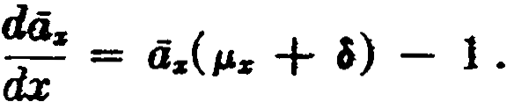 (2.37)
- Varying annuities

Annuity fonns are frequcntly cncountered under which thc rate of payment varies from time to time. Thesc are known as varying
annuities.

SEC. 5] VARYING ANNUITIES 51

The present value of a. varying annuity may usually be expressed as a combination of the present values of certain level annuities. Consider, for example, a varying annuity to (x) which provides annual payments of 1for n years followed by payments of 2 for the balance of the lifetime of (x ). Its present value is obviously equal to the sum of the present values of a life annuity of 1and an n-year
deferred life annuity of 1, ax + ni ax ; or it may be expressed as
the sum of an n-year temporary annuity of 1 plus an n-year de­ ferred annuity of 2, a=ñl + 2111ª2: •
As a second example, let us suppose that a varying annuity-due provides annual payments of 1 for th first n years, payments of 2 for the next m years, and payments of 1 again for the balance of the lifetime of (x ). This -series of payments is evidently the same as would be provided by a life annuity-due of 1 plus an n-year de­
ferred m-year temporary annuity-due of 1, iix + nlindz .
Special symbols have been assigned to certain common forms of varying annuity in which the payment pattern follows sorne regular law. The case in which the annual payments increase or decrease in arithmetical progression is of particular importance.
The symbol (la)x denotes the present value at age x of an in­ creasing lije annuity which provides payments of 1 at age x + 1, 2 at age x + 2, 3 at age x + 3, increasing by 1 for each year that
(x) survives. Thus,

IO
L
(la)% = tvttPs .
t-1

(2.38)

This pattem of payments is clearly equivalent to that provided by the following series of level annuities: an annuity of 1 (ax ), an annuity of 1 deferred 1year (11as), an annuity of 1deferred 2 years (21as), and so on. From this point of view,
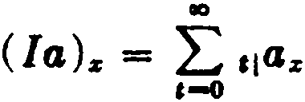
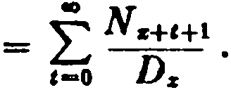

If now we define thc new commutation function,
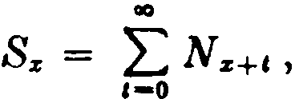

52 LIFE ANNUITIES (CH. 2

the formula may be written ( la):z: = :1 •
(2.39)

For the n-year temporary increasing lif e annuity under which the increasing payments cea8e with the n-th payment of n, the value may similarly be expressed as a sum of n deferred temporary an­
nuities, each ceasing with the payment due at age x + n:
n -1 n-1 N N

( I a)z:n] =
,L-o
t l n-,a:z; == L z+t+l ;; z+A+l
,-o

_ S:z:+1 - S:z:+n+1 - nN:z:+•+i
- Dz

( 2.40)

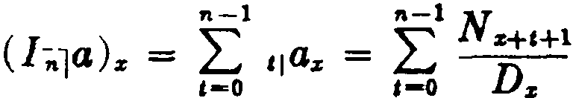
Another type of increasing annuity provides increases of 1 each year until the n-th year with payments remaining constant at n for the remainder of the lifetime of (x ). The present value, denoted by (ln1a)z , may be expressed as the sum of the values of n de­ ferred annuities:

= Sz+i
-S:z:+n+i
Dz
( 2.41)

A temporary decreasing lif e annuity which provides a payment of
n at agc x + 1 decreasing by 1 euch year and ceasing with the
n-th payment uf 1 may be expm,se<l ai-; a sum of n level temporary annuities:

Nz+l - Na+t+l
( D ) = =
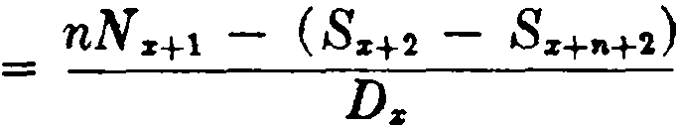
a z:ñl L,-J1 az: tl ,LJ1 Da:

(2.42)

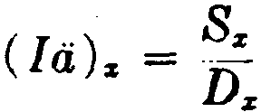
The formulas for the corresponding varying annuities-due are easily obtained from the above immediate annuity formulas by simply making each numerator refer to an age one year younger. The two following examples may he readily verified :

8EC 5) VARYING ANNUITIES 53

( DA )
_ _ nN. - (Ss+l - s-+"i-1)

a:11 1 - Da •

Although the formulas are useful in certain special cases, it should be noted that the formula for any varying annuity, with regular or irregular variations, may be developed from first prin­ cipies by expressing the benefit as a sum of pure endowments.
When varying annuities are payable more frequently than once a year, two different cases arise depending on whether the rate of payment is constant or varies during each year of age. If the rate of payment during the year is constant, the total annual pay­ ment is made in m equal, instalments with increases or decreases oc­ curring only at the beginning or the end of the year. A varying annuity of this type may be expressed as a sum of a series of level annuities, and it is consequently possible to obtain approximate formulas for varying annuities payable m times a year by an ex­ tension of the process used in approximating the values of level a.nnuities payable m times a year. For example, an increasing an­ nuity payable m times a year is equivalent to a series of successively deferred level annuities payable m times a year. Thus,
m - 1

ao ao Na+c+l + -
( la )"'> = L ,,a!"'> =: L
2-DsH

,-o ,-o Da m
m - 1
+
Sa+1 N.
= ----D=z ---

(2.43)

The second type of varying annuity with m payments per year provides that the rate of payment increase or decrease m times a year. Suppose that an increasing annuity is paya.ble at the rate of 1 1 2
- per annum at the end of the first - years, - per annum at the
m m m
1
end of the second - years, and so on. If this annuity is issued at
m
age x, the first payment due at age x +-1 . then be 1 , .

th. . 1
m w1ll
2m smce

18 payment covers a per10d of - years and the rate of payment.
m

54 -LIFE ANNUITIES (CH. 2

during this first period is _!_ per annum. Then the second payment
m
at age x + will be -;, and so on. Denoting the present value of
m m
such an annuity by (/<"'>a )!m> , we have
([ <"''a)!"'> = _!_ i:,_!_ Dz+ .
Ds ,-1 m2 "'
Expanding this summation by means of Woolhouse's formula as
far as the tenn involving the first derivative, we obtain

(l e,..,a ) ,,..,
z
1 {
z ,-1
= D
tDz+c + m-
- 1 [tDz+c ],-o
2m
--

+ m - 1[d J
2
...}-

12mt dt ( tDz+i ) ,-o -
Since
[i(tD,+,ll.. = (D,+1 - tD,..,(¡,,+1 + a)l,-o = D.,
this simplifies to

( I (m)a )! "'' =. ( ] ) + m2 - 1
• a z 12m2 .

( 2.44)

When the frequency of payment m becomes infinite in the above formulas, expressions for continuous varying annuities are obtained. Corresponding to the increasing annuity under which the rate of payment is constant during each year of age, we have the continu­ ous increasing annuity, with present value (la)z , which provides for payments at the rate of 1 pe: annum at each moment of time
during the first year of age x to x + 1, at the rate of 2 per annum
during the second year, and so on. Thus,
(lii)z = lim (la).z<"'> .
111-+CO

This function may be regarded as a sum of successively deferred level continuous annuities. Then
ao
L
Ua)z = ,1a:r
,-o
= f Ñ z+c
,-o D7 '

SEC. 6]

and, letting
VARIATIONS IN INTEREST AND MORTALITY 55

we ha.ve

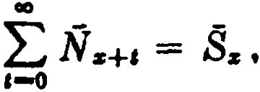

(lá)z = -

(2.45)

An approximate formula for (Ia )z may be obtained by letting m
become infinite in formula (2.43) for (la) •> . We thus obtain
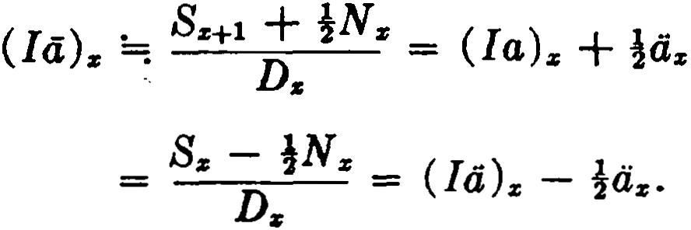
This result indicates that approximate values of Bz may be calcu­ lated from
Sz =; Sx - }Nz .
Corresponding to the type of increasing annuity under which the rate of payment increases during each year of age, we have the continuous increasing annuity, with present value (la)z , which provides for payments at the rate of t per annum at the moment of
attaining age x + t. The present value may be expressed in the fol­
lowing ways:
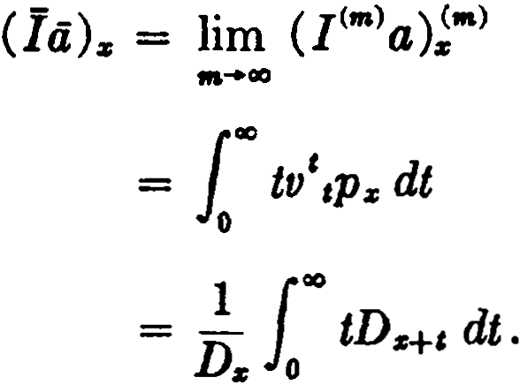
(2.46a )

(2.46b)

(2.46c )

By letting m become infinite in fonnula (2.44) for (I<"')a)!m>, the following approximate relation is obtained:
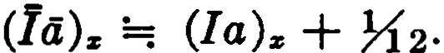
(2.47 )

- The effect of variations in interest and mortality
We nonnally regard ax as a function of x defined by a particular mortality table and rate of interest. Suppose that we change our

56 LIFE ANNUITIES [CH. 2

point of view and think of the different values of az produced for a given x when changes in mortality and interest occur. It is important to be able to estimate the effect of such variations.
The effect of a change in interest alonc can be estimated by con­
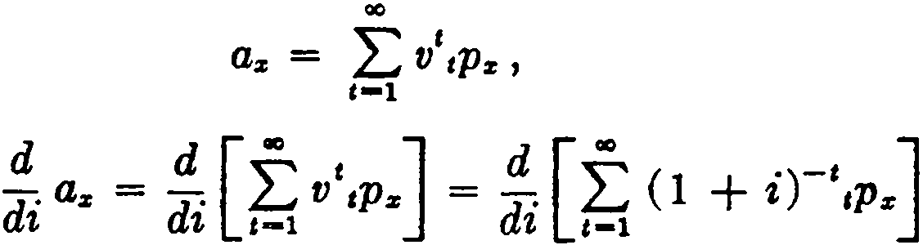
idering the derivative of az with respect to i. We write

and then

= (1 ·)-t-1 t
,¿-, 1 - t + i tPz = -v ¿, tV ,P z ,
,-1

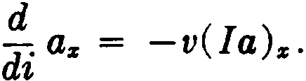
or (2.48)

The negative sign reflects the fact that az decreases as i increases.
Formula (2.48) may be expressed in differential form as
da:i: = -v (la)z di,
and, since the differential of a function is an approximation to the change in the function corresponding to a given change in the in­ dependent variable, we may write
Aaz =: -v (la)z· Ai.
It must be remembered that the differential provides a satisfactory estimate ortly when the change in the independent variable (Ai) is small. This produces the following approximate formula for values of az at a new rate of interest j when functions are tabulated at a closely neighboring rate i:

<L;;i =. : <i:,: - j - i ( I )' .
l + i a z

(2.49)

There are a number of other practica! devices for approximating annuity values. If values are tabulated at severa! rates of interest, an interpolation may produce a satisfactory estímate of the value at an intermediate rate. More elaborate methods are also available, but these are not often applied in practice and need not be con­ sidered herc.

SEC. 6] VARL\TIONR IN INTEREST AND MORTALJTY 'f>7

Changes in mortality asmme many different fonns and we can note here only a few simple results.
The efiect on as of a change in the ratc of mortality at a single age, say x + n, is easily detennined. We write
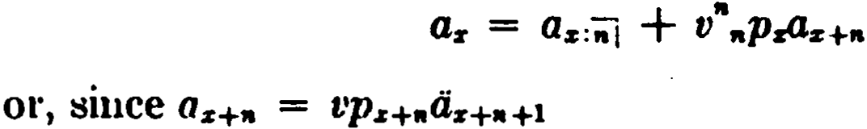
and P.r+n = 1 - Qz+n ,
If now qz+n is replaced by qz+• + e, we can see that the change in
az will be -cv"+1 •
nP;rOz+n+1
Let us next examine the effect of a constant change in the force of morta]ity. Since the annuity value az can be expressed as the sum of pure endowment values, it will be sufficient to study thc effect of this change on nE.r . Writing
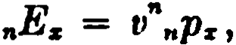

and substituting
v n = e-In
= e-f"o ¡Jt

and
- e- o""s+ t d t
" z - '
P f

we have
•Ez - e- f"o
<l's+ t +I) di •
(2.50)

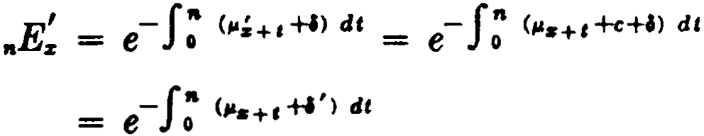
If now a constant change e is ma.de in P.z so that a new force of mortality, , is formcd equal to P.s + e for all x, the corresponding pure endowment .E; may be exprfSSed as follows:
-

where ,,, = ,, + c.
Compa.ring this result with (2.50), we note that ,.E; can be com­ puted using the values of µ. on the original mortality basis if the
force of interest is adjusted by the constant addition c. For the pure endowment, then, a constant change in the force of mortality is equivalent to the same change in the force of interest and it follows that this will also be true for annuity values.
When the mortality follows a mathematical law, the effects of changes in the various parameters can of ten be easily expressed.

58 LIFE ANNUITIES {CH. 2

For example, with Makeham's law,
µ:i = A + Bcz,
a change in the constant A, producing a constant change in the force of mortality, is equivalent in its effect on annuity values to a change in thc rate of interest. A change in B may be seen to be equivalent to a constant change in the age x. For, if B assumes the
new value Be", then the new force of mortality µ; , being equal to
Aµ: + Bcz+", is the same as µz+1t. . If e is changed to e' = e\we have
= A + Bc"' x = µkx , a result which can be visualized in tenns of
an expansion or contraction in age.
- Summary of notation
Principles A through D of Chapter 1, Section 9, should be re­ viewed.
  - A suffixed subscript may consist of a compound symbol of the form x :nl. This indicates that the function depends upon the joint
duration of a life aged x and a term-certain of n years.
  - A suffixed superscript (appearing at the upper right-hand comer of the principal symbol ) indicate.s the periodicity of events. lt is always enclosed in parentheses or brackets.
  - When the periodicity of events becomes infinite, a horizontal bar over the principal symbol rcplaces thc use of the suffixed superscript.
  - The dieresis above an annuity symbol is used to distinguish
annuities-due from immediate annuities.
A pplication to pure endowment and annuity benefits
    - The following principal symbols are used:
E, the present value of a pure endowment of 1; a, the present value of an annuity of 1;
s, the accumulated amount of an annuity of 1; (1a), the present value of an increasing annuity; (Da), the present value of a decreasing annuity.
    - The horizontal bar over an annuity symbol means that pay­ ments are made momently (Principle G). When the bar is used over the I or D of a varying annuity symbol, it indicates that the increases or decreases occur momently.

REFERENCES

Comments. It will occa.sionally be found that two different sym­
bols will specify the same function. For example, the temporary annuity is expressed by Principie E as Oz :·;-: . Using Principie e,
however, it may equally well be denoted by "ªz , and this symbol is occasion.ally encountered.
The symbol (]Cm>a) is not defined in the International Code, and the notation for the corresponding continuous benefits is acrord­ ingly not standardized. In earlier actuaria} Iiterature the function which is here denoted by (la)z is represented by (Ja )z . To avoid confusion, the student should note carefully the definitions of these symbols when they are encountered elsewhere.
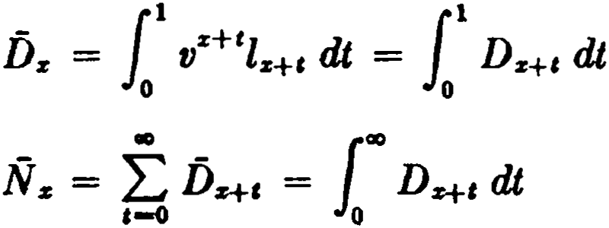
eommutation fu.nctions
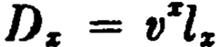
IO
N s = ¿Dz+,
,-o

IO
L
Ss = Ns+c
,-o
•
= L ( t + l)Ds+,
e-o

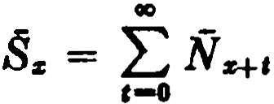

IO
= L ( t + l)Ds+t
e-o

References
2. When mortality is given by a mathematical law, annuity values can sometimes be computed directly without recourse to a morta.lity table. For the case of de Moivre's law, see Exercise 6 following. The case of Makeham's law is treated by Mereu (1962). 3, 4. The Woolhouse formula. is derived in standard texts on numerical methods, e.g., Freema.n (1960), p. 193, or Froberg
(1965), p.'214.
The errors in the approximation methods have been investigated by Mereu (1961).
S. A useful method which simplifies the derivation of formulas for complicated varying benefits has been given by Menge (1935).
6. Much ingenuity has been expended in developing methods for computing annuity values at new rates of interest when commuta-

60 LIFE ANNUITIES [CH. 2

tion columns are not available. Among the classical methods are those of Allen (1907) and Lever (1920) for ordinary annuities, and of Lidstone (1893) and Evans (1929) for varying a.nnuities. Lidstone's method is the basis of Exercise 21. Interpolation methods are discussed by Baughman (1965). Experiments in obtaining annuity values by Monte Cario methods using a digital computer have been described by Boenneester (1956).
EXEReISES
l. Pure endowmente
l. If B(x ) = Xo vlOO - X, what is the present vs.lue at 3% of a 17 year pure endowment of 1 on a life aged 19?
(Given 1117 = .6050 at 3%.) (Ans. .5378)
- Find by the 1958 eso table with interest at 3% the present va.lue of a
sum of $1000 to be received by a person now aged 20 if he is alive at a.ge 40.
(Ans. $529 .41)
- What is the value of $1000 at age 50 accumulated to age 65 with interest at 3% and with survivorship given by the 1958 eso table?
(Ans. $2,001.40)

- Life annuities with annual payments
  - Show that
(a) áz = l + t1p2:4,.+1
(b) a,.:;¡ - a,.:iil = 1 - .E,. .
  - A man wishes to purchase an annuity of $1000 paya.ble to bis son, now aged 10, at the end of each year for life, with first payment at the end of his twenty-first year. What sum must he provide, assuming 3% interest and
1958 eso mortality?

  - Show that when de Moivre's law is assumed
(Am. $18,226.79)

n - 4:,
az =
--. -
1n

wbere ft =

(al - %.

  - Prove a)gebraically, and explain by general reasoning:
•
a.., = E ,,q,.·e1c .
,-1
- Annuitiee payable more írequently than once a year
  - Find the present va.lue of an annÜity providing $500 at the end of every 3 months for life to a person now aged 50, assuming 1958 CSO mortality and 3% interest. Use the standard approximation.
(Am. 132,00ó.87)

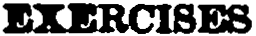
61

  - Show that -> may be expressed as
(•) 1 • • .
L L
O. - _ n Ds+i+'-·
"fflJJ/s C-ti-1 •

Making the aseumption Ds+,4. '-! Ds+1 + !. (Da+1+1 - D.+a), derive the
    - m
formula a(.•> '-! a. + m--¡-;;;1-.
  - Give a formula in eommutation funetions for the net single premium for an annuity of $10 per month to (30), firet payment at age 40 and payable monthly thereafter for 10 years, using the standard approximation.

-'·Continuoua annuitiea
  - Show that cls:;J '-! Gs:;J + i(l -J.)
= i(da:;J + Gs:;J).
  - If deaths in the year of age z to z + 1are uniformly distributed over that year of age, show that

{a)
D. = (&a-sd)D. + (i--¡;-&) D.+1

{b) 4 i) • !- _ .. (!- )
si 1 ¡t rs 1 11

{e)
,.-
1 d
da - ¡+ ¡¡

Ñs+I - ¡+ p
ti d

  - If the force of mortality has the constant value p. between ages z and
s + n, prove that
1 - .,.,.
4s:al - p + I - 4ii)
at a foroe of intereet equal to " + l.
1.f. Show t"hat
d% 4.:;J - (p. + l)cl.:iil + .E. - 1.
,J
S. Varying annuitlea
- Express in terma of commutation functions, using standard approxi­ mations where necessary:
•

{a) ¿ tDs+I 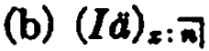
·-·
(e) (Dá)

62 Lil'E ANNUITIES (CH. 2

- Express in commutation symbola the present V&lue at age % of a
series of 25 payments commencing at 1at a.ge x and increasing annually by
0.1 for 5 years, the sixth and subsequent payments being of uniform amount.
- Express in commutation symbols the net single premium for a varying immediate annuity to a life aged x providing for annual payments of 100 the first year, 400 the second year, 700 the third year, increasing by 300each year until 1600 is reached, after which the paymenta decrease by 400 per year until 400 is reached, thereafter remaining constant.
- A varying temporary annuity to (x) provides for an initial payment of h at age y, and successive annual payments increasing by k each year until n payments have been made. Show that the value at age z is
hN,, + k(811+1 - 811+-+1) - (h + nlc)N•+•
D,.

How would the formula be rnodified if the benefit were decreasing by 1c
each year?
How would the formula be modified if the payments remained constant after n years?
- Show that (2.46c) can be expressed as
(la). = _!_ t f 1 (t + n)D•+•+• dt.
D,. "•º o
Assuming linearity for Dz+t+a over each year of age, show that
(14),, (la),, + .
- The eff'ect of variations in interest and mortality
da,, da,.
=
  - Show that -v(1a),. .What is ,where 6 is the force of inter-
di di

est?
  - (a) Show that
(la),. = -(1 + i) ·
(1 + i)
1 +
= -(A.a,. - JA a,. A'ca. - ···),

where the differences of a,. are taken over the interval Ai.
(b) Write the formula tha.t you would use to estimate the value of (Ia)60
at 2% being given the values of ª'° at 2%, 21%, and 3%.
  - Estima.te the value of ªªº on the 1958 CSO table at 3.1% interest using
only the data of Table A in Appendix I. (Ans. 22.0967)
  - Show that for annuity values a constant chánge of e in P.z is equivalent to a change in the rate of interest f rom i to ec(l + i) - 1.

EXERCISES 63

  - A life aged 40 is subject to 1958 eso mortality except at age 45 where it will b exposed to an extra hazard producing an addition of .01 to the
eso rate of mortality. Calcula.te the value at a.ge 40 of an im.media.te an­
nuity of 1 per annum to this life at 3% interest. (Ans. 19.22465)
p :
  - The values of in a new mortality table are related to the Ps values of a standard ta.ble by p = (1 + r)ps for all z. Show that annuity values on
the new table at rate of interest i are equal to those on the standard table
at rate of . ., = i - r .

mterest i
+ r
--- 1

- Summary of notation
  - Write a single symbol for ea.ch of the following:
    - the present value at a.ge 35 of an annuity of 1 per annum, first pay­ ment at age 42;
    - the present value at age 35 of a 15-year temporary annuity-due of
10 per month ;
(e) the present value at a.ge 40 of an annuity of 1 payable every 6 months, first payment at the end of 3 months;
(d) the present value at a.ge 50 of an immediate annuity paya.ble monthly with first payment 1, second payment 2, increasing by 1 each month;
(e) the present value at a.ge 20 of a 15-year deferred 10-year tellli>orary continuous annuity of 1per annum.

Miscellaneous problems
'n. Write expressions for evaluating ea.ch of the following in terma of the commutation functions D, N, and S, using standard approximations where necessary:
(a) 1¡dpoJ , assuming a 5-year select period ;
(b) 11ua1:>
(e) 1114io (d) 1111411
<e> c1c1>W
(f) (lcl)u .
- Given "the following values at 3% interest, obtain an approximate
value for the force of mortality at age 40:
z a.
39 17.711
40 17.384
.U 17 .062 (Ans. .00793)
- Assuming a mortality ta.ole with a 5-year select period, derive a for­ mula for the present value of a life a.nnuity-due of 1 per annum, the life being eelect and aged 30, based on interest of 2% during the select period

64 LIH ANNUITIES [CH. 2

and 3% thereafter. Commutation functions are available both at 2% and at 3%.
- A substandard mortality table is derived by taking tbe force of mor­ tality 1.&! to be (1 + /c)p,,, , where ,.,.,,, is given by a standard Gompertz table. It is found that the values of the substandard life annuities a! can be ob­
tained by rating up the age in a table of the standard life annuities, thm!:
a! = a.+., . Find &D expreesion for the constant addition r.

CHAPTER 3
LIFE INSURANCE

l. lntroduction
The functions described in the preceding chapter relate to pay­ ments which a.re contingent on the survival of a life. The functions now to be considered relate to payments which are contingent on death rather than survival; such payments are provided by in­ surances.
An insurance provides a payment of a specified amount upon the death of a given life, known as the insured. Values of insurances have traditionally been calculated on the assumption that the payment is made at the end of the year of death, even though the usual practice of insurers is to make payment as soon as possible af ter the occurrence of the death. This assumption is a convenient one in that the probabilities of death and survival to the end of a year can be calculated exactly from mortality table data. As will be seen le.ter, there are various methods of adjusting values be.sed on this assumption to take account of the fact that in practice the payment is me.de immediately; sorne insurers now make these adjustments directly in the original formulas and thus avoid the prior calculation of values based on the traditional assumption.
2. Insurances payable at the end of the year of death
An insurance which provides a payment only if death occurs within a limited period is known as a term insurance. The present value or net single premium at age x for such an insurance with term perio of n years and amount 1 is denoted by A!:,¡¡ and we may write
A!:ñ1 = vq. + vl1¡q. + v'1¡qs + º º ' + V"t1-llqs •
Each term in this expression representa the probability that death will occur in a particular year multiplied by the present value of a payment of 1 at the end of that year. The expression me.y be written
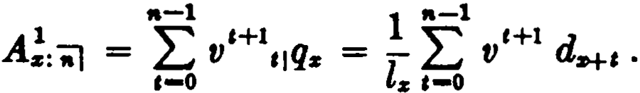 (3.1)
65

66 LIFE INSURANCE [CH. 3

If the term period is extended to the end of the mortality table so that the insurance is payable whenever death occurs, the value of n becomes w - x, and we have the whole lif e insurance with present value A% :
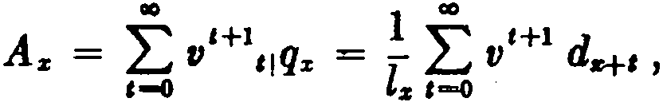 (3.2)
the symbol oo being used for w - x - 1in this case.
If the payment is made only if death occurs after the expiration of a period of n years, we have the def erred insurance with present value
n¡ A% = LJ V Hl ,¡q% = 1 LJ V Hl d, . ( 3.3)
l
,-. a •-•
It is obvious that A% = ·A!:-;¡ + "1Az . In practice, the deferred insurance is ·not encountered alone, but nl Az sometimes appears in combination with other insurance functions.
The expressions above are sirnplified by the introduction of the commutation functions
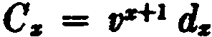
and 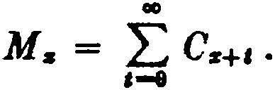
1 _ 1 l.,Hl d _ 1 l r,r+t+l d
Then A
z:"iil - - LJ " I - - LJ I
l% t-0 r,%la t-1
_ 1 1 C _ M. - M.._.
- D. {::::, ..., - Dz ' ( 3.4)
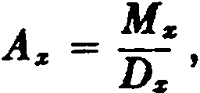 (3.5)
and 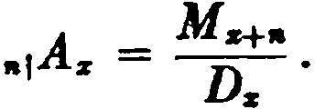 (3.6)
An n-year endowment insurance of 1 provides a payment of 1 at the end of the year of death if the insured dies within n years or a payrnent of 1at the end of n years if the insured is then living. This is clearly a combination of an n-year term insurance with an n-year pure endowment. Hence, its value Aa:"iil can be expressed

SEC. 3] INSURANCES AND ANNUITIES 67
as Aa:il = A!:-., + ,.E. or
A _ M z - M .....,. + D..."

s:'ii\ - Ds
(3.7)

The pure endowment value is frequently given an insurance symbol, Az:.¡.Then, Aa:.¡ = Az: ;i + As: .¡ .
1 1 1
- Relations between insurances and annuities
Since Ca = 1 ds = v+i(l. - ls+1) = vDs - Ds+i , it follows that M s = vN s - N Si-1 ; and, dividing by Ds ,
Ms Ns N 1
- = v - - --
D. Ds D. '

or As = V - Os .
(3.8)

It is interesting to verify this relation between the life annuity and the whole life insurance by general reasoning. The expression
va. represents the present value of an annuity-due of v per annum
to (x), and such an annuity has the same value as an annuity of 1 paya.ble at the end of ea.ch year that (x) enters upon. The expres­ sion a.representa the value of an annuity of 1payable at the end of ea.ch year that (x) completes. The difference between these two
annuities is evidently a single payment of 1at the end of the year tha.t (x) entera upon but does not complete. Since this a.mounts to a pa.yment of 1 at the end of the year of death, it has the same value as the whole life insurance, A• .
For the n-year term insurance, the corresponding relation is

A!:al = V4a: ii1 - 0a:ii1 •
For the n-year endowment,
Aa:;i = A!:.¡ + ,.E. = vtia:.¡ - Clz:.J + ,.E.,
·but .E. = a.:ti1 - O.: 11-11 ,
(3.9)

and hence As:-., = V:-;i - Os:ñ=i] . (3.10) The student should formulate verbal interpretations for relations
(3.9) and (3.10).
Formula (3.8) can be written in another form which is often useful. Since
Vds - 0a = V - ( - 1) = 1 - (1 - v)ds = 1 - OOs ,

68 LIFE INSURANCE (CH. 3

we have
A.= 1 - da• . (3.11)
This equation can be interpreted as follows: A. is the present value of a payment of 1 a.t the end of the year of death of (x). If this payment were me.de now, its value would be 1; but since the pay­ ment is deferred, we must deduct the value of the interest which it earns between now and the end of the year of death. The value at the beginning of the year of the interest on 1is d, and the pres­ ent value of the interest for ea.ch year that (x) entera upon is
da• . Hence, A. = 1 - das .
A similar relation for endowment insurance is Az:ñJ = 1-ddz: ñJ •
There is no corresponding formula for term or deferred insurances, since in those cases a payment is not certa.in to be made.
Multiplying by (1 + i) in formula (3.11), we have
(1 + i)As = (1 + i) - ia. , since (1 + i) d == i,
or, since ªª == l + as ,
1 -= ias + (1 + i)A• . (3.12)
This reftects the fa.et that a unit now is equivalent to the present value of a unit at the end of the year of death, A. , plus the present
value of interest on the unit at the end of ea.ch year in the mean­ time (including the end of the year of death), ias + iA:s . Formula
(3.12) is the usual basis of estate and inheritance true statutes, which define ias as the "life estate" and (1 + i)A. as the "re­
mainder," (1 - ias) .

- lnsurances payable at the moment of death
In practice, the payment of the amount of an insurance is not deferred to the end of the year of death. If the payment under a. whole life insurance were due at the end of the 1/m-th part of a yea.r in which (x) dies, the expression for the net single premium would take the form
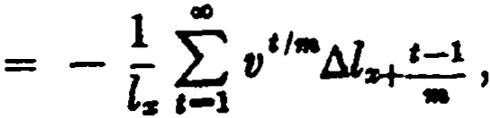

SEC. 4] INSURANCES PAYABLE AT MOMENT OF DEATH 69
where the interval of diff erencing is 1/m. As m becomes infinitely large, this expression npproaches the net single premium for a whole life insurance payable at the rnoment of death instead of at the nd of the year of death. Dcnoting this value hy Az , wc havc

A% = h•m Az(111)
= h•m - l1 L00V 1/ffldlz+ t_::_1_ J

m-+oo ...oo [
-

-- - l1 100 V ' dlz+t ,
z o
z e-1 t11

or, sincc d{ .• r = - lz+ ,µz+ t dl ,
- 1 ( 00 ,
A z = l- },, V lz+t /.J.z H dt ,
z o

(3.13a)

or A-z =
100
V 'eP:rl'z tt dt. (3.13h)

0

The formula may be seen to be plausible by general reasoning, since ePz/J.%+1 dt can be thought of as the probability that (x) will
die at the moment of attaining age x + t, and v' is the discounted
value of the amount of 1 then payable.
The integral in (3.13a) can be evaluated by using the technique of integration by parts:
f ydz = yz - f zd y.
In (3.13a), we take v' as y and lz+ ,µ.z+i dt as dz. Then dy is
v' log v = -v' and z is -lz+e .We thus find
Á, = :: (1-•' ,_.,];' - B { •'l..,_, dt) ,
which reduces to 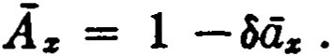 (3.14)
The analogy with Az == 1 - daz is clear.
The corresponding relations for the n-year. term insurance pay­ able at the moment oí death are
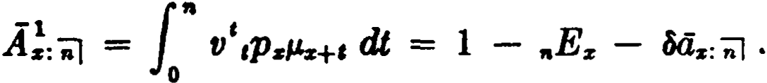 (3.15)
For the n-year endowment,
Áz:ñJ = Á z: ñ) + n z = 1 - ód:r:ñJ , (3.16)
- -1 E

iO LIFE INSURANCE [CH. 3
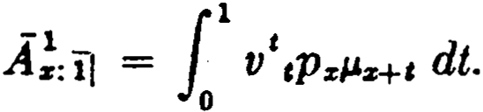
When a uniform dist.ribution of deaths is assumed, there is a particularly simple relationship betwecn t he immrance payable at the moment of death and the insurancc payable at the end of the year of death. This may be seen most easily in the case of a one-year term insurance. We have
Making the assumption of a uniform distribution of deaths, we note from (1.24b) that the expression ,pzµz+ t in this integral may be replaced by qz . Then
A:ÍI =: [ v' qz dt = qz f v' dt.

1
1
The integral

dt will be recognized as the continuous annuity­

certain

Hence
v'

1 - V ÍV
áT¡ =-- = ·

-1 , Í i 1
i
A::il =: vqz = 5 Az:TI .

From a practica! standpoint, it is highly convenient that a con­ stant factor i may be used at all ages as the approximate adjust­
ment for changing the value of an insurance payable at the end of the year of death to an insurance payable at the moment of death.
Another approximation can be derived by general reasoning. If , instead of assuming that deaths are uniformly distributed throughout each year of age, we regard the total deaths as being concentrated at the middle oí the year of age, we find that the insurance payment is made a half-year earlier on the average when paid at the moment of death than when paid at the end of the
year of death. In other words, an immediate payment of 1 is equivalent on the average to a payment of (1 + i)l at the end of
the year of death. It follows that
A :il =: (1 + i)1A:il

SEC. 4] INSURA.NCES PAYABLE AT MOMENT OF DEATH 71

or, introducing a furt.her approximation,
J;,11 =, (1 + üA;, .
Thc values of the three factors , (l + i) I, and 1 +;differ very
little from one another at the usual rates of int.erest. }i'or example, when_ i is 3%, = 1.0149261, (l + i)l .= l.0148892, a1Hl
1
i
1 + 2 = 1.015.
These approximations are not restricted to the one-ycar term

. . -1
,a-1
t - 1 - 1 i 1

msurancc. 8mce A%:ñl = ,-o v ,p%+t:il , and A z:.ft:il i A s+1:i1 ,
u

it follows that
-1 • i 1
A%: ;-, =¡ A %:ñl .
i
(3.17)

An important special case is
- i
As i As .

( 3.18)

For endowment insurance, only the value of the term insurancc portion is adjusted, since the pure endowment remains payable at the end of the n-th year if (x) survives. Thus,
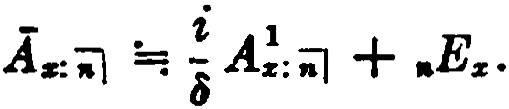 (3.19)
The factors (1 + i)l and 1 + ;ma.y be used in place of !in all
these forma.
Specia.l commutation functions may be defined for use with insurances paya.ble at the moment of death. The formula
A-. = 1·fJ 'tPs/.'z+e dt =-l1 1·fJ t ls+el's+e dt
o s o
= 1 1·.,e+•",s+. •l-'z+• dt
VSls o
suggests the following definitions:

72 LIFE INSURANCE [CH. 3
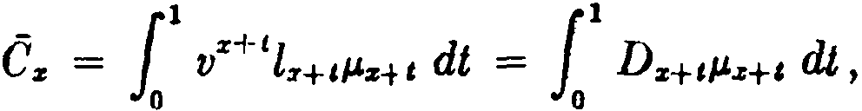

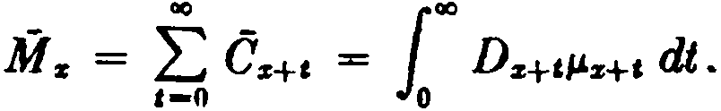
We may theu writc Á z - f:,
-1 _ Mz - Mz+n
A
z:il - ----­
Dz
- _ },f z+n
"r A z - -fJ- ,
and 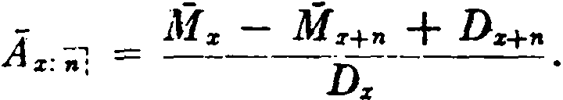
In practice, Cz is romputed by a formula consistent with the
usual approximation:
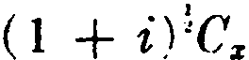
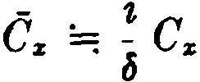 or or 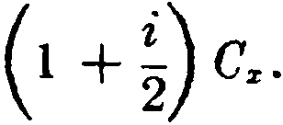
- Varying insurances
An insurance which provides an increasing or decreasing death benefit is called a iw·11ing insurance. There are severa} standard types for whieh simple formulas may be developed. The commu­ tation symbol Rz is used :
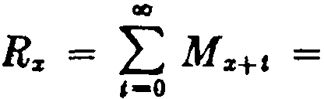
oc
L ( t + l)Cz+t •
,-o
An increasing whole lif e insurance provides a death benefit of 1 in the first year, 2 in the second year, and so on, increasing by 1 each year to the end of life. lts value is given by the expression
. (1A )z = vqz + 2v\1qz + 3v\qz +
f
= _ll ( t + l )vt+1 dz+t
z ,-o
l oc •
= D L ( t + l )Cz+t
,-o
z

( 3.20)

SEC. 5) VARYING INSURANCES 73

Thc increa.'ting il!rm insurance provides a death benefit of 1 in the first ycar, incrensing by 1 each year, but with no payment if death occurs aft r.r n years. Its value is easily seen to be
Rs - nMs+n
( / A )1 _ Rz+" -
z :ñl - Dz . (3.21)
A whole life insuran<"e providing a death benefit which increases for n years only and then rcmains constant at n has thc net single prcmium
(/ A ) = R:r - R:r+n
;¡ z Ds . ( 3.22 )

The decreasi,ng term ins-urance provides an initial death benefit of n decreasing by 1 each ycar, with no payment if death occurs after n years:
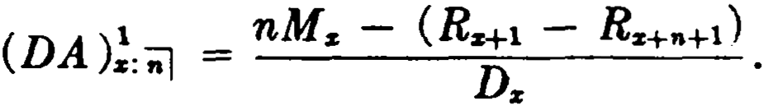 ( 3.23)
The relationship that exists between the increasing annuity and the increasing insurance is easily derived. Since M x = vNz - Nz+i , it follows that R:r = vS.z - Sz+t , and, divi<ling by Dz , we obtain
R" vS" Sz+i
D" = n-; - Dz '
or (IA)z = v( la)z - (la)z . (3.24)
Since ( /a )z = (lii)z - ª" , the rclation may he transformed to
(/A).z = iiz - d(lii):i . (3.25) J.ormulas (3.24) and (:3.25) are analogous to formulas (3.8) and
(3.11) for level insumnce.
lf the payment under the increasing insurance is made at the moment of death, the net. Hingle premium (lA)z may be expressed as follows:
(I -).z = -1·· L...J ( t + l) - = -- -1 ¡_ - ,.

A Dz e-o
l'z+t
M
Dz t-0

Dcfining the commuta.tion symhol R:r. n.s
oc
ilz. = L M z+i ,
e-o

74 LIFE INSURANCE {CH. 3

we have (I -)s = Íls
( 3.26 )

A Ds"

There is another type of increasing insurance that appears occasionally in combination with annuities or other insurances. It provides increases in the death benefit at intervals which are
fractions of a year. Let the death benefit be .!:_ during the first .!:_
m m

years, 2 durm. g the second 1
years, and so on, m. creasm. g by l

- -
m m m
each .!_ years. Although the increases occur at fractions of a year,
m
let us considcr first the case where the claim payment is deferred to the end of the year of death. The net single premium at age x is then denoted by (J<•>A )s , where the superscript (m) indicates
that the increases occur at intervals of .!_ years. An approxima-
m
tion for the premium may be derived by noting that the average
1

payment in the yéar of age x + t to x + t + 1is t + m
2
we therefore have
, and

u<•>A )s =: _!_ f (t + m + 1

CsH

Dz ,-o )
Rs+l + m + 1 M s
D.
m - 1
R. - M s
=

m _ 1

{JA. )s - As • (3.27 )

The reasoning here is equivalent to the assumption of a uniform distribution of deaths, and the formula is exact under that as­ sumption. In applying the formula, it must be remembered that
an initial amount of !.. is assumed. For a.n insurance which is
m
inítially 1and increases by 1every !_ years, the net single premium
m
is m(J<•>A )s .

SEC. 6) SUMMARY OF NOTATION 75

We consider next the case where the claim payment is made at the moment of death. The net single premium at age x is then denoted by ([<"''.A)z , and we have from (3.27)
- m - 1 -
Rz - -- Mz l
(IC"'l.A )z =: ; =: (IA )z - m : Ái; . ( 3.28 )
2
If the increases in insurance occur momently instead of at the
end of 1/m years, so that the death benefit is t at the moment of attaining age x + t , the present value, denoted by (i.A )z , may be
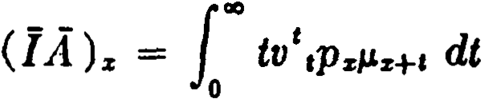
expressed as

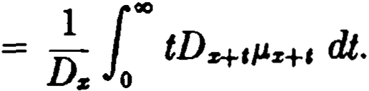
( 3.29)

This may be approximated by letting m become infinite in (3.28) :
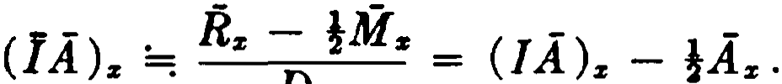 (3.30)
It is quite easy to see that this result is a reasonable one. During the first year, the payment under (]A)z increases from O to 1 and may be regarded as having an average value during that year of }. Similarly, the average payment during the second year is 1!; and so on. Comparing with (l.A)z , which assumes a pay­ ment of 1 during the first year, 2 during the second year, and so on, it is evident that (i.A)z is less than (I .A)z by approximately
the value of a level insurance of!payable at the moment of death.
We thus have

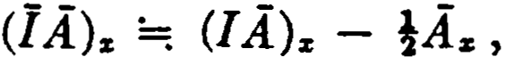
as above.
- Summary of notation
Principies A-H of Chapters 1 and 2 should be reviewed.
(3.31)

l. When a r.om pound symbol is used as a suffixed subscript, as x:nJ, a 1 written ahovr one clement of the subsC'ript indica.tes thn t the evcnt. is determi ncd upon the prior failurc (or expiration)

76 LIFE INSURANCE [CH. 3

of that element. If the 1 is not used, it indicates that the event is
determined upon the first failure of either element.
Applications to insurances
l. The following principal symbols are used:
A , the present value (or net single premium) of an in­ surance of 1;
(IA ), the present value of an increasing insurance;
(DA), the present value of a decreasing insurance.
  - The horizontal bar over the A of a principal insurance sym­ bol means that the payment is made at the moment of death (Principie G) ; e.g., As , ([.A)s .
  - The horizontal bar over the / of an increasing insurance symbol means that the increases occur momently (Principie G) ; e.g., (]A )s .
Comments. The symbols used here for the continuous increasing insurances are not in the International Notation. In the earlier literature, the function (J.A)s was sometimes denoted by (I A)s .

Commutation functions

- (1 s+t

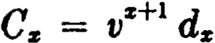 Cs = J
0
V ls+ll"s+t dt

= ilDs+cl/ts+c dt
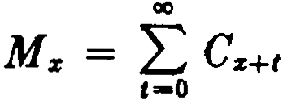
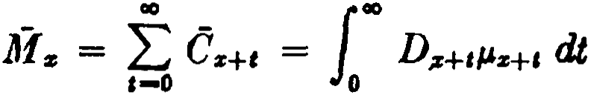
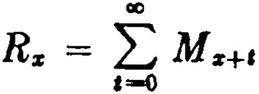
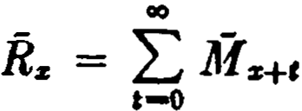

= ¿( t + oc...,
e-o
0D

0D
= ¿( t + l)ésH
e-o

References
4, S. The errors in the approxima.tions ha.ve been studied by Mereu (1961).
A useful technique for deriving formulas for the more compli­ cated varying insurances and annuities has been described by Menge (1935).

EXERCISES 77
The technique of integration by pam will often be used in the chapters that follow. A paper by G. J. L. and S. E. M. (1910) gives pra.ctica.l hints on the application of this method to lif e contingency problems. The student will find this an interesting reference when he has completed more of the work in this book.
EXERCISES
1, 2. Insurances payable at tbe end of tbe year of deatb
l. Calculate A:o,io} assuming that morta.lity follows the law lz = 100 - x
and that interest is a.t 4% per annum. Given v10 at 4% = .6756.

- Show that
  - M. = D. - dNz
(b) .[& C,., ••-.-, + D•+•] = ""
(e) L l.+'A•+' = l.a.
1-1
(Ans. .116)

- Obtain a formula for the net single premium at a.ge x for an insurance of 1payable at the end of 20 years from the date of the policy if death occurs within that period or at the end of the year of death if death occurs af ter 20 years.

S. Relations between insurances and annuitiea
- Find the rate of interest if ª" = 13.257 a.nd A. = .19304.
V - A.,.+i)
ª•
- (a) Show that :-;J = d .
(b) Sh h t 1 - itJs:i=i] = Ms - Ms+ I + Ds+I
t a 1 + i Dz •
OW

(Ans. 6%)

- An annuity-certain providing a payment of 1 at the end of each year for n years is bought by a person aged :i. Prove that ita va.lue immediately alter the t-th payment may be expressed in the form

P·ti.+• + Q•A:s+, + R· tr'
1

and determine the values of P, Q, and R, independent of t and the mortality table.
- Derive the relations
(a.) A!:iil ... 1 - .E. - d4.:ii)
(b) As:iil = 1 - d4.-:.J

78 LIFE INSURANCE fcH. 3

- Insurances payable at the moment oí death
1
8. Show that A"'> = m(v;;a"'> - a...> ) = 1 - d<111>a"'> .
What is the effect of Ietting m become infinite?
  - Show that C:z + 8Dz = Dz - Dz+i .
  - Show that
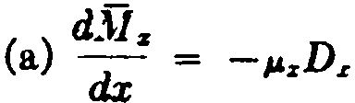
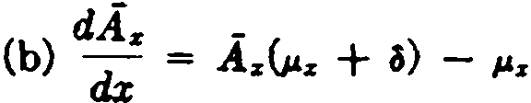
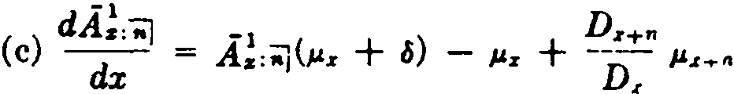
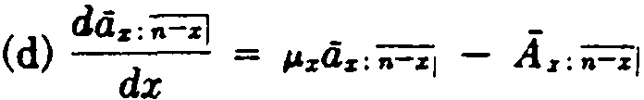

ll. lf a mortality table follows Makeham's Law, show that
Az = Aaz + (µz - A )a; ,
where A is the usual Makeham constant and where a; is calculated at a special rate of interest.

- Varying insurances
  - Express in commutation functions the net single premium at age 40 for a Double Protection to Age 65 policy which provides insuran<'e of 2 in the event of death prior to age 65 and insurance of 1af ter age 65.
  - A policy is issued at age O with the following graded scale of deat h benefits:
Ag,  o | Deotls Be,,efit  100
1 | 200
2 | 400
3 | 600
4 | 800
5-20 | 1,000
21 and over | 5,000
W rite the net single premium in terms of commutation f unctions.
  - Express in commutation symbols the net single premium at age 40

EXERCISES 79

for an insurance providing for a payment of 1,000 the first year, 4,000 the second year, 7,000 the third year, and so on, increasing by 3,000 per year until 16,000 is rea.ched, af ter which the payment decreases by 4,000 per yea.r until it rea.ches 4,000 and then rema.ins constant.
dAr
=
  - (a) Show that di -v( I A)z . Hence suggest a method for a.pprox-
imating (JA )z when Az is known at several rates of interest.
(b) What . d.Az ?
18 di
  - Show that
(a) (J.A )z = 4r - !(I4)z
(b) (1.A )z = as - a(lá)z
  - Show that
(a) (14);, = D1z 1'° Ñz+I dt
O

1 ("°
(b) (li.)z = Dz JO M s+, dl

- Surnmary of notation
  - Write the definitions of C and M for a mortality ta.ble with a 5-year select period. ·
  - Describe the functions denoted by the following symbols and give formulas for their evaluation in tenns of commuta.tion f unctions, using standard approxima.tions where needed:

    - .Aao:iil

(b) (DA):o:iil (e) (I<•>A)40
(d) (IA)a

  - The following symbols have not been specifically defined in the text. Assign meanings to these symbols in accordance with the principles of the International Notation, and derive pra.ctical formulas for their evaluation:

(a) 101¡.4•

(b) (liJA)!o,iiJ

(e) (IA)!;;J

(d) (IA)o

80 LIFE INSURANCE [CH. 3

Miaeellaneoua prol,leme
  - (a) Determine whether or not a constant increaae in the force oí mortality has the same effect on .Aa as the same increase in the force of interest. ·
(b) Show that, if the single r&te of mort&lity 9a+a is inereased to
9a+a + e, then Aa will be inereased by
etr+'•Pa(l - Áa+11+1},
  - Give an expression in terms of commutation symbols and interest f unetions for the net single premium for &n endowment for t years at age z
1
which provides that the death benefit shall be an annuity of - for n yean,
n
certain, but that if the life survives to age x + t the annuity shall be paid
for n years certain and as long thereaf ter as (.z) survives.
  - The net single premium for a pure endowrnent of $1,000 issued at e. certain age and for a certain period is $700 with retum oí net premium in event of death during the period, or $650 with no return at death. Find the exact net single premium for a pure endowment oí Sl,000 issued at the same age and for the same period, if one-half of the net premium .is to be retumed at death during the period. (Ana. $674.07)
  - Assuming a uniform distribution of deaths, find a formula for (1.A)!: 1
in terms of interest and commutation symbola.

CHAPTER 4
NET AN NUAL PREMIUMS

l. Annual premiums for insurances and deferred annuities
Insurance is .more commonly purchased by means of a series of periodic premium payments than by a single premium payment. These periodic payments form a life annuity-due payable by the insured to the insurer. The first premium is payable at the incep­ tion of the agreement and subsequent premiums are contingent on the insured's survival. The amount of the premium required for a given insurance may be determined from the principie that the present value of the sequence of net premiums must be equal to the present value of the insurance. In symbols,
P·a = A
or P =­A (4.1)
d '

where P is the net premium on an annual basis, d the present value of the appropriate life annuity-due, and A the net single premium for the insurance, all functions being computed for the age at which the agreement becomes effective.
In the case oí whole life, term, and endowment insurance where level premiums are paid once a year, principie (4.1) leads directly to the following expressions: ·

Whole life

Term

Endowment
p = Az = M z
:z: éi:i: N:i:
1 _ A: ;;J _ M s - M*'
P
s:.J --- - -----
Oz:;i N s - N:i:+a
P:z::;i = A:i::iil = }.,[ :,; - M st-a + Dst-n

(4.2)

(4.3)

-- --------
(4.4)

Oz:;;-1 N:z: - N z+n
The symbol P:i:: is used for the pu.re endowment, and

1
p 1 A:i:: ;¡ Dz+"
:z::ñ\ = iiz:;J = N z - N z+11 •
81

(4.5)

82 NET ANNUAL PREMIUMS {CH. 4

A relation connecting Pz and iiz may be derived by dividing the

express1. on Az =
I - U,JÜ,;:.z by az, y1.eIdºmg Az
= -1:- - d ,

or P.=

1 - d.
tia;
-
O,z az

(4.6)

A similar relation for endowment premiums is

P.z:iil = -.. 1
az:ñl
- d.

(4.7)

Each of the above formulas assumes that premiums are to be paid over the entire duration of the contract; that is, for the whole of life in the case of a whole life insurance,1 for n years in the case of an n-year endowment, and so on. Principie (4.1) also applies where the premium-paying period is less than the insurance period, as for example in the case of .a whole life insurance where premiums are to be paid for a maximum period of t years. For "limited-pay­ ment" insurances of this type, with premiums payable for t years at most, the annual premiums are determined by dividing the net single premium by a t-year temporary annuity-due, as follows:
t-payrnent life

,P.z = z = M.z
az,"'il N z - N z+t
t-payment n-year term (t < n)
(4.8)

t P1 ;J
z:
_ A!:;i _ M.z - M z.+-,.
- -- - -----
dz:c] N z - Nz+t

(4.9)

t-payment n-year endowment (t < n)
P - - A.r:il - M z - Mz..ta + Dz.t,.

(4.10)

l z:n l - az:- -
tl
N z - N z.+-t

It will be noted in the formulas above that the P symbol, with the associated prefixes and suffi.xes, defines not only the type of insurance but also the premium-paying period. All of these formulas apply to insurances payable at the end of the year of death. When
1 Whole lif e insurance with premiums paya.ble throughout the duration of the contra.et is commonly known as ordinary lije insurance.

SEC. 2] FRACTIONAL PREMIUMS 83

the insurance is payable at the moment of death, a different nota­ tional device is used to represent the net annual premium. In this case, the P symbol is used in conjunction with the net single pre­ mium symbol ii:idicating immediate payment of claims. For ex­ ample, the net annual premium for a whole life insurance payable at the moment of death is denoted by the symbol P(Az). If pre­ mium payments are limited to t years, the symbol is ,P(Az).
It is not uncommon for an insurer to issue a policy for which the annual premium is not level. Suppose, for example, that a whole life policy is issued with each premium payable during the first five years equal to one-half of each premium payable thereafter. lf the initial annual premium for such a policy is denoted by P, the value of P is determined from the formula
or p = As = M s .
t.i::61 +2 lítª" N" + N:+lí
This is again an application of principie (4.1).
Annual premiums are also encountered in connection with de­ ferred annuities. The annual premium, payable for t years, for an n-year deferred annuity-due of 1 to (x) is denoted by ,P(n1 dz) :

P( ,,. ) _ ,.1a" _ Ns+"
i nlU.z --- -
lls:il N s - N z+t

(4.11)

In practice, t is usually equal to n. The notational principie here is the same as that used to express the net annual premium for insurances payable at the moment of death: the P symbol is used in conjunction with the net single premium symbol.

- Fractional premiums
An insured often elects to make his premium payments more frequently than once a year. In this case the amount of the net annual premium payable m times a year, p< m> , is determined in accordance with principie (4.1) with the annuity factor adjusted for payments m times a year, thus:
p<m) = a<m) . (4.12)
The adjustment in the annuity factor is usually made on the basis

84 NET ANNUAL PREMIUMS [CH. 4

of the practica} approximation illustrated in formula (2.22),

a!•> a. - m
tions of (4.12):
:_ 1 . This will be seen in the following a.pplica­ 2

p<•> _ A. :.... A.
• - a!"'> -= m - 1
a.-
M.
N s - -rm- Ds
m - 1

pi<•>
_ s:il

:....
M s - M »+•

s:il - a(•) -:
A
1
m - 1

•=il N. - N•+• - -rm- (D. - D +.)
< > ( .,a.i: . N•+•
,P "' "'d.) = 4<•> =: m - 1
-rm-
•="il N. - Ns+, - ( D. - Ds+,)

In using these formulas, it must be kept in mind that P<•> repre­ senta the annual amount of premium paya.ble m times a year, and
1
that the actual amount of ea.ch premium payment is - P<•>.
m
When premium payments are made with great frequency so that m is large, as for example in weekly premium industrial in­ surance, it is convenient to assume that the payments are made continuously. The symbol P is used to denote a continuous pre· mium. For whole life insurance with premiums paya.ble for the duration of the contra.et, the continuous premium P. is given by
P. = Aª•. = lY!• ,
N .
and corresponding expressions may be written for other forms of insurance. 1f the insurance is paya.ble at the moment of death and premiums are paya.ble continuously, we have
P( A.) = • = ::.

The relation

P( A.) =-1 - a
ª•

may also be obtained, using (3.14).

SEC. 2] FRACTIONAL PREMIUMS 85

It is important to distinguish symbols like E'z , P(A,,J , and P (Az) , The bar over the P symbol refers only to the continuous mode of premium payment, and the bar over the A symbol refers only to immediate payment of claims. To indicate an insurance payable at the moment of death with premiums payable continu­ ously, a bar must appear over both P and A.
It is convenient to be able to calculate pcm> from the value oí the
corresponding annual premium P. For whole life insurance,
P"'> = .1,:, Az 1.
az .. m -
az -

Dividing numerator and denominator by az and replacing z by
az
P., we have

m - 1 1 ·
l ---·- 2m <iz
. 1
Smec, from formula (4.6), ª• = Pz + d, we have finally

1 - m2 1 ( p z + d ) .
(4.13)

The formula enables us to approximate P:"'' when Pz and d are known.
Formula (4.13) lends itself readily to a verbal interpretation. When premiums are paid on the annual basis, the insurer receives a fu!! year's premium in advance each ycar including the year in which death occurs. When fractional premiums of the P<•> type are payable, there are two significant diff erences. In the first place, the insurer earns less interest on the fractional premiums, since he receives them on the average at a later date. Secondly, he receives less premium on the average in the year of death, the fractional ·
premiums for the balance of the year not being collectible after death has occurred. To compensate for these two differences, the amount of premium must be greatcr when paid on t he fractional basis than when paid once a year.

86 NET ANNUAL PREMIUMS (CH. 4

Bearing these facts in mind, let us retum to formula (4.13), which we now write in the following form:
p<•> == p + m - 1p<•> d + m - 1p<•>p (4.14)
s . s 2m s 2m s s .
Here it is clear that P "'> exceeds Ps by the value of two adjust­
1

ment terms. The first adjustment, m
l -1 d
¿t ·
: p •> d, is equal to 2

-P"'> and represents the approximate annual loss of
m ,-o m
interest on the deferred portions of the fractiona.l premium. The
1
second adjustment, m2 p •> Ps , may he interpreted as the
annual premium required to provide insurance in the amount of

m - 1
P "'>. Now m -
1 P "'> is equal to - p:•> ¿- and repre-

2m 2m m a-o m
1 -1 t
sents the average loss in fractional premium incurred by the insurer in the year of death, on the assumption oí a uniform distribution of
deaths. The term m -: 1P"'' ·Ps thus represents the adjustment
2
required to compensate the insurer for this loss.
The above reasoning leads readily to formulas for fractional premiums íor other forros of insurance. In the case of term in-
<•>
surance, the fractional premium P :;-1 will exceed the annual
premium P :íil by (1) the approximate loss of interest adjustment
m :i 1 P! d and (2) the approximate loss of premium adjust-
2
:•>
m - 1 1
ment Ps:,i"\Ps:i\ .Hence,

P.<:•.>¡ • 1
+ m - I P >
+ 1 ) , (4.15)

Ps:a!
s:-1 (d
Ps:il

and
(•) P!:"iil
P!:=: --------­

m - 1
I - (
1
P.:.¡
+ d)
(4.16)

ln the case of endowment insurance, the relations are

SEC. 2) FRACTIONAL PREMIUMS 87

Pz(W:ñI)l
• p + m - 1 p("') ( d + pl )
(4.17 )

=; z:111 z:
z:"'iil 2m i"J
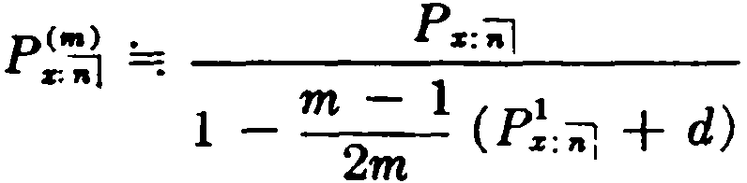
and
(4.18)

lt is important to note that in this case the loss of premium is covered by a term insurance and not by an endowment insurance. This is because the loss of premium is incurred only in the event of death, and not in the event that the insured survives to ma­ turity.
In Jeveloping similar formulas for limited-payment insurances, it must be remernbered that the loss of premium in the year of death ean only occur while the policy is within t.he premium-paying period. Consequently, the loss of premium adjustment is eovered by a term insurance for the premium-paying period. For example,
p(m) . p m - 1 p<m) ( d pl )
+ 2m ' + z: ,, ( 4.19)
' % =; ' % %

and

p<m) :.- ,Pz
' z -: m - 1 1 •
+
1 - 2m ( Pz:'1 d)

(4.20)

If formulas (4.16), (4.18), and (4.20) are compared, it will be uoted that they are all of the same form, with the premium in the
<lenominator being determined by the premium-paying period of the policy. These formulas can also be derived by analytic methods similar to those used in deriving formula (4.13).
Corresponding formulas for continuous premiums can be ob- tained by letting m become infinite. Then m :_ 1 becomes i, and
2
formula (4.13), for example, becomes
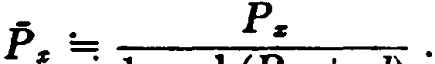 (4.21)
Insurers sometimes accept premium payments m times a year

88 NET ANNUAL PREMIUI\IS [CH. 4

with the condition that any unpaid instalments for the balance of the year of death will be deducted from the claim payment. For example, if the insured dies after paying one quarterly premium for the current year, the three unpaid instalments for the balance of the year are deducted from the policy proceeds. Premiums cal­ culated on this basis are called instalment premiums and are de­ noted by the symbol pCmJ to distinguish them from the p< m> type, which are often called true fractional premiums.
For an ordinary life policy with instalment premiums, the aver­ age amount of premium to be deducted from the proceeds is
1

m :P!1111
2
- The net payment by the insurer in the year of death

is thus 1 -2mm- 1Pzt 1111 on the average. Hence,
P!•l =¡ A, (1 - pJ•l)
ª111)
= p•> (i _ m :;1 p!•l).
2

Substitut ing for P:111
'
from (4.13) and solving, we have
!"' I :..... Pz
P
• -= m - 1 ·
1 - --d
2m

( 4.22 )

Since there is no luss of premium in the year of death in this case, it is only necessary to adjust the annual prernium for loss of in­ terest. This may be seen when (4.22) is written in the form
p[1nJ = p + m - 1 p[mJ d
2m ( 4.23)
z • z :i: •

Formulas analogous to (4.22) are valid for other plans of insurance. A third type of fractional premium is the ap port frmable pre­ mium. It is the practice of sorne insurers to provide in their con­ tracts that when death oceurs a pro-rata premium refun<l will be made eovering thc pcriod from t he <late of death to t lw dnt e to whi<·h pr<'miun1s are paid . For cxample, if deat h o<·<·ur oll<' mont h af ter u quarterly premium has bcen paid, t wo-t hirds of t his qua r-

SEC. 2] FRACTIONAL PREMIUMS 89

terly premium is refunded with the sum insured. Premiums pay­ able on this basis are cal1ed apportwnahle, and are dcnoted by the symbol pf•I. If the apportionable premium is payable annually,
it is denoted by P111•
The effect of the apportionable feature is that the insurer refunds
an average amount of 2 pl•l as part of the policy procecds. Thus, for ordinary life insumnce, we have
.1z (1 + 2_m_ P!"'I)
pl•I :- .
z -= a •) .
= p;•> (1 + },;; P!"}

Substituting from (4.13) and solving, we have
P!*l =: m___P_lz _
1 - --d - !Pi:
2m

(4.24 )

For the special case of the apportionable premium payable an­ nually, this becomes
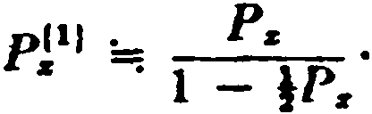
When (4.24) is writ.ten in the forro

pl•I == p + ffl
m l pzl•I d + 1pzt•lpz , (4.25)

z • z 2 2
· we see that the adjustment for loss of premium in the year of death provides for an amount of lP!ª1, reftecting the fact that the
insurer receives only a half ycar's premium on the average in thc year of deat.h.
In writing fommlas for apportionable premiums for other forms
of insurance, it must be remembered that the approximate loss of premium of JP1ª1 in the year of death is covered by a term in­
surance for the premium-paying period. This is illustrated in the following formulas:

90 Nm' ANNUAL PRIDUUM8

pl•I . Pe;¡
•:al 91! ' 1
[CB. f
(4.26)

1 - - tl - fP1: ;¡

ni•) 1a .Pa
...- . . ffl - 1 1
1 - -¡;¡- tl - tP.:iJ
(4.27)

- Analyais ol the endo•nient premium
We have seen that endowment insurance may be regarded n.s n combination of level tenn insurance nnd pure endowment, and the formula
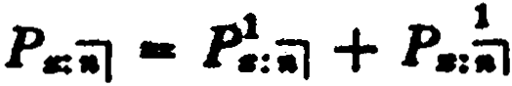 (4.28)
illustrates the separation of the net annual endowment premium into these two elements. There is an altemative analysis by which the endowment premium is seen to be ma.thematically equivalent to a combination of a savings fund premium and a premium for decreasing term insurance.
The endowment policy is a promise to pay a certain sum 011 a given future date, or prior to that date in the event of death. The same result can be achieved by using a savings fund, supported by equal periodic contributions of the amount necessary to accumu­ late the full endowment sum by the maturity date, together with a supplementary decrea.sing term insurance for the difference between the full sum and the amount accumulated in the savings fund at any time. Thus, if the . insured survives the endowment period, the full sum is available in the savings fund and the term insurance expires, or, if death intervenes, the savings fund will have accumulated to a smaller amount and the term insurance provides the balance of the face amount.
Let us a.ssume that the total sum . insured is 1, payable a.t the end of n years at the latest, and that a savings fund is being accu-
1
mulated by means of annual deposits of :-. At the end oí the first
8iiJ
.!
year, the sa.vings fund will amount to 1 i or , and the de-
. . u•1 a;.¡
creasing term insurance must therefore provide a first year dea.th benefit of 1 - . Similarly, at the end of the second year, the

SEC. 3) ANJ,LYSIS OF ENDOWME T PREMIUM 91

s¡¡
insurance required is 1 - :-, and, generally, for t.he m-th year,
8iil
the deereasing insurance must provide an amount of 1 - ;;¡ .
s;i
For an insured aged x, the net annual premium for this decreasing term insurance is given by
(1 - i}) Cz + (1 - il) Cz+l + • • • + (1 - I)Cz+n-1
p = Sñ"! Si] S,íl

N z - N z+n
The total endowment premium is then
1

Pz:ñJ = S::n-¡ + P.
( 4.29)

It may now be shown that the savings fund-decreasing insurance combination of (4.29) is indeed mathematically equivalent to the term insurance-pure endowment combination of (4.28).
We first write the expression for P as

P = 1
I":(1 - s=¡-¡) ez+t-1

Nr - N z+n c-1 SnJ

1 [ n
L
=
N N
1
Cz+t-1 - d---;:-
11
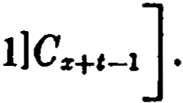
L [( 1 + • t
i)

z - z+n t-1 SnJ s-1
Now, performing the summations and noting that

"
L
,-1
(l + i f Cz+t-1
I":vrd z+t-1 = vruz - zz+n )
,-1

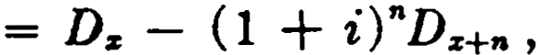
we obtain
p = M z - M z+n _ Dz - ( 1 + i )"Dz+n - ( M z - M z+n ) .
N z - N z+n dsn1( N z - N z+n)
Then, writing Dz - d N z for llf z , and Dz+n - dN z+n for M z+n in the last term (from exercise 2(a) in Chapter 3) and rearranging, we have
P = P :"ñl d( N z - N z+11 ) - Dz+n ((1 + i)" -1)
dsnJ (Nz - N z+n)

92 NET ANNUAL PRlllflUMB [CH. 4

rJ
=
:;i -
1 + P 1 .

r. :s¡¡¡
•:iil

When the savings fund premium of is added to this decreasing
8'il
insurance premium, we obta.in the desired equivalence
Ps:i.l = P 1 = P:iil Pa:;} .
+ .. +
s,;i
The student will gain further insight into the significance of this analysis in Section 3 of Chapter 5.
The same type of analysis may be applied equally well to ordi­ nary life insurance. Under an ordinary life policy, the sum insured is payable at age w at the latest and the contra.et may be regarded as an endowment to age w, or an (w - x)-year endowment. The ordinary life premium, P11 , me.y be resolved into an investment
element, , which builds up to the amount of the policy at the
811-:rl
limiting age of the mortality table, and a decreasing insura.nce element which provides insurance equal at any time to the differ­ ence between the accumulated savings fund and the amount of the policy. The endowment and the ordinary life policy are identical in principie, the apparent differences in the two forros of insurance arising solely from the íact that the savings fund accumulation is completed at an earlier date under the endowment.
- Summary of notation
  - The principal symbol P is used to denote a net annual premium.
  - Except for simple insurance benefits payable at the end of the year of death, P is used in conjunction with the net single premium symbol; e.g., ,P(,.¡iis), P(1Íz).
  - A prefixed subscript with P indica.tes the number of years in the premium-paying period (Principie C). If no subscript is used, the premium-paying period coincides with the term of the policy.
  - A suffixed superscript with P indicates the periodicity of premium payments (Principie F). If no superscript is used, annual payments are implied.
  - The horizontal bar above the symbol P indicates that pre­ miurn payments are made continuously (Principie G).

JJXERCISES 93

Reference
The a.na.lysis of the endowment premiwn in Section 3 is taken from Linton (1919).
EXERCISES

l. Annual premiums for insuranees and deferred annuities
l. Given P11:iil = .042'>, 1oPu = .0299, and Au = .6099, find the value of P 1:iil . (Ans. .0110)
- (a) Obtain a formula in commutation symbols· for the net annual premium, payable for 5 years, for a 10-year deferred 2'>-year tem­ porary immediate annuity of 1to (30).
(b) Find the net annual premium ü the annuity in (a) has the addi­
tional provision that the net premiums paid will be returned in the event of death within the 10-year deferred period.
- Express in commutation symbols the nét annual premium at age 40 for a double protection to age 65 policy that provides level insurance for the initial amount of 2 to age 65 and insurance for the ultimate (one-half the initial) amount thereaf ter, if the net annual premium reduces at age 65 to the ordinary life net premium at the original age for the ultimate amount.
d(I4).
=
- Show that P[(IA).] 1- - .
d.

- Fraetional premiums
  - The net annual premium at age 'l"/ for an ordinary life policy of $1000 on the 1958 CSO table with 3% interest is $12.09. Using the standard ap­ proximation, compute the corresponding premium payable quarterly (a) on the true basis, (b) on the instalment basis, (e) on the apportionable basis.
(Ans. $12.28, $12.22, $12.30)
,Pt
  - Obtain an approximate formula for in terms of net premiums

  - Show .that .l.im..P "'l = .l.i.m..
P "'>. What is the common limit? Why does

payable annually and the rate of discount.
.l.im..P."'J have a different value?
  - In practice, apportionable premiums are ref unded only for complete
months, with no refund for any part of the month of death. Show that on
this usumption the fonnula for pJ•lis

l•l . P.
• · m - 1
1 - d - 1J,í4, P.

9. Show that (1+ dtk4.)·P-(
r d.,4.: = µ. •

.11.,1:) - tk

NET ANNUA.L PRBKIUMS (CH. 4

- Analyaie of the endowment premium
  - The following criticism is sometimes heard: "In buying endowment insurance, a man pays for two separate benefits on one only of which he can relize." Explain the implication, and state how you would reply to it.
  - (a) Show that

-=1n-- Cii1C• + ;¡¡C.+1 + ···+1;¡c.....-1) - el.:i1 -

D +.

'il •
- -- .

1;;i D.

(b) Find the net annual premium payable for n years for a deferred life annuity of 1per annum, Í88ued to a life aged z, with the first annuity payment n years af ter date of issue and with a provision that, if (z) dies within the n-year period, the net premiume paid are to be returned with compound interest to the end of the year of death. Aseume that the interest allowed in the return of premium
. benefit is at the rate used in the calculation of the premium.
  - A man must meet an obligation of 1at the end of n years. He purchases an insuranee policy which provides an increasing death benefit, payable at the end of the year of death, equal at any time to the present value of thia obligation at rate of interest i.Find the net level annual premium payable for n years, assuming interest at rate i.
  - An n-year decreasing term insurance policy issued to (z) provides a
death benefit of 1 - i.J for the m-th policy year (m = 1, 2, . . . , n). All
i1iiJ
calculations involving interest are made at the same rate. Express the net
annual premium in terms of P;i) , P.:, and interest functions.
  - An m-year endowment policy issued at age z provides for the payment of a,¡ if death occurs during the first policy year, ci¡;¡ if death occurs during the second policy year, etc., and 4;i] if death occuI'8 during the m-th policy yea r or in event that (z) survives the m-year period. Show that the net annual premium P payable for r years is given by

p - Áz:;f -Á;:iiil
1 - As:rl
where A;:¡¡¡¡ is at rate of interest j = (1 + i)t+1 - 1,i being the rate assumed in the premium calculation.

- Summary of notation
- Express each of the following by a single symbol, and give formulas for evaluating each in terme of commutation functions (using standard ap­ proximations where necessary):
  - the net annual premium payable continuously for 20 years to pro­ vide an insurance to age 60 on a life aged 25;
  - the net annual premium payable quarterly for 15 years to provide a deferred &nnuity of 10 per month to (45) with first payment at
aae flO;

EXERCISES 95

(e) the net annual premium payable montbly on the apportionable basis for 10 years to provide a 20 year endowment of 1on (35} with death benefit payable at the moment of death.
- Give formulas in commutation symbols for the evaluation of ea.ch of the following (using standard approximations where necessary) :
<a> 10PJ,to1
(b) P((IA),ii11
(e) 1oPl11
Miecellaneous problema
- A new mortality table is constructed by increasing the Pz values of a standard table by a constant percentage so that
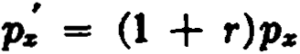 for all x.
Prove that ordinary life net_ annual premiums may be calculated on the new basis at rate of interest i from the formula

' 1
P. - - - d,
4z

i .

. i - r

where d = --.and 4z IS from the standard tab1e at rate of mterest --.
1+ i 1 + r .
- A life aged 50 is subject to 1958 eso mortality except at age 54. During
that year of age, the life will be expoeed to an extra hazard which is equiv­ alent to an addition of 400% to the eso rate of mortality. ealculate the net annual premium for a 5-year term insurance of $1000 on this life, a.ssuming interest at 3%. (Ans. $18.20)
- Compute the value of P1t)iol using the standard approximation, given
1
Pa0:ioJ = o, Pa0:ii1 = oo, soPao = o, and d = OO·

- Show that t P-(.11l'.s+c) dt = log "ª•4 .
L
t iYs+I
(Ans. u)

- A policy is issued at age 10 with level premiums payable for life. lf death occurs prior to the attainment of a.ge 15, the death benefi.t is the return of the net premiums paid with interest to the end of the year. If death occurs af ter age 15, the death benefit is 1. Assuming that the rate of interest in the retum of premium provision is the same as that used in calculating the premium, show that tbe net annual premium is independent of 'the mor­ tality prior to age 15.
- Find the net annual premium payable for n years for a. deferred an­ nuity-due of 1to (%) with first payrnent at a.ge x + n and with the net pre­
miums returned in the event of dea.th before tha t a.ge. lf (x) survives the n years, the annuity is to be paya.ble for t yea.rs certain and for the subsequent lifetime of (r).

CHAPrzB 5
NET LEVEL PREMIUM RESERVES

l . The nature of the reserve
When an annuity or an insurance policy is issued, the insurer assumes the obliga.tion of providing certain sums in the future (the benefit payments). In retum, the insured undertakes to ma.ke certain premium payments. At the outset, the present value of the payments to be made by the insurer is exactly equal to the present value of the net premiums which he expects to receive. As time goes on, the present value of the payments to be made by the insurer changes; it generally decreases for annuities and gen­ erally increases for life insurance policies. Similarly, the present value of the premium payments still to be received generally de­ creases during the premium-paying period. It is therefore im­ portant for the insurer to have a measure of the amount which he should have on hand at any time to assure the payment of the benefits, assuming of course that all future premium payments will be made by the insured during bis lifetime as they fall due. The concept of a reserve arises from this necessity of measuring the insurer's net liability with respect to a group of policies at times subsequent to the date of issue.
For illustration, consider an ordinary life policy of unit amount issued at age x. At the end of t years, the present value of the bene­ fit payment is Az+t , and the present value of the future net
premiums, including the one due at the beginning of the (t + 1)-th
year, is P:c·d z+e . The difference between these amounts,
A"+' - Pz·+t ,
represents the insurer's net obligation at that time and is called the policy reserve. In this form, the reserve is defined as the excess of the present value of the future benefits over the present value of the future net premiums.
When the reserve calculation involves net premiums of uniform amount and is based on the mortality and interest assumptions used in computing these net premiums, the resulting reserve is known as the net level premium reserve. This is the classical type of

SEC. 2 PROSPECTIVE FORMULAS 97

reserve, and in the subscquent sections of this chapter the word "reserve" will be undcrstood to imply "nct level premium re- 8crvc."

- Prospective formulas
The reserve definition given above may be called a _ pros pective definition since it is in terms of future bcnefits and premi_ums, and the formulas which follow from this dcfinition are known as pro­ spective reserve formulas. The. expression "future premiums" in
this definition must be understood to include any premium cur­ rently due.
For an ordinary life insurance of 1 issued at age x, the symbol
,Vs is used to denote the reserve at the end of t years. As shown above, the prospective formula is
,V s = ...4.sH - Ps· iis+t

Ms+t - Ps· Ns+I
Ds+t
(5.1)

For an n-payment whole life insurance, the reserve at the end of t years is obtained from the following formulas:
n y A p .. M»+, - ,.Ps( N s+c - Ns+n ) t
= = <
, s »+• - " s·as+e:ñ=il D 1or n,
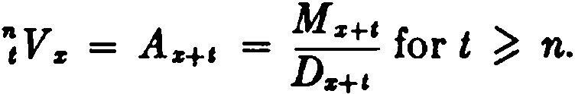
z+t
Note that in the second case, for t n, there being no further pre­ mium payments, the reserve is simply the net single premium at the attained age. A new notational principie is illustrated here, the superscript n being used before the V symbol to denote the number of years in the limited-payment period.
As another example of a prospective formula, consider an n-year endowment:
t Vz: ñi = As+t: -;=,i - P s: ñj ·iis+c: 'ñ=il
_ Ms+ I - Ms+n + Ds+n - Ps: ñj ( N:z+t - N:z+n )
- Ds+c
For n-year term insurance, the reserve symbol is ,v::;¡. The student should be able to write the formula.

98 NET LEVEL PREMIUM RESERVES [CH. 5

A different type of symbol is used to denote the reserve for insurances payable at the moment of dcath, and also for armuities. In these ca.ses, the ,V symbol is uscd in conjunction with the nct single premium for the benefit. For an ordinary life msurance paya.ble at the moment of death, for example, we write
(5.2)
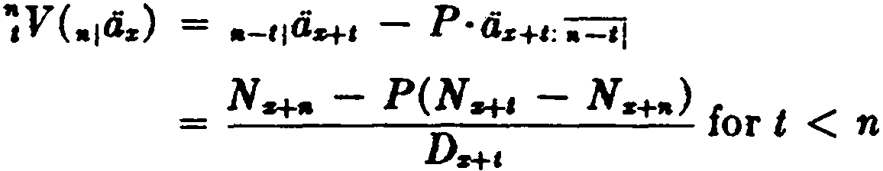
For an n-year deferred annuity-due of 1 per annum with annual premiums paya.ble for n years, the reserve at the end of t years is given by

V(,.1a.) = ti:r+c = Ns+,
Ds+t
where 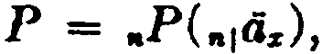 for t n.

The same notational device is used in any case where the simpler type of symbol does not adequately specify the function.
It has been assumed in the formulas above that the duration t is an integra/, number of years. Under this assumption, the func­ tion ,V relates to the end of a policy year and is called the t-th year terminal, or final,, reserve.

- Retrospective formulas
The formula for the prospective reserve may be transfonned in
a significant way.
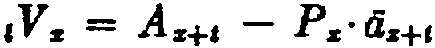
where 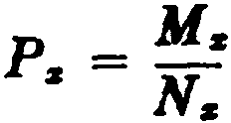
_ Ms+ I - P.· Ns+e
- Ds+,
M s+e - P.·Ns+a + ( P.- N. - M.)
D,,H
since P.·N. - M. = O

P.( N. - N...,)
=
---
,=----
D...,
M. - M...,
n..., (5.3)

SEC. 3) RETROSPECTIVE FORMULAS 99

In this result, the first tenn will be recognized as the accumulated value of the premiums paid during the fust t years and may be expres.sed as P ·S:r::,i . The second tenn is seen to be equal to
AE!:!] , and thus represents the net single premium for the first
' z
t years' insurance accumulated to the end of t years. This tenn
is known as the accumulated cost of insurance, and is denoted by
Je. , where

k _ M. - M s+i

(5.4a)

' :r; -
Ds+, •

When the insurance is payable at the moment of death, the cor­ responding function is

- _ Mz - Ms+I
'kz - D .

(5.4b)

s+t
It is now clear that formula (5.3) expresses the reserve as the excess of the accumulated value of the premiums paid over the accumulated value of the benefits provided. This expression for the reserve, being in tenns of past premiums and past benefits, is k.nown as the retrospeclive definition, and reserves written in this fonn are called retrospective reserves.
Although the retrospective definition has been discussed with reíerence to a particular form of policy, its generality should be apparent. A few additional exa.mples of retrospective formulas follow:
,V :;i = P :;i·ss;;1 - ,k.
_ P :;;¡(N. - Ns+,) - (Mz - M s+,)
- Ds+c

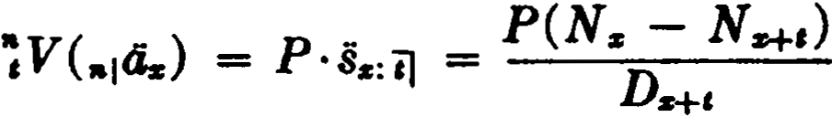 for t < n
where P = ,.P(,.1ás)

,V( A-s:;¡ )
p ..
·Sz:il -
=
k-s = P( N s - N s+,-)=--(Ms -
Dtt,
,
M s+.;t._)

where P = P( Ar.;¡ ).
In the case of an n-year limited-payment life insura.nce, the re-

100 NET LEVEL PREMIUM RESERVES [CH. 5

serve at time t > n is expressed in retrospective fonn as

& z = " s'Sz:;-J ·-E-- - & -z
"V P · l k
,_,. z+n

_ ,aPs(Nz - Ns+n ) - ( M-z - M s+i )
- Ds+i
Notice how the formula is modificd to recognize that premium payments cease af ter n years.
It is instructive to consider a specific policy and examine the way in which the financia! details work themselves out as applied to a large group of lives insured at the same time and at the same age. Let us choose a 10-payment 15-year endowment
of $1 issued at age 35, and let us adopt the 1958 eso mortality
basis with interest at 3 % per annum. We note that in the CSO table [36 equals 9,373,807 and it is therefore convenient to com­ mence with 9,373,807 policies issued at age 35. The net leve) premium for each policy is
_ M 36 - M i0 + D¡o
=
1oP3i:U j = N N .074905,
31 - '6

and the total amount of premium paid in the first year by the 9,373,807 lives is $702,145. Let us trace the history of this initial fund of $702,145 as it is augmented by interest eamings, reduced by claim payments, increased by additional premium payments, and so on, until at the end of 15 years ali the remaining policies mature. The details are shown in Table 4.
At the end of the first year, the fund has grown to $723,209 by the addition of intere.st at 3 %. The 1958 CSO table indicates 23,528 deaths at age 35 out of the original group and, after the claim payments have been deducted, the fund stands at $699,681. The second year's premium is now payable from each oí the 9,350,279 survivors at age 36, a total of $700,383, which, added to the existing fund of $699,681, brings the fund to $1,400,064 at the beginning of the second year. The subsequent operation of the fund should now be cleá.r from Table 4. After the first 10 years, no further premiums are credited, and the only increment is in­ terest. At the end of the 15 year period, the fund has built up to the a.mount which is exactly sufficient to provide the required endowment of $1 to each of the lives that are surviving at age 50.

SEC. 3) RETROSPECTIVE FORMULAS 101

It is evident from the table that the net premiums received are more tha.n sufficient to meet the death claim payments that become due, and that the accumulated excess gives rise to the total fund whose growth is shown in column (6). This excess of accumulated premiums over accumulated benefits is precisely the aggregate reserve for the group of policies according to the retro-

TABLE 4
ACCUMULATION OF FUNDS UNDER 9,373,807 ENDOWMENT POLJCIES OF $1 ISSUED AT AGE 35
1958 CSO 3%Basis
P = u,Pu:ii( = .074905

(2)

Total Premiums Received
ln+t-l"P

(3)

Total Fund at Begio- oing of Year
(1)
(4)
1 (5)
(6)
1 (7)
.
1 Fun(d8)per Survivor
Year I
Fund with Interest (1.03) ·(3)
1 Death
Claims
da'-t-1-1
Fund at End of Year t
1 Numr of jºVu:ii] =
(4) - (5
)
Surv1vors
ln+e
(6)
(7)
1
2
702,145
702,145 723,209 23,528 699,681 9,350,279
700,383 1,400,064
1,442,066 24,685' 1,417,381 9,325,594
.07483
.15199

3 | 698,5342,115,915 | 2,179,392 | 26,112 | 2,153,280 9,299,482 | .23155
4 | 696,5782,849,858 | 2,935,354 | 27,991 | 2,907,363 9,271,491 | .31358
5 | 694,481 3,601 ,844 | 3,709,899 | 30,132 | 3,679,767 9,241,3591 | .39818
6 | 692,224 4,371,991 | 4,503,151 | 32,622 | 4,470,529 9,208,737 | .48547
7 | 689,780 5,160,309 | 5,315,118 | 35,362 | 5,279,756 9,173,375¡ | .57555
8 | 687,1325,966,888 | 6,145,895 | 38,253 | 6,107,642¡ 9,135,122 | .66859
9 | 684,266 6,791,908 | 6,995,665 | 41,382 | 6,954,2831 9,093,740 | .76473
10 | 681,167 7,635,450 | 7,864,514 | 44,741 | 7,819,773¡ 9,048,999 | .86416
11 | 7,819,773 | 8,054,366 | 48,412 | 8,005,954¡ 9,000,587 | .88949
12 | 8, 005,954 | 8,246,133 | 52,473 | 8,193,660 8,948,114 | .91569
13 | 8,193,660 | 8,439,470 | 56,910 | 8,382,560¡ 8,891,204 | .94279
14 | 8,382,560 | 8,634,037 | 61,794 | 8,572,243 8,829,410 | .97087
15 | 8,572,243 | 8,829,410 | 67,104 | 8,762,3061 8,762,306, | 1.00000

spective definition, and the average fund per policy as shown in column (8) is the reserve function 1 Va1i:íij .
That the retrospective reserve is always equivalent to the pro­ spective reserve in the case of net level premium valuation may readily be established. At any moment of time during the prc­ mium-paying period of an insurance policy, the value of ali the premiums past and future under the contract must be equal to the value of the policy benefits already provided and promised for the future. Dcnoting the current value of the premiums, past

102 NET LEVEL PREMIUM RESERVEP. [CH. :1

and future, at time t by

P· s, + P· a, ,

and the va.lue of the past a.nd futurc benefits by
,k + A, ,

we must have

P· s, + P·a, = ,k + A, .

When this is written a¡
P ·s, - ,k = A, - P ·a, ,
the left mem her will be recognized as the retrospective reserve and the right member as the prospective reserve. Similar reason­ ing shows that this equivalence holds also for durations beyond the premium-paying period.
An important principie is easily derived from the retrospective expression for the reserve. Consider two different insurance policies which provide the same death benefit. Their reserves may be written formally as

a.nd

Subtracting, we find
,V = P·s, - ,k

,v' = p'·s, - ,k.

,v - ,v' = (P - p' ) s, .

Thus, if two insurance policies provide the same death benefit and are vaÍued on the same basis, the difference of the correspond­ ing terminal reserves is equal to the difference of the net premiums accumulated with interest and survivorship.
In writing reserve formulas, the student should attempt to anticipate whether the prospective or retrospective method '"·ill yield the simpler expression. There are two obvious principies:
- The prospective method is more convenient for durations beyond the premium-paying period. The reserve is then simply the net single premium for the future benefits at the attained age. For example, for t n,
Y. = As+i and V ("1az ) = ªª+' .

SEC. 3] RETROSPECTIVE FORMULAS 103

- The retrospective method is more convenicnt during a de­ ferred period when no benefits havc as yet bcen provided. Thc reserve is thcn simply the accurnulation of thc past prcmiums.
For exarnple, V (,.¡dz) = ,.P (n1<'iz) ·sz:il for t < n.
The existence of the reserve is a natural consequence of the practice of financing insurance involving an íncreasing risk by means of level annual premiums. Most of the common forms of insurance are of this type, the premiums in the earlíer years being more than sufficient to cover the current risk. This is not always the case, however. There are certain forqis of insurance which provide for a decreasing scale of benefits, and under these cir­ curnstances the leve!premiurn may be inadequate in the early years of duration with the result that negative reserves are pro­ duced for a number of years. When this happens, the premiums in the later years are more than sufficient to cover the current death claims, and the earlier deficit is ultimately extinguished.
The possibility of negative reserves may be illustrated in the case of the hypothetical decreasing term insurance policy which was described in Chapter 4 as one of the elements into which the endowment policy may be analyzed. It will be recalled that the endowment policy may be envisaged as a combination of a savings fund which accumulates to the maturity value, together with a decreasing term insurance for the difference between the sum in­ sured and the amount accumulated in the savíngs fund at any time. Let us apply this analysis to the 10-payment 15-year endow­ ment policy of Table 4.
The savings fund premiurn applicable in this case is payable for 10 years and must accumulate with interest at 3 % to the sum of 1 at the end of 15 years. This premiurn is

1
(1.oa)lísioJ = .073054.

Since the total endowment premium is known from Table 4 to be
.074905, it is apparent that the premium for the decreasing term insurance portion will be .074905 - .073054 = .001851.
Let us now ex11.mine the reserve at the end of 1 year on the de­ creasing insurance. The amount of insurance duríng the first year is equal to the excess of 1 over the accumulated savings fund. At the end of the year the savíngs fund amounts to

104 NET LEYEL PREMIUl\t RESERVES [CH. 5

.0730,">4 (1.0:q = .07;'>2-10,
and thc amount of immrn1wc is accordingly 1 - .07;,;24u = .B24754. Thcn, using the retrospectivc definition, thc reserve at thc C'nd of 1 year will he
.001851 D3• - .924754 Cu -.000416,
D;:s
the negativc rcsult rcflecting the initial inadequacy of the pre- · mium. In issuing a policy of this type, an insurer takes the risk that t hc insurcd may discontinue premium payments without repaying t hc dcficit agaiust his po]icy. In the above illustration, this contingcncy is avoidcd sincc the insurance described is not issucd as an individual policy, and exists only as a component. of thc endowmcnt policy. lt will be seen that the negativc reserve of -.00041ü eombinc<l with the savings fund accunmlatiou of
.075246 produces the reserve of .074830 shown in Table 4 for the endowmcnt poliey.
The im;uranee that we havc used for illustration is on a limited payment basis, and this fcaturc helps to keep the magnitude of thc negative reserve small. If prcmiums were payable throughout the full term of thc policy, the <lecreasing insurance premium would be smallcr and the first-year benefit larger and both of these eff ects would increase the deficit in the reserve. :Kcgative reserves can be avoided eutirely by suitably limitiI•g the premium-paying period and this is one of the standard devices adopted by insurers when policies with decrcasing benefits are issued.
- Other formulas for terminal reserves
There are many usef ul transformations of the basic reserve for­ mulas. From the prospcctivc formula for t V:r , for example, the following series of formulas may be derived:
,r:r = Az+I - P:r · dz+I

= 1 - ( Pz + d )az+t
since Az+t = 1 - 00:s+a
1 - ciz+t
a:r
(5.5)

(5.6)

since Pz + d = _!_
ás

SEC. 5] SUCCESSIVE TERMINAL RESERVES 105

= as - as+I
(5.7)

- as--

Az+, - As
=
----
1 - As
. _ 1 - As

1 - As+c

(5.8)

smce Os = d and <iz+c = --d-- •

The following development yields other relations:
V A P .. A (l Pz · dz+I )

I z = z+t - z· a.z+I = ..'1.z+t - Az+t
(1 - )

= Az+i
Pz+i
= ( Pz+I - P.i: )iiz+I
_ Pz+, - Ps
- Pz+t + d .

(5.9)

(5.10)

(5.11)

With suitable modifications, corresponding formulas also hold for endowment insurance (see Exercise 8).
Verbal interpretations may be given for all these formulas. Formula (5.5) is analogous to the formula Az = 1 - dii,z , for ex­ ample, and may be explained by a similar argument. If the death bencfit were payable now, its value would be l. Since this pay­
ment is deferred to the end of the year of death and is contingent upon the payment of premiums for each year that the insured enters upon, the present valuc of the interest and of the future premiums must be deducted. Thus,
,Vz = 1 - ( Pz + d)iiz+a .
As another example, formula (5.10) demonstrates that the re­ serve is equivalent to the present value of the difference between the premium that the insured should pay at bis attained age for the future benefits and the premium that he is actually paying.
- Formulas connecting successive terminal reserves
When the quantity Pz is added to hoth sides of the basic pro­ spective equation (5.1 ), we have

106 NET LEVEL PREMIUl\I RESERVES [CH. 5

With the substitutions

and 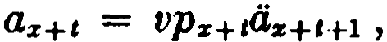 this becomes
,l':r + J\ = (t>q:r+I + VJJ.+1A:r+1+1) - P:r (VP:r+1<iz+1+1)
= vq:r+t + vp:r+1 (A:r+1+1 - P:r d:r+1+1)

(5.12)

Formula (5.12) shows that the reserve at the cnd of t years, ,V:r , increased by the premium then due, P:r , provides insurance for thc ncxt year, vqz+i , plus a pure endowment of the next year's re­
serve, VPz+i· 1+1V:r • Or, if the equation is multiplícd by (1 + i)l z+t,
l:r+t ( tV z + P:r )(l + i) = dz+t + l:r +Hl'1 +1V:r , (5.13 )
we see that the aggregate reserve for a group of l:r+1 lives, increased by the premiums due and a year's intercst, is just sufficient to provide benefit payments of 1 for each of the dz+, lives that fail during the year plus the new terminal reserve of ,+1V:r for each of the lz+1+1 lives that survive to thc end of the year. It will be recalled that this was the principie used in the construction of Table 4.
If Pz+c in formula (5.12) is replaccd by 1 - qz+c , there follows (,V:r + Pi:) (1 + i) = 1+1V:r + q:r+, (1 - 1+1V:r ), (5.14)
l:r+ t (1Vz + P:r)(l + i) = lz+t· Hl V:r + d:r+c (1 - 1+1V:r ) , (.5.15)
In this forro, the equation shows that for a group of lz+t policies the t-th year terminal reserve increased by one year's premiums
and interest is sufficient to provide the (t + 1Hh year reserve
for all the lz+t policies plus the difference between the insured amount of 1 and the reserve for each of the dz+t policies that be­ comes a claim during the year. The amount by which the reserve falls short of the face amount, 1 - 1+1Vz , is called the net amount
at risk for the (t + 1)-th year; and the expression, qz+,0 - 1+1V:r ),
representing the insurer's expectation of having to pay the amount at risk, is caJled the cost of insurance based upon the nel amount at
risk for the (t + 1)-th year.

SEC. 5) SUCCESSIVE TERMINAL RF.SERVE6 107
This discussion need not be confined to ordinary life insurance, and the results may be generally summarized in the equations:

( ,V + P) (1 + i) = qz+, + Pz+t ' ,+1V,
( ,V + P) (l + i) = 1+1V + qz+e (l - e+1V).
(5.16)
(5.17 )

With P = O, these equations apply also to single premium insur­ ance and to limited-payment insurance when t exceeds the pre­ mium-paying period.
Solving equation (5.17) for P, we obtain
P = vqs+e (l - 1+1V ) + (v·1+1V - ,V).
This equation demonstrates that the net annual premium is suffi­ cient in any year to provide (1) an amount which will accumulate with interest to the cost of insurance based upon the net amount at risk and (2) an amount which together with the previous year1s reserve will accumulate with interest to the terminal re­ serve for the current year.
This analysis suggests that the reserve can be expressed as the accumulation of the net premiums with int.erest minus the ac­ cumulation at interest of the cost of insurance based upon the net amount at risk. We can obtain an algebraic justification by writing (5.17) as
Hl V - (1 + i)t V = P (1 + i) - K z+&
where K z+t = qz+i (l - ,+1V), the cost oí insurance ha.sed upon the net amount at risk for the (t + 1)-th year. Multiplying by (l + i)n-t-i and summing, we have
L [ (1 + i) n-H t+lV - (l + i)n-t ,V]
•-1
,-o
n-1 n-1
L
= P (l + i)n-t - (l + i)n-t-1 K z+t •
,-o t-0
Since O V = O, this expression reduces to
n-1

n V =
/> ·b•.-;;-J - """' (l + 1'.) n-,-1 Kz+t •
,,-t.o_
(5.18)

Although P and K are functions which involve mortality, the accumulations in this formul are at interest only. The result is

108 NET LEVEL PREMIUM RESERVES [CH. 5

not restricted to policies with level amounts of insurance; it has usef ul applications to policies with varying insurance benefits as well.
- Reserves on policies with fractional premiums
The symbol ,v<m> is used to denote the reserve at the end of t years on a policy with true fractional premiums p< m> . lf pre­ miums are assumed to be payable momently, the reserve symbol
becomes ,V. For ordinary life insurance,

and
,V"'> = Az+c - P"'> - :!
,Vz = Á z+c - Í's·ds+c ,
(5.19)
(5.20)

We can estimate how much ,V!"'> differs from ,Vz by using the following expressions for P m> and a !:
pz(m) == p + m - 1 p<rn> ( p + d)
2m
  - z z z

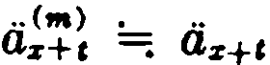
m - 1
2m
Making these substítutions in (5.19),

t Vz<"'> .===:
A z+c - p<s"'> (a··z+t - m - 1)

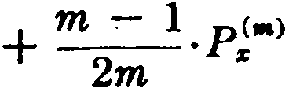
=e A,+1 - [ P, + m;: 1 P!ª' ( P, + d ) ] 0.+1

( As+t - Pz iiz+t ) + m2
l P"'> [1 - ( Ps + d)as+,1

:

,V, (1 + "!.i,;. 1 P!ª') , using formulas (5.1) and ( 5.5).

I•'rom this result,
y<'"> == V (i+ m - 1 p<"'>)

( 5.21)

' z . ' z 2m s ,

we see that the reserve is larger when t rue fractional premiums are paid. This is because there will be a loss of premium in the year of death if death occurs before all the fractional premiums

SEC. 6] POLICIES W1TH l'RACTIONAL PRmllUMS 109

a.re due. The average loas is a.pproxima.tely m
2
1 P ,,.>, a.nd the

reserve on the fractiona.l premium ha.sis is approximately equal to the reserve on an annual premium basis for an insurance with a benefit of 1plus the average loas of premium.
When the insta.lment type of fractional premium is payable, the
amount of the policy proceeds can be approximated as
1 - m - 1P.l•J . W
e then ha.ve
S Vl•l :.- As-f-l (1 -m - 1pl•l) - pC•l,.<11!'>

a -:
- • USTI

. A m - 1 nl•l( 1 ,lA )
=: a,.f-1 - C• - u.us.+I
(4 1)

pt•J m -
- • s+• -

= As-+-s - as+, P.r•l (1 - m - 1d)

As-t , - Pa 4s+,
= ,v• .
by (4.22)

(5.22)

Hence, no reserve adjustment is necessary in this case. The result is not surprising, since there is no loss of premium in the year of death.
With apportionable premiums, there is an average loss of premium oí i P •J in the yea.r of death, and general reasoning suggests that
,VJ"' 1 ,Va (1 + i P;"' 1 ). (5.23)
We can verify this result algebraica.1ly. Recalling tha.t the policy proceeds can be estimated as 1 + ;m P ª1, we have
1Vl•l :... As+I [1+ 21m p•l•l] - pl•"'l;;<•>

s -;
Us+&

= As+I (1 + .1.pl•IJ - As+I m - 1pl•l - pl..l,a.<•>

J" •
s a u.s+i

110 NET LEVEL PREMIUM RESERVES [CH. ,5
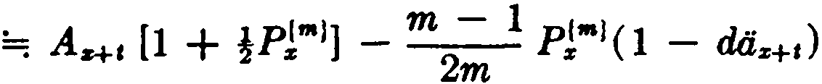

pl•l (·· m - 1)
-- Az+t [l + i pzl•l] - pzl"'l - [1
- z az+I -r 2

2mm- 1d] .

2 O:r:+t -
But by (4.24), pJ•l (1 - m l d) =; P,( I +!PJ*1 ).
2
:. ,VJ..l =; A* ' [1 +!P "'1] - Pz( 1 + }PJ"'1 )a*,
= ,Vz [1 + }PJ"'1].
For other forms of insurance, the added reserve which is re­ quired in the case of true f ractional and ap portionable premiums is on a term insurance basis, since the loss of premium will only be sustained during the premium-paying period. This is illustratcd in the following formulas:

(m)
V
t z:nl
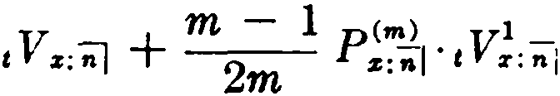
1 :z: 2 ' n z ' t z:;-J for l < n
n y + l pf•l vl

:rnd for t n.

7. Reserves at fractional durations
In the formulas derived for ,V thus far, an integral value of t has been assumed, and the resulting functions have been defined as terminal reserves. For accounting purposes, it is often neces­ sary to compute reserves at fiactional durations. The mean reserve t+i V is especially important since, in making an over-all valuation of an insurer's policy liabilities, it is customary to assume that on any particular day the average duration of all policies issued
between l and t + I years earlier is l + !years.
Consider an ordinary life policy of 1 with premiums payable annually. An exact expression for the prospective reserve at
duration t + h (t integral and O < h < 1) is
t+AVz = U1 \1-A9z+l+1' + l-APz+1+AÁz+e+1)
-

- Pz'l-JilOz+c+A ·
(5.24a)

BEC. 7] RESERVES AT ll'RACTIONAL DURATIONS 111

It should be noted that it is not correct to use As+a+r. in place of the first term of (5.24a). As+i+r. would provide for death payments
at the ends of years measured from time t + h instead of at the
ends of policy years.
Another exact expression for the reserve ma.y be obtained by analogy from (5.14):
1.µVs (1 + i)l-l = HlVz + 1-Aqz+a+A (1 - HlVz). (5.24b)
It can readily be shown that (5.24a) and (5.24b) are equivalent. Neither formula, however, is amenable to exact calculation, and neither suggests a simple approximation. Consequently it is customary to obtain a value for •+A Vz by mea.ns of linear inter­ polation based on reserve values for integral durations.
Since the reserve ,Vª is based on the payment of exactly t
annual premiums, and the reserves e+A Vz and 1+1V:r are based on the payment of exactly t + 1 annual premiums, the interpolation must be between ,Vs + Pz , defined as the initial reserve for the (t + 1)-th year, and a+IVa , the terminal reserve for that year,
rather than between ,Vs and 1+1Vz , the successive terminal reserves. We thus ha.ve
c+r.Va ==: (1 - h)( 1Va + Pa ) + h· ,+1V z . (5.24c)
In the general case, considering a policy with insurance of 1
a.nd premium P paya.ble annually, the formula is
,+'v =; (1 - h) <,v + P) + h·e+1v
= (1 - h},V + h·1+1V + (1 - h)P (5.25)
for integral t and O < h l. Since the terminal reserves are normally tabulated for all integral durations, formula (5.25) a.ffords a convenient approximation.
It is interesting to consider the analogue of (5.24a} when the
insurance is paya.ble at the moment of death:
a+r.V (As } = Áa+Hlt - P(.,L:} ·1-11dz+Hh •
By using the linear interpolation
Ás+t+r. ==: (1 - h) Ás+t + h.Aa+t+l
and the standard approxima.tion
1-.\l+Hh =¡ 4.+c+A - (1 - h) =¡ (1 - h} Oa+t + Mz+Hl - {1 - h),

112 NET LEVEL PREMIUM RESERVES {CH. 5

the formula reduces to
t+hV' (,L:) ==: (1 - h),V (..,L:) + h· ,+1V (.A:.:) + (1 - h)P (A:i:),
which is the exact analogue of (5.25 ).
When (5.25) is applied to limited-payment plans, there is of course no need to adjust for the net premium at durations beyond the premium-paying period. In such cases, as for single premium insurance, the interim reserve is obtained by interpolation be­ tween the terminal reserves.
When fractional premiums are paid m times a year, two cases arise in evaluating the reserve at duration t + h.
1
Case 1: h is a multiple of -. Assuming a policy of 1 subject to
m
k
true fractional premiums, we let h = - where k is an integer, and
m
consider the computation of HV(m>. Now the terminal reserve
ffl

t y< m> is based on the payment of premiums for exactly t years, and t+i y< m> assumes premiums paid for exactly t + 1 years. If we
interpolate directly between ,y< m> and i+1V( m>, we obtain a value consistent with the assumption that premiums have been paid for
t + years, and this is precisely what we require in this particu-
m
lar case. Hence we can write

L y<m ) :..... (i k) y(m) + k y(m)
t+ --: - - t - • t+l '
"' m m
without any premium adjustment.

(5.26 )

Case 2: h is not a mvltiple of
!__ Let h = + r with r <
.!:_ ,

m m m
and consider the value of,+r y< m> . Interpolating directly
•
between ,y< m> and 1+1y< m> produces a value which is consistent
with the assumption that premiums are paid for t + m + r years. Since premiums are in fact paid for t + + .!.. years, it is neces­
m m
sary to adjust the interpolated value by adding the diff erence of
( - ) p<m> . We then have

SEC. 8) CONTINUOUS RESERVES 113
,'· ,.V'"'>-::...... (1 - k- - r) 'y<-.>
- ffl (5.27)
+ (+ ,) 1+1v -> + (i-,) p<•>.
1
Formulas (5.25), (5.26), and (5.27) are all contained in the following general rule: Interpolate between successive terminal reserves and add the amount of net premium paid for any period beyond the date of valuation.
In practice, it is frequently desirable to express formulas of this kind in terms of existing tabulated values of annual-premium ter­ minal reserves. This can always be done by substituting the ex­ pressions derived in Section 6 for the fractional-premium reserves in the formulas above.
- Continuous reserves
When we consider a whole life insurance payable at the moment of death and purchased by continuous premiums P( X,J , we encounter a reserve function, ,V (Ar ), which for a given age x is a continuous function of time t. Premiums are being paid continu­ ously, interest may be considered to be credited momently, and the insurance costs are deducted at each instant. Although pro­ spective and retrospective expressions for this reserve are readily formulated by analogy with the formulas already considered, a
diff erent approach is possible which gives valuable insights into the application of calculus methods to life contingency problems. Consider a group of l: whole life insurances of 1 issued at age x.
The insurance is payable at the moment of death, and premiums are payable momently. Let us examine the fund which results from the continuous crediting of premiums and interest and the continuous debiting of death benefit payments. We write ,V for
,V (A:.:). Since ,V represents t.he share of each policy in this fund at duration t, the total fund at time t is given by lx+t ·,V, and it is possible to find an expression for ,V from consideration of the rate of change of lx+t ·,V with respect to t. At any instant each existing policy is contributing premium to the fund at the rate of P per annum, and the total fund lx+t ·,V is increasing on this account at time t at the rate of lz+t .f' per annum. In terest is bcing added to the fund at time t at the rate of o· lx+t ·,V per annum. The fund is

114 NET LEVEL PREMIUM RESERVES [CH. 5

being decreased at each instant by the, claims incurred, and the rate of decrement on this account at time t is lz+úl;+t . The net effect of these three factors is to produce a total rate of change at
time t of Plz+ I + M z+i· ,V - lz+úlz+ t ' and we may write the fol­
lowing diff erential equation for lz+i ·,V:
d( lz+,· ,V ) - -
= +
dt Plz+, óls+' ·,V - lz+tµz+t .

Multiplying this equation by v' and rearranging tcnns,
, dO:r:+1 ·,V ) '(l - ) '( -l )
dt - = P
V · ÓV z+c · ,V V :r:-+ t - lz+tP.z+t ,

we note that the left-hand side is the derivative of v'l:r:+i ·,V, and integrating both sides between the limits O and t , we have

v lz+i ·,V
t -
= it v1.P-l:i:+1 dt - i' vt lz+tP.:r:+t dt

0 0

Then,

that is,

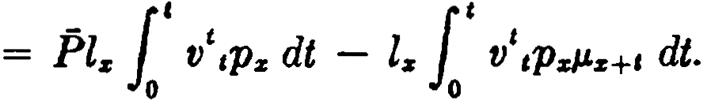

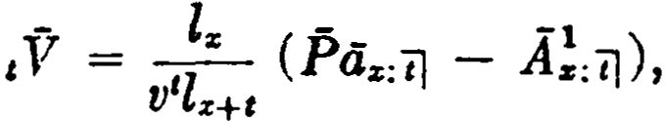

,V (Az ) = Ps:i:TJ ,kz . (5.28)

The reserve is thus seen to be equal to the accumulation of the past premiums minus the accumulation of the insurance coverage provided-a direct expression of the usual retrospective principie. The prospective formula may also be derived. Expressing (5.28) in commutation symbols,
V( A ) = P( Ñ:r: - Ñ z+, ) - ( M z - M z+, )
11
' D:i:+1 '

we have
,V(A:r:) = ( M z - .P ·Ñ:r:+t ) - ( M z - M z+, )
Dz+i

M z+1 - P·Ñ•+'
Dz+a

SEC. 9]
THE FACKLER RESERVE FORMULA
115

or ,V(.As) = ÁsH -. P·<is+c ,
the corresponding fonnula in prospective tenns.
(5.29 )

The difference between ,V (A.) and ,V. can be estimated. We
write
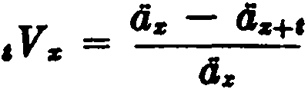 from (5.7)
and there is a similar expression for ,V (A.) :

,V-(A-.)
= ª· - da..+, .
ás

Since - az+i =: áz - az+i from (2.27 ), it follows that
'V( Az ) =: 'Ys· :.

Since

we have

-ª• .=: ª• + t =
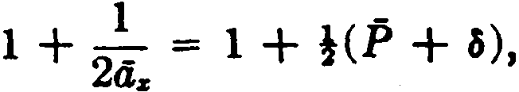
Oz tlz

(5.30)

In this result, the adjustment of }.P covers the average loss of a half-year's premium in the year of death, and the factor of !o
covers the average loss of interest on the sum insured due to the immediate payment of the death benefit.
- The Fackler reserve accumulation formula
Solving for ,+1V in equation (5.16), we obtain
i+iV = ( ,V + P)(l + i) - q, .
Pz+I

With the substitutions

1 + i

and
-Pz+I
= "»+'

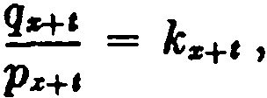
this becomes

116 NET LEVEL PREMIUM RESERVES [CH. 5

(5.31)
The U:i: and kz functions are called Fackler valuation functions, after the American · actuary, David Parks Fackler.
1 + i ( 1 + i )lz Dz
Uz = P, = lz+l = Dz+l ( 5.32)

kz = qz = !!:_=._ = Cz Pz lz+l Dz+l
(5.33)

Note that kz is a function of mortality alone, being independent of the rate of interest. Both uz and kz are special cases of more general functions defined earlier. From (2.15), we see that Uz is the same as S:dl (or 1'Uz ), and from (5.4a ), kz is the same as 1kz . The continuous forms 1Zz and kz are also used.
The Fackler formula (5.31) forms the basis of a convenient method for preparing reserve tables. When the values of Uz and kz are available at ali ages, we require only the value of the net pre­ mium on a policy to produce termina] reserves sequentially for
all durations, starting with the initial value o V = O. Since the
formula produces these values by a continued accumulation proc­ ess, the work is self-checking, and the calculations can be assumed to be accurate if the reserves accumulate to the correct amount at maturity.

JO. Methods of valuation
The process of computing the aggregate reserve for a group of policies is called valuation. We consider here certain practica! aspects of the valuation process.
One of the standard valuation methods is based on the retro­ spective formula

V - P( N z - Nz+,) - ( M z - M z+, )
' - Dz+e '

(5.34)

valid for any life, term, or endowment insurance of level amount 1 for which premiums have not ceased. By this retrospective method , all policies of the above type .having the same year of issue and age at issue can be grouped together for valuation. For each of the resulting groups, the total net premiums ( !.P ) and the total sums insured (!.S) are obtained. Then the formula

SEC, 10) METHOD8 OF VALUATION 117
p (N• - N-+') - S (Mª -M.._,) = .V (5.35)
DzH D.._,
produces the total t-th yea.r terminal reserve for the group.
The retrospective method can be further improved by a device which permits the replacement of the two-fold grouping by age and year of issue by a single grouping by attained age at the valuation date. This atlained age fonnula is derived from formula (5.34) by adding M z to the numerator and subtracting the equiva- lent expression Pz • Ns . Then,
,V = M.._, - P · N zH + (P - P:I& )N z
DzH

or ,V =
A z+c - P .. + (P-D Pa )N z .

(5.36)

s+C
az+c
It must be remembered that P stands for the net premium on the plan being valued and Pz is the ordinary lif e net premium at the same a.ge. The expression (P - Ps )N z is constant throughout the duration of the policy and its use is the characteristic feature of the attained age method. It is denoted by Bz , and its value is recorded for each policy issued. The actual valuation then requires a single sorting of policies into attained age groups. For each group, the total net premiums (P), the total sums insured (S), and the total 8-factors (9) are obtained. Then a single applica­ tion of the formula

S ·A..-, -P - azH + Dio
z+c
produce.a the total terminal reserve (l:,V ) for the group of policies. The retrospective method and the attained age method are conveniently adapted to punched-card systems using mechanical tabulating equipment, and these methods have been widely applied in this way for many years. Through the use of electronic computers, a high degree of efficiency can be obtained without introducing special methods which require a considerable amount of prior data processing. It is found, for example, that a simple seria.tiro method of valuing each individual policy, or a grouping method based on plans of insurance, can be used advantageously
with high-speed computers.

118 NET LEVEL PREMIUM REF;ERVES (CH . 5

ll . Eft'ects of ,·arialion in interest and mortality
It is often useful to be able to determine in advancc t hc effcct on reserves when changcs are to be made in the interest and mor­ tality assumpt ions. Evcn though thc cffect of such changes on nct premiums may be readily determined, it is not always easy t o analyze their effe<:t on reserves, and even the most careful mathemat.ical investigations of the problem have been found to lead only to a partial solut ion. The most significant contribution to t he subject was mude in a paper presented to the Institute of Attuaries by G. J. Lidstone (1905 ). His principal result may he summarized in the following theorem.

Lidstone's 1'h.eorem. For an insuranec of uniform amount 1 with level annual premiums payahle throughout the n-year duration of the policy, let P and ,Y denote the net level premium and thc tenninal reserve at the end of t years on a standard basis wit h

interest rate i ami mort ality rates q, and let />
1
and ,·v' denote the

corrcsponding net premium and reserve on a special basis with interest rute { and mortality rates q'.
Conider the "critica} funct ion"
e, = ( ,V + P ) (i' - i) - ( q: - q, )(1 - 1+1l'), O t < n.
If t he crítical funct.ion always decrcases as t increases, the special reserves 11/' excced the standard reserves ,V for O < t < n; if the eritic.:al function always inereases wit h t , the special reserves
are lcss than the standard reserves for O < t < n; and, if the critical function is constant , the special reserves are equal to the
standard reserves for O l n.

lt should be un<ler.3tood that thc theorem refers only to termi nal reserves, with t assuming only integral values from O to n. Thf' proof of t he t heorem involves a closely reasoned argument, thC' steps of whieh are set forth for coneiseness in the accompa nyiníl;
<leductive scheme ( pagc 119).
Two irnportant corollaries to Lidst one's theorem may be
derived. Suppose that t hc special basis involves only a change in the mte of int crcst. Then q: = q, , :rnd t he crit i,·al func-tion
become
e , = (,l· + P ) ( { - i).

Paoor or L DSTONs's THsORKII

Statemeats

l. ( ,V + P)(l + i) = 1+1V + q,(1 - 1+1V)
and
(,V' + P')(l + i') = &+1V' + q;(l - 1+1V )
2. ( ,V + P)(i' - i)
+ ( ,V' - ,V + P' - P)(l + i')
(q; - q,)(1 - 1+1V)
+ (1 - q;)( ..,V' - 1+1V)
3. Define R, = ,V' - ,V
and S , =
( ,V + P)(i' - i) + (P' - P)(l + i')
- (q - q,)(1 - l+I V)
4. R,(1 + i') + S, = p; R,..

5. Ro = R.. = O

R.euom

Formula (5.17)

Subtracting the equations in Statement 1 and . re­ arranging terms

Definitions

Substituting for R, and S
in Statement 2

oV = oV ' and ,.V = 111 V '

6. .S ,can neither be positive for every t nor be Statements 4 and 5
negative for every t.

- If S, is constant, it must be equal to zero. Statement 6

- If S, is eonstant, then R, = O for every t, Statements 4, 5, an<l 7
and ,V' is aiways equal to ,V.

- lf S , is first positive and then becomes and remaim negative, then R, > O and ,V' > ,V for O < t < n; if S, is first negative and then becomes and remains positive, then R, < O and ,V.' < ,V for O < t < n.
- If e, =
(,V + P)(i' - i ) - (q; - q,)(1 - 1+1V)
always decreases, then S , is first positive
and then beeomes and remains nega.tive; if e, always inereases, then S , is first nega­ tive and then positive; if e, is eonstant, S, is constant.
Statements 4 and 5

S, =
e, + ( P' - P)(l + i'),
and the term
( P' - P)(l + i') is con­
stant. Also Statement 6

- lf e, always decreases, then ,V' > ,V for Statements 8, 9, and 10
O < t < n ; if e, a.lways increases, then
,V' < ,V for O < t < n; if e , is constant,
then ,V ' = , V for O < t < n. q.e.d.

119

120 NET LEVEL PREMIDM RESERVES [CH. 5

If Í is greater than i and ,V increases with t, it follows that e, is an increasing function, and the theorem indicates that the special reserves are less than the standard reserves. If ,/ is less than i and ,l' increases, e, is a decreasing function, and the special reserves exceed the standard reserves. These results may be summarized as follows:

Corollary 1. An increase in the rate of interest produces a decrease in reserves, and a decrease in the rate of interest pro­ duces an increase in reserves, provided that the reserves increase with duration.

The second corollary relates to the eff cct of a constant change in the rate of mortality, with no change in the rate of interest.
Let q: = q, + k, and, since Í = i, we then have
Ct = - (q: - q,) (1 - t+l V' )
= -k (1 - t+l l').
If the reserves increase with duration, the net amount at risk, 1 - t+l V, is a decreasing function. Hence, if k is positive, e, in­ creases, and the special reserves are decreased; if k is negative, e, decreases, and the special reserves are increased.

Corollary 2. A constant increase in the rate of mortality produces a decrease in reserves, and a constant decrease in the rate of mortality produces an increase in reserves, provided that the reserves increase with duration.

The requirement that reserves increase with duration is nor­ mally satisfied in the case of ordinary life and endowment insur­ ance, but not in the case of term insurance. The two corollaries thus do not hold for term insurance.
It will be seen that Lidstone's thcorem is of limited utility, applying only to ccrtain forms of insurance and being restricted to three spccial typcs oí critica! function. Furthermore, the be­ havior of the critica! function is not usually evident mtless the standard and special hascs are connected by a simple mathe­ matical re]ationship.

SEC. 11] VARJATION IN INTEREST AND MORTALITY 121
When Lidstone's theorem cannot be· applied, it is sometimes possible to use other criteria. For example, with ordinary lif e insurance, it follows from formula (5.6) that

according as

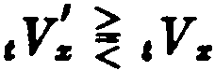
l _ dz'+ I l _ dr+t
··' < .. '
Oz

,
Ó:z:+e < ii:z:+t
>-_-
or -::r
ª% a:z:
I I
or -ll..z-+i <> d-:,::­
ª..r-H az
I
Here it is only necessary to calculate the values of z for all values
az
of x, and a simple inspection of these values then shows the ages and durations at which ordinary life reserves on the special basis exceed those on the standard basis. The criterion is

,Vz < ,Va: according as
I >

I I
Óz+c < dz d..r+t > dz ·

There is a similar criterion for endowment insurance. Thus,
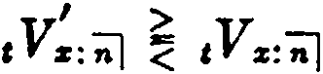
according as 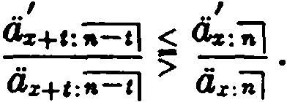
These criteria apply equally to changes in interest, or mortality, or both.
A problem of somc interest is to determine the condition under which two different mortality tables produce identical reserves over a given interval. Suppose that an ordinary life policy issued at age x has identical terminal reserves for the first m years on two diff erent mortality bases, the rate of interest being the same on both bases. Then,
,v; = ,Vz O t m
I I

and Óz+t
tiz
= - O t m.

iiz+t <iz
This implies that the ratio a' is constant over the interval, and
a

122 NET LEVEL PREMIUM RESERVES [CH. 5

we may write
ª"' = (1 + k ) a;
where k is constant and x y x + m.

Then 1 + vp"'li,,+1 = (1 + k ) + (1 + k )vp;a;+i .
Replacing (1 + k ) a;+i in the righ t member by Ü.y+1 , we have
VPwiiv+t = k + VPA+1 •

Then
P11 = -.k. - + '
l'lly+l
Pv

or q'V' = q¡¡ + -.k.--
Vay .n
for X y < X + m. (5.37 )

The quantity d¡,+1 normally decreases as y increases, nnd hence we see from (5.37 ) that when the reserves are equul, thc mortality rates differ by an amount which increases with age.
A sufficient condition for thc equality of these reserves can be
given in the following forrn:
' k
H q" = q11 + --- for x y < x + m,
Vt1w+1
where k = ª;+• - 1 then ,v; = ,V,
Oz+111 J
for O t m.
The proof is by induction. Suppose that, for sorne age u on the interval x < u x + m,
ª" = (1 + k )a: .

Then,

0.-1 = 1 + vp.-1a.
1+ w (P:-1 + )(1 + k )a:
= (1 + k )(1 + vp:_1a:)
(1 + k )a:_1 .

SEC. 12)

Since, by hypothesis,
PAYMENT OF RESERVE 123
iiz+• = {l + k )<4+• ,

it follows by induction that
áw = (1 + k )a;
for ali y such that x y x + m,

and hence that

,V = tVz for all t such that O t m.

- Payment of reserve in addition to face amount
The nature of the reserve is not always dearly understood by those who purchase life insurance, and there havc been many demands upon insurance compan ies for the paymen t of thc reserve in addition to the faee amount of insurance upon the death of the insured. In the case of the usual insurance contract, such a demand must be met with an explanation that the premiums are calculated to provide only the face amount of insurance at death, and that they are not sufficient to cover the increasing amounts of insurance that would result from the additional payment of the amount of the reserve. The insured must be shown that the reserve at any time while the policy is in existence is a measure of the value of the policy at that time, not a surplus accumulated in excess of that value, and that it. exists oruy as a technical or accounting conse­ quence of the payment of a level premium for a risk which iu­ creases from year to year.
lt is possible, however, to prepare a special type of policy which will provide for the payment of the amount of its reserve in ad­ dition to the face amount of insurance upon death. Such a policy requires a net prcmium correspondingly higher than when only the face amount is payable. The method of determining the necessary special premium will be illustrated for the case of an ordinary life insurance. ,
We will assume that an ordinary life insurance of 1 is issued at age x with the provision that the reserve will be paid in addition to the face amount in the event of death during the first n years, the extra premium for the additional benefit to be payable for n

124 NET LEVEL PREMIUM RESERVES (CH. 5
years. The death benefit in the (t + 1)-th year is 1 + t+i V and the corresponding cost of insurance based upon thc net amount at risk is
K.+t = q.+t[ ( 1 + a+l V) - Hl V] = q.+t .
We can now determine the premium P payable during the first n years by using formula (5.18), where ,.V is simply the ordinary life reserve II Vs , the usual ordinary life death benefit being payable after n years. We thus have
11-l
L (
11v. = Ps;i - 1 + i )" _ _ q.+t .
1 1
,-o
The summation term can be simplified as follows:
11-l 11-l
L ( 1 + i)11-Hq•+' = ( 1 + i)ª+" L Vs+t+iq•+t
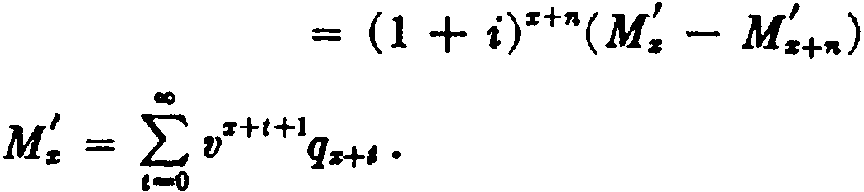
,-o ,-o

where

Solving for P, we have
p = ,Ys + (1 + i)+"( M; - M+,.) .
8-;J

( 5.38)

Af ter n years, when the extra death benefit is no longer in effect, the premium reduces to P• .
It should be understood that the special symbol M; has been
introduced here as a convenient simplifying device for this par­ ticular context only . It does not define a standard function, and will not necessarily be used in the same sense elsewhere.

- Summary of notation for reserves
  - The principal symbol V is used to denote a reserve value.
  - Except for simple insurance benefits payable at the end of the year of death, the V symbol is used in conjunction with the net single premium for the benefit; e.g., ,V (As ), V (111a.).
  - A prefixed suhscript with V indicates the duration in years
at which the reserve value is taken.

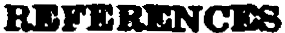
125

4. A prefixed superscript is used with V when there is a limited premium-pa.yment period, and indica.tes its dura.tion in yea.rs.
5. A suffixed superscript and a horizontal bar over the V sym­
bol relate to the frequency of premium pa.yment and ha.ve the same s•ign1"ficanee as when used wi•th p ;e.g., ,y(sfll) ,,Tv7'a:iif , ",y•f•) .
References
7. Mereu (1961) has investigated the error involved in the a.ssumption of linearity of reserves. Procedures for obtaining interim reserves by ada.pting these formulas to digital computers are described by Davidson and Birkenshaw (1958).
8. A generaliza.tion to other forros of insurance is given by Mereu (1963).
11. The classical paper is tha.t of Lidstone (1905). Extensions of Lidstone's results are given by Gershenson (1951) and Baillie (1951). The inductive proof of the sufficiency of the condition for equal ordinary life reserves is taken from T. N. E. Greville's dis­ cussion of Gershenson (1951), TSA 3, pp. 533-4.
12. The original paper is that of Marshall (1933). Using a different approach, Nowlin and Greville (1956) obtained a result tha.t is slightly more general than our formula (5.38). Further generaliza.tions a.re cited in Chapter 6.
EXERCISES
l, 2. Prospective formulas
- Write prospective reserve formul&a in terms of commutation functions for the following:
::v
  - IO:ii}
  - uV(A,ü1)
- Show that -•-tVs = 11 - Ps .
,vU.> i., (1+ n,v•.
- Show that

Write the corresponding approximation for ,V(Ás :il),
- Retroepeetive Cormulas
- Write retrospective formulas for V. in commutation functions, con­ sidering the c&aes where t < n and t > n. In each case, show that the retro­
spective expression is equivalent to the prospective formula.

126 NET LEVEL PREMIUM RESERVES [CH. 5

- Suppose that 90,000 lives aged 30 each purchase an ordinary life in­ surance of l. The net annual premium is .02. If interest is at 3% and if the mortality table used provides for 700 deaths at age 30, compute 1Vao .
(Ans. .013)
- Show that the product of the t-th year terminal reserve for an annual premium n-year pure endowment issued at age x a.nd the annual premium for a pure endowment of like amount issued at the same a.ge but maturing in t years is constant for ali values of t.

- Other formulas for terminal reserves

  - Show that (a) ,Vz :o: Az+ I (1 + 1T
+ . ) _ I + i p
i % •
P..

  - Show that
(a) ,Vz ,;;¡ = 1 - (Pz , ;;J + d )az+t ,;=,¡
- 1 - tlz+t :n-1/
0.r :ñl

d.r :ñl - az+1:;=¡]
éi.r :-;;']

Ar+t :;=¡¡ - A¿ : ñl
1 - A ..:ij

(b) ,l-•z :-;;J = A ..+1:íi=il (
1 - Pz: ;;J )
P.s+c :ii=i]

-= ( Pz+1 ..-,1 - P.s:"i!)Oz+1:-;;=;i
Pz+t -;=jj - P z ""ñJ
Pz+1: ..-,1 + d .
  - (a) Given tables of P.. for x = 10 to 70 and tables of ,.Vz for the same range of x and for n = 1 to 20, show how you would find the rate oí interest and the values of qz for ages from 10 to 89.
(b) Find the fifteenth-year terminal reserve for a.n endowment at a.ge 65 policy issued at a.ge 47 with a.nnual premiums, given only a complete table of terminal reserves for annual premium twenty­ year endowment policies issued at ali ages.
  - Find the va.lue of P ;;¡ if ,.V z = .080, Pz = .O'M, and Pz: = .200.
(Ans. . )

- Formulas connecting auccessive terminal reserves
  - Show that
P + d· ,V == vq...+,(1 - ,V) + v7,:..+1C1+1Y - ,V),
and give a verbal i nterpretation of this equation.

EXERCISES 127

  - A life aged 35, whose bea.lth is impaired, parchases a $1000 policy on the 10-payment 15-year endowment plan. The substandard net premium which he pays is $5 greater than the normal net premium at that age. If the insurer maintains the usual 1958 CSO 3% reserves, for what rate of mor­ tality does this total premium provide in the first policy year? (Use the net premium and reserves given in Table 4.) (Ans. .0081) 13. An insured under an ordinary life policy for $1000, issued at age 20,
is to be subject during the eleventh policy year to an extra mortality not covered by the terms of the policy. This extra risk may be expressed as an addition of .01 to the normal rate of mortality during that year. If the eleventh year terminal reserve is $81.54 and the tabular rate of mortality at a.ge 30 is .008427, calculate on a net basis the theoretical reduction in the amount of insurance the company should require during the eleventh year if the policy is to be amended to include the extra risk. (Ans. $498) 14. A special retirement plan provides an annual payment of 1 at the end of ea.ch year of survival and a death benefit of one-half of the reserve at the end of the year of death. lf retirement begins at age x and if ,R,., denotes the reserve immediately before the t-th retirement payment , find
1+1R: in terms of cRz , p, q, and i.

6. Reserves on policies with fractional premiums
15. Show that ,'t\ :o¡ (1 + Pz),Vz .
- Given Pz = .0240, ,Vz = .0600, and d = .026, estímate the values of
Vl'>, ,VJ 121, ,Vl1l, and ¡t\ , using the standard approximation.
4
- Write formulas which express the following in terms of reserves sub­
ject to annual premiums (using the standard approximation):
Cm>
(a) ,V!;;¡ ,
(b) !Vl"'' for t < k,
lni l
(e) ,V¿;¡ ,

(<l) c'Vz:-;;J .

- Reserves at fractional durations
  - Write the expressions you would use in obtaining approxima.tions to the following:
(a) ,.:v101
Cb> , .!:v !!1

(C) i
10 yltl
l/C (401

  - On February l, 1922, a $1000 ordinary life policy was i88ued eubject
to true net monthly-premiums ·OÍ Sl.80 each. lf the reserve on the corre-

128 NET LEVEL PREMIUM RESERVES {CH. 5

sponding annual premium policy would have been $240 on January 31, 1936, and $260 on Janu.ary 31, 1937, compute an approximate value for the reserve on tbe monthly premium policy on January 31, 1936; January 31, 1937;
September 30, 1936; and October 20, 1936.
20. Verify the following formula for computing mean reserves:
.,v•.p. + 1000 Q.+r ,
where rV. ie the r-th year terminal reserve for insurance of $1(8),
P•+'I - 1(1 + -,,.....,)

and

l.. Centiauoee raena

o.•., - tOf -l .

- Show that the ha.sic differential equation for ,f can be writt.en as
1,v - P + ,.,, - ,.,.a+' o - ,t>.
Give a verbal interpretation.
- Show that, if premiums are paid continuously and claims are pay­ able a.t the moment of death, formula. (5.12) beeomes
,V + Páz-..t :I! = At="i'J + VP.r+t·t+i f .

- Show that

(a)

;d¡¡ f, - - )J A.,+, - Jl:c+'ª'"+'

á.,
VU:r

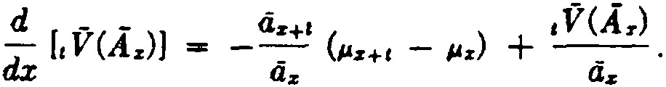
(b)

- Thc Fackler reserve accumulation formula
24. Find IV. , given P" = .025, u:c = 1.032, and k., .015.

  - Show tha.t k.a =
-
U.:i

l _
A.,,11 .

  - Wright's reserve accumulation formula is
1+1V = (cV + P - C.:+1)U z+1 .
How mnst Cz+t be defined i n this formula?

- Methods oí valuation
Zl. How should fJ"' be. defined so that the attained. age formula can be . applied to a single premium n-year term insurance?

EXERCISES 129

  - Show that the reserve at the end of t year.s for an annual premium n-ycar deferred immediate annuity issued at age x can be expressed as

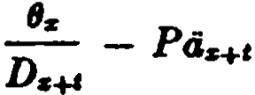 where t < n
and P is the net premium. What is 8" ?
  - Show that the n-th terminal reserve under any net level annual pre­ mium policy for an insurance of unity issued at a.ge x , premiums not having ceased, equals
(1 + B"D;.:_ ,.) - (P + d)4z+•
where P is the net annual premium and (J" is a function i:ndependent of duration.

- Eft'ects ol variation in interest and mortality
- Determine the eff ect on ordinary life reserves if ea.ch p " in the mor­ tality table is multiplied by (1 + k), where k is a positive constant.
- lf the critica! function in Lidstone's theorem has the·constant value
e, show that P = P' + cv'.
- A certain substandard class is subject to extra mortality which re­ sults in ordinary life annual net premiums p; which are related to standard
ordinary life net premiums P" by the formula
p = (1 + k)P" + c.
Show that the substandard class reserves will be greater than, less than, or equal to the standard ordinary life reserves according as e is less than, greater than, or equal to kd.
- Given the following data based upon two mortality tables T and T':
,.,...
• ,. ,,.
30 .981 .870
40 .988 .815
so .979 .757
Rank in order of magnitude the values of 10Vao , 10V•o , 10V o , and 10Vo .

- Payment of reserve in addition to lace amount
- Draft a letter of reply to a beneficiary under one oí your company's ordinary life policies who claims that the policy proceeds should include the amount of the reserve on the policy in addition to the fa.ce amount.
- An ordinary life policy of 1 is issued to (x) with the provision that the reserve will be paid in addition to the fa.ce amount in the event oí death during the first n years. Show that the net annual premium for this policy payable for the lifetime of (x) is given by

130 NET LEVEL PREMIUM RESERVES

Ás+" + (1 + i)s+.(M; - M;+")
;¡ + Ó.r+>i
[CH. 5

where M = L:!vt-'- 'q¡, .
- Derive a formula for calculat íng net annual premi ums for a special 20-yea.r endowment poliry which provides for the payment of t he terminal reserve on the ent ire poliey in addition to the fa.ce amount in the event of death withi n 20 years but which matures for the fa.ce amount only. Give a formula for oht aining a. reasona.bly close approximation to the true pre­ mium for this pol icy, indicati ng t he nat me of the error im·oh·e<l.
Miscellaneous prohlems
- Given .E! n log (1 - 1V.r) = -log 7/5, find úl'a1 correct to two decimal places. (Ans. .29)
- An applicant aged 25 purchases an ordinary life poli ey. Each year he invest s elsewhere the ditference between the net premium for his policy and the corresponding net premium for a twent y-year endowment policy. Ap­ proximately what interest rate must he earn on t his investment in order that it may accumulat e at the end of twent y years to t he differenc:e bet ween the face nmount and the reserve for his poliey? Given :
au = 23 ii,o; at 31 per cent = 14 .i
d45 = 16 ato; Rt 4 pn c•ent = lU
<iu ioJ = 15 d = .0338 for i .035
d = .0.385 for i .04
Explain briefly why the rate he must earn on his inve!!t ment differs from that used in the calcu)ation of the annual premium .
- An n-year term policy providing decrea. ing insurance calh; for level annua) premiums payable for k years (k < n ). The amou nt of i nsurarn·e i n the t-th polic.r year is B, , and
where :r is the age at issue.
  - Show that all terminal reserves will he posit i ve if t he fi rst year terminal reserve is positive.
  - Prove t hat t he largest value oí k permissible if termi nal reserves e.re never to be negative is the large.st val11e of k for whir·h
±

Ns+t > lVs - BDC B,CHl-1 •
¡ :I t-l

- An ordinary life policy oí unit amount is issued on a life aged x. The annual premium is payable Cor five years, at the end of which t ime t he in­ sured has the option of either continuing the policy or convert ing it , hy

EXERCISF.8 131

payment of an increased annual premium, to an endowment for the same face amount and maturing at age x + n.
  - lf the conversion option is elected, find an expression for the net. annual premium payable for the remaining term of the endowment.
  - Show that the reserve by the prospective method at the end of five years after such conversion, immediately before payment of the 6th increased premium, is equal to the reserve which would have been held had the policy not been converted, together with the difference in the net premiums paid, accumulated with interest and survivorship. Assume that the reserve is calculated on the same mortality and interest basis as the net premiums.
, .52
- Two mortality tables T and T' are such that q,, = q11 - - at a.ges
ª11+1
90 through 99, where the interest rate used for calculating ªv+i is 4%. At the same interest rate, ,V90 = ,V o for O < t < 10. The limiting age w for
a:
table T is 101. Find the value of 00 at 4% interest.

CHAl>TER 6
THE EXPENSE FACTOR

l. The evaluation of expenses
The determination of life insurance and annuity premiums on a commercial basis involves certain elements not yet considered. The rate of premium charged for a given contract must not merely cover the net value of the benefit; it must also be sufficient to pro­ vide for . the ·expenses which the insurer will incur in carrying out the contract. lt is important to understand the character of these expenses, since they have a significant effect upon the actuaria.! basis of the policy of insurance.
A considerable portion of the total expense on a policy is in­ curred when the policy is issued. This initial expense includes the cost of underwriting the risk, which may involve medieal fees, and the clerical expense of issuing the policy and listing the details of the transaction on the insurer's records. After the policy is estab­ lished on the insurer's books, there are continuing administrative expenses, and finally, when the policy is terminated by death or maturity, there is the cost of settlement. In addition to these types of expense, there are commission payments and premium taxes to be taken into account. Under the usual American system of agents' compensation, the rate of commission is higher in the first year than in the renewal years, and thus the initial expenses are further weighted on this account.
In calculating premiums which make allowance for expenses, insurers first make detailed cost studies in which each expense ítem is expressed as a percentage of the premium, or as a flat amount per $1000 of insurance, or as a flat amount per policy. The expenses which appear as a flat amount per policy can be translated into a flat amount per $1000 of insurance by the use of an assumption as to the average amount of insurance per policy. The expense data can thus be reduced to a form which is easily assimilated in the premium formula. Once the expense rates are available in this form, the premium formula is established from the principie that the present value of the premiums to be received must equal the present value of the benefits to be provided plus the present value of the expenses to be paid.

SEC. 2] MODIFIED RESERVE SYSTEMS 133

For example, suppose that the expenses on an ordinary life policy are assumed to be as follows: 75 % of the first premium, 20 % of the second premium, 10 % of the third through sixth premiums, and 5% of each premium thereafter, plus $10 at the beginning of the first year and $2 at the beginning of each subsequent year per
$1()00 of insurance, with $5 per $1000 as the cost of settlement. If G is the annual premium per $1000 of insurance with provision for expenses and the immediate payment of claims, we have
G·iJ,, =¡ 1005 (1 + ) A,+ .75G + .2G(<i,,¡¡ - <i.,1¡)
+ .lG(dz;i] - d:i::i]) + .05G(a:i: - tir:61 ) + 10 + 2a.r
G =¡ 1005 {1 + ) A. + 8 + 2<i,.
or
.95ds - .05ás:ej - .ld:i::i] - .55
The premium actually charged, including provision for expenses
and any provision for safety margins and other factors which the insurer may feel to be nécessary, is called the gross premium. The amount by which the gross premium exceeds the assumed net premium is called loading.
Gross premium formulas may become quite complex. It is often
found, however, that the result of a complicated gross premium formula can be approximated with sufficient accuracy by adding sorne simple loading to the net premium. For example, the net premium may be loaded by a percentage of itself, or by a constant, or by a percentage plus a constant. We shall often use a simple loading of this type when gross premiums are required in our sub­ sequent work.
Fractional gross premiums are usually established as a constant percentage of the corresponding annual premiums. Thus, a particu­ lar insurer"might calculate all semi-annual premiums as one-half of the annual premium increased by 2 %. The actual percentages used are determined from an analysis of the net fractional pre­ miums of the appropriate type-true, instalment, or apportion­ able-and by a study of the extra expense involved in making the more frequent premium collections.
- Modified reserve systems
When the net level premium reserve is used as the basis of an insurer's valuation, the loading available for expenses is a level

134 THE EXPENSE FACTOR {CH. 6

amount from year to year, although the actual expenses are higher in the first ycar than in subsequent years. There is a('cordingly a dPficiency in the first year which must be made up by drawing t.emporari)y on the insurer's surplus, with the amount drawn in this way being returned in later years as the loading becomcs more t.han enough to meet current expcns,•s. For a small or a newly­ fomwd company, with a relatively small working capital, this need to draw on surplus for the financing of new business could be a real hardship. Such a company might find itself in a position where it could not afford to accept any additional new busin for a tem­ porary period.
This situation can be alleviated by the use of a reserve system which gives recognition to the decreasing incidence of expense and provides a larger loading in the first policy year than in the renewal years. This of course implies that the reserve must be built from a first year net premium which is lthan the renewal net premiums. In any modified reserve system of this kind, the sequcnce of net leve!premiums P is replaced during a speci.fied number of years k by a reduced first year net premium a followed by a series of in­ creased renewal premiums (3. If the modification period of k years is le.ss than the premium-paying period, net level premiums and full net level premium reserves are used after k years. The initial value of the sequence of modified net premiums must be equal to the initial value of the net level premiums P during the k-yea r
period. If x is the age at is.sue, we have
a + fj ·az;i=i] = Pds:il .
From this equation, the renewal net premium fJ may be obtained when the value of a is known:

fj = Pds:i] - a .
:í=i}

(6.1)

If we substitute as:Rl = dis:i] - 1, the formula ma.y be trans­ formed to

fJ = P + fJ - a
Os:i] ,
(6.2)

which is useful since sorne modifications are defined in terms of

SEC. 3] THE FULL PRELIMINARY TERM PLAN 135

the excess of the rcnwal nct premium /3 ovcr thc first year net premium a.
The following formulas give the reserves for the general case of an n-payment m-year endowment insurance under a modified valuation method with a modification period of k years. For t k n, the prospective formula is
,a Mod
,Vz:.i]

= Az+e:..=-;¡ - 11P:i::-J ·iiz+e:-;;-=;i - (/3 - n Pz:iñ] )l1.xH:k-t l
and the retrospective formula is
,. VMod 1 + IJ .. k

t z:,ii] = a· E IJ ·Sz-tt:7=il - , x .
(6.:-b)

(6.3b )

' %
For t k, the reserves are net level premium reserves.
The reserves can also be computed sequcntially using the Fackler accumulation formula (5,31) with P replaced by the appropriate modified net premium.
In the sections that follow, we shall examine the details of severa] specific modification methods. In the notation, we shall continue to use certain special conventions which have been introduced above. The symbol P refers to the net level premium for an un­ specified plan and issue age. The symbols a and /3 refer to modified net premiums with the plan, issue age, and modification method ali unspecified. The symbols ,V and ,yMod refer to net level reserves

subscripts are used, as in Pz and ,v: ,
will identify the plan

and modified reserves for an unspecified plan and issue age. When
they
and a.ge in accordance with the standard rules. Although we shall sometimes use these symbols without subscripts even when they refer to a specific plan or age, the specification should always be clear from the context. Particular modification methods will al­
ways be indicated by a superscript, as in a', {3can, ,ycom.
- The full preliminary term plan
In order to avoid a negative reserve at the end of the first year, the first year modified net premium must be not less than the cost of insurance for that year. In other words, we should have for any modified reserve system a A : iJ . The reserve method for which

136 THE EXPENSE FACTOR (CH. 6

a = A:'il , and under which the largest amount of first year loading is therefore available, is known as Jull 1rreliminary term valuatiou. In this context, A::il is usually represented by thc symbol Cs :
Ca
A 1
Cs = s:'il = Dz •
The modification extends over the cutirc prcmium-paying period,
and, with a = Cs , the renewal net premium /3 may be detennined
from formula (6.1). We let a' and {J' denote the first year a.nd the renewal net premiums respectively on the full preliminary term basis, and then, considcring again an n-payment m-year endow­ ment insurance issued at age x,
ar = Ca (6.4a)

and from (6.1),
f3' = 11Ps:tii] ·Os:nf - Cs = Ms - Ms-ta + Dz+. - Cs
Bz:i=¡¡ Nz+l - Nz+11
_ Ms+i Mz+• + Ds-ta _ As+1:tii=i] _ p
- N N - - a-1 z-+1:iii=i'] •
z+l - z+• '2z+l:ñ=i}

(6.4b)

Thus the renewal net premium is the net level premium for a simi­ lar insurance issued at an age one year older, with premiums pay­ able for one year less, and maturing at the same age as the original insurance.
It is apparent that this method assumes that the entire first year gross premium is needed for expenses and death claim pay­ ments. Accordingly, the reserve at the end of the first year is zero. In the renewal years the premium required is the same as the net level premium for a policy issued at the end of the first year at an age one year higher. It follows that the reserves on the full pre­ liminary term basis, ,V',can be expressed in tenns of the net level premium reserves for an insurance issued at an age one year older, thus:
,.-1y

",Vz:'iii'l =
,- s+l:iii='i] , (6.5)

The full preliminary tenn reserves can also be calculated from formulas (6.3) with a taken as Cs and fj as ,._1Ps+i:iii=i] .

SEC. 4] MODIFIED PRELIMINARY TERM PLANS 137

- Modified preliminary term plans
In the full preliminary term method, the first year net premium at a given age is the same for all plans of insurance, and the extra first year expense allowance is large or small according as the in­ surance is on a high or low premium form. For example, the first year net premium es is a much smaller part of the 20-year endow­ ment gross premium than of the ordinary life gross premium at the same age, so that a relatively larger portion of the endowment premium is available as first year loading. If the full preliminary term method is regarded as providing equitable first year expense allowances on low premium forms such as ordinary life insurance, it must be concluded that it provides unnecessarily large allow­ ances for high premium forms such as 20-year endowment insur­ ance.
Because of this fact, most state laws which specify a mínimum valuation basis restrict the use of the full preliminary term method to certain low premium forms of insurance. For the higher premium forms a modified preliminar y term basis is prescribed. A number of different modi.fied preliminary term systems have been used. The various modifications diff er in the length of the modification period and in the amount of the extra first year expense allowance. In each case, the modified net premiums can be determined from (6.1) or (6.2). We shall consider two methods which are of current inter­ est; others will be described in the exercises.
  - ) The Commissioners reserve valuation method
Most states which specify a mínimum valuation basis prescribe the Commissioners reserve valuation method for policies currently being issued. This method provides a special modi.fication for poli­ cies for which the net renewal premium on the full preliminary term basis exceeds the full preliminary term renewal premium for 20-payment life insurance at the same age. Thus, this modifica­ tion, which we shall call the Commissioners modification, is used
for policies for which [j' > 19Pz+i , where x is the age at issue. For
all other policies, those for which {j' 19Pz+i , the method requires full preliminary term valuation.
The Commissioners modification extends over the full premium­ paying period of the policy and prescribes the following relation­ ship between a and /3:

138 THE EXPENSE FACTOR (CH. 6

(6.6)
This is equivalent to a requirement that the first year loading ex­ ceed the rcncwal Ioading by the same amount as the full preliminary term method allows for 20-payment life insurance.
Combining (6.6 ) with (6.2), we have

{3Com = p + 19P.rl - C,: '
az:"il

( 6.7a )

where P is the nct levcl prcmium, x is the age at issue, and n is the premium-paying period. From (6.6 ),
aCom = f)Com - (19P,:+l - C,:) . (6.7b)
Thc Commissioners reserves may now be obtained by using formulas similar to (6.3a ) or (6.3b), or by using the Fackler ac­ cumulation method.

(b) The Canadian reserve valuation method
The Canadian method prescribes a special modification for all policies with a net level premium greater than the ordinary Iife net level premium at the same age, and full preliminary term valuation for all other policies. The modification, which extends ovcr the entire premium-paying period, is based upon the excess of the net level prcmium P over the first year modified net premium a, and this exccss, P - a, is set equal to the corresponding diff erence, P1: - Cz , produced by the full preliminary term method applied to ordinary life insurance. We thus have
p - aCan = pz - C:r for P > Pz ,

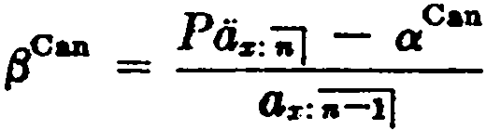
whence 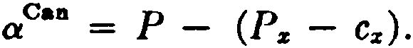 Then, from (6.1)
(6.8a)

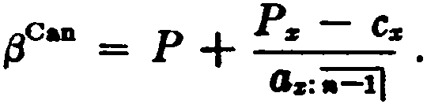
which reduces to
= P:i"J - P + ( P,, - Cz)
Oz:a=i)

(6.8b)

SEC. 5] CASH VALUES 139

- Cash values
An important feature of the modern lif e insurance policy is the provision for nonforfeiture in the event of default in premium pay­ ment. The usual nonforfeiture clause provides for a cash surrender value, together with a choice of other options involving insurance benefi in place of the cash value. The determination of the equi­ table amount of cash value to be paid to a discontinuing policy­ holder is a problem requiring careful analysis. The surrendering policyholder is entitled to a value based on the amount which he has contributed to the insurer's funds, after deductions have been made for the cost of insurance and expenses. In policies of term insurance, the resulting value is often so small that no nonforfeiture clause is required. With life and endowment plans, however, the nonforfeiturc clause is a standard provision.
For many years, it was the practice to compute cash values by applying a scale of deductions to the terminal reserves. Thesc de­ ductions varied by duration and by plan of insurance, and were designed so that the resulting cash values would have a proper relation to the actual funds accumulated by the insurer on the given policies. The method was somewhat artificial, and since the deductions were called surrender charges, they were of ten misunder­ stood by the policyholders.
Modern practice involves the computation of cash values by a more realistic approach, the adjusted premium method . The laws of most states now prescribe this method as t.he basis for deter­ mining mínimum cash values.
With this method, the expense on a policy is assumed to be of two kinds: (1) a level amount E incurred each year throughout the premium-paying period, and (2 ) an additional first year amount
E1• The total first year expense is thus E + E 1 •
The gross premium G is assumed to be made up of an adjusted premium pA plus a loading equal to the level annual expense E:
G = pA + E.
Letting A denote the net single premium at issue for the insurance bcnefit., and a the present value at issue of a temporary life annuity for thc prcmium-paying period, we have the gross premium equa­ tion
G·a = (PA + E)a = A + E·a + E1,

140

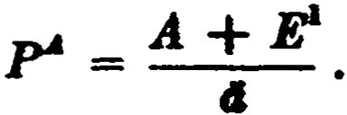
whence
(ca.·,

(6.9)

Thil formula can be rewritten 88 follows (replacing el by a +1):
(r - E1 + r - a = .A .
)
This shows that the first year net premium can be taken 88 J>' - J/
and the renewal net premium as r.The ca.sh vaJues are now de­
fined as the modified. preliminary tenn reserves with a = P"' - E'
and fJ = r.using the prospective fonn, and assuming for illustra­
tion an ordinary life policy issued. at age x, the cash value at the
end oí t years is given by
.CY s = AsH - J>!· da+s , t l. (6.10)
When appropriate aasumptions are made for interest and mor­

tality and for the extra initial expense E1
,
the adjusted premium

P'4 is fully defined by (6.9) and the values computed as shown in (6.10) provide a scalc of cash values which makes allowance for the extra initial expense.
The mínimum cash values which an insurer may offer are defined by la.w to be adjusted premium surrender va.lues computed on a prescribed. mortality and interest ha.sis with the extra initial expense E1 derived from the following formula (based on a IeveJ insurance amount of $1000) ;
- 40 % of the adjusted premium for the policy, but the amount not to exceed $16; plus
- 25 % of the adjusted premium for the policy or of the ad­ justed premium for an otherwise similar ordinary life policy, whichever is les.5, but the amount not to exceed $10; plus
(e) $20.
The formula allows the extra initial expense to vary with the plan of insurance-but only within a reasona.ble range, from about $25 per $1000 of insurance on the Iowest premium plan to a maximum of $46.
The simple formula for P-'- given by (6.9) ca.nnot usually be di­ rectly applied to find the adjusted premium, since E1 is defined partly in terms of certain percentages of P-'-. Furthennore, care must be taken that the maximum elements, defined in (a) and (b), a.re not exceedd. It will be noted that the maximum amount of

BEC. 5) CASH YALUES 141

$16 in (a) must be used whenever P.. is greater than $40, a.nd the
$10 maximum in (b) must be used if the ler of pA and the ordi­ nary life a.djusted premium at the same age exceeds $40. The for­ mula. for pA will thus va.ry according as
  - pA is greater or lesa than $40,
  - P.. is greater or lesa tha.n the ordinary life adjusted premium
P: at the same a.ge, and
  - P. is greater or lesa the.n $40.
These limitations on E1 can be reduced to the following formula, a.ssuming a. unit a.mount of insurance is.sued at age x:
Ñ = .4 [ J + 5 [EJ + .02 • (6.11)
where the smallest of the quantities in each bracket is to be used. P.. is the required adjusted premium, paya.ble for n years, and P: is the ordinary life a.djusted premium.
In using the formula., one first computes the ordinary life ad­ justed premium. We ha.ve
P: = A. + E1
dz

g = + + m = + m
and E1 = .016 + .010 + .020 = .046
These lead to the following formulas:
for P: .04 for P: > .04.

and
P: = A. + .02
dz - .65
P: = A. + .046
d.s

for 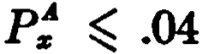 (6.12a)
for P: > .04. (6.12b)

Suppoee now that we wish to compute the adjusted premium
for a 10-payment 15-year endowment issued at age 35. Let us as­ sume, as will usually be the case, that the value of Pt, is Iess than
.04 and the value of 1J>t.:ii1 is greater than .04. We can compute
J>t, from (6.12a), and then
_ A11:ii) + E1
lOÁ 11:iil - A ;;¡J J
ul6:l01

142

where
THE SXPENSE l'ACN>B {CH. 6
E = .016 + .25 P + .020.

The mínimum cash values for the policy may be expresscd·prospec­
tively 88
!CVa:ii) = Aa+e:11-,f - .P:a:1"i)·cia+u.-,¡ , 1 t 10.
1
Although the statutes define minimum cash values in terms of the adjusted premium method, insurers are free to calculate their cash values on any basis that produces values which are not less than the prescnbed mínimum. Many policies provide the full reserve as a cash value after a certain number of years.
The cash value fonns the basis of another important policy pro­ vision-the loan clause. This provides that the insurer will grant, on the security of the policy, a loan not greater than the cash value. If,as a result of the operation of this clause, there is any indebted­ ness outstanding at the time of settlement of the policy, the amount of the debt is deducted from the policy proceeds.
- Paid-up insurance and ext.ended in81ll'allce
One of the options available in place of a cash value is reduced paid-up insurance. Under this option, the insurance is reduced to such an a.mount as the cash value will purehase on a net single premium ha.sis, the calculation being made on the mortality and interest assumptions specified in the policy. With ordinary life insurance, for example, the amount of paid-up insurance provided at the end of t years by the cash value of ,CV. will be

.ov.
As+, .
If there is a loan a.gainst the policy when the paid-up option is elected, the amount of the cash value is reduced by the amount of the indebtedness before being applied to purchase the paid-up insurance. The paid-up policy is then free of indebtedness.
The amount of paid-up insurance that can be provided on an ordinary life policy at duration t by the full net level premium re­ serve ,V.is denoted by ,W., and

.w. = .v. .
A-+•

(6.13)

SEC. 6) PAID-UP ANO EXTENDED INSURANCE 143

This can be expressed as
W _ As+e - Ps·as+,
' a - As+'
= 1 _ Ps
Pz+,·

(6.14)

Formula (6.14) can be obtained by general reasoning. After t years the net annual premium for an insurance of 1 effected at the at­
tained age is Pz+t . An annual premium of Ps payable at that age
p
is sufficient to provide insurance of only p z • Since Pz is the
z+t
amount of premium actually being paid for a policy providi.ng in­ surance of 1, the amount of paid-up insurance provided by the re­

serve must be the balance, or 1 -
Pz
- .
p
z+t

Formulas (6.13) and (6.14) take the following forms for endow­ ment insurance:
'Wz:'iil _ I Vz:";;J _ l _ Ps:';1 •

- As+e:i=il -
Pz+•=

For an n-payment life policy, we have

Ws = Vz = 1 - ,
Az+, tl-,Pz+t
A second insurance option, known as extended insurance, pro­ vides for the use of the cash value to purchase term insurance for the full amount of the policy for a limited period. If the face amount is 1, the extended insurance period n is determined from the re­ lation
A.!.,:;i = ,CV
where the value of n is customarily interpolated to days.
In the case of endowment policies, the cash value at the later durations may be more than sufficient to purchase term insurance for the full amount to the end of the endowment period. In that case, the excess of the cash value over the amount required to pay for the term insurance to the end of the endowment period is ap-

144 THE EXPENSE FACTOR [CH. 6

plied to purchase a pure endowment payable at ma.turity. The amount of the pure endowment is given by the expression
,CV - A;:¡:¡:n1
AH :
where n is the number of years remaining in the endowment period. If the policy is subject to indebtedness of amount L, the policy usually provides that the extended insurance will be for the amount of 1 - L. Otherwise the policyholder would be able to increase the insurer's risk by his own action in electing this option. The term
of the extended insurance. is then the value of n for which
(1 - L)A :a::,:-;i = ,CV - L.
This method provides a smaller amount of extended insurance for a longer period, and helps to protect the insurer against possible anti-selection in the use of the option.
- Summary oí notation
In this chapter, a few special conventions have been adopted which are not part of the standard notation. These are described at the end of Section 2.
Reíerences
l. Expense analysis and the other topics in this chapter are covered in greater detail in the course of study for the Fellowship examinations given by the Society of Actuaries. Students who wish to pursue these subjects in more detail at this time will find suit­ able references in the course of reading prescribed for these exami­ nations.
2, 3, 4. The chapter on Modified Reserve Systems in Menge and Fischer (1965) provides a good elementary introduction to this subject. A more detailed treatment may be seen in the papers by Menge (1936), (1946).
An early version of the text of the Standard Valuation Law, which defines the Commissioners reserve valuation method, is quoted by Menge {1946). The language of the statute does not define the method in the same terms that we use here, but it may be seen in Menge's paper that the two definitions are equivalent.

EXERCISES 145

This paper also discusses the application of the method to policies with varying benefits or premiums.
Commissioners reserves using continuous functions are discussed by Smith (1961 ).
5. An early version of the text of the Standard Nonforfeiture Law, which defines the adjusted premium method, may be seen in Reports and StatemenúJ on N onf orf eiture Benefits and Related M atters, National Association of Insurance Commissioners, 1942, pp. 266-270. The Standard Valuation Law is also included here, pp. 271-274.
A policy which provides for the payment of the cash value in addition to the face amount is discussed by Gold and Wilson (1963). A more general treatment of this type of policy is given by Smith (1964).
6. Hummel and Stedman (1958) give an interesting mathe­ matical analysis of the rate of increase in the paid-up insurance values as compared with the rate of increase in the cash values.
EXERCISES
l. The evaluation of expenses
l. Derive a formula in tenns of annuity valuea for the grosa annual premium at age x payable for n years for a whole life insurance of 1 if the expenses consist of a flat amount of h per year plus an additional amount of k in the first year plus j per cent of each premium paid.
- Gross premiums for single premium endowment insurances are to be calculated with the following expense assumptions:
Tax: 2% of the gross premium; Commission: 4% of the gross premium;
Other expenses (per $1000 of insurance) : $5 in first year and $2.50 in renewal years.
Derive a formula in commutation functiona for the gross single premium per $1000 of inaurance including provision for immediate payment of claims.
- Obtain a formula for the gross single premium at age x for an immediate life annuity of 1 per annum payable m times a year if the expenses are k per cent of the gross premium plus a flat amount of h per year.
- Derive a formula in commutation symbols for the net annual premium for a whole life insurance providing for the return of the gross premiums paid along with the sum insured of l. Assume that the gross annual premium
G is related to the net annual premium P as .follows: G = (P + e)(1 + k ).
- Modified reserve systems
  - For a preliminary tenn valuation method where the modification covers the entire premium-paying period, show that the modified reserve

146 THE EXPENSE FACTOR [CH. 6

,yMod differs from the net level premium reserve ,V on a policy with pre­ miums payable for n years by the amount

,V - ,VMoc1 = (JJ - P)da+t:.-=i\ ,... (tJ - a) da+c:;:J¡.
da;;J
  - Show that when k = n
,v!·?t == 1 - (/J + d)4.+c:;::;i.
  - The attained age method is to be used in valuing a group of policies on a modified reserve basis with first year net premium a and renewal premium fJ. The formula is
,.
+
,VMod """ Ás+t - fJ·4a+I D- .
•+•
Find the expression for e. in this formula.
8. In a modifi.ed reserve system with an n-yeat modification period, the reduced first-year net premium is equal to one-fourth of the net level annual
premm· m. Express -{J -¡;P- m. terms of Os:'i=i} , where fJ 1.8 the m. creased re-
newal net premium and P is the net level annual premium.
- The full preliminary term plan
- Give a mathematical demonstration of the following equivalence:
W!-.-1 =;:Y +1;;::i\-

- Show that

,Ys,:"iil

= 1 - d.+C:11-•I

for 1 < t < n.

- A twenty-five payment whole life policy issued at age 40 provides insurance of 5 during the first twenty-five years and 1 thereaf ter. Give ex­
pressions for a' and fJ' in terms of commutation functions.
- Modi.fied preliminary term plans
- The n-th year terminal reserve by the Commissioners reserve valua­ tion method for a premium-paying policy issued at age x, where fJ' > u Ps+i , may be written as
"ycom == om + T(N. - N:+fl)

Find the expression for T.

Ds+a
1 n < 20.

- Give formulas for the net premiums and the first, seventh, and fif teenth year terminal reserves for a 10-payment 20-year endowment policy issued

EXERCISES 147
at age 25 and valued according to the Commissioners reserve valuation method.
- The New Jersey modified preliminary tenn reserve rnethod provides for a first year net premium of c. , renewal premiurns of {J J frorn the second to the twentieth year inclusive, with net level premiuma payable thereaf ter. For an n-payment m-year endowment, show that

where P = ..Ps:;¡¡ , n > 20.
fJ' - P + P - c.
a.:iil

- The Illinois modifi.ed preliminary tenn reserve method defines a rnodification for policies issued at 11.ge x , with fJ' > 1.Ps+1 , such that fJ l - al = 1.Ps+1 - Cs , wbere the rnodifi.cation period is the lesser of 20 years and the prerniurn-payment period.
For an n-payment m-year endowment with fJ' > 1ePs+1 and n > 20, show
that
Rl _ P + uP•+l -c.
(ª)
t1 - 11 s:,iij A 1
....:io]

C Ya:iiij > C z:ii) for t < n.
(b) 11 ¡ •yCom
- Cash values
- Derive an expression, corresponding to formula (6.9), for the adjusted premium P A on a policy issued at age x when it is known that P! < P A < .04.
- Compute 1oPf1:iiJ given the following values on the 1958 CSO 3% ha.sis: 1oPu:iil = .07490, Au = .35866, áa = 22.01926, áu:11>1 = 8.67455.
(Ans. .07957)
- Assuming that the value of the adjusted prernium is known, write formulas for computing adjusted premium surrender values for the fif th and the twelf th years for a 10-payment 15-year endowment issued at age 35.

- Paid-up insurance and extended insurance
- For a 30-year endowment policy with fa.ce arnount 1issued to (x), the amount of reduced paid-up insurance at the end of 10 years is .55. For a
20-year endowrnent policy with face arnount 1issued to (z + 10), the amount
of reduced paid-up insurance at the end of 5 years is .30. For the 30-year endowment policy issued to (x), fi.nd the amount of reduced paid-up i n­ surance at the end of 15 years. Assume that ca.sh values are equal to net level reserves. (Ans. .685)
- At the end of the sixteenth policy year, as a result of the non-payment of the premiurn then due, a $2,000 endowment at age 65 policy issued at age 43 is changed to an extended insurance basis. Loan indebtedness of $100 is out-Btanding. The cash surrender value is equal to the reserve according to the Commissioners reserve valuation rnethod. Derive an expression for the

148 THE EXPENSE FACTOR [CH. 6

cash surrender value and, asswning that the net value is used to purchase extended term insurance at net ratee for the fa.ce amount of the policy less the loan indebtedness, show how to calcula.te the a.mount of pure endowment paya.ble to the insured at a.ge 65.
- A 20-yea.r endowment policy of 1, issued a.t a.ge 25, is lapsed at the end of 15 years when there is indebtedness of L outstanding against the cash surrender value of C. Express in terms of commuta.tion symbols:
  - The amount of reduced paid-up insurance¡ and the amount of pure endowment at the regular maturity date if extended insurance for the fa.ce amount of the policy less indebtedness continues to the regular maturity date.
  - The retrospective and prospective expressions for the reserve on the extended insurance and pure endowment three years af ter the date of lapse. Show that the two expressions are equivalent.

Miscellaneous problems
- Find an expression in commutation functions for the gross annual premium for a whole life policy for $1000 issued to (x) and subject to the
condition that, in the event of a cla.im before a.ge z + n, the only death bene­
fit will be the return of gross premiums paid without.interest. Allow for a loa.ding of 20% of the net premium plus $3.
- Write expressions for the difference between the Commissioners re­ serve and the net level premium reserve at the end of t years for
- 30-year endowment insurance issued a.t a.ge z, where fJ' > 1.Pz+i ¡
- whole life insurance with premiums to a.ge 65 issued at a.ge x > 45.
- Give the retrospective formula for the net level premium reserve at attained a.ge y for a 20-payment life policy issued at age x, for '11 < x + 20.
Derive and give a. verbal interpretation of the difference between this re­ serve and the reserve at the same attained age for paid-up term insurance for the fa.ce amount of the policy, purchased by the net level premium re­
serve on the 20-pa.yment life policy a.t a.ge x + t , for t < y - x.
- A 20-pa.yment life policy issued 10 yea.rs ago at a.ge x is to be changed to a fully-paid life policy for the same amount. Ea.ch of the following expres­ sions has been suggested a.s the net cost to the insured for this change:
(1} toPz·<lz+l O :iil ,
(2) (1 - ws)A.,+10 ,
(3) A.1:+10 - :v.. .
Explain the rea.soning by which ea.ch expression has been obta.íned. Demon­ strate the ma.thema.tical equivalence of the. three expressions.
- A 20-payment life policy issued at a.ge 30 ha.e outsta.nding against it at the end of the fif teenth year a. loan equal to the f ull net level premium terminal reserve. lf the rate a.t which the loan draws interest and the in­ terest rate at which the insured rnay expect to inveat are each equal to the valuation interest rate of 4 per cent, and if all lirnited payment liíe premiums

EXERCISES 149

are loaded 10 per cent of the net, plus C dollars for each dollar of insurance, what is the maximum value of C in order that it be to the insured's ad­ vantage to continue hia present policy instead of taking out a 5-payment life policy for the present net amount at risk?
Given that do = 16.09 and du:il = 4.53. (Ans. .01366) Tl. A policy is issued at age 20 with a maturity value of $1,500 at age 50. Obtain an expression involving commutation symbols for the net annual premium where the death benefit prior to a.ge 50 is return of gross premiums paid, with interest at the rate used in the premium calculation. Assume a
loading of 10% of the gross premium.

CHAPTER 7 SPECIAL TOPICS
l. lntroduction
The practice of combining more than one insurance or annuity benefit in a single policy has resulted in many unusual problems of premium determination. The solution of these problems always depends upon the application of principies established in the earlier chapters, but special methods are often required in order to ob­ tain results which are suitable for computation. We shall discuss a few specific cases which will illustrate sorne important tcchniques not yet described.
- Cash refund annuities
A cash refund annuity is a combination of the usual life annuity benefit with a death benefit equal at any time to the exress of thc total premium paid over thc sum of the annuity payments re­ ceived. There is no death benefit whcn the surn of thc annuity payments exceeds the amount of prcmium paid.
Let G denote here the gross single premium for an irnmediate cash refund annuity of 1 per annum issued at age x, with a loading of r per unit of the gross premium. Then the net single premium, (1 - r )G, is equal to the combined present value of the annuity and the death benefit. The annuity portion alone has thc value az . The decreasing death benefit is G during thc fin;t year and
reduces by 1 each year. Kow if n is t he grcatest integer in G, thc death benefit will extend over n + 1 years and its prescnt value,
as.5uming payment at the end of the year of death, may be ex­ pressed as
G( }.f z - Mz+,.+1 ) - ( Rz+l - Rz+n+l - nMz+n+i )
D.r
Hence,
(1 - r )G
1

SEC. 2) CASH REFUND ANNUITIES 151

and solving for G,
G = Nz+1 - ( Rz+1 - Rz+n+i - nMttn+i ) . (¡.1)
{1 - r) Dz - (Mz - Mz+n+l)
Since n in this formula depends upon the magnitude of G, trial values of n must be tested until a consistent value of G is obtained. Let us now consider the general case in which the annuity pay­ ments are made m times a year. The death benefit now decreases by 1/m at the end of each m-th part of a year. If n is the greatest integer in G, the death benefit will extend over n complete years,
those between ages x and x + n, and over a portion of the
(n + 1)-th year which starts at age x + n.
An expression for the value of the death benefit during the year starting at age x + t, O t < n, can readily be derived by as­
suming a uniform distribution of deaths during the year of age. During thc age interval x + t to x + t + I / m, the death benefit
is G - t, and, with a uniform distribution of deaths, the present
value at agc x of the insurance for this period is (G - )Cz+t .
m z
During the age interval x + t + 1/m to x + t + 2/m,
the death benefit is G - t - 1/m, and has a present value at age x

(G - t - 1/m)C ,
o_f:
mD,, •+ .
Proceeding throughout the year of age in

this way and summing the results, we obtain
Ctt, 1 (a - t - i) = C""' [ mG - mt - m( m - l )J
2m
mDz i-o m mDz
= CsH (a _ t _ m - 1)
Dz 2m
the present value at age x of the insurance benefit during the Jear of age x + t. Now summing for ali ages from x through z + n - 1, we have
t. . (a - 1)
l ctt, t - m - =
e-o D,, 2m
' '

!(G -m
2
1
) (M,-M<tt ) -[R.a-1- R<tt - (n - l)M.a-.]}.

To this must be added the value of the death benefit for a frac-

152 SPECIAL TOPICS [CH. 7

tion of the year of agc x + n to x + n + l. The death bcncfit at the bcginning of this yeu.r is G - n, and if we let k denote the

greatest m· teger m·
the rati·o G-n, wc can express t.he va Iuc of t h1.s
1
m

partial year's insurance as
Cz+n ± (G _ n _ '±-) = Cz+n [ ( k + l)(G _ n) _ k ( k + 1)]
,-o
mDz m mDz 2m
= (k + 1)C s+n (a _ n _ }_) .
mDz 2m
To the above two expressions must be added thc prescnt value of the annuity payments, a;"'>, and the total can then be equatcd to the net single premium (1 - r )G:

(1 - r )G =, }{N.,-1 +m:z: 1
D,
+ (G -m
2

1
)(M.- M,+J

- [Rz+i - Rz+" - (n - 1)M z+,a) + ( k +ml )Cz+,.(G -n - 2km)}.

Solving for G, we have

whcre

. A
B ' ( 7.2)
G

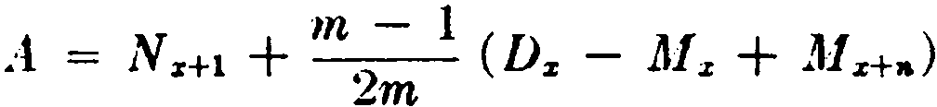

an<l
- [Rz+i - Rz+,¿ - ( n - 1) M z+nl - k-;+,i-l (n +
km) C:i:+n 2

In this formula, both n an<l k <lcpe11d u pon the magnitude of G, and trial values of n all(l k mut be uhstituted until a c·011siste11t value of G is obtni11rd.
In practire, formula (7.2) is simplified by arbitrarily in trodu<'ing

SEC. 2] CASH REFUND ANNUITIES 153

one of severa! possible substitutions which will eliminate k. For example, the substitution k = m - 1 leads to the approximate formula
G (7.3)
Nz+l - (Rz+l -Rz+n+l -nM z+n+l ) + 2m ( Dz - M z +Mz+n+l )
m - 1
(1 - r) Dz - ( M z - M z+n+l )
The value of G given by formula (7.3) never exceeds the value given by (7.2), since when the true value of k is less than m - 1 the effect of the approximation employed is to include in the pre­ mium the value of a negative death benefit in the latter part of the year under consideration. This introduces a credit element into G which would not be present in the true value. The magnitude of the error is negligible for practica! purposes.
It can be shown that the average degree of error introduced by substituting k = O is the same as the average degree of error in the approximation represented by (7.3), and is again in the direction of understating the premium. However, the resulting formula is more complex than (7.3).
Formulas for single premium def erred cash refund annuities may be similarly developed. Let us assume that the annuity is issued at age x and provides an annual income of 1 payable m times a year
commencing at age x + t. The benefit will then be a t-year deferred
cash refund annuity-due. During the deferred period, the death
benefit is equal to the gross single premium, and this death benefit is reduced by the payments made at age x + t and thereafter. The
student should undertake to verify the following expressions for the present values at age x of the various elements in this benefit. The method and assumptions are similar to those used in the der­ ivation of formula (7.2).
Present value at age x
Net premium (1 - r )G

Annuity benefit 1 ( m - 1 )
Dz N"+' - D:e+t

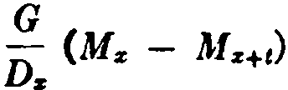
Death benefit between ages
x and x + t

l M SPECIAL TOPICS [CH. i

Death benefit between ages
x + l and x + t + n .[G(M•+• - M,+1+.J
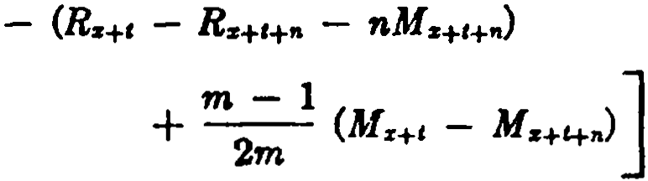

Death bencfit betwecn ages
x + t + n and
x + t + n +-k
m
where n is the greatest integer in G
kC&+'+" ( e _ n _ k + 1)
mDz 2m

where k is the greatest integer in m(G - n).

Equating the net single prcmium to the sum of the prcsent valurs of the benefit e]ements, and so]ving for G, we find
. E
G
F ' (7.4)

where
E = Nz+I - ( Rz+, - Rz+c+.& - nMz+c+")
- m :; l (D.+, - M ,+1 + Mtt,..,.) - (n + k
2 2

1 C,m,

and
)
The formula may be exprcssed more l'oncisely if we modify thc standard notat.ion here and write
N<•> = N .. - m---I D..
" • 2m •
and R<•> = R - m - I M
2m
" v 11 ·

Then the numerator E in (7.4) can be written:
11., = z+c - *' - z+ t+" - n z+H" - m n + z+H" •
7:, N<•> en<"'> R<•> M ) k ( k + I)c
In this case, a more convenient practica! formula may be ob-

SEC. 3) A1"N UITIES WITH A TERM-CERTAIN 155
tained by substituting k = O:
n<•> M )

N ( m)
G
z+ t
( R(R}
- z+t
- z.+ t+n - n z+Hn
( 7_ 5)

(1 - r) Dz - ( M z - M z+t+n)
As in the case of formula (7.3) for the immediate annuity, the ap­ proximation understates the premiwn slightly (unless the true value of k is O), although the understatement is here due to the elimination of positive benefits in the final year rather than the introduction of negative benefits. The approximation resulting from k = m - 1 gives results which are, on the average, equally accurate, but produces a less convenient formula.
Another practiral formula independent of k, similar to (7.5), may be derived by assuming a uniformly diminishing death benefit
over the entire year of age x + t + n to x + t + n + 1, in place
of the true benefit which diminishes uniformly over the fractional
age period x + t + n to x + t + n + - The student may show
m
that with this assumption the present value at age x of the final year's death benefit is
Cz+Hn (m - 1) ( G _ n),
Dz 2m
leading to the following approximation, which yields a result never less than the true value:

G == N{m) - e n<•)
n<m)
-
- nM(III) )

( _ )

z+t
z+t
z+t+n
z+t+n 7 6

· (1 - r) Dz - ( M z - M ++ n) '
where N(ml and n< m> are defined as above and

M <•> - M - m - 1 C
1' - f/ 2m 11 ·

Although the formulas appear complicated, the work can be arranged in a systematic way so that the computation, including the testing of trial values of n, is not unduly burdensome. With a digital computer, it is possible to produce complete tables of pre­ m.iwns by,age very quickly.
- Annuities with a term•certain
Another type of refund annuity provides for the continuation of payments after the death of the annuitant in the event that

156 SPECIAL TOPICS [CH. 7

the annuitant has failed to receive a given minimum number of payments. This mínimum may be either a specified number of years, such as 5, 10, or 20, or the number of years required for the total payments to equal the amount of premium.
In the first case, in which the mínimum number of annuity
payments is independent of the gross premium, the benefit may be expressed as a combination of an annuity-certain and a deferred lifc annuity. Thus, the gross single premium, loaded r per unit, for an immediate life ammity of 1payable m times a year issued to (x) with payments guaranteed for n years may be obtained from the formula,
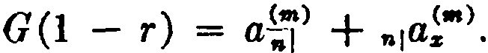 (7.7 )
In thc second ca.se, in which the annuity payments are continued until a sum equal to the gross premium G is retumed, the length of the certain period n depends upon the mugnitude of G. If the gross premium G is an exact multiple of the nnnuity payment, we
can let n = G in (7.7 ) and write

G (l
- r )
= ªo(Jm) + (a)·
(7.8)

Since the gross premium G is nom1ally not an exact multiple of the annuity payment, the annuity functions in (7.8) will in general not be defined. As a result, formula (7.8) cannot be directly ap­ plie<l, and it is customary to find G by means of an interpolation device. If we write
01ª
ar
f (G) = + o¡ a;"'> - G (l - r ), (7.9)
then the value of G is required for which J(G) = ·o. The procedure is to determine by trial an integer n for which f (n) > O and f (n + 1) < O. Then by a. linear interpolation,
. J(n)
G n +f (n) - f (n + 1) · (7.10)
This type of annuity is called a refund or instalment refund annuity.
As an examplc, consider an instalment refund annuity providing a monthly íncome of $10 issued to a life aged 65 with a loading of 6 % of the gross prernium. Using formula (7.9), we write
•

f (n) = ª"(1U) + (12)
"lªH
- 94 n.

SEC. 4] COMPLETE ANNUfflES 157
Suppose that after a few trials we find /(15) = .4739 a.nd /(16) =
-.1094. Then from (7.10),
4739
G · 15 + · 15.8 24
=: .4739 - (- .1094) = l .
For $10 per month, we ha.ve $120 X 15.8124 = $1,897.49.
- Complete annuities
An annuity which provides for a final pa.yment at death propor­ tional to the time el¡apsed since the last payment is called a com­ p 'lete, or apportümpble, annuity. The usual annuity, which doeR not provide a final fractional payment of this type, is sometimes called a curt.ate annuity, a.nd the value of the complete a.nnuity difiera from the value of the corresponding curtate annuity by the value of the proportionate payment at death.
The complete annuity paya.ble m times a yea.r, denoted by a!•>,
is equivalent to a. curta.te annuity, a•> , plus a continuously in­ creasing insurance paya.ble a.t the moment of death, (1A ). , re-
duced at the end of ea.ch interval by !_. The reduction is equivalent
m
to an increasing insurance which provides insurance of O, !_,
m
' ···, and its value is accordingly given by (J<"'>A ). - !_ A• .
m
m
We then ha.ve

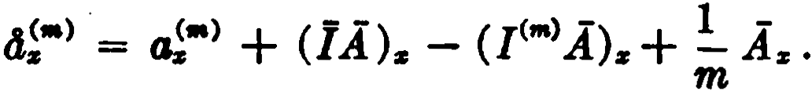
(7.11)

lf we now substitute in this fonnula for (]A ). from fonnula (3.30) and for (I'"'>A ). from fonnula (3.28), we obtain

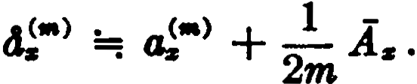 (7.12)
As the fonnula shows, the value of the apportionable feature is
roughly equal to 2 A. , an insurance of half the periodical pay­ ment, death occurring on the average halfway between two pay­ ment dates.
Another approximation,

158 SPECIAL TOPICS [CH. 7

..t <•> == (1 -_!_) -
- 2m az '
is derived from (7.12) by means of the two substitutions
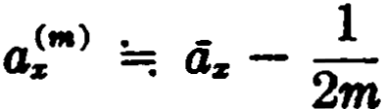
and

(7.13)

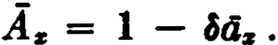

- The retirement income policy
Many insurers off er policies which provide a combination of insurance coverage up to a fixed retirement age and an annuity income after retirement. Premiums are normally payable until the retirement age is reached. The retirement income is often at the rate of $10 per month for each $1000 of face amount and is eus­ tomarily paya.ble for a fixed number of years certain and the re­ mainder of life.
Under normal circumstances the present value at the retiremcnt age of the annuity income of $10 per month exceeds the face amount of $1000. This means that the policy must mature at the retirement age for an amount greater than the face amount, and that the policy reserves and cash values, in building up to the required ma­ turity value, will also exceed the face amount for a period prior to retirement. Since it is impractical to have the face amount of in­ surance less than the cash value, these policies provide that the death benefit will be equal to the cash value during the pcriod when the cash value exceeds the face amount.
Let 1 + k denote the present value at the retirement age, x + n,
of the annuity to be provided at that age for each unit of face amount issued at age x. Then the policy ean be regarded as a
combination of a pure endowment of 1 + k due at the retiremen1
agc and a term insurance up to that age providing a death bencfit equal to 1or the total cash value on the policy whiehever is greatcr. The net premium, P, for the policy can thereforP be writtcn

M z - M z+a + L ( ,CV·Cz+e-1 ) + (1 + k )Dz+n
n
p = l=a+l
N z - Nr+n

( 7.14 )

SEC. 5] THE RETIREMENT INCOME POLICY 159

where ,CV is the cash value at the end of t years and a+1CV is the first cash value that exceeds the face amount of 1.
Since the cash values and the premium P are usually inter­ related, formula (7.14) cannot generally be solved for P directly. Suppose, however, that the cash value.s at durations a and greater are equal to the net level premium reserves. With this assump­ tion we are able to derive an explicit formula for P.
We may assume that the terminal reserves ,V increase from
oV = O to "V = 1 + k. Hence, there is exactly one integer a such that ª V 1 and a;.1V > 1. During the first a years, the death
benefit is the face amount, and we have ··
l
(,V + P)(l + i) = qz+t + Pz+t .t+l v.
After a years, the death benefit is the reserve, and
( ,V + P) (1 + i) = qz+e· t+l V + Pz+I' 1+1V,
or
( ,V + P ) (1 + i) = Hl v. (7.15)
This relation shows that the reserve accumulation is independent of mortality after a years, there being no amount at risk and hence no insurance element. The prospective formula for ª V will thus be

aV = (1 + k )v"-a - P·dñ=a] .
The retrospective formula is
aV = P · B:i:aJ - akz ,
(7.16 )

(7.17)

Equating the twoxpressions for ª V and solving for P, we find
p = .kz + (1 + k) v"-
Bz:oj + a;:=;i

= M z - M z+a + (1 + k)v"- Dz+a
Ns - N *' + tiñ=aJ D*'
(7.18)

The value of a used in this formula depends upon the magnitude of P, and may be determined by a trial-and-error process. It is possible, however, to develop a simple criterion which permits the independent detennination of a.
We shall use the relations

160 SPECIAL TOPICS (CH. 7

P Ps:ol and P > P. ; ;'.+il
which follow from ª V 1 and •+lV . > l.
We first transfonn (7.16) as follows:
•V · (1 + i ) "-ª + P ·s;::.¡ = 1 + k.
In this expression, if we replace (1 + i)"-a by 1 + d s"-•I and use
the inequalities .V l and P Pz:;J , we obtain
1 + (Pz:ol + d)s..-.¡ 1 + k ,

which reduces to
8ii=ol k.
llz:ii¡

(7.19)

Now if we replace a by a + 1 in fommla (7.16 ) and procecd simi­ larly, we obtain

-Sn-a-11 < k .
liz:a+il

(7.20)

Since s;=¡¡ is a decreasing function of t , we can conclude from (7.19)
dz:i]
and (7.20) that a is the greatest integer for which

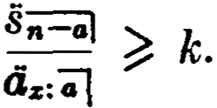 (7.21)
- Family income benefits
Famil y income benefit is the name given to a form of decreasing term insurance which provides that in the cvent of death within n years a monthly income will be payable to the beneficiary for the balance of t.he n-year period. The income commcnces on the date of death and is payable at monthly intervals thereafter until the last regular payment date falling within the original period of n years. This n-year period is called the family incomc period.
The symbol nFz will be used to denote the net single premium for an n-year family income benefit issued at age x an<l providing an annual income of 1 paya.ble monthly commencing at the date of death and continuing for the balance of the n-year period. l f it is
n.sumr<l t.hat the income is payable at monthly int.crvals mcasure<l from the date of issue, rather than from thc date of <leat.h, w i t h thC' first payment falling due on the first <lay of thc policy rnonth fol-

SEC. 6] FAMILY INCOME BENEFITS 161

lowing the date of death, an exact expression for the present value of the bcncfit. would be
(12) (12)
(7.22)
ªñl - ª2.:"'iil .
The differcnce betweeu thc present values of thc annuity-certain and the temporary life annuity clcarly gives the value of the series of incomc payments for the balance of the n years after the death of (x ).
We may now consider how expression (7.22) should be adjusted if payments are to commence upon the date of death instead of at the beginning of a policy month. It is clear that the same number of payments will be made in either case. The series of payments commencing at the date of death, however, will be made on the average one-half a month earlier. We thus obtain the following approximate formula for nF:i :
l
nF2. =: (1 + i)24 (a-M2 > - a! ). (7.23)
It is sometimes necessary to determine family income premiums on the assumption of one interest rate during the insurance period and another rate during the period when the annuity is payable. Formula (7.23) obviously cannot be adapted to this situation, and a new formula must be constructed in which the annuity portion is evaluated separately from the insurance portion.
In the following development, the rate of interest before death is denoted by i and the rate after death by i', with all unprimed symbols referring to rate i and ali primed symbols to rate i'.
Since the death benefit varíes for each month of age, we will ex­ press the net singl premium for the total contract as the sum of the present values of the insurance for each month. If death occurs in the
8 s + 1 .
+ +

month of age from x + t +
to x t I2' t and s bemg
12

integers, the death benefit, evaluated at the date of death, has the present value a':!--!..I ' and the present value at age x of this
12
month's insurance may be expressed as
l
t 1" ft+r • • ..1(12)
1z+e+...!. = v t P2. v -+rPz+tl' e+-+r ª--.1 dr.
12 0 12 12 n-t-12
The value of the insurance for the year of age x + t to x + t + I

162 SPECIAL TOPICS {CH. 7

is thcn obtaincd by summing I s+i+-..!. from s = O to s = 11, and
12
finally the value of thc insurancc for thc pcriod from age x to
x + n is obtaincd by a second summation from t = O to n - 1:
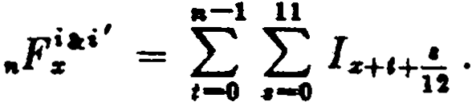
This exact formula is not in suitable form for caleulation, but it can be reduced to a usable fonn by introducing thc assumption of a unifom1distribution of deaths in each year of age.
We will first simplify the definite integral for I s+c+..!. on this as-
12
sumption. From (1.24b) we can write
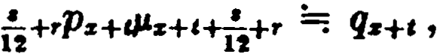
so that
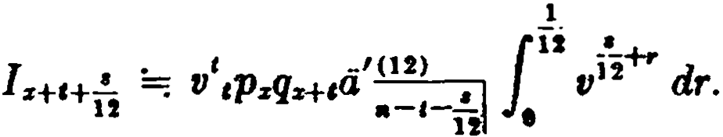
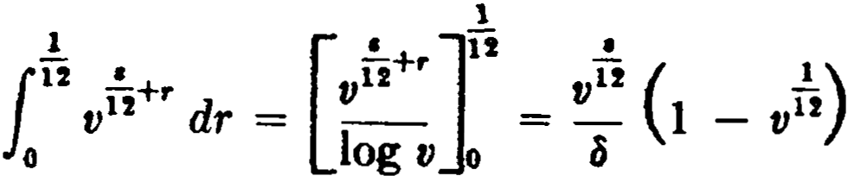
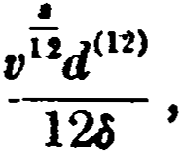
Xow

Making this substitution, and with
where d02
1
= 12(1 - v12).
>

wc have
..t(U) } - ,,,-,_'ii
a rf-.i21 = d'(l2)

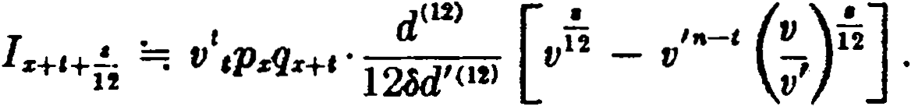

At this point, the introduction of a new rate of interest i" such
that v" = ,will simplify the subsequent derivation. With lhis
V
V
substitution, we perfom1 the summation of I s+i+u from s = O to 11, and noting that

SEC. 6) FAMILY INCOME BENEFITS 163

11 •
¿
v"
( )
= 12aW> = 12 1 - v
12 iv

,-o dC12)
dC12l '

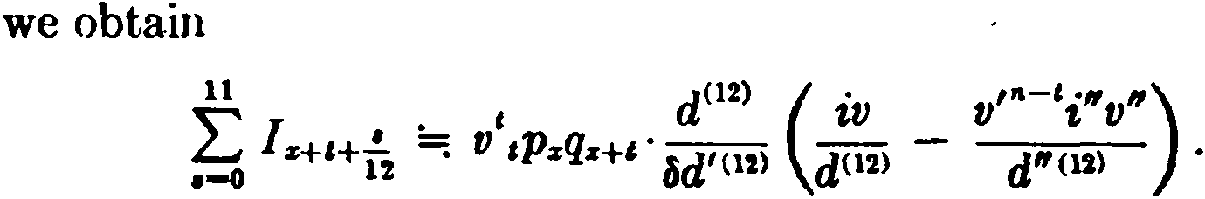
Finally, summing from t = O to n - 1, we have
• rn ""d(l2)
F'"i' . i A' V i A"l
(7.24)
,. s =: &J'(12) s:-;J - &J'Ol)d"(l2) s:'i] •
. .,
+
i - i
The special rate of interest i" is equal to 1 i' .
The use of the special rate of interest i" is not merely an alge­ braic device for simplifying a complex expression. It also provides a convenient practical method for performing an otherwise tedious
calculation. The values of A "!:-;i are easily obtained from the special commutation functions D: = (1 + i'tDs and C! = (1 + i'r-+lcz •
When i' = i, the above derivation leads to the formula
. i l vn . l -1 vn
"Fs =: d(l2) As:ñl - ,aqs =: d02) As:-;J - f nqs . (7.25)
The approximations produced by this formula are very close to those given by (7.23), which is derived from a similar assumption. Family income benefits are commonly issued in combination with permanent plans of insurance. When this is done, the perma­ nent plan is usually modified so that the face amount is not pay­ a.ble until the end of the n-yar fa.mily income period in the event of death during those n years. When the face amount is retained by the insurer in this wa.y, it ma.y be assumed that a portion of the family income benefit is provided by the interest eamed on the face a.mount. If, for example, the permanent plan has a face amount of $1000 and the family income benefit is $10 per month, the face
d'I2)
amount will provide a monthly interest income of 1000 12 pay-
d<H>
able in advance, leaving a balance of 10 - 1000 12 to be provided
by the family income premium. The net single premium for the combination benefit thus consists of the premium for the perma-

164 SPZCIAL 'l'OPICS [CH. 7

nent plan plus thc family income premium of
(120 - 1000d(l2) )raFz . (7.26 )
It should be noted that an additional approximation has been introduced in the reasoning by which (7.26) has been derived. If death occurs during the fami1y income period, the face amount becomes payablc at the end of n years from the date of issue. The monthly payment dates, however, do not usually correspond with the beginning of policy months, and the final income payment normally becomes due lcss than a month before the face amount is payable. Consequently, it should not be assumed that the face
10ooct<12>
amount provides a full interest payment of 12 for this final
fractional period. The error is obviously very small, and is of ten ignored in pract.ice. The derivation of a formula which is free from this error will be suggested as an exercise for thc studcnt.1
Annual premiums for family income bencfits may be derived in accordance with the usual principies by dividing the net single premium by the appropriate life annuity factor. Thesc policies are sometimes issued with premiums on a limited-payment basis in order to eliminate the negative reserves which may occur when a decreasing benefit of this kind is subject to level annual premiums.
- Notation
One new notational principle has been introduced in this chapter:
J. A small circle placed over the principal symbol shows that thc function is complete. This is illustrated by the complete annuity llz .
It should be understood that symbols like the following are not standard notation: N!"'l, raFz , n; . They will not be used outside of
the spccial context for which they were defined in this chapter.

References
2. Employee pension plans are often provided on a group an­ nuity basis, and these plans usually nclude sorne variation of the cash rcfund benefit. A specific example may be seen in Exercise 2.
- Rasor and Greville (1952) have explored the consequences of making a somcwhat diff erent assumption as to the amount of
1 See Exerciae 17.

EXERCISES 165

the fractional payment in the final year under a complete annuity. Their altemative assumption follows naturally from certain com­ pound interest considerations, and their results are in many ways more consistent than those which follow from the classical defi­ nition. This paper will be of interest to students who wish to see additional relationships between the theories of compound interest and life contingencies.
- The original paper on the retirement income policy was that of Fassel (1930). Our treatment here is in a form suggested to the author by Harry Gershenson, F.S.A. An approach using continu­ ous functions is given by Smith (1961).
Adjusted premiums and mínimum cash values for this policy are discussed by Hahn (1946). Rosser's discussion of the paper by Walker and Lewis (1949) gives references to formulas for most of the major reserve modification methods. Nesbitt and Van Eenam (1952) have investigated a related type of policy which provides insurance for face amount or paid-up insurance amount if greater.
6. The treatment of family income benefits is adaptcd from the paper by Cody (1948).

EXERCISES

- Cash refund annuities
l. Obtain an expression in a form involvi ng an integral for a continu­ oua annuity to a person aged y whích provides 1 per annum payable for life, and the refund in cash immediately upon the death of (y) of the excess of an amount k over the total annuity payments previously made. From this expression derive a formula which will enable you to evaluate it assuming you are given k , i, and a table 5>f values of D:r: , N:r: , Mx , and R:, . State any approximations used.
  - An employee pension plan is established under which the employee contributes $3 toward the single premium for each $1 of annual income pro­ vided . at retirement. In the event of death prior to retirement, the em ­ ployee's contribu tion is returned together with compound i nterest to the end of the year of death. Af ter retirement, the death benefit at any time is equal to the excess of the death benefit at retiremen t over the sum of the annuity payments made.
For an annuity issued at age x to provide an annual income of 1 commenc­ ing at age x + t , show that the gross single premium loaded 8% of itself
is given by
Nz+I - (Rz+I - Rz+1+11 - nM20+1+,.) + 3D,, - 3(1 + i) 1(D:1:+t - Ms+I + M:r:+t+,.)
.92D:r:

166 SPECIAL TOPICS (CH. 7
where n is the greatest integer in 3(1 + i) 1• Jt is assmned that t.he interest in the de2lth benefit is nt the s11.me rate us that used in the premium r.alculn­ tiun.
- The gro&, :rnnual prem ium payahle for t years is requi red for an auuu­
it.y of 1payahle m t imes o. ye,u wit h tirst paymen t a t the end of t years with a r<'t11rn at dea t h of t he excess oí premimm; paid over t he annuit.y payments 11111.tlc. Tho loac.ling ii,; r per u nit. of t hc gross prem i um. Obtain the premi111n fun1111la, l'orrospo11di11g to f urn rnla (7.5) for t he siugle prcmium case.

  - Annuities with a terrn-certain
  - Giveu the table of values below, compute the approximate gross single premium for an instalment refund annuity providing a monthly income of
$10 to a life aged 65. The loading is 5% of the gross premium.
(11) (1
• •
ii] •,ªu
13 11.13 2 . 28
14 11.83 1.89
15 12.52 1.55
(Ans. $1,764)

  - Show that the present value of o.n immediate life annuity of 1 per annum, payable for n years certain and the lifetime of (x), given by a-;¡ +
,.¡a,. , may be alternatively expressed as

a;¡Ma - v•N:a+i + N z+'*' az + D,. .

By what reasoning may this latter form ula be derived?
  - Determine in terms of an expression involving comm utation symbols the net annual premium payable to age 65 for an annual annuity deferred to age 65 with payments guaranteed for 10 years under which the sum of ali gross premiums paid is payable in the event of death before age 65. Net premiums are loaded by a percentage plus a constant.

- Complete annuities
  - Show that

oo ·¡1

d. - a. + L fl",.p. tv',P•+nP•+1*• dt.
•-o o
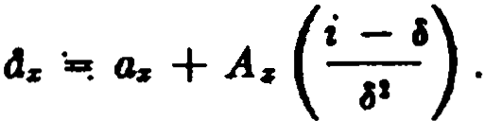
Asauming a uniform distribution of deaths, derive
l - l
  - Show that dz = a. - AdJ·A,.+1 - A2 :iJ·Az+2 - ··· + (1.A )" and explain the result by general reasoning.

EXERCISES 167

  - Explain by general rcasoning the relation
A:s =: 1 - id:s . Why is the equivalence only approximate?
  - Compute the exact value of ds on the assumption of a uniform distri­ bution of deaths throughout ea.ch year of age, given q:s = %, qz+1 = 1, and i = o.
- The retirement income policy
  - A retirement income policy issued at age 40 has a maturity val ue of
1.5 at age 65. The death benefit prior to age 65 is the terminal reserve or 1, whichever is greater. the terminal reserves are less than 1 to the end of the 17th yea.r, but greater thereaf ter. Give a.n expression for the net annua.l premium.
  - Derive a formula in tenns of commutation f unctions for the net single premium at age x for a retirement income policy providing a death benefit equal to 1or the reserve if greater and maturing at the end of n years for
1 + k. Give a criterion for determining e, the number of years during which
the death benefit is constant at l.
  - How will formula (7.18) be modifi.ed if premium payments are limite<l to r years, r < a + 1, where a is the greatest integer for which ..V < 1?
  - An annual premium retirement annuity provides a life income of
$1 a month, first payment at the retirement a.ge, and the return of the gross premiums pe.id, or the reserve if greater, if death occurs before that age. Derive the net level premium for such a policy issued at age x with retire­
ment a.ge :i + n. Assume that the gross premium is loaded a percentage of
the net premium plus a constant.

6. Family income henefits
15. (a) Show that the net single premium at age x for an n-year f amily in­ come benefit providing a yearly income of 1 payable continuously may be expressed in the following four ways:
..,r
=1 a;;¡ - 4r:ii]
= l" v'(I - ,pr) dt
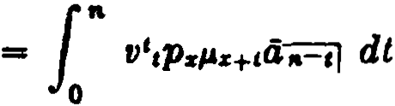
=- 6 As:iil - ,.qr .
(b) lf the rate of interest before death is i and the rate af ter death is
1 -1 V"
i' ,s·how that, without approximation, the net premium in (a) is

168 SPECJAL TOPICS [CH. 7
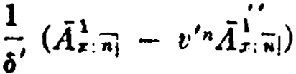

wherc i'' =
-:-:_J

. 1 + 1:' .
ll>. A policy pruvide:s tt cout.iu11011s x111111i t y-<'.crtai n uf 1 µer a11nu m be­ gi1111i11g tt t the date of dcath of {.e). Jf dcalh occnrs wit.hi n 15 years of issuc, t he xn1111i ty is payable to lhe eud uf 20 yeus from issuc. If dcath occurs be­ tween 15 and 20 years from issue, the anuuity is payable for 5 years certa.in. Coverage cea.ses 20 years from issue. Find an exact expression for the net single premium.
- (a) An m-year endowment contra.et for $1000 is modified so that if death occurs within the first n years the death benefit is retained by the insurer until the end of the n-year period and is pai<l at that time. lf death occurs af ter n years, the death benefit is pnid immediately.
Show that the uet single premi urn at age x is giveu by
lOOO(v",.q.. + Áz:;;;-¡ - A!,ii]).
(b) An n-year family income benefit providing $10 per rnonth is issued in combination with the m-year endowment described above. Usiug (7.25) to evaluate the family income portion, show that the total net single premium for the combination policy exceeds the siugle premium of 1000 Az ,;;;] for the normal endow­ ment insurance by the amount of

d1020
- 1000) -1
- (120 - 1000) V".,.qz ,

( 2 )
Áz:ñ] 6

This formul8. corrects the error noted in the text in connection with formula
(7.26).
- A contract provides for the payment of $1000 at the end of 20 years if the insured is then living, or an income of SlO a month in the event of death before the twentieth anniversary of the policy. The first i ncome pay­ ment is due at the e11d oí t he policy rnonth of death but no payments are made af ter 20 ycars f rom da te of issue. Give the fonnu]a for the net an­ nual premium at agc x .

Miscellaneous problems
- A life insurance company sells a single premium complete annuity of $K per year payable quarterly, wi th the provision that, if death occurs in the first policy year, five-sixths of the gross premium will be ref unded, this death benefit decreasi ng by one-sixth of the gross premium each polic.r year thereaf ter un til it becomes zero.
Find, in terms of commutation symbols, the net single premi um at age :r

EXERCISES 169

for the annuity, if the gross premium is equal to the net premium loaded e
per cent. Use standard approximations.
- A 20-year term policy provides that in the event of the death of the insured during the 20-year period the company will pay a yearly income of
$100, payable continuously, until 20 years from issue or for 10 years from the date of death if the latter period is longer. Determine the net single premium at age x for this benefit in tenns of an expression reduced to a form which does not contain integrals.
- A retirement income policy is issued at age x and matures at age
x + n for 1 + k . The death benefit is paya.ble at the end of the policy year
in which death occurs and is equal to 1 or the terminal reserve if greater. Annual premiums are payable for n years. Reserves are computed under a modification, extending over the entire premium-paying period, such that
fJ - a· = g,. . Numerical values of g,. are available. Derive the criterion and
the premium formulas.

CHAPTER 8
POPULATION THEORY

l. Sorne additional mortality functions
The analysis of population statistics forros a specialized branch of actuarial science known as demography. While this subject is in general outside the scope of this text, there are certain basic mor­ tality functions which are common to demography and to insur­ ance mathematics. An introductory explanation of these functions in demographic terms will assist the student in grasping thcir sig­ nificance.
We first define sevcral new functions:

L.r =

.r H
11
f l

dy =
11
lz+i dt

(8.1)

.r O

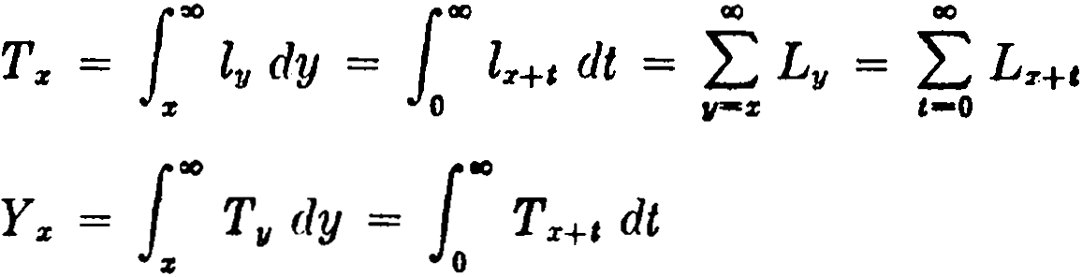

As consequences of the definit ions, we note that

dLr = lz+l - lz = -dz
dx

(8.2)

(8.3 )

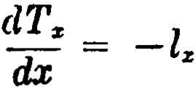

d L T
dx - - z
Throughout this chapter, we shall be using integral expressions and the studen t will find it helpful to keep in mind the following short table of indefinite integrals (arbitrary constants omitted ) :
f l11µ.,¡ dy = -l11
J l!J dy = -T 11
1 "11'\

SEC. 1] SOME ADDITIONAL MORTALITY FUNCTIONS 171
J T11 dy = -Y,,
J yl,,µ,, dy = -yl,, - T,,
J yl,,d y = -yT,, - Y,,
The last two formulas can be derived using integration by parts and may be verified by differentiation.
The new functions can be given concrete interpretations in terms of the mortality table model. Consider the fz lives which survive to age x. We shall show that Tz represents the total number of years lived by the members of this group from age x until death. The number of these lives which die at the moment of attaining age y is given by l11µ11 dy. Since each of these has lived y - x years since age
x, the integral

f OIJ ( y - x )l µ,, dy
11
z

represents the number of years lived by the whole group subsequent to attaining age x. Using the formulas just listed, we find

f OIJ ( Y - X ) l11P.11 dy = lOIJ ( yl 11µ.11 - Xl 11"1,) dy
% z
= [ -yl11 - T,, + xl11J:=: = xlz + T:i: - xl:i: = Tz .
The definition of Lx shqws that it represents the mean value of the function l,, between x and x + 1. By changing the upper limit of integration to x + 1 in the above integrals, it can be seen that
L:i: also represents the number of years lived between ages x and
x + 1 by the lz lives which survive to age x.
T:i: may also be described as the total future lifetime of the l:i: lives which survive to age x. Then Yz. , as defined by (8.3 ), represents the total future lifetime of those aged x and over.
Numerical values of these functions are usually obtained by using the trapezoidal rule to compute t.he integrals:
(8.4)

172 POPULATION THEORY [CH. 8

00
L
Tz }lz + lv
r-s+1
•
Yz =: }Tz + L T,,
rs+l

(8.5)

(8.6)

Thc trapezoidal rule may not be sufficiently accurate when dealing with the values at the extreme ends of the table, and more refined mct hods are sometimes used for the very low and the very high ages.

- The central death rate
The ratio of dz to Lz is called the central death rate at age x and is
denoted by mz :
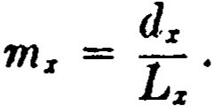 (8.7)
It is known as a cC'ntral ru.te since it relates the number of deaths between ages x and x + 1 to thc mean value of lz over that age
interval.
Evaluating Lz by (8.4 ), we havc thc following formulas connect­ ing mz with qz and Pz :
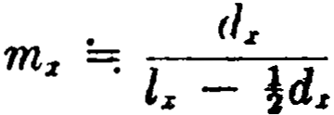 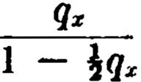 (8.8)
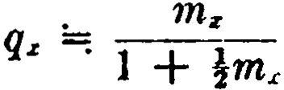
(8.9)

Pz =; 1 + im:
1 !m

(8.10)

The relatiorn)hip bctwecn t.he central death rate and thc force of mortality can be secn when mz is written in the following form:
illz+I • µ,H dt
mz = ll
lz+I dt

Here it is apparent that mz is the weighted mean value of the force
of mortality ovcr the year of age x to x + I where the weights are

SEC. 3] THE EXPECTATION OF LIFE 173
the number of lives attaining each age x + t in that interval. We may use #'z-+i as a reasonable estima.te for this average value.
This can be seen in another way. We use the fact that dz = - ·
and introduce the assumption of a uniform distribution of deaths:
d. 1 dLz . -1 dlz+I
m. = .= - Lz . dx =: lz+t . dx = Pz+t •
In formulas (J.18) and (1.19a) wc noted that -log p. reprcsents an unweighted mean valuc of µ. which can also be approximated as
µ.-+! • Hence,

m. =; µ•-+! =; -log P:s •
(8.11)

- The expectation of life
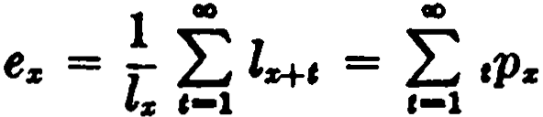
A function which is frequcntly encountered in connection with mortlity tables based on population statistics is the expectation of life. This appears in two forms, the curtate cxpectation e. and the complet.e expectation ., defined as follows:

lz =-1 iao Z2:+c dt = lao ,p. dt.
1
% o o
(8.12a)

(8.12b)

In either form, the function may be interpreted as representing the average future lifetime at a.ge x. The form e:s includes only full years of future lifetime and hence is curtate in the sense that it ignores final fra.ctional years of life while 21 includes thc complete future lifetime. On the average, the complete future lifetime exceeds by half a year the number of integral years in the future lifctime, and hence
.=¡ e,. + j. (8.13)
This formula is analogous to the relationship between the two forma oí life annuity, á:s =; a,. + i, and the expectation of life is in
fact a special case of the life annuity when the rate of interest is zero.
There are expectation functions corresponding to other types of life a.nnuity. For example, temporary expectations of life, e.:-;J and

174 POPULATION THEORY [CH. 8

lz:iil , may be defined :
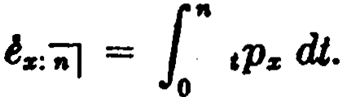
"
ez:nj = L,-1 ,Pz '
Computing the integral by the trapezoidal rule, we obtain the rela­ tionship
z:;-¡ ez: il + J (1 - ,.p,1; ).
When exact valucs oí Tz are available, the expectations may be computed from the formulas:

lz (8.14a)
z = Tz
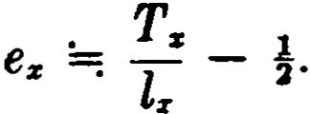 (8.14b)
It should be noted, however, that tabulated values of Tz are usually approximate. When values of Tz computed from (8.5) are used, formula (8.14a ) is approximate and formula (8.14b) is exact.
Itis popularly believed that the expectation of life is widely used in actuaria} calculations. In realit.y, it is of interest to actuaries only because it aff ords an index for comparing diff erent mortality tables. One of the persistent misconceptions is that the present value of a lif e annuity at age x is equal to the value of an annuity certain for a term equal to the life expectancy at age x ; that is, that az and a;;¡ have the same value. We shall show that in fact a;;-1
exceeds az , assuming i > O.
Since ez is in general not an integer, we write
00
ez = L tPz = n + f,
1-1
where n is integral and O f < l. The annuity-certai n with frac-

t1.ona 1 term n +f prov1'des m.
theory a final payment of (l + i.l - l
i

at the end of n + f years.1 At the usual rates of interest, the value of (l + i!' - 1 is very clase to J, and in practice the final payment
it -
i
is taken to be f. It can be shown that both v"+t . (l + 1and
i
1 See Donald (1956), pp. 51f .

BEC. 4] ANALYSIS OF THE SURVIVORSHIP GROUP 175
v"+1,J are never less than v.,.+i .¡, so that in either case we have the following results for n O:
a;;¡ = a;:¡:¡¡ a;i + v"+i .¡
11
= ª•=K+ll + ¿v'(l - ,p.) + v"+1 (J - •+1Ps)
,-1
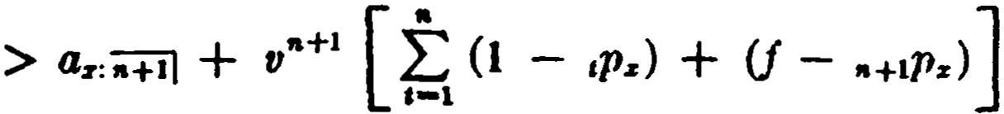
= a.:ñ+i1 + v"+i (n + f - Y,-1: tPz)
== a.:;:¡:¡] + v"+1 (f ,p. - Y: ,p.)
,-1 ,-1
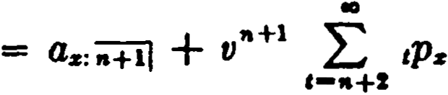
4.:i+il + L v',p.
•-•+2
•

Since the same result can be obtained when n = O (the derivation
is left for the student in Exercise 11), we see that a;;i exceeds as in
a.11 ca.ses.
4. Analysis of the survivorship group
The mortality table, as we have discussed it thus far, can be interpreted either as a model for the expected survivorship of a newly-bom group of lo lives/ or as the actual historical record of the eurvival of lo lives each of whom was observed from birth until death. Sorne applications may require a combination of these two points of view. In each case, we refer to the mortality table as a survivorship group model. We consider now certain properties of the closed population of lives represented by the mortality table when interpreted in this way.
For those members of the population who survive to age x, the average age at death will be x + s , since .represents the average
future lifetime at age x. This is the result that would be obtained if it were possible to observe ea.ch of the lives from a.ge x until death, recording the exact age at death for each one, and finding the average of these a.ges.

li6 POPULATJO THEORY [CH. 8

It will be useful to derive this result in another way. Since each of the lz lives has already survived for x years, we know that their total past lif etime is xl:1: • Their total future lif etime is T:1: , as we noted in Section l. We thus see that their total lifetime is xl:1: + T:1: , which is the same as the total of their ages at death. Dividing by l:1: , the number of lives, we obtain the average age at death as
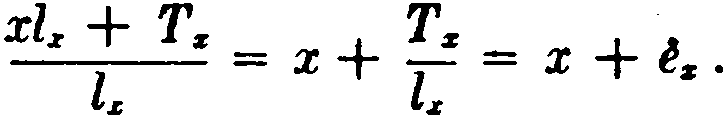

For x = O, we have Ty;o; =
· ·
,the

age at death for the entire

o

original group of lo lives.
average

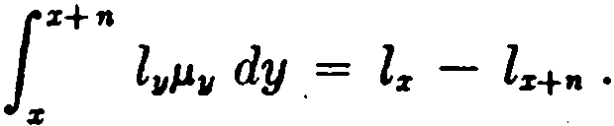
Let us now determine the average age at death for those who survive to age x but die before age x + n. The number of such persons (i.e., the number of deaths) is
The total of the ages at death is

Jz+n y l¡¡µy dy =
.
[ -y l11 - T ]!+ 11

z

= -( x + n)l:r+n - Tz+"' + xlz + Tz .
Hence the average age at death is
11 •
x(lJ - lr+ ,J + ( Tz - T:r+n - nlr+11 ) = X + Tz - T:r+n - nlz+ •
lr - lz+n l.x - lz+n
Since the t otal past lifetime prior to age x for those who survive to age x but die before age x + n is x (lz - lz+1' ) , this result shows that the total future lifetime subsequent to age x for the same persons is Tz - Tx+n - nlz+n . The total future lifetime can also be obtained dircctly by evaluating the expression
z+ n
J
( y - x )l 11µ11 d y.
z

- The stationary population
Problems in demography are sometimes concerned with com­ munities with a stable age distribution for which the population is roughly stationary. It is possible to use the mortality table as a

SEC. 5] THE STATIONARY POPULATION 177

model for a stationary population if we interpret the familiar mortality functions in a somewhat different way.
Suppose that a population is supported by lo annual births, lo
being the radix of a given mortality table, and suppose also that these births are uniformly distributed over each calendar year. Let the deaths among the population occur in accordance with the given mortality table, and let there be no migration into or out of the population. Then it may be shown that when the birth and death process has .continued for a period of years at least equal to the terminal age of the mortality table, the total population remains stationary and its age distribution is constant.
This may be seen by considering the consequences of the assump­ tion that the lo annual births are uniformly distributed over each calendar year. This clearly means that there will be lo births uni­ formly distributed over any year of time, and that in any fraction of a year h, however small, there will be hlo births. It follows that there will be l:i: lives attaining age x in any year and hl:r: lives at­ taining age x in any time interval h, as survivors of the births which occurred in the corresponding periods of time x years ago. Now consider the incidence of deaths. Each of t he hly lives at­ taining age y in any interval h is subject to thc force of mortality
/J.1! , and hence the differential expression hl11µ11 dy represcnts the number of lives dying at exact agc y in that intcrval. Then the
number dying between ages x and x + 1 in any interval h will be
:r:+1
1

given by
:,;
hl11µ11 dy = hdz .There are two conclusions frorn this

result: (1) letting h equal 1, we find that the number dying between ages x and x + 1 in any y7ar of time is d:r: ; (2) since the number
dying between ages x and x + 1 in any fraction of a year h is pro­
portional to h, it is clear that the deaths between ages x and x + 1,
and hence. all deaths, occurring in any period of time are uniformly distributed over that period.
It may now be seen that such a population is indeed stationary.
f"
For, the total of the deaths at ali ages in any interval h is hl11/.lv dy
= h10 , which is the same as the number of births occurring in the interval. Since the interval h is an arbitrarily small period of time, we may conclude that cach life which ]caves the population by death is simultaneously replaced by a new birth.
Furthermore, the distribution of the total population by ages

178 POPULATION THEORY [CH. 8

is stationary. For, consider the lives which are aged x last birthday at any time. These are the lives which have attained integral age x
but not age x + 1. In any interval h, the number of lives which leave this group by attaining age x + 1 is hlz+i , and the number
which leave the group by death is hd:c , making a total decrement of hl:r:+1 + hd:r: = hl:z: • Thus, the total decrement is exactly equal
to the number entering the group during the interval by attaining
age x. In other words, when a life leaves this age group, either by death or by attaining age x + 1, its place is simultaneously taken
by a life entering from the next lower age group. Under these circumstances, the number living at a given age last birthday is always constant.
Now r l:i: + represents the number of lives attaining exact age
!
r
x + m in any int.erval of time !and therefore approximates the
r r

numbcr of
.
hves
between exact ages x + m- and x +-m + 1 at any
r r

moment of time. Hence the number of lives between exact ages x
and x + 1 at any moment of time is
. r-1 l il
hm I: - lz+'!! = l:z:H dt = L:r: .
r-+OO M-0 r r 0
Thus Lz is the constant number oí lives between exact a.ges x and
x + 1 at any moment of time. Similarly, T:r: is the number of lives
aged x and over at any moment of time. The student should note caref ully how this conception of the mortality table contrasts with the survivorship group interpretation. In the stationary population concept, the function l:r: represents the number oí lives attaining age x in any year oí time, and d:r: represents the number of deaths
between ages x and x + 1in any year of time. The radix lo is the num­
ber of births (and of deaths) in any year of time. The functions L:r: and T:z: represent numbers living in the population at any moment of time. If a census enumeration of the population were made at any moment, the number of lives reporting age x last birthday would be L:r: , and the number reporting an age of x or over would be T:z: • The central death rate m:r: can be described as the ratio of the num­
ber of deaths between ages x and x + 1 in any year of time to the
number living between those ages at any moment of time. Although the stationary population coricept is admittedly arti-

SEC. 6) AVERAGE AGES IN THE STATIONARY POPULATION 179

ficial, the theory finds application in the solution of problema where the stationary condition is approximately realized. A problem such as the following illustrates a. practica! situation in which the "popu­ lation" is substantially sta.tionary.
A peacetime army is maintained by 500,000 annual entrants inducted on their nineteenth birthday. Sixty per cent of the survivors of each :year'sentrants are discharged on their twent.y­ first birthday and the remainder on their twenty-second birth­ day. Assuming 1 that the mortality follows the table for U.S. White Males 1959-61, determine the size of the army when it rea.ches a stationary condition.
If the number of annual ent.rants were 1111 , the ultimate size of the army would be
LH + Lio + .41 = (Tia - T21) + .4L21 .
Since the number of annual entrants is 500,000 instead of [19 , the actual size will be
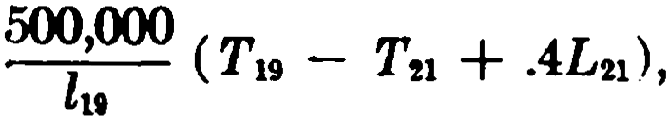
and evaluating the functions from Table B of Appcndix I, we find the result to be 1,197,695 men.
A number of other questions may be easily answered. For in­ stance, the number of men who die in servicc each year will be
,ÓOO (d111 + d20 +.4 d-21) = 1,878.
111
The number of men discharged ea.ch year will be
500l,OOO (.6l21 + .4ln) = 498,122.
19
As a check, it may be noted that the number of men dying and discharged each year is equal to 500,000, the number of annual entrants.
- Average ages in the stationary population
Sorne of the problems that wcre discussed ·in terms of the sur­ vivorship group have exact mathematical counterparts in the stationary population. Although the interpretation is different, the

180 POPULATION THEORY [CH. 8

solution involves the same mortality functions and the same mathe­ matical processes. Thus, the average age at death of ali those in the
stationary population who die after attaining age x is x + z , and
the average age at death of all those in the stationary population is o . Similarly, the average age at death of ali those in the sta­
tionary population whose deaths occur between ages x and x + n is
X Tz - T:z:+n - nlx+n •
+
l z - lz+n
In considering this result for the stationary population, the expres­
sion l:z - lx+n may be interpreted as the number of deaths between ages x and x + n in any year of time, and thus the result corresponds
to what would be obtained by observing the deaths at those ages for a period of a year. The population being stationary, the par­ ticular yearly period used is immaterial.
Problems which involve segments of the population now living at certain ages are peculiar to the stationary population and have no analogy in the survivorship group. Such problems are typicfllly concerncd with sorne subset of the present population, and we shall discuss them under two headings: (1) those involving ali the mem­ bers of thc subset, and (2 ) those involving only the members who die under certain specified conditions.
- As an example of problems involving all the members of a subset, we considcr the subset consisting of those persons now living at ages x and over. We note first that the number of members
in this subsct is Tx = L'° l11 dy. Their total lifetime can be co:r¡iputed
:z;
in three parts. First, their total past Iifetime before age x is clearly xT x • Second, we require their total past lifetime from age x to their present ages. For the l11 dy Iives attaining age y at any moment, this total past Iifetime after age x is (y - x )l 11 dy. Hence, for the entire subset, we have
J00

:z;
( y - x )l 11 dy = [-yT,, - Y,, + xT,,]: = Ys .

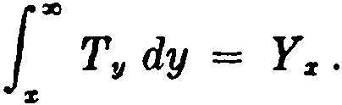
Third, since the total future lifetime for those aged y is T11 , the total future lifetime for thP mtire subset is

SEC. 6] AVERAGE AGES IN THE iTATIONARY POPULATION 181
Summarizing, for the Tz persons now living at ages x and O\"er,
we have:
Total past lifetime before age x = xT z Total past lifetime after age x = Y:i: Total future lifctime = Ya:
Total lifetime = xT :r + 2Y:i:
It is of interest to note that Y:i: can be interprekd here in two q u¡t.e diff erent ways.
From this analysis, it is easy to express the average attaincd a.ge of the membcrs of thc present population. For thc Tx livcs aged x and over, the average attained age is equal to x plus thc average
past lifetime af ter age x ; that is, x + :. The average nttairwd

age of the
.
cntJrc
present popul . .
TYoo .

Since the total lifetime represents the total of the ages ut death, we can now find the average age at death for the Tz lives aged x fü1d over:
at10n 1s
xTa: + 2Y:i: _ + 2Y:i:
Tz - X Tz ·
When x = O, the average age at death of the entire present popub- t1.on 1.s found to bf! 2TYoo .
It is important to note the distinction between ro , which repre­
sents the average age at death for newly born lives and also the average age at death in any period of time for the entire population,
and 2ioº , which represents the average age at death of the present
members of the population. The present members form a closed group of lives, and if their average age at death were to be obtained from observation of published death notices, it would be necessary to ignore the deaths of those who were born af ter the group is closed. The closed group constitutes an aging population in which the average age of the deaths increases in successive intervals of time. It follows that the average age at death of the closed group,

182 POPULATION THEORY {CH. 8

being a composite of the averages in each successive interval of time, will be greater than the average age at death in any interval of time for the entire stationary population (for which all deaths are observed ) ; that is,
2Yo >
To lo •
This kind of analysis can be extended to other segments of the population. Consider the members now living between ages Y1 and y2 • If all the mcmbers of the subset are included, then
the number of members is fª l,, dy;
"1
1"•

their total past lifetime is yl 11 dy;
f/1

f/1
f
their total future lifetime is T,, dy;
111
!"•

their total lifetime is ( yl"' + T.,) dy.
"•
Thc following averagcs can then be obtained:
. total past lifetime

average attamed age = number
o
f members

total lifetime

average age at death = number
o
f members .

Othe:r properties of the subset can often be obtained by making simple modifications in the integrands specified above. Suppose we wish to find the total past lifetime since age 20 for the persons now living between ages 30 and 65. The proper integrand is ( y - 20) Zv , and we thus find
65
1
( y - 20 )l 11 dy = 30Tao + Yao - 65Tn - Yu - 20( Tao - Tu),
30
For the total future lifetime prior to attaining age 80 we have

65
1
( T11 - Tso ) dy = Yao - Y65 - 35Tso .
30
(2 ) When we are concerned with the members whose deaths

SEC. 6] AVERAGE AGES IN THE STATIONARY POPULATION 183
occur under specified conditions, we have a two-variable problem requiring double integration. Given those who are now living at some range of ages, Y1 y y, , we wish to consider those members who die within sorne interval of years in the future, t1 t tt ,
where t1 and tt may be functions of y. The integral

..f'• f( y, t )lll+,µ.H dt dy
1
lll 'ª
(8.15)

represents diff erent properties of the group of members who die,
depending on the fonn of f (y,t ) as follows:
Number of members who die f (y,t ) = 1 Their total past lifetime f ( y,t ) = y Their total future lifetime f (y,t ) = t Their total lifetime f (y,t ) = y + t
In (8.15), the first integration with respect to t produces a sum­ mation over the deaths among those now aged y, and the second integration sums these values for all y in the interval Y1 y y1•

Example 1. Let the members of the subset be those persons now living between ages 20 and 40 who will die before age 70. Find the number oí members and their total lifetime.
With f (y,t) = 1, the number of members is
140 110--V l.,+lµ.H tjt dy = 1'° [- l.,H]::!o-v dy
20 O 20
= 'º ( l, - l10 ) dy = [-T., - yl,u]::
1
20
= T.- T., - 20l10 .
With f (y,t) = y + t, the total tifetime is
40 170-., (y + t)l.Hl'v+I dt dy = i40 [-(y +t)lll+, - Ta,H] : 7o0-., dy
1
H 1
= 1r10º ( yl,, + T., - 10l10 - T10 ) dy
= [ -yT,, - 2Y,, - 70yl10 - yTnJ::
= 20T20 + 2Y 20 - 40T'° - 2Y ,o - 20(70Z10 + T10) .

184 POPULATION THEORY [CH. 8

Example 2. Find the average age at death of those persona now living between ages 20 and 70 who die between ages 60 and 80.
Since the two age intervals intersect, the integrals must be ex­
pressed as follows:
60 180-., 170 180-.,
1
J( y ,t )lfl+tl'v+t dt dy + J( y,t )l11+el'v+• dt dy,
20 16-J, 10 O
where f (y,t ) == I for the number of deaths and f (y,t) = y + t for the total lifetime. The student may verify that the average age at death is
2400leo -4000lao + lOOTso - 70T70 - 50Tao + 2( Y'° - Y70 )
40Z.0 - 50lso + T,o - T70
It is interesting to note that if t1 = O and t1 = oo , the four formu­ las obtained from (8.15) by using the four different forms of /{y,t ) reduce to the four formulas given on page 182. It is clear that thia
should be so, since setting t1 = O and t2 = oo merely eliminates the
requirement of any specified conditions on the time of the deathe. If in addition Y1 = x and Y2 = oo , thenf (y,t) = 1leads to T:s and
J ( y,t ) = y + t leads to xT:r + 2Y:s . This result wBB previously ob­
tained on page 181 in considering the average age at death for all lives aged x and over.
Finally, if we omit the integration with respect to y, we obtain formulas applicable to the survivorship group and to similar prob­ lems in the stationary population. For example, if t1 = O and = n,
then f (y,t) = 1 leads to l11 - · l11+,. and f (y,t ) = y + t leads to
y (l,, - lv+n ) + T11 - T11+n - nl11+n . This result was previousJy
obtained on page 176 and was discussed again on page 180.
It is clear from this discussion that (8.15) is a very general ex­ pression and can be used, in conjunction with the table of indefinite integrals on pages 170 and 171, as a basis for solving a wide variety of problems.
Problems relating to the stationary population have given rise to an extensive literature in the actuaria} joumals. Much ingenuity has been expended on the development of heuristic devices for simplifying the solution of this type of problem. One of the most useful methods, suggested by Grace and Nesbitt (1950), follows from the definition of two special functions:

REFERE!\CES 185
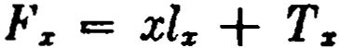
Gz = xT z + 2Yz .
F z is the total lifetime of thc lz livcs that attain age x, and G.is the total lifetime of the Tz lives now living at ages x and over. Suppose that we have determined an expression for the number of members in sorne segment of the stationary population as a linear combina­ tion of the functions lz and Tz . The Grace-Nesbitt principie states that we can then obtain the total lifetime of these members by substituting Fz for lz and Gz for Tz throughout the expression.
In example 1 above, the number of members is T20 - TflJ -
20l10 . Making the prescribed substitutions, we immediately find the total lifetime to be G20 - G40 - 20F10 = (20T20 + 2Y20) - (40Tco + 2 Y40) - 20 (70l10 + T10 ). This affords a simple check on
t.he accuracy of the original integrations. A similar check can be made for example 2 as well as for the average age at dath problem discussed on page 176, and (trivially ) for the average age at death express1.ons x + TT:. and x + 2 y• • In cases where the express1. on
Tz
for the number of deaths is known to be correct so that no checking is necessary, this provides a method for finding the total lifetime without additional integration.
References
3. The proof that the expectancy annuity exceeds the life an­ nuity is taken from King (1902), p. 112. An interesting geometric demonstration of this fact is given by Sarason (1960).
5, 6. Students who feel that they need additional help in analyz­ ing stationary population problems will find useful material in the discussion of the paper by Grace and Nesbitt (1950) and in the paper by Veit 0964) and its discussion.
EXERCJSES

l. Sorne additional mortality functions
d (Ts) IJ,rTs ·
l. Show that dz · ls - -¡; -. l. .
2. What mortality function is represented by each of the following when
i = O?

186 POPULATIO.S THEORY [CH. 8

- l;.Á z
(b) D..:
(e) Ñ,.
(d) '"ª"
- lz(]A),.
- l,.(1a)z

S. Evaluate (a} la" tl-.,p.+1 d t
(h) l.a.., dt
(e) 1·l:rr+I dt.
•
- The central death rate
  - Show tha.t mz is constant for ali values of x if l,. = Ice,-•.
  - Estimate mu if lu = 10,075 and l11 = 9925.
6. Show that L,.+1 = L,.e- f! ••+' 41•
7. Calculate theexact value of the central death rate at age x if mortality follows the de Moivre law.
- The e:xpeetation of lile
- From the following data, compute the curtate expectation of life at age 90 and estimate the complete expecta.tion:
,. .
s  90 | 21 | s  95 | 5
91 | 15 | 96 | 3
92 | 12 | 97 | 1
93 | 9 | 98 | o
94 | 7

- Find e,, assuming de Moivre's law.
- (a) Show that d log T. == - 1 •
--- ;-
d:t c:s

. ,
(b) Show that 1f ,.,.. -

P.z
+ .0e5. ,
then p,., - p. (TT=+.1)·".

- Prove that a;;i > az for the case where O < e.a: < 1.
- Analysis of the survivorship group
  - For the lz lives who survive to age x, write expressions for
    - the total past lifetime subsequent to age y (y < x);
(b) the total future lifetime prior to age z (z > z);
(e) the average lifetime between ages ti and z (y < x < z).
  - For the in a survivorship group who survive to age 30 but die before
age 50, find

EXERCIS 187

    - t.he total past lífetime between ages 10 and 30;
    - the average future lif etime subsequent to age 30.

- The stationary population
- A staff is maintained in a stationary condition by 300 annual entrants at exact age 20. Ten per cent leave at the end of five years, 5% of those re­ maining are promoted af ter ten years into jobs outside the staff, and at age 60 the balance retire on a pension. Express in terms of mortality table f unctions
  - the size of the staff ,
  - the number promoted each year,
(e) the number of pensioners on the books.
- An organization of 1000 active members is kept in a stationary state by admission of a uniforrn number of entrants at exact age 30. There are no
withdrawals other than by death except that of those who reach age 55 retire at that age, % X>f those who reach age 60 in service retire at that age, and ali those remaining in service are retired at 65. Express in terms of tabular functions
  - the number oí annual entrants at age 30,
  - the total number of deaths in service each year.
- In a stationary community supported by 5000 annual births, each person contributes $200 on attaining the age of 25 and $10 on each succeed­ ing birthday up to, and including, his 65th birthday. On each birthday thereaf ter, he receives an annuity payment of $150. A payment of $50 is made at the death of each contributor who dies hefore receiving the first annuity payment. Find expressions for
  - the constant number of persons who have made their first contribu- tion but. not their last,
  - the receipts in any year,
(e) the total annuity payments in any yea r,
(d) the death claims in any year.
d -
17.(a) Show that dx (lz) = -lzAz . .

(b) In a stationary community, ali persona now aged x and over agree to contribute a single sum equa1ly to a fund from which a unit will be paid at
the death of each of them. Show that thc payment to be made by each is es .
- Average ages in the stationary population
  - An organization of 10,000 members who enter at a.ge 20 and retire at age 60 has reached a stationary condition. Each year there are 100 deaths, the average age at deat h being 40. Wha.t is the number entering and retiring each year? (Ans. 300, 200)
  - (a) Find t.he total number of future years that those in the stationary population now between ages x and x + n will live before attaining age X + n.

188 POPULATION TH'.EORY [CH. 8

(b) Find the total number of future years that those now between ages x and x + n will live in the next m years.
  - (a) Find the average age at death of those in the stationary popula­ tion who are now living between a.ges x and x + n.
(b) Find the average a.ge at death of those in the stationary popula­ tion who are now living between ages x and x + n and who will die before attaining age + n.
21. Find the average attained age of those in the stationary population now living at a.ges under 30. ,
22. Find the average age at death of those in the stationary population who are now living between ages 20 and 30 and who will die between a.ges 30 and OO.

Miscellaneoua problems

23. (a) Given eu:'il = n (1 - n 1

1
) for all n, derive an expression for

(b) Find the derivative of e., with respect to l., .
(e) Show that '° 111 es,il dt ... a .
1
O
- In a stationary community of 600,000 lives, the number of deaths is 10,000 annually. The complete expectation of life on attaining majority at age 21 is 50 years. If one-third of the population is under a.ge 21, how many lives atta.in majority ea.ch year, and what is the average age at death of those who die under age 21?
- Find the total lifetime of those in the stationary population now living between a.ges 20 and 70 who will die between ages 60 and 80 within 50 years
f rom now.
26. (a) Show that dt ( ,p.,e.e+•> = -,p., •
d
00 1
1
(b) Show that 1111Pires+1 dt =-= - (e., - 4.,).
o 8

Part II
MULTI-LIFE FUNCTIONS

CIIA.PTER 9
THE JOINT-LIFE STATUS

l. lntroduction
The mathematical theory of life contingencies has beeu developed in Part I in terms of functions of a single life only. This chapter and the succeeding chapters in Part II are devoted to an expansion of the basic theory to cover the realm of multi-life functions which provide the means of solving problems involving two or more lives in combination.
The theory is develope<l from a <·oncept of group survival. Con­ sider a body of m lives with ages X1 ,x2 , • • • , X m • Looked upon as a single collective entity, this body oí live:::; can be said to "survive' at least as long as ali of its component members survive; it becomes a matter of choice whether we say that it ceases to exist upon the first death among its members, or when thc last survivor dies, or at sorne intermediate point. In practica! applications, thc com­ ponent lives which are combined in an annuity or an insurance are often associated in sorne conunon undertaking, or are perhaps related by blood or marriage, and through their mutual activities may be simultaneously exposed to many of the same mortality hazards. For development of the general theory, however, the survival probabilities are assumed to be independent. J oint-lif e functions, as discussed in this chapter, are defined on the assump­ tion that the group terminates its existence whcn the first death occurs. Thus the joint-life status (x1x2 ··· X m ) continues in exist­ ence as long as all the lives (xi ), (x2), ··· , ( xm ) survive, and fails upon the occurrence of the first death.
It will be seen that this joint-life concept is precisely the t.ype of status involved in the practica! situation of a joint-life insurance payable upon the first death among the insureds, or a joint-1if e annuity payable as long as ali the annuitants survive.
.Joint-Jife probabilities
Let us consider how the probabilities of failurc and survival for a joint-life status may be obtained. Although single-life mortality is measured by means of statistical studies, i t is obviously im-
191

192 THE JOINT-LIFE STATUS (CH. 9

practica! to attempt to obtain joint-life mortality rates by similar observation of groups of lives. This recourse is in fact unnecessary, since the probabilities of joint survival can be easily calculated from single-life mortality ta.bles.
The probability that the joint-life status (x2 • • • x"') will sur­ vive for n years is denoted by aPz1z1...z,,. , and, since joint sttrvival requires the individual survival of ali the component lives, we have
(9.1 )
The other basic probabilities then follow in terms oí •P•,••....... .
The probability that the joint-life status will fail within n years is
(9.2)
The probability that the status will fail in the (n + 1)-th year is
The usual annuity and insurance functions may now be defined for the joint-life status. For example, consider an immediate life annuity under which a payment of 1is made at the end of ea.ch year as long as (x1), (x1), ··• , (x,,.) are ali surviving, that is, as long as the status (x1xs ··· x) survives. The present value of this benefit is denoted by a.1•1•• ·z,..:
•
ª•1s1..·• = L,-1 v\p..1ª,.....
The joint-life insurancc, with present value A.1 ,.... , provides a payment of 1at the end of the year in which the status (x1x2 ··· x.) fails:
•
Ás1SS" ·s,.. = E VHl ,¡qsl......._ '
e-e
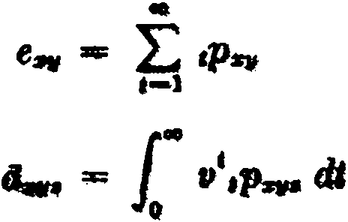
Other joint-life functions me.y be fonnulated by replacing the single-lüe probabilities in the corresponding single-life functions by the appropriate joint-life probabilities. For example,

SEC. 3] JOINT-LIFE MORTALITY FUNCTIONS 193

([A ).-sv6 = L,-o (t + 1)vt+I • ,1q111zvs •
•
3. Joint-life mortality and commutation functions
The formula 11P• ·= ll:- has the formal joint-life counterpart

_ z.1+w1:z1+a:•• •:z.+• aPztz1···Za -
Zz1z1· ..z.
where lzlz..-·z. remains to be defined.
Also
(9.4}

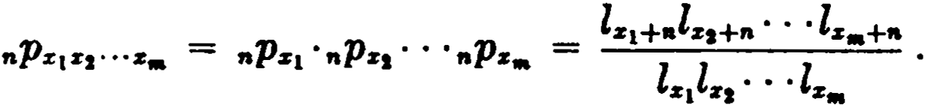
From these two expressions for nP.1:1z,···• , we find that
ls1+n:za+n:•• • :sa+• = lz1+alz,+n • • • l:r..+"
Z.1:tzi···.1:a l.1lz, ···l••
and this suggests the.t we define the joint-life function lstz...-z. as proportional to the product of the single-life l's; i.e.,
(9.5)
In practice, the constant of proportionality k is generally taken to be sorne power of 10-•, so chosen as to reduce the product values to a desired order of magnitude.
Then \
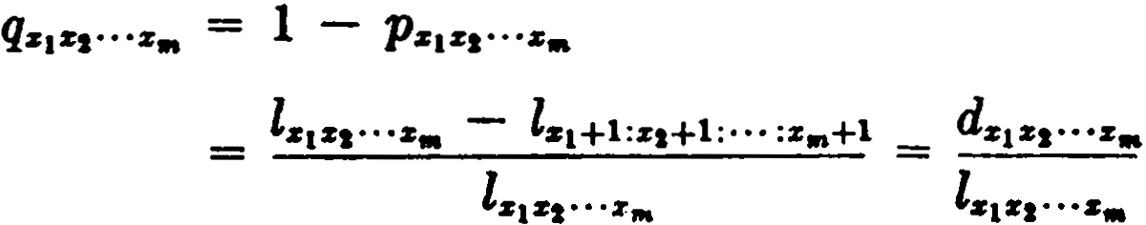
where, by definition,
It is important to note that dstzi ...•• is not the same as kdct dz1• • • dz,,,.
Just as
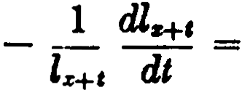
d log Zs+c
dt

194 THE JOINT-Lil'E STATUS [CH. 9

so for the joint-life status we have, by definition,
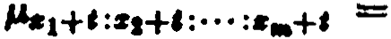
1 dla1 +,:sa+l:•••:s..+I la1+•:•1H:• .. :s..H dl
= - d log la,+•=••+•:·· ·:•..+•
dt
But this may be expreesed in terms of single-lif e l's as
_ d log klz1 +1ls1+1 • ' • l••+e
dl

(9.7)

= _ d log z.1+• _ d log z•• +, _
dt dt
= P.z1+I + P.s1+I + ··· + l's,..+c •
- d log z••+,
dt

Thus the joint-life force of mortality is equal to the sum of the single-life forces of morta.lity :·
l"•1•2"·•,.. = J.'s1 + 1-'st + ·• ' + P.za • (9.8)
Commutation functions for the joint-life status are defined by analogy with those for single lives; thus,
•1+•1+···+•.
D.1 ,. ...... = V "' ZZJZI".... . (9.9)

By usm. g the exponent X1 + X1 + • ·· + X ,., the var1•ous¡1·ves m·
m
the

status are made to enter the function synunetrically, and an in­ crease of one year in the age of each lif e produces an increase of unity in the exponent, so that the function behaves mathematically like its single-life counterpart.
Similarly, by definition,
•1+•1+· • ·+-"'+1
Cs1z1...z,,. = V "' dJZI"'ª• • (9.10)
The functions N, S, M, and R are defined by summation in the standard way.
Since these functions bear the sa.me relation to the joint-life mortality functions as the corresponding single-life commutation functions bear to the basic single-life mortality functions, it follows that each joint-life benefit will have a formula in commuta.tion

SEC. 4] JOI NT-LIFE FUNCTIONS UNDER M AKEHAM'S LAW 195

symbols which exactly parallels the single-life formula for the same benefit. As illustrations, we may write
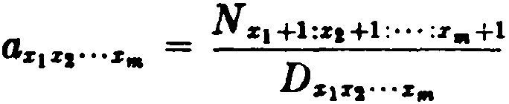
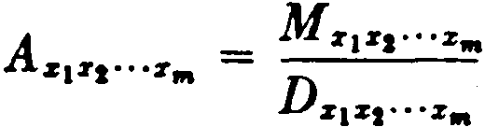

Many cases arise in practice in which it is not reasonable to assume that all the individual lives of a joint-life status are sub­ ject to the same single-life mortality table. Supposc, for example, that the joint two-life status (xy ) is composed of the life (x ) subject to mortality table T and the lif e (y) subject to mortality table T' . The joint-life functions of this status will rcflect the dual mortality basis if the values of l::c11 are computed as k ·lx ·l , using lx from table T and l from table T'.
It is important to observe that the functions Zx1r2···z,,. and dz1 x2·· ·Zm are mathematical abstractions which are even more highly idealized than their single-life counterparts lx and d x . Whereas the latter functions lend themselves readily to an interpretation in terms of numbers of lives surviving and dying, t.he functions lx 1 x2 ···r,,. and
d:c z • •. z,,. , if they are to be given a physical meaning, must be rc_>­
1 2
garded as numbers of groups of lives existing and failing, where existence and failure are construed in the special sense applicable to the joint-life status. Since, however, their usef ulness in joint-life t heory rcquires only that they satisfy certain mathcmatical defini­ tions, any physical interpretation is irrelevant, and the student should regard them as having the nature of commutation functions, that is, purely as mathematical tools for simplifying the formuh,­ tion of a particular class of problem.

- Joint-life functions under Makeham's law
The problem of tabulating numerical values for joint-life funt­ tions presents certain obvious difficulties. A single function, cven in the simplest case of two lives, requires a very extensiv table if provision is made for all combinations of ages. In the case of tables following Makeham's or Gompertz's law, a remarkable simplifica­ tion is possible and the volumc of tabulated· data can be consider-

196 THE JOINT-LI.FE STATUS [CH. 9

ably reduced. We shall examine first the eft'ect of a Makeham as­ sumption.
Under Ma.keham's la.w, the proba.bility of surviva.l for a single life is given by
nPs - s"gea<c--1> •
Then for a joint-life status (X1Xt • • • x,,.), the probability of joint survival will be

and, by substituting
we obtain
(9.11)

Thus in calculating probabilities of survival, the status (x1x2 ···x.) involving m lives of unequa.l age can be replaced by the simpler m-life status (ww ··· w ) where ali the components are of the same age. Furthermore, there is a simple rela.tion for the determination of the "equivalent equal age" w in the condition
(9.12)
This condition may also be expressed in tenns of the force of mor­ tality, for, if we multiply through by B and add mA to both sides,
A and B heing the usual Makeha.m constants, we ohtain
m (A + Be"') = ( A + Be:r 1) + (A + Be•2 ) + ··· + (A + Bl"•),
whence
(9.13)
Thus, the equivalent equal age w may be described as the age for which the single-lif e force of mortality is equal to the arithmetic mean of the single-life forces of mortality at the individual a.ges
X1 , X2 , • ·• , X"' •
When joint-life functíons a.re tabulated on a Makehamized basis, the values of µs or of e• are customarily shown for all ages. From these, values of ,o can be obtained by interpolation using formula (9.12) or (9.13).

SEC. 4] JOINT-LIFE FUNCTIONS UNDER MAKEHAM 1S LAW ]97

This property of Makeham's law has the important consequence that any joint-life function, regardless of the ages involved, may be evaluated as the same function of joint lives of equal age. For, if a group of m lives of unequal ages may be replaced by m lives of equal a.ge in calculating probabilities of survival, the same replace­ ment may be made in any joint-life function depending on those
probabilities. Thus, since nPxizi· ··z. = nPww· ""' , it follows that
ªz1z1···z. = awu,...• , As1:.i:1···Z· = Au,v,...v, , Pz1:.i:1···z,,. = p IDVl• • •'IJJ , and so on. Under these circumstances, it is only necessary to tabulate joint-life functions for equal ages, the extensive tables required for
lz1z1···z. l dz1z1···z... , Dz1z1·•·Z· , and the other functions being now
replaced by si,ngle columns of lzz,.,z l dzz.··z , Dz:.i:• ••Z , and so on.
In the past many important mortality tables were constructed on a Makeham ha.sis in order to gain this advantage. The 1941 CSO table follows Makeham's law between ages 15 and 95. Table 5 shows certain annuity values on this basis, together with values of c-z.
As an example, suppose that the value of dao:16:46 is required on the 1941 CSO 2 % basis. Using Table 5, we first compute
SO + 35 + 46

e"' = e c
3
e = 26.477.

Then, by linear interpolation in the table, we find w = 38.363, and hence
iiao:3i:u = t.i38.asa:aa.asa:38.aea .
Finally, a linear ihterpolation between x = 38 and x = 39 in the table of values of iizzz produces the required annuity valuc of 15.27735. In this result, we cannot expect all five decimal places to be correct in view of the interpolation procedure, but the loss of accuracy is slight enough to be unimportant in most applications. There is a minor theoretical error which should be noted, al­ though it has very little practical importance. The function which represents ls in Makeham's law is positive for all values of x, im­ plying an infinite limiting age in the mortality table. The 1941 CSO table used above, although Makehamized over most of its
range, has l100 equal to O. If we recognize this limiting age in com­ puting the life annuity value above, we have, since 1p45 = O for t > 54,

118

TA:81..E 5c
VALUD ..,.A M.u:&H.HI- Ta11,a
1941 CS0 2%
s | 11s.
30 | 206.3897
31 | 20.27406
32 | UJ.9003
3.1 | 19.52954
34 | lt. 15026
35 | 18..76695·
38 | 18.37945
37 | 17.98838
38 | 17.59385
39 | 17.19500·
40 | 18.79545
41 | 16.39232 .
42 | 15.98714
43 | 15.58011
44 | 15.17162
45 | 14.76Z33
46 | 14.35245
47 | 13.. 94244
48 | 13.53291
49 | 13.12403.
50 | 12.71666
51 | 12.31105
52 | 11.90776
53 | 11.50720
54 | 11.11010
56 | 10.71676
56 | 10.32771
51 | 9.94354
58  00- | 9.56463  9. un.m:
60 | 8.824fi8
61 | 8.46435
62 | 8.11113
63 | 7.76562'
6f | 7.42783

..... | r | ,r
JS.48172 | 12. 964- | 3&
18. 111&3 | 14.100 | 31
17.73:'1(W | 15.366 | 32
17.36885· | 16-.736 | 33
16.97680 | 18. 2'28 | l4
l6·.59cl81 | 19.852 | 35
1.6.20371  15.81326 | 21.§22  23.549 | 36  :n
15.4 | 25.648 | 38
15.02593 | 27.934 | 39
14.63()0!} | 30.424 | 40
14.23310 | 33.136 | 41
13.83565 | 36.089 | 42
13.43796 | 39.306 | 43
13.04049 | 42.809 | 44
12.64403 | 46.625 | 45
12.24878  11.85624 | 50.781  55.307 | 46  47
11.46409 | 60.236 | 48
11.07548 | 65.605 | 40:
10.69038 | 71.453 | 50
10.30898 | 77.822 | 51
9.93186  9.55942 | 84.758  92.313 | 52  53
9.19240 | 100.541 | 54
8.83102 | 109-.á02 | M
8.47580 | 119.262 | 56
8.12727 | 129.892 | 57
7 .78572 | 141.470 | 58
7.45161 | 1M.a79 | 5t
7.12530  6.80713 | 161.812  182'.770 | '6°1
6.49731 | 199.060 | 6Z
6. 19648 | 216.803 | 13
5.90444 | 236.127 | 64

SEC. 5} THE LAW OF UNIFORM SENIORITY 199

H , H
.. ' ' '
,P-
aao:a& :45 = LJ V ,Pao:16:'5 = LJ V = uvwv:ii]
,-o ,-o
where w = 38.363. For greater accuracy then, dao:a&:46 should be evaluated as dvvv:ii] insteacl of as a_ . The dift'erence between these two values, however, involves a small number of annuity payments discounted over a long period and contingent on the joint survival of three lives to advanced ages. It can be shown in this particular case that the error is too small to affect the fifth decimal place. Although this error can safely be ignored in practice, the student should be aware of its existence.
- The law of uniform seniority
In the case of a joint ttvo-life status, the equivalent equal age under Makeham's law may be determined in a particularly simple
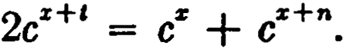
way. We know that the status (x : x + n) can be replaced by the equal-age status (x + t : x + t ) provided that
Removal of the factor ¿z: in this rclation yields
2c' = 1 + e",

whence
t = log (1 + e" ) - log 2 .
log e

The result indicates that the seniority t of the substituted lives over the age of the younger of the original lives depends only on the difference n in the original ages. This makes it possible to con­ struct a simple table showing the value t of this uniform seniority for each diff erence in ages n. When such a table is available, it is unnecessary to refer to the values of JJ.:¡; or of cz in order to deter­ mine the age w.
The table of uniform seniority for the 1941 CSO basis is shown in Table 6. Because of the special methods used in the construc­ tion of the 1941 CSO table at the youngest and the oldest ages, the table of uniform seniqrity does not apply accurately if either age is under 15 or over 90.
Suppose that we require the equivalent equal age on this basis for the status (30:40). Since the difference in ages is 10, we enter Table 6 with n = 10 and find t = 6.036. Adding this value of t to
the younger age 30, we find that the equivalent equal age is 36.036.

200 THE JOINT-LIJl'E STATUS {CH. 9

Diflereace of Ap
•
TABLE 6
UN1roa11 SsmouTY
1941 eso T..u1L11
Addition to Youn¡er Ace
'

1 0.511
2 1.043
3 1.596
4 2.170
5 2.765

6 3.380
7 4.015
8 4.670
9 5.344
10 6.

11 6.747
12 7.474
13 8.218
14 8.978
15 9.753

16 10.543
17 11.346
18 12.163
19 12.992
20 13.833

21 14.685
22 15.547
23 16.420
24 17.301
25 18.191
Does not apply if either age is under 15 or over 90.

The principie may be extended to the case of three joint lives, but the procesa is more complicated, and it is simpler to inter­ pola.te for w in a table of l'z or cz.
The case of four joint lives can be treated, however, by meaos of the table of unüonn seniority for two lives. Consider first the special ca.se of the status (xxyy), involving four Iives but only two distinct a.ges. The equivalent equal age w must satisfy the

BEC. 6) JOINT-LIFE FUNCTIONB UNDER GOMPERTZ'S LAW 201

condition
4ctD = 2c'Z + 2c",

but this is the same as the condition
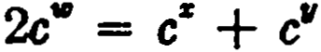
for which (xy ) is equivalent to (ww ). Hence the equivalent equal age w for (xxyy ) is the same as for (xy ).
The case of four lives of unequal age (uvxy ) may be reduced to the preceding case. First the equivalent equal age for each of the
pairs (uv ) and (xy ) is found from the table of uniform seniority. Suppose that (uv) = (rr) and (xy) = (ss ). The joint four-life status now becomes (rrss), and, as above, the equivalent equal age
for (rs) will be the equivalent equal age for ( rrss ), and hence for (uvxy ). The ages r and s are normally fractional, so that the last step involves interpolation in the table of uniform seniority. In this case, thc method is not necessarily more convenient than the proc­ ess of averaging the values of µ.% or e%.
In the case of the two-lif e status the table of uniform seniority makes possible a precise determination of w, since it gives values based on an exact mathematical formula. In addition, it has the practica! advantage of eliminating the calculation involved in interpolating w from the table of values of c-z or µ.% .
Even when a mortality table is not Makehamized, it is sorne­ times possible to adopt a table of uniform seniority that will pro­ duce joint-life values for unequal ages with suflicient accuracy for many practica! purposes. Although the 1958 CSO table is not a Makeham table, extensive test calculations have shown that a
table of uniform seniority with log10 e = .04 can be used to produce
interpolated values for annuities, net annual premiums, and re­ serves which are reasonably close to the true values. The table of uniform seniority is given in Appendix I. The degree of accuracy in the resulting joint-life values depends upon the ages involved and the particular function being computed. This method should not be used with other tables without adequate testing, and if a high degree of precision is necessary, the method cannot be used.
- Joint-life functions under Gompertz's law
With Gompertz's law, the evaluation of joint-life functions can be simplified still further. Since

202 THE JOINT-LIFE STATUS [CH. 9

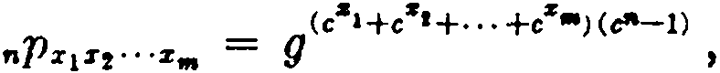
by substituting cw = ci:1 + C + ··. + c-z•,
71
we obtain
(9.14 )

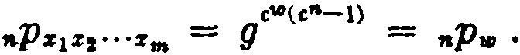

Thus, the joint-life status (x1X2 ··· Xm ) can be replaced by the single life (w ), and joint-life functions can be evaluated directly from single-life tables, it being only necess'lry to determine first the age of the equivalent single life from the relation

(9.15)
or (9.16)
In this case, w is the age at which the single-life force of mortality is equal to the force of mortality for the original joint-life statl;IB. It should be noted that the substituted single life (w ) is always oldcr than any of the original lives (x¡), whereas with Makeham's law the equivalent equal age is intermediate in value to the origi­ nal ages.
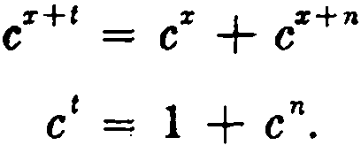
A law of uniform seniority holds also for Gompertz's law. The joint two-life status (x : x + n) may be replaced by the single-life status (x + t ) provided that

or Hence,

t = log (1 + en )
log e ·

The seniority of the substituted lif e can be measured equally well from the older agc, and, where this is done, values of t - n are tabulated for each value of n.
In the Gompertz case, the same table of uniform seniority may be used with any number of lives by simply replacing pairs of joint lives by single lives until the original age status is reduced to the age of a single life. The result is independent of the order in which the lives are rombined in pairs. This cxtension to more than two lives is not of great importancc since the agc of the equivalcnt single life is normally fractional, and it becomes necessary to in-

SEC. 7] SUMMARY OF NOTATION 203
terpolate in the table. It is usually easier to interpolate in the table of P.z or of c'z.
Table 7 shows annuity values at 3 % for a Gompertz table to­ gether with the table of uniform seniority. Suppose that the value of a60:i6 is required. We enter the table of uniform seniority with a diff erence in ages of 5 and obtain a seniority of 6.858, and, noting that the table measures seniority from the older life, we have (50:55) = (61.858). Then, by interpolation in the column of annuity values,
fl&O:i& = llsl .868 = 11.70476.
If the value of alio:ru6 is also required, we interpolate in the table of uniform seniority for a difference in ages of 65 - 61.858 = 3.142 t.o find (61.858: 65) = (72.645). Hence,
a60:i6:61i = a12 .6u = 7.88446.
- Summary of notation
  - The special symbol (x1x2 ··· Xm ) denotes a joint-life status in which the individual lives are aged x1 , x2 , • • • , x .. . When, for the sake of distinctness, it is desired to separate the ages in such a
status, a colon is placed between them; e.g., (20:25), (x + t : y + t ).
  - When a suffixed subscript consists of two or more ages with­ out any distinguishing mark, a joint-life status is intended. Thus:
lz11 , a20:30:40 ,
  - Brackets are used to denote select mortality; e.g., A l40J 16o 1 ,
[ [zJH:[111 +e •
  - When a joint-life status is involved and the absence of any distinguishing mark would lead to ambiguity, the symbol is
placed above the lives included-as in Ai:nJ .
  - Commutation functions
211+z1+···+z.
Dz1z1· ..z,,. = V "' lz 1 za· ..z,,.
1
1
Dz1za· ..z• = Dz 1 +c:z1+c:, .. :z,,.+c dt
z1+z1+· • ·+z..+l
Cz1z2 ..,z.. = V "' d:r 1z1 ...z.
1
1
Cz1z1 .. ,z,,. = Dz1+C:z1+c : ..,:z,,.+cµz1 +c:z1+C:• .. :z"'+c dt
The functions N , Ñ, S, S , M , M , R, R are obtained by summation in the usual way.

TABLE 7
UNIFORM SENIORITY I N A GoMPERTZ TABLE
Annuity Values at 3% Table of Unüorm Seniority

% a.: Difference of Ages 1 Addition to Older
Age

40 | 19.52384 | o | 9.122
41 | 19.19752 | 1 | 8.632
42 | 18.86680 | 2 | 8.160
43 | 18.53179 | 3 | 7.707
44 | 18.19268 | 4 | 7.273
45 | 17.84964 | 5 | 6.858
46 | 17.50283 | 6 | 6.461
47 | 17.15249 | 7 | 6.082
48 | 16.79884 | 8 | 5.721
49 | 16.44204 | 9 | 5.377
50 | 16.08243 | 10 | 5.050
51 | 15.72020 | 11 | 4.739
52 | 15.35566 | 12 | 4.445
53 | 14.98909 | 13 | 4.166
54 | 14.62080 | 14 | 3.902
55 | 14.25107 | 15 | 3.653
56 | 13.88028 | 16 | 3.417
57 | 13.50872 | 17 | 3.195
58 | 13.13677 | 18 | 2.986
59 | 12.76477 | 19 | 2.789
60 | 12.39309 | 20 | 2.604
61 | 12.02211 | 21 | 2.430
62 | 11 .65224 | 22 | 2.266
63 | 11.28381 | 23 | 2.113
G4 | 10.91726 | 24 | 1.970
65 | 10.55296 | 25 | 1.835
66 | 10.19131 | 26 | 1.709
67 | 9.83271 | 27 | 1.591
68 | 9.47754 | 28 | 1.481
69 | 9.12620 | 29 | 1.378
70 | 8.77904 | 30 | 1.282
71 | 8.43646 | 31 | 1.192
72 | 8.09883 | 32 | 1. 109
73 | 7.76647 | 33 | 1.031
7-t | 7.43975 | 34 | .958

204

REFERE:NCES

TABLE 1-Continued

.890
Annuity Values at 3% |  | Table of Uniform Seniority
% |  | Difference of Ages | Addition to Older  Age
75 | 7.11896 | . 35
76 | 6.80441 | 36 | .827
77 | 6.49642 | 37 | .768
78 | 6.19521 | 38 | .714
79 | 5.90105 | 39 | .663
80 | 5.61416 | 40 | .615

References
4. The values of cz shown in Table 5 are taken from Heckman (1946 ). This paper also gives joint-life mortality and commutation functions on. the 1941 eso basis with interest at 2> % and 3 %.
When Makeham's law holds, joint-life annuities can be com­ puted from a single-life table with a change in the rate of interest. The method is described by Jones (·1930) and forms the basis of Exercises 11 and 12.
The theoretical error in replacing an by aww is pointed out by Gershenson (1957 ).
- The data of Table 6 are taken from Thompson (1941 ). The extension of this method to three joint lives requires two tables of uniform seniority. It is illustrated by Spurgeon (1932), p. 259.
For the 1958 eso table, the complete table of uniform seniority and the tests of accuracy for various functions may be seen in the Report of the General eommittee on Publication of Monetary Tables, TSA 11, pp. 1049 ff.
- The data of Table 7 are based on the 1937 Standard Annuity Table, described by Kineke (1938).
A general treatment of laws of mortality which satisfy a uniform seniority principie is given by Greville (1956).

l, 2. Joint-life probabilities
EXERCISES

l. Express each of the following in tenns of the singlc-lif e probabilities
,.pz and ,.pi/ :

206 THE JOINT-LIFE STATUS [CH. 9

- the probability that (xy) will survive n. years;
- the probability that exactly one of the lives (x) and (1,1) will survive
n. years;
(e) the probability that at le88t one of the lives (x) and (y) will survive
n. yeam;
(d) the probability that (x11) will fail within n. years;
- the probability that at le88t one of the lives will die within n years;
- ) the probability that both lives will die within n years.
,q. , "'q" , .,q. :
- Express in tenns of .. and
  - the probability that all three lives (x), (y), and (z) will die in the
(n + 1)-th year;
  - the probability that none of the livee will die in the (n + 1)-th
year;
(e) the probability that at le88t one of the lives will die in the
(n + 1)-th year.
- Show that the probability that (x) survives -n years and (11) eurvivee
n - 1 years may be expressed either 88

or ae 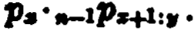

- Show that the probability that two lives (30) and (40) will die at the same age 188t birthday can be expressed 88
10Pae(l + e,o :co) - 2 11P1o(l + eco:,1) + p,0·11P1o{l + e,1:0),
- Joint-life mortality and commutation functions
  - Since lar = kl.l11 , a student assumes that the following relations are correct:
    - dar = kdst4
(b) ,..= kµ.p.,
(e) Psr =-= PsP11
(d) q,.,. = q.ql/
Which of these are incorrect? Give the correct expressions.
  - lf a special mortality table is derived from a standard table by the relationship = kp.z (k integral), show that ,p; == sPn···<l> .
  - Show that
a+;,
(a) Dz11 = k (l + i)•D.·D11
(b) c•• = tJD,.,,, - Ds+1:11+1
(e) D,.,,, = yD..·D""
  - Find the derivativee with respect to x of :
(a) log ,p,.,,., (b) In .

-'· Joint-life functions under Makeham.'• law
  - Use the fact that the 1941 eso table is Makeharnized to evaluate the following functions on the 1941 eso 2j% basis:

(a.) a,o :\o | EXERCISES | 207  (Ans. 13.33810)
(b) A ,o:'°  (e) P,o :H |  | (Ans. .65029)  (Ans. .04535)
(d) áao :,0:10 |  | (Ans. 13.56522)
Explain' how you would proceed if the 1941 CSO table were not Makeham­ ized.
  - Two single-life tables, one for male and onefor female lives, both fol­ low Makeham's law and have a common value of the constant c. From these two tables, a joint two-life table is constructed applying to pairs of lives one of which is male and the other fema.le.
Prove that by this joint-life table for a male life (x) and a female life (y)

ª·ti/ = ª"""
c:ie + kC'I

where

k being equal to
c"' = l + k '

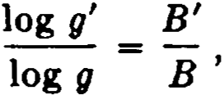
the primed symbols applying to the original female table and unprimed symbols to the original male table.
  - Assuming Makeham's law, show that
nPz11 = ,.E.,, ,

where e"' = c:ie + c11 and nE,,, is calculated at rate of interest i 1
8

1, 8

being the usual Makeham constant.
  - Prove that if a. mortality table is constructed according to Make­ ham's law the value of an annuity on m joint lives aged x , y , z , ··· calculated at a. rate of interest i is equal to the value of a single-life annuity at age w calculated at a rate of interest i' where
., 1 + i

i - .,--1
- 1.

Show tha.t the a.ge w may be detennined from the relation
J.l:,e + J.111 + P.a + • • •
11.-+,\ =
m

where

log m
h = -log e ·

5. The law of uniform seniority
13. (a) Use the table of unifonn seniority to evaluate a,0 ,,o on the 1941 CSO 21% basis. Compare your answer with that obtained in exer-

208 THE JOINT-LIFE STATUS [CH. 9

cise 9(a) and explain why there is not an exact areemen t. i n the two resulta. (Ans. 13.33769)
(b) Use the tables in Appendix I to compute an approximate value for
a,o :,o on the 1958 CSO 3% baais. (Ans. 14.08285) 14. Show that the law of unifonn seniority holds for two Iives when the
law of mortality is
JI.a = a + bx.
15. What is the formula for calculating the table oí uniform seniority for the joint-life table of Exercise 10?

- Joint-life functions under Gompertz's law
  - (a) Calculate a,o :7o from Table 7. (Ans. 7.10323)
(b) For the calculation of a6o:u:u shown in the text, verif y that the same result is obtained if the lives (55) and (65) are combined first.
  - With Gompertz's law, if (z) is the single life which is equivalent to the joint status (xy), show that there is a theoretical inaccuracy in writing
ª• = a.,., for a table which has a finite limiting age w. What is the correct
relationship? Why can the inaccuracy generally be ignored in practice? ·
  - (a) A mortality table for male lives follows Makeham's Jaw, and an­ other table for fema.le lives follows Gompertz's ]aw with the constants B and e the same as for the male table. Show that in the evaluation of a joint-life annuity on m male lives and n fema.le lives, all of unequal a.ges, m male lives of equal a.ge can be sub­
stituted for the m + n lives.
(b) Show how the table of uniform seniority may be constructed for the ca.se where m = n = l.
Miscellaneous problems

  - lf the Fackler valuation functions u.,., = DDss and k.,., =
z+l :z+l Dz-tl :z+l
are computed at a certain age y on a certain mortality basis with i = .03, it is found that u1111 = 4 kl/J/ . Find p., . (Ans. .86)
1

  - Compute eu:H if µ., = 00
1 - X
, O <; x < 100. (Ans. 25)

  - You are given the following probabilities:
    - The probability that three persons aged 20, 30 and 40 will live 10 years is .758.
    - The probability that a person aged 45 will die within 5 years, while another pereon aged 40 is alive at the end of 5 years, is .063.
    - The probability that four persona aged 20, 25, 30, and 35 will live for 5 yeare, while a fif th person aged 40 will not be alive at the end of 5 years, is .045.
Find the probability that a person aged 20 will be alive at the end of 25 years. (Ans. .812)

EXERCISES 209

  - A mprtality table is graduated according to Makeham's law: JJz
A + Be"' .A new mortality table is constructed such that
p.; = A' + B'c"' ,
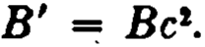
where

1
A' =
2

and

Express az , based on the new mortality table, as a single-life function de­ rived from the Gompertz table which is a specialization of the original Makeham table.

CHAPTER 10

LAST-SURVIVOR AND GENERAL MULTI-LIFE STATUSES
l. The last-survivor status
In the last chapter we noted that a body of m lives, considered as a single collective entity, can be said to fail upon the first death among its component Iives, or upon the death of its last surviving member, or arbitrarily upon sorne intermediate death. The con­ cept of group failure upon the first death leads to the joint-Iife functions; thé major alternative, that of defining the failure of the group as occurring when its last survivor dies, leads to the last-survivor status and the various functions of that status. The expressions "longest-Iife" and "joint-and-survivor" are also used in insurance practice as synonymous with "last-survivor."
The symbol (x1X2 • • • x,,J denotes a group of m lives aged x1 ,
x2 , ··· , X m , comprising a last-survivor status. The group con­ tinues to exist as long as at least orw of (x1), (x2), ··· , (x,,. ) is alive, and fails upon the occurrence of the last death.
The symbol nP:,;1:,;1• • ·:i:m denotes the probability that the last­ survivor status (x1x2 • • • Xm ) will survive for n years. This function may also be described as the probability that at least one of the lives (xi), (x2), ··· , (xm) will survive for n years, or as the proba­ bility that the last survivor will be alive at the end of n years. There is, of course, no way of knowing at the outset which one of the lives will be the last survivor. It should be understood that the language, "the last survivor will be alive," does not imply that none of the other lives will also be surviving; it is merely an alternative way of saying that at least one of the lives will be in existence.
It is evident that nP:i:1:,;1• ..:z,,. may be expressed as the comple­ ment of the probability that all the lives will die within n years. Thus,
nP:z1:z1 ...:z,,. = 1 - (1 - nP:z1 ) (1 - nP:z1 ) ··· (1 - nP:,;.)
= (nP:z1 + nP:z, + · ·· + nP:i:..)

SEC. l] THE LAST-SURVIVOB STATUS 211

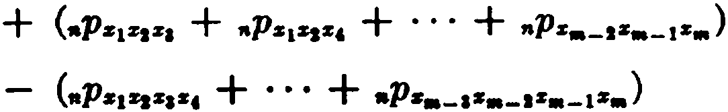
+ ···
+ (-1)'"+1.p.,....... .
This expression may be written more concisely as follows:
"P•1•1···s.. = L aPs1 - L •P•1s1 + L t1Ps1•1•1
- L 11Ps1sa:r1•, + ... + (- l )'"+ 11Ps1:r1, ,,:l'..
1

(10.1)

where the summa.tions are understood to cover a.11 possible com­ bina.tions of the lives taken one at a time, two at a time, three at
a. time, a.nd so on. It is thus evident that the proba.bilities of sur­ vival for the last-survivor status ma.y be obtained in terms of single-life and joint-lif e probabilities.
The probabilities of failure for the status (z1z, ···z ) may now be defined in terma of.p;¡;¡:-;:.;; .The probability that the status will fail within n years is
.q•1•1···•• = 1 - •P•1s1···•• • (10.2)
The probability that (z1z. ···z.) will fail in the (n + 1)-th year is given by
"'q•1•1···•• = t1P•1•1···•• - •+11'•1•1···•• · (10.3) The most common last-survivor functions are those which in­ volve only two lives or three lives. In these cases, asswning that
the lives are (x), (y), a.nd (z), we have from (10.1)

,.p., = L.p. - ,.p.,, =.p. + "p,, -.p.,,
11P'iii = L.p. - L .p,,. + .p.,,.
(10.4)

=.p. + ,.p,, +.p. _.p.,, -.p.. - ,.'J),¡, + ,.p.,,.. (10.5)
Other functions can be expressed in a similar wa.y; for exe.mple,
,.q., = 1-.p;; = 1 - (.p. +.p. - ,.p.,,)
= ,.q. + •Ir - ,.qs,,
= L.q. - ,.q..,

212 LAST-SURVIVOR AND GENERAL MULTI-LIFE STATUSES [CH. 10
(nPz + nP11 + nPz - nP%JI - nPzz - "P111 + nP%Jlz )
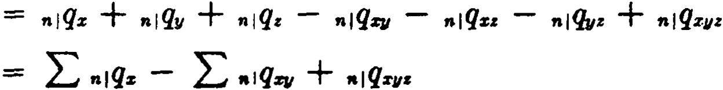
(n+lPz + n+1P11 + n +tPz - n+lPZJI - n+lPza - n +lP•z + n+IPz¡,,,)
00
ªzr• = L vt ,piiíz
t ...1

00
= ,L-1 v' (ePz + tP11 + ,p, - tP%11 - tPzz - 1P11z + tPZJlz )
O:r + ay + az - ar¡¡ - a:r, - llvz + ªZJIZ
= Laz - L ª%JI + az¡¡,
In each of the special cases considered above for two lives and for three lives, it will be observed that the forro of the result is the same as the form of (10.4) or (10.5). It will be apparent upon reflection that this is not merely coincidental, but that the similar­ ity follows necessarily from the manner in which each of the func­ tions depends upon the probabilities of survival. The functions,
1

nq, n 1 q, and a, can ali be expressed
as linear combinations of the

values of ,p. lf we let F (,p ) denote such a linear function of ,p,
it will follow from the property of linearity that
F (,Pz1z1 ..·z,,.) = F ( LtPz1 - L 1Pz1z1 + ··· + (-1)m+I tPz1z1· ..z.)
= F (L tPz1 ) - F ( L tPz1z1) + ·' · + ( -1)m+l F (ePz1zr•z 11J
= L F(ePx1 ) - L F ( iPz1z, ) + ··· + (-l)m+IF(,P:r 1z1...z11J,
Hence, any last-survivor function, Fs1z1...z. , which can be written as a linear combination of values of ,p, may be expressed in terms of
single-life functions F:.1 and joint-life functions F zizs , F z1z1s1 , • • ·,
Fz1:z1...z. , in accordance with the relation
F = (10.6)
. 1 The function nq becomes linear in ,p when written as op - ,.p, where
•P = l.

SEC. 2] COMPOUND STATUSF.S 213

The nét single,premiums for the common annuity and insurancc benefits can normally be expressed as linear combinations of the probabilitics of survival, and relation (10.6) therefore holds in these cases. Examples of functions which are Mt linear in ,p are net annual premiums and reserves. For example,
P=. = A;, = A.1: + A. A
SJI a;; as + d. - a.tll '
which is clearly diff erent from Ps + P. - PSIi • For the reserve va.lue, the expression to be used depends upon which lives are still in existence at the time of valuation. Thus, in the case of the insurancc Aii , the t-th year terminal reserve will be
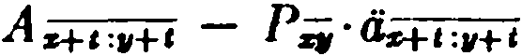
if (x ) and (y ) are both alive,
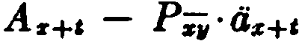
if only (x) is alive,
or
A•+• - P;;,·<4+1
if only (y ) is alivc.

- Compound statuses
Both the joint-life status and the last-survivor status have been defined only for groups of single lives. It is possible, however, and frequently useful, to relate these concepts to groups of individual statuses which are not necessarily single lives. For example, the annuity a;;:.. is payable during the joint existence of the last survivor of (w) and (x) and the last survivor of (y) and (z) ;the com­ pound status (wx: yz ) is a joint status of which the individual com­ ponents are themselves last-survivor statuses. As another example, the insurance benefit represeilted by A ..:;; is paya.ble when the second failure of (wx) and (yz) has occurred, so that (wx:yz ) is a compound last-survivor status of which the components are a joint-life status and a last-survivor status.
Functions of this kind can always be expressed in terms of single­ life and simple joint-life functions. The procesa will be illustrated for the two cases cited above.

214 LAST-SURVIVOR AND GENERAL MULTI-LIJ'E STATUSllS [CH. 10

IO
L
a;.:wi = ,-1t1\p;;:;.
•
= ir'cP-·,p.; (since both (vr.i) and (pi) must survive)

tD
= L v' ( ,Pt,, + tPs - ,p..:,: ) ( 1P11 + ,p. - 1P11: )
e-1
ao
L,-1 v' (,Pv:11 + t'Pvz + tPZN + t'Pu - t.1'"'1J z: - ,p.q, - ,p.""
- ,P111:sz + t'Ptn,,z )
= a,,,,.,.+ a.,, + G:q, + Osz - 0.,,.s - a:,:,,• - tlw:q, - 6-.i + iJu.qz
Á111s:p = L,-a vf+\¡qvs:is = L,,..11&+1 (,Pvs:ii - HlP111s:ii)
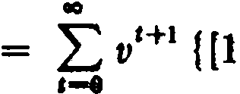 (1 - ,P,u) (1 - ,p;;)}
(since ,Pws:ii is the complement of the probability that both (wx) a.nd (yz) will fail in t years)
IO
L
= ,... vt+I {[1 - (1 - •P111s)(l - ,,,,, - ,p.+ ,.)]

IO
= L l't+1 (,p,, +
t'P,,11 + •P•s -
•P•m + ,Pnr-}

,-e [
1P11 -
1P.st1 -

(1+1Pw + HlP• - HlJlr,z + HIPvs - HlP.iW
- Hl]),,s. + H1Pw311•)]
ao
= L,-o a,Hl (etfit + ,,q.. - ctfp + t¡qvs - tl9w. - tlfwa
+ •tfwap)
= A. + A. - A,,z + A.s - A•• - A111n +A .... •
While it is of fundamental importance for the understanding of the subject that the student be able to resolve compound expres-

SEC. 2] COMPOUND STATUSF.S 215
sions of this type into their single- and joint-life elements, it will be noted that in practice the expansions required can become tedious. Certain general relationships between last-survivor and joint-life statuses make it possible to reduce very markedly the steps needcd for these expansions.
Consider first the function a;., where (u) and ( v ) represent any type of status thus far defined-single-life, joint-life, last-survivor, or term-certain. Whatever the individual statuses (u) and (v ) may be, we know that the last-survivor annuity a.; will provide annual payments of 1 for a period determined by the longer surviv­ ing status. On the other hand, the joint-life anuity a,,., provides payments only during the existence of the shorter surviving status. Hence, a;. provides an annuity payable during the continuance of one of the statuses (u) and (v), and a1n provides an annuity on the other. It follows that

whence
ª•• + ª•• = a. + ª• ,
a;; = a,, + ª• - ª•• . (10.7a)

It. will be observed that the two-life case of relation (10.6)· ap­ plied to annuities is merely a special case of the above result. Similar reasoning produces an analogous relation for the present values of insurances:
A;; = A" + A. - A.... (10.7b)
Next consider the function ª"=;; , where again the statuses (u), (v), (w) are not necessarily single lives. This function provides annuity payments for as long as (u) survives jointly with the longer
surviving of the two statuses (v) and (w). The function ª"- , on
the other hand, provides payments for as long as (u) survives jointly with the shorter surviving of the two statuses (v) and (w). Hence, a.:;; ispayable during the continuance of one of the statuses
(uv) and (uw), and ª".. provides an annuity on the other. It fol­ lows that

whence
a.:;; + a.- = a.. + a.. ,

a.:;; = a.,. + a.,.. - a.- . (10.8a)

216 LAST-SURVIVOR AND GENERAL MULTI-LIFE STATUSES [CH. 10

The corresponding result for insurances is
(10.8b)
The two examples discussed earlier may now be used to illustrate how these general relationships reduce the number of steps needed to ob\ain the required expansion. Thus, for the function a;;:;; , we use (10.8a) :
a;;:rz = aw:v + aw : : - Uwi :vr .
Applying (10.8a) a second time,
a;;:iii =
(°"'1, + aZJ/ - llu.ZJI) + (au,z + a:rz - llwu) - (a..i.,z + az - ª"'ZJIZ ),
agrecing with the previous result.
Similarly, A w:r:"i is first expanded by (10.7b) to
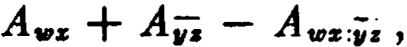
and then expanding Ai,i and applying (10.8b) to the term Avziz ,
we find
Á w:r :ii"i = Áv:r + (A + Á z - Á yi ) - ( Avzv + A ,m - Á wJ.11:),
as before.
It should be noted that the general reasoning by which formulas (10.7) and (10.8) have been derived is equally valid when the compound status involves a term-certain. Consider an annuity pay­
able until the death of (x ) or until (y ) attains a.ge y + n, whichever
period is longer. The two statuses are (x ) and (y:n]), and the an­ nuity is payable during the continuance of the last-surviving status. We thus have, from (10.7a),
ª<s>< :iil> = a:r + O., :ñj - aZJ1:"'ii1 .
If the annuity is paya.ble until (x ) attains age x + n or for m
years certain, whichever is longer, the statuses are (x:ñj) and
(mj), and we have ª<:r:ñl><ml> = as:iil + ªiiil - as::iil:tiiJ . For m < n,
the status · (mi ) fails before the status (nj), and hence the joint
status (x:n¡:mj) is the same as (x:mj). The function a:r :ñliiil can be written in this case as a:r :-I . We thus have
m < n.

SEC. 3] THE GENERAL MULTI-Llll'E STATUS 217
An aruruity payable w1til either (x ) attains a.ge x + n or (y )
attains a.ge y + m (m < n), whichever period is longer, has the
present value
ª<z:"ñl) c.,:-J) = az:nl + llw:-1 - aq:ñJ:;;J
= az:ñl + =-1 - ª-:-i , m < n.
- The general multi-life status
The joint-life status and the last-survivor status may be re­ garded as special cases of a general multi-life status. Let the m
lives, (xi), (x2), ··· , (x.), comprise a status which is defined as surviving as long as at least r of the individual lives survive and
which therefore fails upon the occurrence of the (m - r + 1)-th
r

death. This general status is denoted by the symbol (x1Z2 • • • Xm ) . When r equals m, this reduces to the joint-life status; when r equals 1, a last-survivor status is defined.
The symbol nPz1z1 . ..:... denotes the probability that the status
r
(x1Z2 • • • x..) will survive for n years, that is, that at least r out of the original m lives will still be in existence n years hence. In order to evaluate this function, it is first necessary to find an expression for the probability that exacay r lives will be surviving at the end
(r]
of n years, denoted by ,aPz1z1 • • •S111 •
If the m lives are all of the same a.ge x, the probabi]ity that exactly r designat.ed lives will be surviving at the end of n years,
the other m - r being dead, is clearly
(,aps)" (1 - •Ps) "'-r.
Now there are (:') ways of selecting a group of r lives out of m, and the probability that any group of exactly r lives will be sur­ viving, and the others dead, is
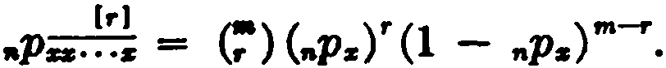 (10.9)
Note that this expression is equivalent to the coefficient of (
in the binomial expansion of {,aps·t + ,aqst'.
Suppose now that the m lives are not ali of the same age. The probability that exactly r specified lives, (xi), (x2), ··· , (xr ), will be surviving at the end of n years and the others dead is

218 LAST-SURVIVOR AND GENERAL MULTI-LIFE STATUSES [CH. 10

nPz1 " ,iP:r:1 ··· nP:r, (1 - nPzr+ l ) (l - nPzr+t ) ·' ' (1 - nP:a:,,J .
The probability nP:a:1:a:1... is the sum of all such expressions con­ taining exactly r factors nPz¡ and exactly m. - r factors 1 - nPz¡ • To find this sum, we write the following product:
(nP:a:1 ·t + nqz1 HnP:a:1 ·t + ,.q:rt ) ··· (nPz,,. ·t + nq:r,,.) •
In the expansion of this product, the coeffi.cient of { is the sum of all the terms which can be formed by multiplying r factors of the form nPz, and m. - r factors of the form nq:a:¡ , and is thus equal to
the required sum for nPz 1z1• • • • We rewrite the product as
[1 + (t - 1) nPz1Hl + (t - 1) nPz1] ··· [1 + (t - 1) nP:rm]
= 1 + (t - 1) Z1 + (t - 1)2 Z2 + ··· + (t - 1)"' Z ,,. ,
where Z, denotes the summation ¿nPz :a: ...:r. taken over all the possible combinations of s lives out of m.. Now t appears only in the terms involving Z, where s r. The coefficient of t in the
1 1
term involving z. , that is, the term (t - 1)' Z, (s r ), is
(-1)'_,. (. )Z, .
Hence the total coeffi.cient of t" is
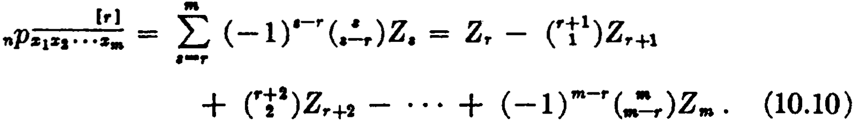
The presence of the binomial coefficients in this formula suggests
the following formal device. If we regard the indices of Z as expo­ nents and assume that zt = O for t > m, the formula may be
written in the following symbolic form:
(r] zr

n"P"'z-1z-1·-··:a:. = (l + Z) r-+-1 •
(10.11)

As an example of the use of formula (10.11 ), we obtain the probability that exactly two of the four lives, (w ), (x), (y), (z), will survive for n years. Since m = 4 and r = 2, we first write

0 !'Z)• = z
2
- a.za + 6z4.

Then,

SEC. 3] THE GENERAL MULTI-LIFE STATUS 219
"p;;;¡ = nPvs + nPt1111 + nPvz +--,.pJIII + nP:n + tt'P,¡:
(t] .
- 3 {nPtozr, + ttPvsz + •Pt1111z + •Ps ) + 6 •P•s,,: • A partial check can be obtained by letting nP = 1 for each single life. We then find
.p.;.. = 6 - 3· (4) + 6 = o.
(t]
This is clearly correct since if each life is certain to survive, the probability that exactly two will survive is O.
We now retum to the probability •Ps1s1... .that at least r lives will survive for n years. We shall show that this probability can be expressed as follows:
.
.
nPz1z1 ·• •zr = ,L....J,. (-1),-,. (,'--rl ) Z , = Zr - (r1 )Zr+l
111
+ (11)Z,.+2 - ··, · + ( -l)m-r (::)Zm . (10.12)
The proof is by induction on r. When r = 1, the formula is
nPs s • • •1s• = Z1 - Zs +· Za - • • · + ( -1)"'-1Zm .
1 1
Since this is equivalent to (10.1), we see that the formula is va.lid in this case. We now show that if the formula holds for 1· = k, it also holds for r = k + l.
i+l .1: (11)
=
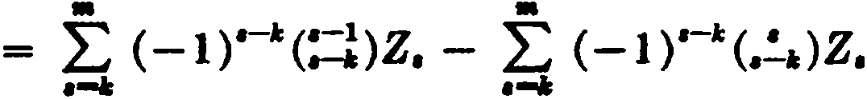
•Ps¡s1·-·-s. nPs1sa···s• - ttPs1s1• ··••

= L•
,-11
(-1)-.1:( <:=l ) - (. .;)]Z,
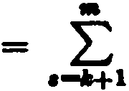
-l)a-1:-1 ( ,-1 )Z
(
•-:--.1:-1 ''

where the expression (::l) - (. ) has been replaced by - (,;1)
for s k + 1 and by O for s = k. This relation is familiar from
Pascal's triangle of the binomial coefficients; it can be easily derived as an algebraic identity. Since the result is the same as
(10.12) for r = k + 1, the induction is complete and we conclude
that (10.12) holds for ali positive integers r . The formula may be written in symbolic form as

220 LAST-SURVIVOR AND GENERAL MULTI-LIFE STATUSES [CH. 10
r zr

nPs1s1·· ·s.. = .(.,.l_.
+_z-=) r (10.13)

As an example of the use of formula (10.13), we obtain the probability that at least two of the three lives, (x ), (y), (z ), will be alive at the end of n years. Sincc m = 3 and' r = 2, we first write·

Then,
z2 2
(1 + Z) t = z - 2.z'.
t

nP'iir = ,.pSfl + nPu + nPuz - 2 •P:sJ1• •
As a check in this case, if we lct "p = 1for each single life, we have
2
.p;.. = 1 + 1 + 1 - 2 = l.
If each life is certain to survive, the probability that at least two will survive is 1.
zr
The expression (l + zr of formula (10.13) may also be used to
expand any linear function of the probability •Psisa ... .in tenns of the corresponding joint-life functions. For exa.mple,
ªivi = as¡¡ + ª= + .- 2as¡¡.
2 '
A;;. = A.SIi + Aw:u + Á w¡,, + Á s¡¡z - 3A.,:q¡• .
1
When the insurance symbol is used in this way, it must be kept in mind that ...4s1z1... .. represents an insurance paya.ble upon the
r

failure of the status (x1x2 ·• ·x,.) .The insurance, therefore, is pay­ able not at the r-th dea.th but at the (m - r + 1)-th death.
Similarly, the expression ( 1 +Zy+1 of formula (10.11) may be
used to expand linear functions of ,.ps1s1 • • . As an example, the present value. of an annuity of 1 payable at the end of ea.ch yea.r if exactly one of the three lives, (x ), (y), and (z), is then surviving is given by
•
. = as + + ª• - 2 (a. + ªª + a.,.) + 3a_• .
(1)

SEC. 4] BUMMABY OP NOTATION 221

It should be noted that this benefi.t is a fonn of deferred annuity, no pa.yments being made until two deaths have occurred. The expression can be checked by noting the annuity payments that are provided while the diff erent numbers of lives are surviving. When ali three are a.live, ea.ch of the annuity functions contributes
a payment of 1, and the total payment is 1 + 1 + 1 - 2 - 2 -
2 + 3 = O. When exa.ctly two are alive, there is a payment for two
of the single-lile functions and for one of the two-life functions, and the total payment is 1 + 1 - 2 = O. When exactly one is alive,
there is a payment of 1, as required, from one of the single-life functions. This is also a useful device for checking the corresponding probability expansion.

- Summary of notation
If a horizontal bar appears aboye a suffixed subscript, then survivors of the lives, and not joint lives, are intended. The number of survivors is denoted by a symbol over the right end of the bar. If that symbol, say r, is enclosed in brackets, the meaning is exactly r survivors; without bra.ckets, the meaning is at least r survivors. If no symbol appears over the bar, then unity is assumed and the meaning is at least one survivor.

References

3. The formula for nP:i1z1... was derived by Waring in 1792. In its general form, Waring's Theorem gives the probability that exa.ctly r out of m events will occur, and thus has wide applications. The theorem is discussed in standard texts on probability, e.g., Bizley (1957). White and Greville (1959) ha.ve discussed computa­
tional devices which simplify the application of the theorem. A related method of computing the values of the individual shares in a last-survivor annuity has been given by Rasor and Myers (1952). The proof by induction for formula (10.12) was suggested by
Harry Gershenson, F.S.A.
EXERCISES
l. The last-surviror status
l. Show that q = qz· q11 , and give an nlternative expression in terms of
qz , q11 , and qz11 •

222 LAST-SURVIVOR AND GENERAL MULTI-LIFE STATUSES [CH. 10

- Express each of the following in terma of single- and joint-life func­ tions:

(a) 4-..
l
(b) P.i:.J

- Find the probability that at least one of the two lives (z) and (y) will die in the (n + 1)-th year. Is this the same as nlqi; ? Explain.
- Describe the benefit whose net single premium is nlaii . Show that
,il<Jii is not equivalent to tl'nPs.,ai+a:.+11 nor to 1111,,p.;a . Give a correct expression for "1a.. .
- Given a mortality table following Makeham's law and two ages x
and 71 for which (ww) is the equivalent equal-age status.
(a.) Show that ,p. is the geometric mean of ,p. and ,p,, .
(b) li x "F y, show that ,p,. + ,p11 > 2cp., and hence that a.. > a- .
- Given <iz11 = a.. on a Makehamized mortality table, and y < x. Rank
the following in order of magnitude: a11 ,a., , , a- , a;; , a;; .

- Compound statuses
  - Describe the benefit whose net single premium is denoted by A s:wl •
Show that As:i) = A. - Ás:'il + 1111•
  - Show tha.t
a.:;. = a; + a¡; - a-.. '
and explain by general reasoning.
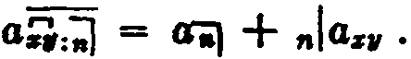
  - Show that
Describe this benefit.
  - Express a.,,.:;¡; in terms of joint-life annuities.
  - Express in annuity symbols th value of an annuity of 1 payable at the end of each year until the survivor of (25) or (30) reaches age 50, or until bis death if both lives die before attaining that age.
  - Express in annuity symbols the value of a deferred annuity of 1pay­ able as long as either (25) or (30) is living after age 50.
  - Give an expression for evaluating a.:11:ñ) in terms of annuities-certain and single- and joint-life annuities.

- The general multi-liíe atatua
  - Show that the symbolic formula
r zr
.,...... = (1 + ZY
may be obtained form&lly by an algebraic summation over a of

EXERCISF.8

l•J ze
,••...• - (1 + z).+1.
  - Express in terms of single- and joint-life probabilities:
1
    - •P•
(b) .p:
  - Describe in words the probability indicated by the following expres­ sion:
,p,.I< + ,p..,, + ,p,.. + 1Pic11 + ,p•• + 1P11•
  - Give an expression in terms of joint-life annuity values for the net single premium for an annuity of 1payable at the end of each year if exactly 3 of the 4 lives (w), (x), (y), (z) are then alive.
  - Find the value of au!, given that

aun = 11.900, au.u.s = 10.750 and ª•.u.rn = 9.675. 19. Prove mathematically and by general reasoning:
(Ans. 1.125)

(1 1
=
a.,. - as.- a.;; .
- Express in terms of annuity values and the rate of discount the net single premium for an insurance payable at the end of the year in which the third death occurs among the four lives (w), (x), (y), (z).
1
- Obtain an expression for evaluating a..:;:;. , an annuity-due paya.ble
for as long as (w) survives jointly with at least two of the lives, (x), (y),
and (z).

Miscellaneous prohlems
- A partnership is formed by five men, all of whom are aged x exactly. Find:
  - The probability that not more than three of the original partners will be alive at the end of n years.
  - The probability that not more than one of the original partners will die in the n-th year.
- An extra.et from a ta.ble of joínt-life annuities valued at 3 % reads as follows:

Ace of LiveÍ
26: 20: 28
29: 26: 20
28: 29: 26
20: 28: 29
29: 26: 28: 20
Net Single Premium Joint-Life
Immediate Annuity
14.40
14.30
13.80
14.00
12.50

224 LAST-SURVIVOR AND GENERAL MULTI-LIJ'E STATUSE8 [CH. 10

Find the net single premium for an insurance of $1000 payable at the end of the year of death of the second life to fa.il out of four lives aged 20, 26, 28, and 29. {Ans. $324)

- An annuity of 1 is payable to (x) a.nd (y) on a last-survivor basis commencing at the end of m + k years, provided that both lives survive m
years. Show that its present value is
- An annuity of 1 is payable yearly to (2:) as long as he livea jointly with (y) and for n years after the death of (11) except that in no event will
payments be made after m years from the present time, m > n. Show that
ita present value is
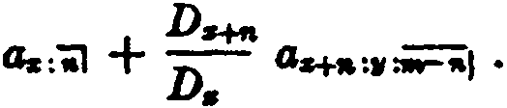
- An insurance of 1 is to be payable in the event that (z) dies before age x + n and (y) dies before age y + m, where m < n, the face amount
becoming paya.ble at the end of the year in whicb the second death occurs.
Show that the present value may be expressed as
l l
+
A;;ii¡ v•,.p (1 - p )Ai+tii :11-1 ,
&nd that the net annual premium would be determined by dividing by
4;;:tii) + .,.,,..pz(l - ..p.)az+•= ii=iiil .
'Zl. Last-survivor annuities often provide for a reduction in the amount of the annuity payment after the first deatb. An n-year temporary annuity­ due payable to (xy) provides annual payments of 1while both lives survive, reducing to M on the death of (x) or to on the death of (y). Express the present value in terms of annuity vales.
- An annual annuity is to be payable so long as any of the lives {w), (x), (y), and (z) survive. At each death the rate of annual payment is re­ duced 50% from the rate in effect prior to such dea.th. Find a simplified
expression involving only single- and joint-life annuities for the cost of the contract per unit of initial annual payment.
- Obtain an expression in annuity eymbols for the net single premium for a continuous annuity of 1per annum payable wbile at least one of the two lives (40) and (50) is living and is over age 60 but not wbile eitber of them is living under e.ge 55.

C1u.PTER 11 CONTINGENT FUNCTIONS
l. Introduction
In the various types of multi-life status discussed in the pre­ ceding chapters, the component Iives are not distinguished ac­ cording to the order in which they die. The status (xyz), for exam­ ple, terminates upon the first death, whether it is the death of (x), of (y ), or of (z) ; and the status (xyz) terminates upon the last death regardless of the particular order in which the individual deaths occur.
A different group of functions is required in situa.tions where the order of deaths is significant, as, for exa.mple, in the ca.se of an insurance paya.ble upon the death of (x ) provided that he dies before (y). Functions of this type, depending upon a. specified order of deaths, are k.nown as contingent functions.
The present chapter deals only with the simplest class of con­ tingent function-that in which the order of failure is prescribed with reference to only one of the individual components involved. A subsequent chapter will describe functions in which the order of failure is prescribed for more tha.n one of the components-the compound contingent functions.
- Contingent probabilities
When the lives of a group are all of the sa.me age and subject to the same mortality, ea.ch has the same chance of dying first, or second, and contingent probabilities a.re easily eva.luated by reference to the possible orders of dea.th. Thus, in the case of two lives ea.ch aged x, the probability that a specified one of them will die first is simply equal to j. Similarly, the probability that the specified life will die first and within n years is
l ·,.q.,
"q= representing the chance that the joint lifetime ends within n years, and j being the chance that it is terminated by the failure of the specified lif e.
In general, the lives involved a.re not of equal a.ge. Consider

226 CONTJNGENT FUNCTIONS (CH. 11

first the case of two lives aged x and y, and let q_!. denote the probability that (x) will die before (y) and within one year­ in other words, that the joint lifetime will fail within one year beca.use of the death of (x). This proba.bility may be expressed in definite integral fonn as

1 .
q. = 1tPzw#'z+c
·dt =
0
1 [1
Za+t
0

:w+ll's·H

dt, (11.1)

since the differential iPzrP•+ , dt represen the probability tbat
(z) will die at the moment of attaining age x + t, (y) being still
alive.
The other basic contingent probabilities for two lives may be written as follows:

.q!_ = 1·tPSlll'z+c dt
.q!., = f..11';.,.+1 d,
•+I

( 11.2)

(11.3)

•I = f•
aP-H dt.
(11.4)

Note the symbol used in (11.3) for the probability that (x) will
die before (y) with no Iimit on the time of death.
If the specified life (x} is to die second within n years, the proba­ bility is
.q!tt .= f.ª ,pz( 1 - aPw) l'a+c dt.
= lª 1PJJ.s+1 dt f.ª •P-"s+c dt
= ,.qs - ,.q,1,.. (11.5)
The result may be obtained by general reasoning, since if (x)
dies within n years he will die either before or after (y); i.e., ,,,qs =
,.q + ,.q!i, .
The probability tha.t (x) will .die second and during the
.(n + 1Hh year may similarly be seen to be
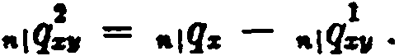
(11.6)

SEC. 2) CONTINGENT PROBABILITIES
Note that (y ) need not die in the (n + 1)-th yea.r, but may die at a.ny time preceding the death of (x).
The probabilities involving three lives, contingent upon the death of a specified life (x), are as follows:

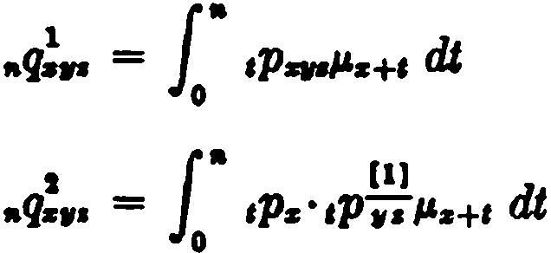
(11.7)

= f.ª tPs(,p. + tP• - 2,f)w.)#'s+I dJ,
= .q1.. + .q•1• -q""q•1•• (11.8) 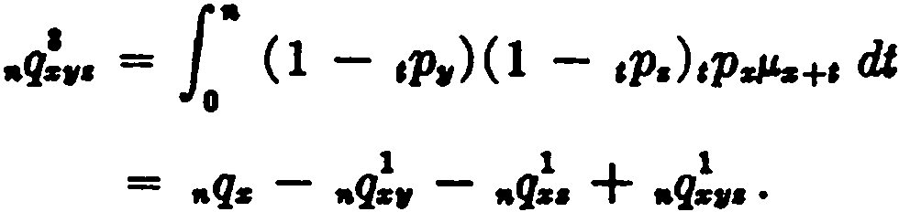 (11.9)
The probability "=• , that either (x) or (y) will be the first to die within n years, is an instance of a. function in which the specified status is not a single life:
•t..1=• = .q1... + .q.,1,• . . {11.10)
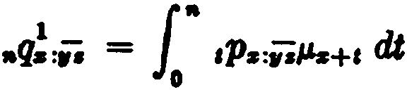
The probability that (x) will die within n years and before the suryivor of (y) and (z) is

= f.ª 1Pa( 1Pw + •P• - 1Pw•)l'sH dJ,
= .q•1• + .q1.. - ,.q1.. . ( 11.11)
This function may also be described as the probability that (x) will die either first or second a.nd within n years, and an alternative formulation is
.q1.:1.. = ,.q1._. + ,.q.1_• . (11.12)
In view of (11.8), this la.tter expression may easily be seen to be equiva.lent to that obtained a.hove. Another expression for this

228 CONTINGENT FUNCTIONS . (CH. 11

probability is

.qz - .q1_. .

Consider the function n :.i , representing the probability that the survivor of (x) and (y ) will die within n years, predeceased by (z). In fonnulating this probability as a definite integral, it is necessary to express the diff erential probability that the survivor of (x ) and (y ) will die at moment of time t. This expression is
[,p:r (I - ,p,,)µ.:r+ e + ,p,,( l - ,p:r )+ ,J dt

or

Hence

( tPzJJ.z+ 1 + tP""1,+ I - 1P%flll.:r+ I:+ I) dt.

nq};:z = i" (1 - t Pz )( t Pzµz+I + t P11P.,,+1 - 1P:rt1µz+l :11+1 ) dt
- Evaluation of contingent probabilities
In the elementary case where the lives are of equal age, con­ tingent probabilities can be evaluated directly from general probability principies. It is sometimes helpful to write the integral expression and carry out the integration as a check on the direct reasoning.
For three lives all aged x, we know that the probability that a specified life will die first within n years is
nq;u = 3, ·,aq=:r = Í [l - ("Pz ) 3
],
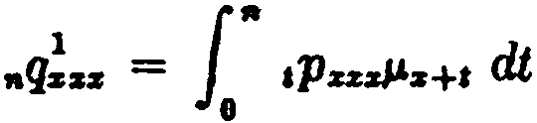
Using the integraf form, we have
= f' (,p:r)2,Ps_!' +' dt
- f t-n (,p:r )2d( tPz )
,-o
[- 73 (,pz)3] = 73 [l - ("p:r )3].

SEC. 3] EVALUATION· 011' CONTINGENT PROBABILITIES 229

It is important to distinguish this probability from two others that are similar.
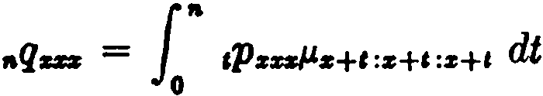
  - If the failing life is not specified, the probability that the first death occurs within n years is simply the probability that the joint-life status fails within n years:

= l• aP=z ·3µs+t dt
= 3nq!u = 1 - ( nPz )3.
  - The probability that a specified life dies within n ycars an<l the other two survive the n-year period is
l" tPzµz+t ·nP:u dt = nqz • nPzz = ( 1 - nPz )( nPz )2•
If the failing life is not specified, the probability that exact]y one will die within n years is 3(1 - nP,J (nPz/.
Suppose that the three lives aged x are A, B, and C. What is the probability that either A or B will be the first to die within n years? The joint lifetime of A and B must fail before C, and hence the solution is given by n<T=:z . Using (11.10), we find nq:z =
2 nq!zz = % [l - (nPz )3 . The solution by integration is
)
n :z = l" ,puµz+e :z+t ·ePz dt
= 1" t Pzzz · 2 l'z+I dt
= 73 [1 - (nPz )3).
When these functions involve lives of unequal age, the integra­ tions cannot be directly carried out and special methods must be used. Standard methods of numerical integration are available which can be programmed for a digital computer if a large volume of calculations must be made.
Another method of evaluation is based upon the assumption of a uniform distrihution of deathR. In thc formula
1
1
qI/ = t P x11µx+t dt ,

230 CONTINGIINT l'UNCTIONS [CH. 11

we substitute from formula. (1.24b)
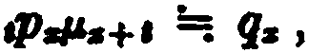

and obtain
1 :.... 11 dt :.... dJ.+l

( 11.14)

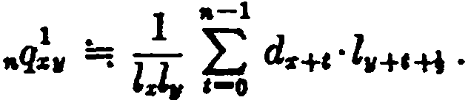
where Z.+l is taken as j (Z. + 4+1). Then
qªJI q. o ,,. lJ.

( 11.15)

A similar approxima.tion can be used when more than two lives
are involved:
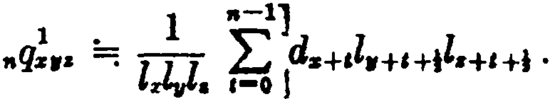 (11.16)
When either Gompertz's or Makeham's law applies, special formulas are available which make possible an cxact evaluation. For instance, with Gompertz's law,
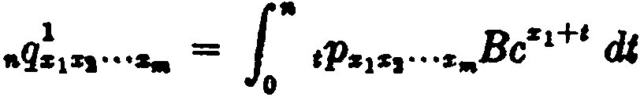
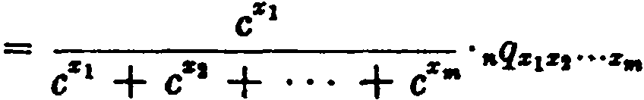

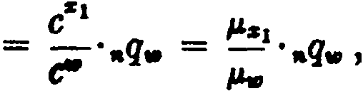 (11.17)
where w is the age of the equivalent single life. A special case of the above result is
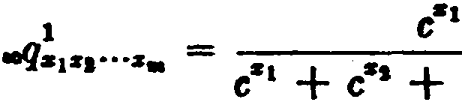 (11.18)
We may then write
,.qs1•t···z• = ooqs1z1 ..·••',aq:a:1:a:1···•• • {11.19)
1 1

SEC. 3] · EVALUATION 011' CONTINGENT PROBABILITIES 231

Thus, with Gompertz's law, the proba.bility tha.t (x1) will die first within n years is equal to the proba.bility tha.t (x1) will be the 6.rst to die multiplied by the proba.bility that the joint lives will fail within n years.
A precise fonnula. may a.lso be obta.ined when Makeham's la.w applies. With this law, we have
.q!1•1......= f.ª ,p.1•1•••._(A + Bc• +') dt
1
= A f.ª •P•asa ......dt

+ r •

e"•
• 1·,p•••,...••Be'(e•1 + er1 +. ... + e•.

) dt

c • +c • + ··· +c • •

= A 1" ,p.
dt + -------
e"•----

º 1.,•••••
e·• + c 1 + ···+ eª•

· 1.·,p........ (1&•1+• + 1,1,1+1 + ··· + "'••+' - mA) dt
= A f. " ,p•••,...._ di.
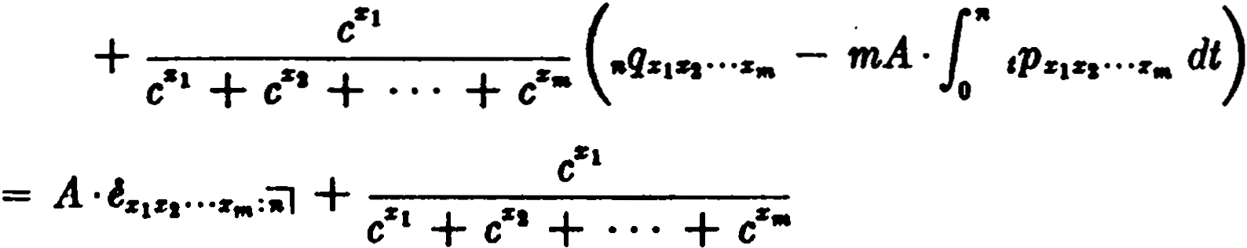
·(,.q.1•1..••• - mA ·....1.....,.:;¡)
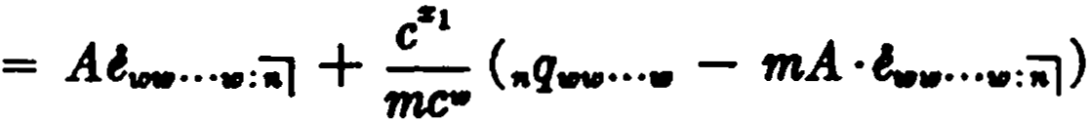
Replacing A by - log s and rearranging terms,
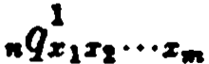
(11.20)
Thcn as a specin.) case

232 CONTINGllNT l'UNCl'IONS [CH. 11

1 · c"

(1 )

aoqz1z1· ··z.. = e- m + log ,.t..,...• - log s·..... (11.21)
1
No special techniques are required for the evaluation of prob­ abilities contingent upon a second or subsequent death, since these can always be expressed in terms of probabilities contingent upon the first death.
- Contingent insurance functions
Let A., denote the net single premium for a. contingent insurance of 1 payable at the end of the year of death of (x) provided that (x ) dies before (y ). Then
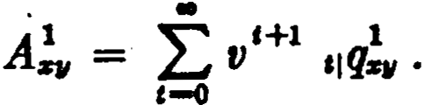 (11.22)
When the value of A11 is known, the complementary function
Az! i8 easily obtained from the relation
A + Az! = Azw .
For the contingent term insurance, we have
..-1
A l :ñ} = LJ V t+l ,,qZ1II •
,-o (11.23)
The payment is made at the end of the year of dea.th of (x ), pro­ vided that (x ) dies before (y ) and within n years-or, iri other words, if the status (x ) is the first to fail of the three statuses, (x ), (y ), and (nj). It may be noted that the case where (x ) is thc first to fail of the two statuses, (x) and (ñj), is merely the familiar single-life function A :ñl .
When the insurance is payable at the moment of death, instead of at the end of the year of death, the formulas appear in definite integral form.
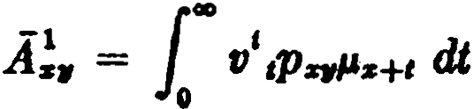 ( 11.24)
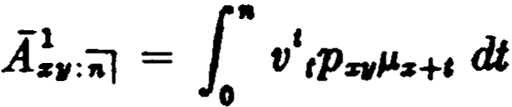 ( 11.25)
A fcw examples involving three lives follow :

8EC. 4) CONTINGENT INSUUANCE FUNCTIONS 233

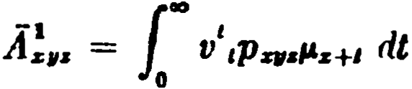
Á-zi:.r = 1.,V 'tPqJ.'z+t :11+1 <ft = [
V ·tPr,¡z( l-'r·H + l-'tl+c ) dt
( 11.26)

0 0
= .1t!.,.r + 1ti!. (11.27 )
-1 -1 - 1
Au A,,.r - Azw = •
+
A!z + A!. - A!,,.r - A.i!z . (11.28)
Note tha.t the contingent functions in this last rcsult can ali be made to dcpcnd upon (z) dying first:
Á-z1i:c = ( A-.u - A-zc1) + {A-,,z - Ai,.) - ( A-z,,z - Á-zyz1). {11.29)
- 1
Coutingcnt insurauccs can also be defincd when thc sp<:cificd status is not the first to fail. For examplc, the symbol A;11 denotes
the net single premium for an insurance of 1 payahlc at the end of
thc yca.r of dcath of (x) providcd that (y) has dicd beforc (x) :
(11.30)
The result is cvidmt from general rcasoning, since A11 + A! =
11
Az . Similarly,

Á-2:z:11 =
V ( l - ,pi, ),p;rµ:z: H dt = Ar - Á za, .
0
1"° 1 - -

( 11.31)

The cfofinite integral which appears iu (11.:H ) can be trans­ formed in an intcresting way. We first note that the exprefüÜon
1 - ,p,, can itself be written as the definite integral
,q,, = {'.p 11µ.11+• ds, and this leads to a double integral for A;., :
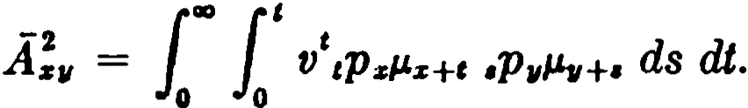
By inverting the order of integration, wc obtain the following equivalcnt exprcssion:

234 CONTINGENT l'UNCTIONS [CH. 11
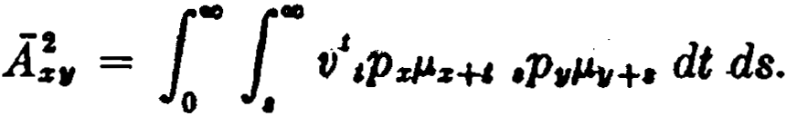
Performing the integration with respect to t, we have

-1
1., -

Az, =
•P,JJ11+•\,t-4 ds
0

O
= f
v'•PawlJ1,-:if, Á z+r ds. ( 11.32)

In this form, the function appears as a varying insurance on the lif e of (y ), contingent on the survival of (x). The amount of the varying insurance at any time is the net single premium for in­ surance of 1 on (x ) at bis then attained age.
It is not necessary in general to derive separate formulas for contingent functions of both the A and A type as we have done
above for A;11 and A in (11.30) and (11.31). The relations among
the net single premiums are the same whether the insurance is
payable at the end of the year of death or at the moment of death. It will be found that the net single premium for any contingent insurance, when written as a definite integral, can readily be trans­ formed to an expression which is solely in terms of single- and joint-life functions and contingent functions dependent on the
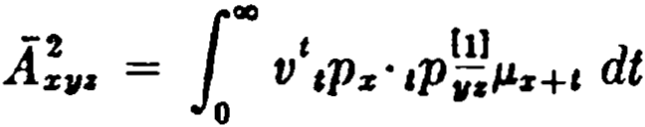
first death. This is illustrated in the examples that follow:

-1 -1 -1
= +
Á zi, Á zz - 2Az11z
Ak , = f 'J v'( 1 - ,p.) ,pqJ.lz+e :11 +& dt
00
-i t
1

(11.33)

( 11.34)

Az11:i =
V ( 1 - aP11 ) ( 1 - tPz )tP:z:ll.z+ I dt
0
(11.35)

= Á :r
-
-1
- Á z11
-1
- Az,
-1
Áz11• •
+

A special notation is used when these insuranccs are on a tcm­ porary basis, in that the term period is indicatf'<l by a prefixed subscript. For cxample, an insurance on thc life of (.r ) payahlP
if he dies after (y ) and within n ycars is represented hy "A;11 •

SEC. 5) EVALUATION OF CONTJNGENT INSURANCES 235

It should be noted that the symbol A:"it] denotes an insurance payab]e upon the death of (x) provided that (x) is the second of the three statuses, ( x ), ( y ), (ñj), to fai], and this benefit is different from the tenn insurance described above. It is thus important that symbols like nA!11 and A!v:ñ] be correctly distinguished.
- Evaluation of contingent insurances
When it is neces.sary to evaluate a large number of contingent insurance functions on the same mortality and interest basis, the construction of special commutation columns will simplify the calculat.ions. These are usually based on the approximation af­ forded by the as.sumption of a unifonn distribution of deaths,
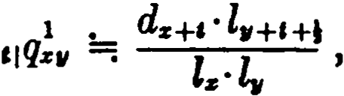

so that

•+11
l
ao ao -¡-+'+Id
A 1 _ """' Hl 1 V s+a ' 11+&+-J
,-o -z
•11 - 4J V ,¡q.,, -. 4J stt
,-o 1
" t ··

where
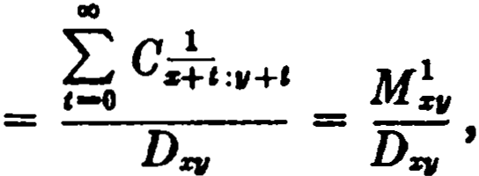

1 +1
= " kdJ'll+t with k = l
e
2
l.·l,,
•

(11.36)

and
M!., = :,-Eo c.,:11+1 .

(11.37)

For the contingent term insurance, we ha.ve
1 _ M!., - M;:;;: +"
A 11
.,,:ñl - Dq
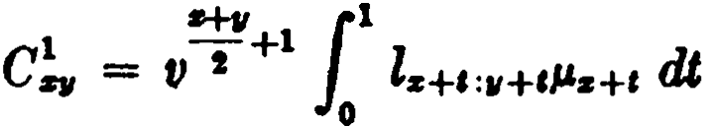
The exact definition of C!., is

(11.38)

the form given by (11.36) being merely a convenient a.pproxima­ tion to the ti:.ue value.

236 CONTINGENT FUNCTIONS [CH. 11

These commutation functions apply to insurances payable at the end of the year of death. When the insurance is payable at the moment of death, the payment is made on the average one-half year earlier, and one of the usual approximate relationships may be assumed, for example:
A =; (1 + i ) 4 A.
In most instances in practice, only a few isolated contingent insurance values are required, and the simplest method of evalua.­ tion is approximate integration. This device is particularly con­
venient when the mortality assumption must be changed at sorne point in the contract. Suppose, for example, tha.t A!,is to be evalu­
ated on the basis of mortality from Table A while both lives survive and from Table B after the death of (y). This is easily handled by first using (11.32) to write
-2 1., t -
1
Á zv = l l V lz+el11 H"11+cAz+c dt.
11 o
Then, after an appropriate formula of approximate integration has been chosen, the required values of l:+e , l.,+ e , and "11+ e are taken from Table A and those of As+c from Table B.
As in the case of contingent probabilities, an exact evaluation is possible when either Gompertz's or Makeham's law applies. With Gompertz's law, we have
-1 1 -
=
Áz 1zs···z,,. coqz 1z1...z,,. ·Áz1z, ...z,,.
Z¡ (11.39 )
+ + ... +
= e•- A"' , where e"' = Cz1 CZt cz,,..
In this case, thc value of the contingent insurance is the same as the value of the joint-life insurance multiplied by the probability that (x ) will die first.
With Makeham's law, we have

1
A-1z z, ...z"' = Cz
(-1A-""" ..."' + log s·áwu,...,.,) - log s·a- _.....,

1 Cv, m
where mc'lll = c'Z 1 + ¿rt + • • • + cr"'. (11.40)
The <leriva.tions of thcKc formulas are not given here, sincc they parallel closcly thosc of thc <'orrcsponding contingcnt prohn.hilities which were set forth in detail in Section 3.

SEC. 6] ANNUAL PREMIUMS AND RESERVES 237

- Annual premiums and reserves
A contract of contingent insurance may terminate in either of two ways: (1) by the occurrence of the event insured against, in which case a claim is incurred; or (2) by the occurrence of a death contrary to the order of deaths insured against, in which case the contract expires. When contracts of this type are subject to annual premiums, both of the above pos.5ibilities must be considered in detennining the premium-paying period, since premiums should not be made payable beyond the period during which the insurance is in force.
In the case of an insurance contingent upon a specified status being the first to fail, the contract will either become a claim or expire upon the occurrence of the first failure, and the annual premiums are accordingly made payable during the joint existence of all the statuses. This is illustrated by

and 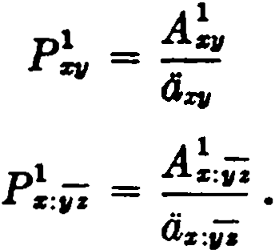
When an insurance is contingent upon a specified status being the last to 'fail, the insurance continues in foroe until the failure of the specified status, and the annual premiums may be made pay­ able during the existence of the failing status alone. In the general case involving m statuses where the insurance is contingent upon a specified status being the n-th to fail, the annual premiwns may be made payable during the joint existence of the failing status with at least m-n of the other statuses. In practice, however, there are often underwriting considerations which require that premium payments be limited to a period shorter than the maximum indicated above,
and consequently it is not possible to give unique definitions for functions like P.'....
Tenninal reserves for contingent insurances are computed by the prospective method, and the amount of the reserve at any time depends upon the then surviving combination of lives. As an illustration, consider the terminal reserve at the end of t years for an insurance on (x) if he dies second of the three lives (x), (y ), and (z ), with annual premiums paya.ble during the joint lifetime of all

238 CONTINGENT l'UNCTIONS [CH. 11

three. If the lives are all surviving at the end of t years, the reserve
is
A.!c:11+,:•+• - Psr,.·Oai+c:v+•=•+' ·
If (y) has died, the reserve is Az-!_, =•+' , and if (z) has died, the reserve . Ai+i i :s,+ , •
IS
- Some special contingent functions
The probability that (x ) will be alive n years after the death of
- is
l'° H11P2:·cP11"1,+c dt = rtPz l'° cPz+n:s,"1,+c dt = •Pz·ooqz+,.:!• (11.41)
Similarly the probability that (y) will be alive n years after the death of (x) is nP11 • ooq :u+rt , and the probability that at least n years will elapse between the two deaths is therefore
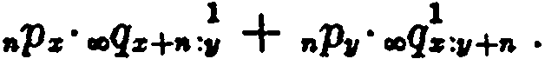 (11.42 )
It follows that the probability that (x) and (y ) will die within n
years of each other is
(11.43)
The probability that (x) will die before (y ) or within n years after the death of (y) is the complement of the probability that
(x) will be alive n years after the death of (y), or
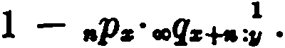 (11.44)
The probability that (x) will die during the n years following the death of (1/) is
{º ( 1Pz - C +rtP:1 )cP11 "1,+c dt = ooqz! - aPz·ooqz+.:!, ( 11.45)
which is evidently correct since the required probability is the probability that (x) will survive ( y ) but not be alive n years after the death of (y ).
We may now consider the va.lues of insurances which depend on contingent probabilities of the a.hove type.
The net single premium for a pure endowment of 1 payable if
(x) is alive n years after the death of (y) is

SEC. 7) SOME SPECIAL CONTINGENT FUNCTIONS 239
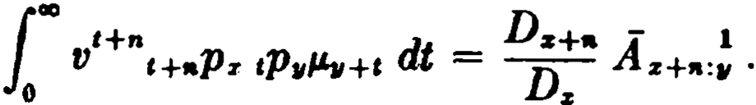 (11.46)
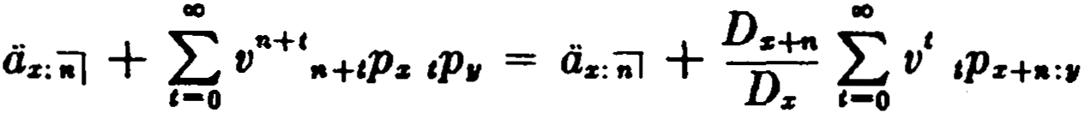
The annual premium is obtained by dividing the single premium by the present value of an annuity-due payable until the death of (x) or until n years after the death of (y), whichever period is shorter. The present value is

= a··z:ñ] + DzD+zra a··z+R:S, .
(11.47 )

In this expression, the first term represents the present value of the first n payments, which are independent of the survival of (y), and the second term takes account of the payments after n years, which are made only if (y ) was alive n years before.
The present value of an insurance payable upon the death of
(x) provided it occurs at least n years after the death of (y ) is
100
Vn+ ( 1 - ,p,, ),.+iPz· P.z+ra+t dt = Di/:( A.z+,a - A ,.: 11 ). (11.48)
1
The annual premium is determined by dividing by d.z •
The present value of an insurancc payab)e if (x) dies before (y ) or within n years after (y ) is equal to A.z minus the value of an insurance payable if (x ) dies at least n years after (y ) :
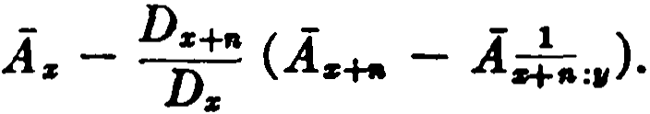 (11.49a)
Alternatively, this value may be expressed as
100

Áz:ñl +
V tt +&Pz· tP11 ·J.&z+n +t dt

-1 t1+t

0
since the insurancc must be payable if (x ) dics during the first n years, and is payablc after that time if (y) is alive n years before the death of (x). This alternative expression reduces to
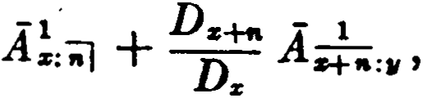 (11.49b)
which may be seen to be equivalent to the formula first obtained.

240 CONTINGJCNT l'UNCTIONS [cB. 11

The annual premium is determined by dividing by

ds:.J + D•+- 4.+.:• .
Ds
- Summary of notation
  - The notational principie used with simple contingent func­ tions is an extension of Principie I (Chapter 3) :
When a suffixed subscript consists of severa! statuses, a numeral, say r, written above one of the statuses indicates that the function is determined by that status being the r-th to fail. For example,
the suffi.x xyz refers to the contingency that (y) will be the second
to die of the three lives; the suffix xy iw to the contingency that
(z} will be the second to fail of the three statuses (zy), (z), (w).
  - With contingent term insurances, the temporary period is
denoted by a prefixed subscript; e.g., A . (When the insura.nce is contingent upon the first death, however, either .A!w or A!w:-;i
is correct.) This device is sometimes used as an alternative notation under other circumstances. For example, the symbol as:,ij is sometimes written "ªs , and A!:iil is sometimes written nAz .
  - Contingent commutation functions:
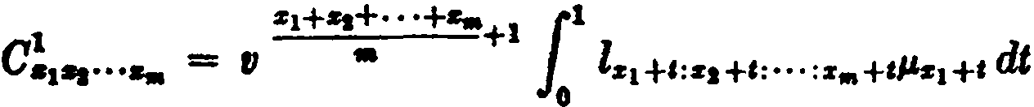
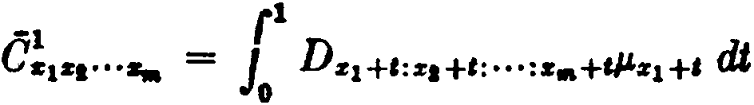

The functions M, M , R, R are obtained by summation in the usual
way.

References
1, 2, 3, 4. This material is also covered by Spurgeon (1932) and by Hooker and Longley-Cook (1957).
- The method of formula (11.40) is due to Hume and Stott
-1

(1905). Another method of evaluating
Az 1s1,.,s,,. under Make-

ham's law was given by Evans (1925) and may be seen in Hooker
and Longley-Cook (1957), page 147. A paper by Groeschell a.nd Snell (1951) shows how Evans' method is applied to the valuation of reversionary interests for taxation purposes. The numerical illustrations in this paper, comparing the results of Eva.ns' method

EXERCISES 241

with others described in the present cha.pter, will be of interest to
students.
Spurgeon (1932) a.nd Hooker and Longley-Cook (1957) de­ scribe severa.l other a.pproxima.te methods of evaluation. Sorne of these form the base.s for .Exercises 5, 6, 19, 20, and 21.
- The family-type policy currently issued by many insurance
compa.nies affords an interesting application of contingent in­ surance principies. A paper by Samoff (1958) discusses this policy, with special reference to the problem of valuation.
EXERCIS

I, 2. Contingent probabilitiee
- Show that •qii:. = %.
1
- Given the three lives A, B, C, ali aged x. Write an expression in terms of ,.pz for the probability that A and B will die within n years, A predeceas­ ing B, and that C will survive for n years.
- Given.q!11 = .4, q!. = .5, and .q!,. = .3, find the numerical value of
.q!... (Ans. .3)
- Express aoq.!.,. in terms of probabilities contingent upon the first death.
- Evaluation of eontingent probabilitiee

  - Using the fact that aeZII = p.zeq .q!_ (see Appendix 11), derive the
in
approxima.te formula
.q ., ""! P.zezi, + j{ea-1:, - la+i:,),
  - (a) Assuming that P.a+t =: 2ll (ls+i-1 - Zz+1+1) for ali values of t, show
s+C
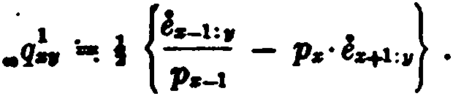
that
(b) Determine whether (x) is older than (y), given
ez-l:11 = 10.682 Za-l:11 = 10,250,000
tr+1:, ... 10.000 Z.:, ... 10,000,000
Zz+i:11 = 9,740,000.
  - In a mortality table known to follow Ma.keha.m's la.w, you are given:
A = .003, c11 = 3, and e..:IO = 17.
Find.,!o._. . (Ans. .2765)

242 CONTINGENT FUNCTIONS [CH. 11

  - Assuming that Makeham's law holds a.nd given the following data
1
find as closely as possible the value of .r/ u:":"':41 •
logu 4.0 - .60

logu 4.1 = .61278
log10 4.2 =- .62325
log10 4.3 = .63347
log10 4.4 = .64345
e ... 1.1
log. a = -.00619
l,o,,o:o,u = 13.880
tH:41:41:41 = 13.429

(Ans. .725)

- Contingent insurance functions
  - Show that the net single premium for an insuranee of 1payable at tbe end of the year of death of (x) ,provided that (y) is then alive may be ex­ preseed as
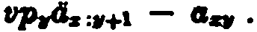
  - Show by general reuoning that
A - A!, > O.
Is this true if i = O? Explain.
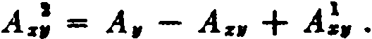
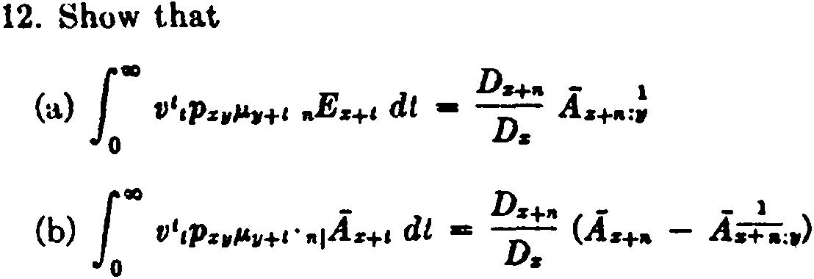
  - Show that

In ea.ch case, describe the benefit.
13. Express A...!11• in terms of irumrances contingent on the first deatb.

- Evaluation of contingent insurances
1
  - Describe the benefit denoted by the symbol As:;;¡' and give a for­ mula for it in commutation symbols.
  - Given #'z = 0.002 + 10-5 cii and c10 = 3, express ÁJ,ao in terms of
.A40:IO and 040:U .
  - Give the full <lerivation of formulas (11.39) and (11.40).
  - Show that, if a morf.a.lity ta.ble fullows Makeham's la.w,

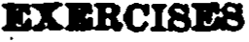 243
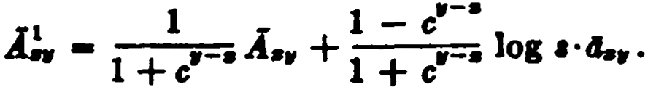
  - Given the following data from a table known to follow Makeham'1
law, find the value of A :H:11 •

"" - .0106
"" = .0136
l'H = .0316
%

49
50
·80.6
88.2
9.0
8.7
.73
.74
(Ana . .099)
84

  - Show that
aw == ,,.4.,- A!, . Hence derive the approximate formula
8%

l.+c-1 - l.+i+1
  - A88uming that "-+• 9! l,
2
for all valuea of t, derive the formula
J'I {4s-1:, }

Jlq .. i -- -,.- 4.+1:, .
Pa-1
What ia the correaponding formula for A!:;. ?
  - Aesuming that "-+• ..qs+, for ali valuea of t, derive the formula
A!. - p.·4.+1:w .
- Annual premiums and reserves
  - Give formulas for ,V!,.,888uming that the annual premium is paya.ble during the joint lifetime of (x) and the survivor of (y) and (z).
  - A policy insurea a bUBband aged 40 and his wife aged 35. If (35) dies fint, the payment at her death is $1000. If (40) dies first, the payment at hia death is $10,000 during the first policy year; thereafter it decreases by
$100 at the beginning of each policy year until it reaches $8000 and then remains constant. Give a formula for the net annual premium in terma of commutation functions.

- Some speclal eontingent íunction•
- In the case of 3 lives aged 70, 75, and _79, the probability that exactly 2 lives survive 5 years is .45 and that at least one dies within 5 years is

244 CONTINGENT FUNCTIONS [CH. 11

.775. Given that _!.... , _!_ ,and _!_ are in arithmetic progression and that
,pn ,p1, ,p10
.q:0:aa = .3, find the probability that 2 lives aged 70 and 75 will die within 5 years of each other. (Ana. .445)
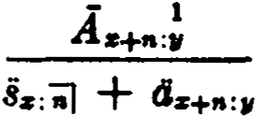
- Show that the net annual premium for a pure endowment of 1payable if (x) is alive n years after the death of (y) is given by
- A deferred annuity of 1 is payable annually, beginning m years f rom now. Annuity payments are made if at the time of payment (x) is alive and
  - .either is alive or has been dead less than n years (m > n). What is the
present value of this annuity?
Zl. Find the present value of 1 paya.ble at the moment of death of (50) provided that (20) has then either died or attained a.ge 40.
- Derive and simplify an expression, in terms oí single premium sym­ bols, for an insurance payable on the death of. (x} af ter (y}, provided (y) dies during the n years preceding the death oí (x}.

Miscellaneous problems
- Fin<l the single premium with a loading of 7! per cent of the net premium for a contingent survivorship policy paya.ble ií a life aged 30 dies before a life aged 60, or within 5 years aíter the death oí the latter, with return of the single premium without interest 5 years after the death of the life aged 60 if no claim under the policy arises by the death of the life aged 30.
- Find the value of loo ,qz! cPzz P.z+c dt.
- An insurance is to be paid at the moment of dcath of (x) if he survives (y). The payment is equal to the number oí years (includi ng fractional parta oí a year) elapsed from the date of issue to the moment of death of ( y ). Write thc net single premium as a definite integral.
- Dcvelop a formula i n terms of an expression which does not involve integrals for the net single premíum for an insurance of 1 paya.ble 10 years af ter the death oí (x), ií both or either of ( y ) and (z) survive (x) and both are <lead before the end of the 10-year period.
- A corporation has a president, aged 50> and two vice-presidents aged 48 a.nd 45 respectivcly. They wish to purchase the following insurance: lf the president dies first, $1000 is to be paid immediately and $2000 is to be paid upon the first death of the two vice-presidenta. lf one of the vice-presidents dies first, nothing is to be paid until the second death among the three officers n.t which time $3000 is to be paid.
Comp11t.e the net single premi um for this i nsurance, &S1'1Uming imme<liatc

EXERCISES 245
payment of claims, given the following values at 21% from the mortality table to be employed :

ciu:41 = 10.95
<iao :u = 11.26
ª"'º 11.46
4u:'8:U = 9.30
(Ans. $1974.38)

CHAPTER 12
COMPOUND CONTINGENT FUNCTIONS

- lntroduction
The contingent functions considered in the preceding chapter were of a type in which the sequence of deaths was restricted by a condition on a single one of the lives (or statuses) involved. Thus a typical problem arose from the condition that (y ) die second of the lives (x), (y ), and (z), and nothing was said about the multiple condition exemplified by, say, the requirement that ( y ) die second predeceased by (x) among (x), (y), and (z). The present chapter deals with functions of this latter type, known as compound contin­ gent functians.
It is obvious that no compound contingent function can arise from a two-life status, since an ordering restriction on one life will automatically determine a complementary condition on the other. A compound contingent function thus requires three or more lives with two or more conditions on the sequence of deaths.
- Probabilities
Given the three lives (x), (y), and (z), what is the probability that their deaths wíll occur in the order named? This probability
is denoted by ooqz!.. , and it may be expressed in several different
1 '
ways:

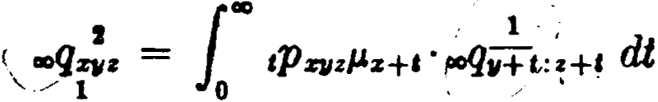

00
f.
or tQz' tP11zJJ.v+c dt
or fa ,qz: . ,p..µ..+t ·at. .
00
(12.la)

(12.lb)

(12.lc)

These three expressions are derived by letting t refer to the moment of death of (x), of (y), and of (z) respectively. The integrand in the first case expresses the condition that at the moment of death of (x), the lives (y) and ( z) are both surviving and that (y) will later predecease (z). The second integral reflects the fact that when (y)

SEC. 2] PROBABILITIES 247

dies, (x) is already dead and (z) is surviving. The third expression is based on the fact that (x) and (y) have already died in the order named when the death of (z) occurs.
The three integrals may easily be shown to be equivalent mathe-
matically. If, in (12.lb), the substitution of { 6 pzµz+s ds is made
for ,qz , a double integral results. By inverting the order of integra­ tion and simplifying, formula (12. la) is obtained. If, on the other
hand, the substitution of {'º ,pzµz+• ds is made for tPz in formula
(12.1b), then when the order of integrat.ion is inverted formula (12.lc) will be obtained . .
All three expressions will normally require approximate integra­ tion methods, and formulas (12.la) and (12.lc) are less convenient to evaluate because of the presence of contingent functions under the integral sign.
By using (12.lb), it is possible to express aoqzZz in terms of simple
1
contingent probabilities. Writing 1 - tPz for ,qz , we have
aoq;z = 1ao ( 1 - tPz ) tP11zµ,¡+t dt
1ao tP11zµ,¡+e dt - Lao tP%Jl:i µ,¡+c dt
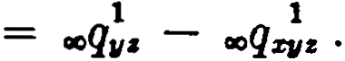 ( 12.2)
In the symbols used for compound contingent functions, it is important to note the significance of the numerals which appear above and below the suffix. The numeral above the suffix dis­ tinguishes the life upon whose failure the function is finally de­ termined, and numerals below the suffix indicate the order in which the other lives are to fail. In the case of aoqzZz , for example, the
1
probability is determined upon (y )'s dying second, predeceased by (x).
When more than three lives are involved, the functions become more complex and it is not always possible to set up integrals which are themselves free of contingent functions. For example, to take a four-life case, the probability that (w), (x), (y), and (z) will die in the order named is

248 COMPOUND CONTINGENT FUNCTIONS [CH. 12

..<]w11 = [ "° ,q.,· ,pZ11zµz+t ·.,qw!t :•+t dt
12"
or fe ,q,.,;· tPJ12JLu+c dt.

( 12.Za)

( 12.2b)

Other equivalent expressions can be formulated by basing the inte­ grals on the moment of death of (w) or of (z). It will be found, however, that the formulas are simpler when the variable of intc­ gration t refers to the moment of death of one of the intermediutc Iives, as (x) in (12.2a) or (y) in (12.2b).

- Insurances
A single order of deaths among a ·group of lives may give rise to severa! different insurance functions. If there are three lives which are to die in the order (x), (y), (z), tbere are three insurance functions corresponding to payment of the benefit upon the death of (x), of (y), or of (z). Actually, the first ease presents nothing new since if the insurance is payable upon (x)'s dying first, the order of the subsequent deaths is immaterial. There remain the two cases where the insurance is payable (1) upan the death af ( y ) predeceased by (x) and survived by (z), and (2) upon the death af
  - predeceased by (x) and (y ) in that arder.
For case (1), where the payment is made upon the death of (y ),
the net single premium for an insurance af 1 is given by
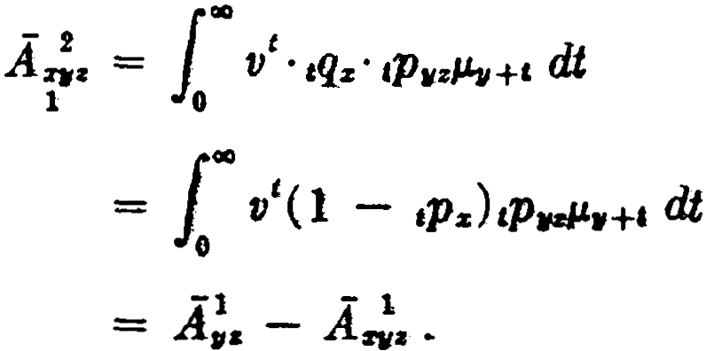 (12.3)
For case (2), where the payment is made upon t.he death of (z),
we have
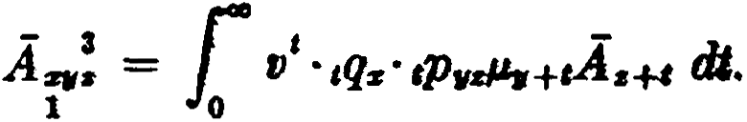 ( 12.4)
Analogous functions may be written for four lives. The student should describe the insurance represented by each of the following:

SEC. 4] COMPOUND CONTINGENCIES WITH TERMS-CERTAIN 249
00
1
- 2 t

AwQz = V ,qv, ·tP%11z#.&z+t dt
l o

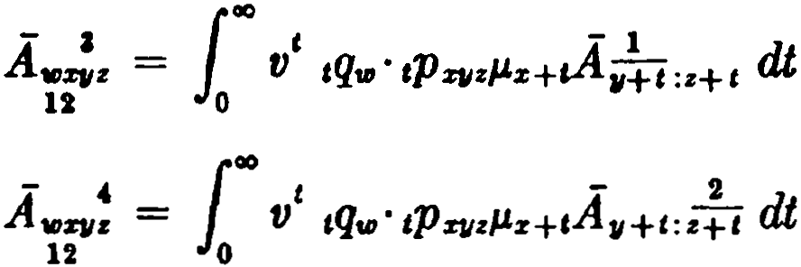
00
1
- 3:t t -
= dt
Áwz 11 z V ,qu, ·tPr11rl.&z+1 A 11+'
12 O
( 12.5)

( 12.6)

(12.7)

(12.8)

Each of the above may also be written as a doublc i ntegral. For example,
A, = [ 1Qw· 1p,P,+1 (fv',P,Jlw+• ds) dt.
In more complex cases, multiple integration is sometimes the only means of writing a precise expression for a given function.

- Compound contingencies with terms-certain
A compound contingent function may involve conditions other than the mere order of deaths, as for example where a condition as to the time interval between deaths is introduced. No new theory is needed for the formulation of such functions, and in fact they are always best handled from first principies without any attempt at classification. Since these functions are of such varying types, it is not feasible to assign specific symbols for them. The examples which follow will illustrate the techniques used in formulating exprions for such functions.
Consider the probability that (x), (y), and (z) will die in the order named within twenty years, at least five years separating each death. These conditions require the death of (y) within the period from five to fifteen years from the present, and the proba­ bility may be expred as
1fi H (1 - l -iPz )tP11#.&tl +t C t +fiPz - 20Pz ) dt.
This may be reduced to a form involving simple contingent proba­ bilities. Making the change of variable s = t - .5, we have

250 COMPOUND CONTINGENT FUNCTIONS [CH. 12
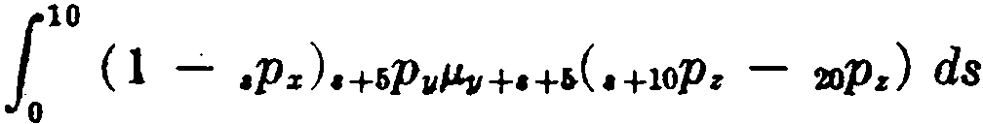
10
= 6P11 ·10Pz o ( 1 - •Pz )•P11+f,/.l.¡¡+H•. •P•+lO ds
1
10
1
- r,p11 · 20P, 0 (1 - •Pz),P11+6 "'11+1+• ds
1 1 1
=
6P11 ·10pzC 1oq11+6:ir+10 - 1oqz:11+6:ir+10 ) - 6P11 ·2opzC 1oq11H - 1oqz:a,+r, ).
Consider next the probability that (x), (y ), and (z) will die in the order named, (y ) within five years of (x), and (z) within ten years of (y). This probability may be expressed as
1
6
( l - tPz ) tP11"'11+tC tPa - t+toPa ) dt

+ {_, ( t-iPz - tPz )t'PII J.'u+l tPz - t+lOPz ) dt,
since, if (y ) dies within the first five years, he must be predeceased by (x), and if (y) dies after five years, the prior death of (x) must have occurred within five years, the death of (z} occurring within ten years after that of (y) in either case. The student may verify that the integrals reduce to the following expression involving sim­ ple contingent functions:

1 1 ( 1 1 )
r,q11z - ooq:r¡¡z - lOPz 6q11:z+10 - coqz¡¡:z+lO
+ 1 1
6P11icoqz:11+6:z-t6 - lOPa+lí ·ooqz:11+6:11+16)•
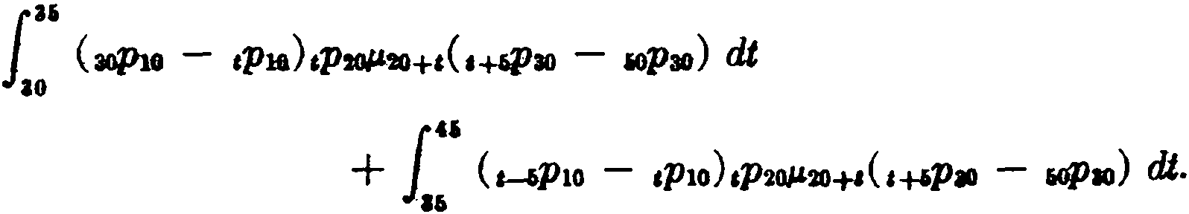
Suppose that we require the probability that the three lives (10), (20), (30} will all die between ages 40 and 80 and in the order named, the first and second deaths occurring within five years of each other, with the second and third deaths separated by at least five years. It may be noted that, in order to fulfill these conditions, the life (20) must die within the period from thirty to forty-five years from the present, and that two separa.te integrals must be written to take account of (lO)'s predeceasing (20) within five years. We thus have

SEC. 5] SUMMARY OF NOTATION 251

As an example involving four lives, consider the probability that (w), (x), (y), and (z) will die in the order named, the first two deaths occurring within the first fivc ycars with not more than two years separating each of the last threc deaths. This probability requires a double integral:
f.' (1 - ,p.),p,i,* (f.'+t ,P,p.,,+.(,p, - o+.P,) ds) dt.
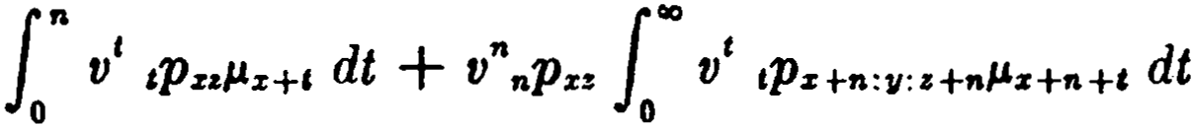
Insurances which involve contingencies of this nature may be similarly formulated. Suppose that an insurance of 1 is payable at the death of (x) if he dies before (y) or within n years af ter (y), leaving a third life (z) surviving. In expressing the net single pre­ mium, we note that during the first n years the insurance is inde­ pendent of the survival of (y), and write

-1
=
Á zz:"ñl
Dz+11:a+n ,A- _l_
D z+n:11:i+n •
+
zz

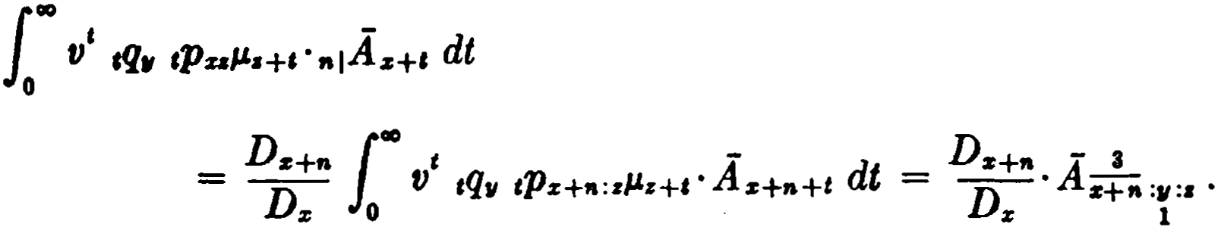
As a second example, consider an insurance payable at the death of (x) if he is predeceased by ( y ) and (z) in the order named with the death of (z) occurring at least n years earlier. This may be regarded as a contingent insurance on the life of (z) in which the amount of insurance at any time is equal to the present value at tha.t time of an n-year deferred insurance on (x). The value may thus be written as
- Summary of notation
Numerals are used with a suffixed subscript to indicate the order of failure of the statuses involved. The numeral written above the suffix distinguishes the status upon whose failure the event is fina.lly determined, and the numera.Is written below the suffix indicate the order in which the other statuses are to fail. In cases where a numeral below the suffix is clearly implied, it is unnecessary

2.52 COMPOUND CONTINGENT FUNCTIONS [CH. 12

to write it, as, for cxamplc, the numeral 2 below the y in .ti.ru! , or
1
thc numeral 3 below the y in .:1:z:yz .
1

References
This material is treatcd by Sµurgeon (1932), Chapter 19, and more briefly by Hooker and Longley-Cook (1957), Chapter 24.
EXERCISES

1, 2. Probabilities
  - Express .,q..,!11,
l

    - as a definite integral ;
(b) i n terms of simple contingent proba.bilities.
  - If the mortality table follows Gompertz's law, show tha.t
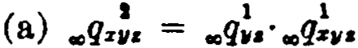

3
(b) .,qis:ao:a 6:to
1 2

  - Show that
1
1 + e&

2
..qt&:30:36:(0 •

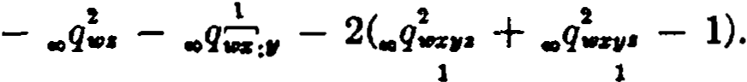

  - Given

q!

= .5537, ..q!. == .6484, .,q! • = .5325, 00qa!, = .,q.,11!.Find ..q..: •

00 11 11

l

(Ans. .2145)

- lnsurances
  - Show that
(a) Á.r11! = A.! - A!:ª
1 1
(b) .J.!v. = .Á;11• - A• .
l

  - The expressions below ha.ve been given for the v&lue oí .A!.z11• • Show
l
clearly why each expression is correct or incorrect. Also give another ex­ pression, which is correct.

EXERCISES
(a) 1·o' ,p.(1 - ,p.)[,p,(1 - ,p.,)1,111+1 + ,p.,(1 - ,p11)1,1.,+1IAw+1 d t
(b) 1·o' ,p. cp.·,q!.l.!,:.+, + ,p,·,q!.A,;,:,,+i) dt.

•
253

  - Assume that the mortality of (y ) and (z) is given in terma of a standard
table and that (z) is subject to the mortality of a special table in which the force of mortality is twice that of the standard table. On the basis of this assumption, derive an expression in terma of the standard table for the value of a unit payable to (z) upon the death of (.i:), if (z) is then living, provided (z} dies after (y).
- What annuity value should be used in obtaining the net annual pre­ mium corresponding to each of the following net single premiums?
  - A!w.
1
(b) A.!w.
1

- Compound contingencies wlth term.s-certain
  - Express in the form of integra.la the probabilities that of the four lives
(w), (z), (y), and (z),
    - the deaths will occur in the order (w), (z), (y), (z), and that (x)
and (y) will die within four years of each other;
    - (w) only will die within 10 years of the present time and (z), ( y), and (z) will die after the 10 years in that order, (y) within 5 years of (x) and (z) within 5 years of (y).
  - Express in integral form:
    - The probability that three lives aged 10, 20, and 30 ali die before attaining age 60, with (20) being the second to die;
    - the probability that (w), (x), (y), and (z) will die in the order named, not more than two years separating any two consecutive deaths.
  - Derive an expression in terma of contingent insurances and commu­ tation functions for the net single premium for an insurance paya.ble at the death of a person now aged 35 if he dies before the survivor of two persona now aged 40 and 50 or within ten years after the death of such survivor, leaving another person now aged 30 surviving.

Mlscellaneous problerns
  - According to a certain mortality table, the probability that three lives aged 70, 55, and 40 will die in that order at intervals of not Iess than fifteen years is .048, and the probability that at least one of two lives now aged 70 will be alive fifteen years before the death of a life now aged 55 is
.8. Find the probability that neither of two lives now aged 40 will survive to age 70. (Ans. .2704)

254 COMPOUND CONTINGENT FUNCTIONS [CH. 12

  - lf it is assumed that #lz+1 = <Jz+1 for all values of t , show that

A-,,,,, = -1 -
- - - (1 -µ.}( -
-
- )J.

!Az111 Au
1 6
Az+l:r•
Az+l:,

  - Write an expression in the form of integrals for the gross single premium, including a loading of 10 per cent of the net, for an insurance payable on the death of a life aged 30, provided that he dies either before a life aged 35 or within three years af ter his death and that both a.re prede­ ceased by two lives ea.ch aged 40 who must die in a specified order. Should the life aged 30 die within the three years a.fter the death of the life a.ged 35, the sum insured is to be reduced by 25 per cent, but should he survive the life a.ged 35 by three years, the other lives dying as before, the premium is to be returned. ·
  - The will of H, now dea.d, lea.ves to his wife (w) the income for life from a $200,000 trust fund, the principal to be divided at (w)'s death in accord­ ancE> with the following conditions. If H' s sons (x) and (y) a.re both alive, they alone share the principal. lf either son predeceases (w), his children living at (w) 's death share the principal. (x) has three children, (a), (b), and
(e) ; and (y) two, (d) and (e). Ali beneficiaries at (w)'s death are to share the principal per ca.pita, i.e., equally without regard to generation. Ignore the possibility of the birth of any further children to (x) or (y).
Find an expression for the present value of (x)'s expectation (not includ­ ing that of bis children) in terms of continuous contingent iilsurances pay­ able on the first death.

CHAPTER 13
REVERSIONARY ANNUITIES

l. lntroduction
A reversionary annuity is an annuity which commences upon the failure of a given status ( A) if a second status (B) is then in existence and which continues thereafter during the existence of (B). A simple example is the familiar deferred annuity nlaz , in which (n]) is the failing status (A) and (x ) the surviving status (B). In the general case where the failing status involves life contin­ gencies, reversionary annuities are a type of contingent function analogous to the contingent insurances discussed in the preceding chapters.
- The basic function
The simplest form of reversionary annuity where the failing status involves a life contingency is an annuity of 1 payable to a life now aged x commencing at the end of the year of death of (y)-or, more briefly, an annuity to (x) after (y ). The present value of this annuity is denoted by llvl:c . Since the annuity con­ sists of a series of payments made at the end of each year provided tha.t (x) is alive and (y ) is not alive, its present value may be written

IO
Oir1:c = L,-1v' ,pz(l - ,p'/1) = - ª%'JI ·

(13.1)

This result is obviously correct since this reversionary annuit.y is the same as a life annuity to (x) with payments omitted during the joint lifetime of (x) and (y ). The same reasoning applies to the
generalized function a,,1" , whatever age status or combination of statuses may be represented by (u) and (v), and we may write
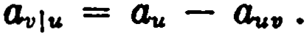 (13.2)
For example, if (u) represents the joint-life status (xy) ·and (v) the single life (z), we have
255

256 REVERSIONARY ANNUITIES [CH. 13

Reversionary annuities of this type may thus be expressed directly in terms of single-life and joint-life annuity values. Two further examples follow:

fo the first of these, the annuity is payable during the lifetime of
(x) after the death of the survivor of (y) and (z). Inthe second, the annuity commences upon the first death of (y) and (z) and is payable until the second death of (w) and (x).
Although known as reversionary annui'ties, these functions are essentially insurances since the payments commence upon the failure of a specified status.
- Modifications of the basic function
The basic function lli,iz makes provision for annual payments, and the payment periods are measured from the end of the year of death of (y ). In practice, the payments are often made more fre­ quently than once a year, and the payment periods are measured from different points of time.
If the annuity is payable to (x) m times a year and commences at the end of the m-th part of the year in which ( y ) dies, the present value is given by

(111) = a"') - n_(lll)
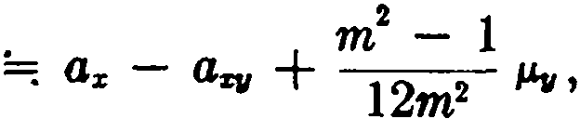
ª111.z -

(13.3)

using (2.18) and recalling that
µ.%11 = µ.s + µ.11 •
If m becomes infinite in the formula above, we have
O¡¡¡s = <is - aztl =: az - lZza, + H2M11 • (13.4)
This represents the present value of an annuity of 1 commencing at the moment of death of (y ) and payable continuously through­ out the remaining Iifetime of (x). An integral expression for this function is

SEC. 3) MODIFICATIONS OF THE BASIC FUNCTION 257

00
l
d¡,¡s =
v' tPz (I - tP11 ) dt. (13.5a)

When the substitution of 1' ,Pfll.'11+• ds is made for 1 - ,p, in (13.5a), we obtain
llitr z = l l' v' tPz ,P 11J.'fl+• ds dt.
00
Then, inverting the order of integration,
llit1 z = loo J.oo v' tPz •P11J.'fl+• dt ds
= loo •P11J.'fl+• . ,1ciz ds
= loo v' •PZ1JJ.'fl+•ªz+• ds. ( 13.5b)
In this form, the contingent insurance character of the function is clearly apparent.
The symbol a is used to distinguish a type of reversionary an­ nuity in which the payments are made periodically with the pay­ ment periods measured from the date of death. The annuity which provides payments m times a year to (x) with the first payment of
1/m due at the end of 1/m years from the moment of death of (y)
has the present value:
A(•) f oo t (•) dt

""llls = J
0
V tP:it1/J1i+1ar+ ,

,o¡ { •' ,p,.,,.+, ( - 2) di
using (2.19) and (2.27),

= Is -
-
1 - 1
- ASIJ
2m

:-.--; az - ªZI/

7 2/Jf/
+ lf
- 21m A- i • ( 13.6)

It will be observed in each of the three cases considered above that the formula for the modified function consists of the expression
SI/

258 REVERSIONARY ANNUITIES [CH. 13

az - aZJI plus certain correction terms. In practice, the correction terms are often ignored, and the net single premium for all three types is computed as az - az11 •
This convenient approximation may also be extended to the
general case of an annuity to (u) af ter (v) :

ª"(m'") . - ·lu . á(m) .
Ov ¡u = au - Ou11 •

===; a1 ===; 11¡u ===;
When necessary, the approxima•tion can be improved by adding
the proper correction terms. In particular, when either of the statuses (u) and (v) involves a term-certain, the correction terms are important and should not be neglected. This case will be ex­ amined in the next section.
From the relation ai·J u =; av u , it follows that annuities with
1
periodic payments may be evaluated as continuous annuities and that either type may therefore be directly computed by methods of numerical integrat.ion in cases where the necessary joint-life functions are not already tabulated. As long as (u) and (v) involve only lives, the definite integrals always assume the following forms:
Ü,¡" = 1"° v' ,p"(I - ,p., ) dt (13.7a)
or 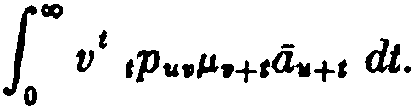 ( 13.7b)
The second form is useful when there is a change in the interest or mortality assumptions after the failure of (v).
- Functions involving terms-certain
We have already notcd that the basic formula
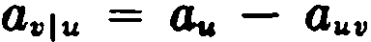
is valid regardless of the type of status represented by (u) and (v). Let us consider a few cases where these statuses include a term­ certain.
If (v) is the term-certain (n]) and (u) the single life ( x), we have
ªnlls = a.i - tlz:;i '
and this will be recognized as the single-life deferred annuity,
nlas , cited earlier as a simple example of a reversionary function.
An annuity to (x) af ter (y) with no payments to be made after
n years from the present time has the present va.lue

SEC. 4) l'UNCTIONS INVOLVING TERMS-CERTAIN 259

a,,,.:;i = lJ.c:i} - °-=iil .
This function may be described as an n-year temporary rever­ sionary annuity. An altemative notation is "a,,1• •
An annuity to (x) a.fter (y ) with no payments to be made within
the first n years from the present time may be interpreted as an annuity to (x) after (y:ñ]), and
a,,:ii')ls = - :s,:i;l = - ll - :i;l + Osi,:i"j
= t1I - nla.ia, •
The function is an n-year deferred reversionary annuity. An al­ temative symbol for the present value is "10.,1s •
It should be noted that the tenn-certain in the above functions
is measured from the date of issue of the contra.et. It is important to distinguish clearly another type of function in which the tem­ porary or deferred period is measured from the date of death in­ stead of the da.te of issue. In the case where the deferred period is measured from the end of the year of death of (y), the benefit is·an a.nnuity to (x) commencing n years after the death of (y ), and the present va.lue is

L,-J1V t1+1Ps 1 - ,p,,
n+a ( )
= DDa-r• (Oz+n - aa+n :s, ) = DDs+" Cli,!s+t1 •
:1 s

For the case where the annuity is paya.ble to (x) for n years after the death of (y ), the present value is obtained by ded'1cting the value of the above deferred benefit from the nonna.l reversiona.ry annuity:
Ds+,.
O.Is - Dz a.1s+n •
Although the approxima.tion ajJ =: Ov1u is often used when (u) and (v) involve only lives, it should not be used when tenns-certain are involved. This may be seen in the case of the simple function
<•>
<Jii1 Is :
(a) (a) (a)
= -
a.¡¡s :ii]

"" (a.+ m2 1) -[a.,il + m 1(1 -Dñ:")]
= ª• - ª•=.J + m - 1.Ds+" . ( 13.8)
2m Ds

260 REVERSIONARY ANNUITIES [CH. 13

The term ·m - 1·D:Dz+:zn may make an apprec1.able contriºbuti.on to
the total value of the function and should not be neglected.
- Annual premiums and reserves
When the reversionary annuity av u is subject to annual pre­ miums, the premium-paying period coincides with the joint life­ time of the statuses (u) and (v). If (v) is the first to fail, the annuity becomes payable, whereas if (u) is the first to fail, the contract ex­ pires, and in either case no further premium payments are made. The following annual premium formulas illustrate this principie:
1

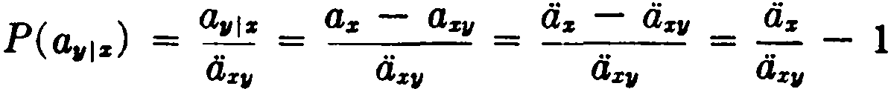
P(0.,11:z ) = a.,,¡ :z
-.. -
az11•
( 13.9)

P( -.¡:z ) = ª..
1:z

O:z:i,.r
Reserve formulas are easily written in prospective form. For example,
(13.10)
if both (x) and ( y ) are surviving, or ,V(a¡, 1:z) = a:z+i if (x) alone is surviving. Reversionary annuities often give rise to negative re­ serves-depending on the ages involved, the duration, and the mortality table used. This feature may be avoided by suitably limiting the premium-paying period.
- Continuous instalments
Reversionary annuities are sometimes issued in combination with other insurance benefits. One such combination policy is known as insurance with continuous instal,ments.
Suppose that a policy provides that at the death of (x) a monthly annuity of 1 per annum will be payable for n years certain and for as long thereaf ter as a beneficiary, aged y at date of ue, survives. At the date of issue, the certain payments have a present value of a2 > • .•{a: , and the deferred annuity to (y), the continuous insta.1- ment portion, has the following value:
, •. e n> D11+n 1"° 1 •. c12>
1

00
V ,p.eyµz+c·n1 ª11+1 dt = D V 1Pz: 11+nJ.&:z+a +•+e dt.
(13.11)

o ,, o

SEC. 6] CONTINUOUS INSTALMENTS 261

The expressions assume that the first monthly income payment is made on the date of death of (x). Earlier in the chapter the symbol a was used to indicate that an immediate annuity commences at the moment of death, and if we now use d to indicate that an annuity-due becomes payable at death, the definite integral in
(13.11) may be written as &;f!tn . Thc total net single premium,
including the certain payments, will then be
•. (12> A- + D11+n !'!(12>

ªni z D 11
az111+n .

This particular combination of benefits is known a.<, whole lif e in­ surance with cantinuous instal,ments.
The continuous instalment portion of this policy expires without value if (y ) predeceases (x ), and when the policy is subject to annual premiums, the payment of the extra premium for the continuous instalment portion is made to depend upon the survival of both (x) and (y ). The total annual premium is thus given by

D11+n !'!(12>
A D
..cu> az111+n
ªni z + -"---
iiz {i,J:JI

(13.12 )

.. (12).A
reducing to ªni .. z upon the death of (y ).
az
Continuous instalments may also be issued in combination with other forms of insurance. In the case of term insurance with can­ tinuous instal,ments, the benefit is payable only if the insured life
(x ) dies within m years. The net single premium for the n-year annuity-certain is a2 > A!:al , and the extra premium required to continue the instalments to (y ) is
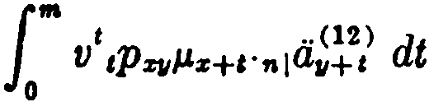

= Jroo V t tPZ11/Jz+t
.. (12) dt m 100 t .. (12) dt
- V V tPz+m:11+m/Jz+m+ t" nl

·n1a11+ t
0
mPZI/
0
ll¡í+m+t

= D11+n !'!(12)

m D11+m+n !'!(12)
- V mPx11

-D az l11+n
-D-- ax+ml11+m+n

11 11+m
J

_ D11+n [ (12) Dx+m: y+n+m !'!(12)
- D Gx111+n - D t1x+m111+n+m •
11 r:y+n
The total annual premium is

262 REVERSIONARY ANNUITIES [CH. 13

D11+ra ( (1!} Dz+wt:11+ra +t11 (U) )
.. (12)A-1 D az111+n - D ª z+•l 11+n+t11
+
a;;¡ z:ml '11 x:11+ra
llz:m] llz11:m]
.. (12).Jl
reducing to ª•I_ z :;;J upon the death of (y).
Os:.i]
In practice, the &<m functions appearing in these formulas are most conveniently evaluated as simple reversionary a.nnuities, thus:
(12) •
ª•lu =: - tluw •
This approximation understates the true value, a fact which is sometimes reflected in the loading formula.
Reserves for continuous instalment policies may be obtained from the usual valuation principies. As an example, consider an ordinary life policy issued at age x with continuous instalmen ts to a beneficiary aged y. The reserve at the end of t years is given by the following expression:

.. 02> V( A- ) D,,+,.+1 c12> p _
+
ªñl , x D az+1 111+n+1 - ·ax+1:11+1 ,
tt+t
Dy+n c12>
nª xh,+n
where P = v the extra annual premium for the con-
dZ'I/
tinuous instalments. This expression involves the assumption that
both (x) and (y) are alive on the valuation date. If only (x) is alive, the reserve is simply ci2> ·,V(Az).
- Compound reversionary annuities
Although rarely encountered in practice, compound reversionary annuities are of theoretical interest since they represent the annuity counterpart of the compound contingent insurances dis­ cussed in the preceding chapter. Under such an annuity, pa.yments are made only in the event that the antecedent deaths have oc­ curred in a prescribed order. Many functions of this type may be defined, and, since little classification is possible, each particular case should be approached from first principies.
The symbol a!,iz denotes the present value of a continuous an­
nuity of 1 per annum payable to (x) commencing upon the death of (y ) provided that ( y ) dies before a third life (z). This benefit may

SEC. 7] COMPOUND REVERSIONARY ANNUITIES 263

be regarded as a.n insurance contingent on (y) being the first of the three lives to die, with the amount of insurance at any time being equal to the present value of a continuous annuity at (x)'s attained age. We thus have
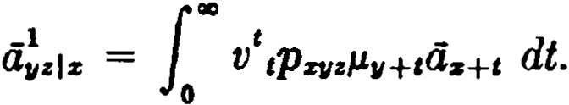 ( 13.13a)
An equivalent definite integral may be written by considering the function from another point of view. Annuity payments will be made at time t provided that (x) is then alive and that (y) has pre­ viously died before (z). We may thus write
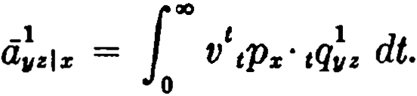 (13.13b)
When a!ziz is known, the value of a11!1x may be obtained from the relation
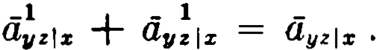 (13.14)
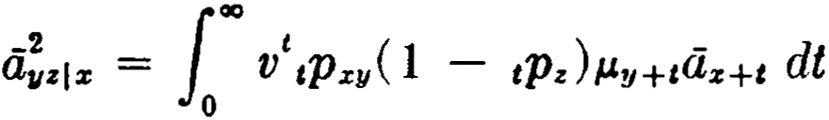
The symbol a;zlz denotes the present value of an annuity to (x ) commencing upon the death of (y) provided that ( y ) dies af ter ( z). This value is given by

The relation
-1

-
<liti.i:
=
- ayzl x • ( 13.15)

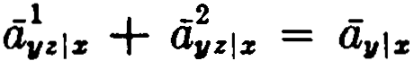
is clearly correct.
Another way of expressing <i;.riz is by regarding the benefit as an
insurance contingent upon (z) dying first with the amount of insurance at any time equal to the current present value of a reversionary annuity to (x) after (y). This point of view leads to the following result:
<i;zl z = f'° v',pzyzµz+elL¡,,+t l x+ I dt = O¡r!l x - llz i xy • ( 13.16 )
The student should give a verbal intNpretation of thi r<'sult ami show that it is equivalent to the one obtained above.

264 REVERSIONARY ANNUITIES [CH. 13

In the case of more complex functions, a notation similar to that used with compound contingent insurances can be adopted. A numeral is written above the life upon whose failure the benefit becomes payable, and numerals written below indicate the rela­ tive order of death of the other lives. For example, a!uzitD represents
1
an annuity to (w) commencing upon the death of (x) provided that
(x) dies before (z) and after (y) :
00
-2 t - -1 _1

azyzlw = V tPwzz( l - tPu )J.Lx+ta.i»+t dt = axz l w - azy.i lw
1
1 O . •
(13.17)

In the two examples that follow, the student should describe the benefit and verify the expressions given:

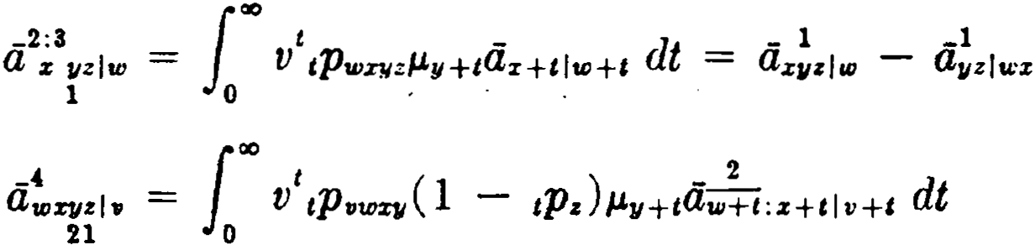
( 13.18)

(13.19)

It is not necessary to give special attention to compound rever­ sionary annuities in non-continuous fonn since, just as with simple reversionary annuities, the values of the discrete annuities are approximately the same as the values oí the corresponding con­ tinuous annuities.
- Summary of notation
A vertical bar separating the elements of a suffixed sub­ script indicates a reversionary function, the status af ter the bar
being understood to follow the status before the bar. Thus a!i;
is an annuity on the life of (x) after the death of (y ) with the first annuity payment of 1/m due at the end of the 1/m-th part of a year in which ( y ) dies, the payment periods being measured from the date of issue of the contract. When the payment periods are measured from the date of death, the distinguishing symbol ác..i is used.
References
1-5. Similar material is covered by Spurgeon (1932), Chapter 18, and by Hooker and Longley-Cook (1957), Chapter 25.
6. Policies with continuous instalments are discussed by Berg­ stresser (1941).

EXERCISES 265

7. Compound reversionary annuities are trcated by Spurgeon (1932), Chapter 19.
EXERCISES

1, 2. The basic function
l. Explain by general reasoni ng and show algebraically :
00
<ii,1. = L,-1v' ,P.z ·1-11q,/i.z.t & •
- Express in terms of single- and joint-life annuities:
  - a.z: l
(b) aw.1- ,
- The last-survivor annuity a;,; is paya.ble in the following way. While all three lives are surviving, (x) and ( y ) ea.ch receive X of the annual pay­
ment and (z) receives 3,1. Upon the death of (x), his share passes to (y), if surviving, otherwise to (z). Upon the death of either (y) or (z), their shares are divided equally among the survivors, the last survivor receiving the total annuity payment of l. Find expressions for the present values of the individual shares of (x), (y), and (z) in terms of single- and joint-life an­ nuities.

- Modifications of the basic function
- Give two independent integral expressions for 111.z: • Demonstrate their equivalence by reducing both to the same expression in terms of sim­ ple continuous annuities.
- Show that
-

éJ -
  - -tlill:r
éJx
= µza11¡z -

-z
A:r11

(b) J!w = Az! - ºª* .
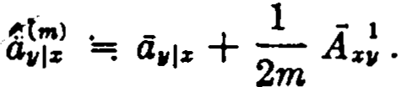
ü. Show that

4,. Functions involving terms-certain
- Express in terma of commutation functions and simple annuity val ues:
  - the present value of a temporary annuity of 1 paya.ble to (x) with the first payment at the erid of n years from the end of the year of death of (y), but with no payments to be made after m years from
the present time (m > n) ;
  - the present value of a temporary annuity of 1 paya.ble to (x) during the lifetime of (y) and for n years af ter the death of (y), but with no payments to be made af ter m years from the present time (m >
n).

266 REVERSIO:SARY ANSUITIES [CH. 13

- An annuity of 1 becomes payable at the end of the year of death of (x) and continues until n years af ter the death of (y). Express the present value in terms of net single premi um symbols on each of the following assump­ tions:
(a.) the annuity is entered upon only if ( y ) is alive at the death of (x) ;
(b) the annuity is payable whether or not (y ) is alive at the death of (x). 9. Find an expression in a form free from integrals or summations for the value of an annuity of $100 per annum payable to (y), the first payment to be made at the end of the t-th year succeeding the year in which (x) dies, provided (x) dies within n years, tlie annuity to be void if (x) lives
beyond n years.
- For each of the following, describe the benefit and give a simple formula (using standard approximations if necessary) :
- (4)
  - Owiz :;J , (b) :iilfw ·

- Annual premiums and reserves
  - Find as close)y as possible the net annual premium for a reversionary annuity of 1per annum to a life aged 40 after the death of another life aged 43, the first annuity payment to be a f ull payment of 1 and to be made on the anniversary of the date of issue, given the following data from a Gom­ pertz table:

"
l' z
X
1
ª"'
40 . ·1¡
43 . . . ....,

IJz

%
------
15.136 | .00990 | 54 . |  | 11.331 | .01950
14 .413 | .01106 | 55 . | . . 1 | 11.024 | .OW77

51 . .

. . .
.. .
12.230 .01631 56 . 1 10 .714 .02216

52 . . . . . . : 1 11.935 .017'27 62 . . . . . 8.808 .03381
53 . 11.635 .01833 63 . . . . 8.488 .03645

1 1

  - Show that ,V(0i,1z) is negative if

<iz+t < Üz+l:i,+I •
á.s ª%•

(Ans. .347)

  - Express in annuity symbols the reserve t years after issue for a single prernium reversionary annuity payable to a life (z) af ter the death of the survivor of two lives (x) and (y).
- Continuous instalments
- An m-year endowment policy with continuous instalrnents provides that if the insured, aged x at issue, dies before the maturity of the policy as an endowment, a monthly i ncome will be paid for n years certain and for as long thereaf ter as the beneficiary, aged y at issue, survives. At maturity as an endowment the income is paya.ble for n years certain and as long there­ after as either the insured or beneficiary survives.

EXERCISES 267
Show that the Mt single premi um for the policy consists of the following four parts:
(U) -

  - for the
. .
annmty certam:
a;¡ A,.,;¡¡¡

(b) for the continuou.s instalments to the beneficiary in the event of the i nsured 's death prior to maturity :
D.,,+ .. (·-OI) D..+..,,+11+• (11) )
-D D
t.i;1,+• - a,.+..t¡v+n+...
, s:r+11

(e) for the continuous instalments to the insured af ter maturity:

m+nltll)

(d) for the continuous instalments to the beneficiary in the event of the insured's death after maturity:
- In Exercise 14, if the a<11> functions are replaced by a< 12J , sho that the sum of pa.rts {b) and (d) of the net single premi um reduces to
( U) (11) D..+.. ..(ti)
a, - .. a.., -
..1 +.1 D,, a..:,+..;¡¡ .

- In the policy described in Exercise 14, the annual premiurns are ar­ ranged so that if the beneficia.ry dies during the premium-paying period, the premium will reduce to that for a policy on the insured 's life only. Using the approximation indicated in Exercise 15, write the formula for the net annual premium.

- Compound reversionary annuities
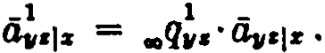
  - When Gompertz 's law holds, show that
  - Give two different expressions in the forro oí integra.Is for the val ue of a continuous annuity of 1 per annum, paya.ble so long as at least one of two lives aged x and y shall survive af ter the death of z, provided z pre­ deceases a fourth life w, and show that your expressions are equal.

00
1
  - Show that a!.,¡. -= v' ,p.A:r:•H dt.

Miscellaneous applications
  - Develop a formula in terms of annuity a.nd insurance symbols for the gross single premi um to provide the followi ng benefits with a. loading oí 61% of the gross premi um: A last-survi vor an n ui ty on the lives of a husband and wife, deferred n yea.rs and reduci ng by one-third on the first death. If the husband's death occurs prior to that of the wife and during the de-

268 REVERSIONARY ANNUITIES [CH. 13

ferred period, the annuity on the reduced basis is to commence immediately to the wife. lf the husband's death occurs after that of the wife and during the deferred period, the single premium is to be refunded.
  - A man aged 35 has a wif e aged 30 and two children aged 5 and 10, respectively. Under an insurance program, upon the man's death while either of his two children is under age 18 a monthly annuity will become paya.ble subject to the following conditions:
    - $30 monthly paya.ble to his wife as long as she survives and either child survives and has not attained a.ge 18,
    - $20 monthly paya.ble to each child as long as the child survives and has not attained a.ge 18, paya.ble whether or not the man's wife is alive at the time the payments come due. ,
Assuming that the monthly functions may be replaced by continuous func­ tions without appreciable loss of accuracy, express the value of the in­ surance program in terms of continuous life annuities.
  - An insured holds a $5000 policy, whole life fully paid up at a.ge 65, issued at a.ge x five years ago. An option in the policy provides for settle­ ment in equal monthly instalments for a period of twenty years, the first payment to be made at the date of death, and such that the present value of the instalments at the date of death is $5000. The insured now desires to provide for an additional benefit, whereby the monthly instalments will continue during the lifetime of the beneficiary now aged y. Find an expres· sion for the additional net annual premium, assuming such premiums are not to be paya.ble af ter the death of the beneficiary. Give an expression for tbe reserve on the additional benefit after five years, as'sumilig both the insured and the beneficiary are then alive.

Part III
MULTIPLE-DECREMENT FUNCTIONS

CHAPTER 14
MULTIPLE-DECREMENT TABLES

l. lntroduction
The analytical methods applied so far to problems involving mortality alone can be extended to form a more general theory involving the simultaneous operation of severa} causes of decre­ ment to a particular body ef lives. For example, one may be con­ cerned with an insurance coverage in which disability and mortality are distinct causes of daim and the interacting effects of exposure to both causes of decrement rnust be analyzed. Similarly, one may wish to study a mortality experience in terms of its component causes of death, treating each cause of death as a separate decre­ ment. Or, one rnay have the problem of valuation of a pension plan where death, disability, withdrawal, and retirement all operate as decrementa! forces against a staff of employees. The mathemat i­ cal model from which analyses of this kind can be made is known as the multiple-decrement table.
2. Probabilities of decrement
A multiple-decrement table is a mathematical model which as­ sumes a large body of lives subject to severa! independent causes of decrernent which are operating continuously. The body of lives forros a closed group, there being no ne,v entrants and no re-en­ trants af ter th_e opera tion of the various decrements.
The following notation is adopted :
l; Tl is the nurnber of lives attaining age x in a body of lives sub­
ject to the operation of m causes of decremen t (1), (2 ), ··· , (m ) ;
d;k> is the nurnber of decrements from cause (k ) between ages
x and x + 1;
d; T> is the total nurnber of decrernents from all causes between ages x and x + 1, so that
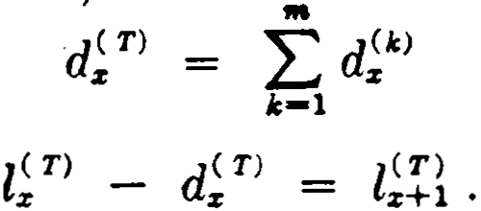
(14.1)

and (14.2)
q?) is the probability that (x ) will leave the body of lives within
271

272 MULTIPLE-DECREMENT TABLES [CH. 14

one year as a result of cause (k) :
(A:) d!A:)
q:,; = l!") . (14.3)
q!2') is the probability that (x) will leave the body of lives within one year regardless of cause:
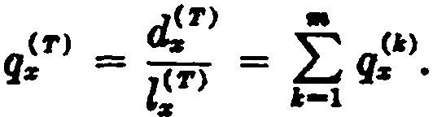 (14.4)
TABLE 8
EC'nON 01' DOUBLE-DECREMENT T.ABLE
Afe s | li,11 | 4> | 4'
24 | 901,020 | 299 | 92,762
25 | f!I.Yl ,959 | 314 | 86,632
26 | 721,013 | 324 | 80,385
'rT | 640,304 | 329 | 74,117
28 | 565,858 | 329 | 67,909
29 | 497,6 | 324 | 61,839

p!T) is the probability that (X ) Will rema.in in the body OÍ }iyeg
for at least one year:

Z (f')
P {t') = 1 - (f') = s-+1
q·
:r: • Z!f'> •

(14.5)

Similarly,
1(2')
(2') tri-•
"P· = z?>

(14.6)

and
"q(.f') =
1 - .p.( f') .
(14.7)

If the values of q A:) are known for ali k , the complete multiple­
decrement table is easily built up. An arbitrary radix is assumed, and the values of d 11>, el; T>, and Z! r> are obtained for each successive
age by using formulas (14.3), (14.1), and (14.2) respectively.
Table 8 shows a section of a multiple-decrement.. table with two causes of decrement. When such a table is available, it aff ords an instrument for calculating various probabilities for the lives in question. The following examples may be verified from Table 8:

SEC. 3] CENTRAL RATES OF DECREMENT 273
m 299
qu = 901,020
(2') 314 + 86,632
qn = 807,959
(2') 497,620
3P21 = 721,013
(2) 80,385 + 74,117
zgu = 721,013

(1) 324
s¡qn = 640,304

3.- Central rates of decrement
The central rate oí decremcnt from ali causes. at age x is defined

as
m!">

d 2')
- L(T )
-
z

( 14.8)

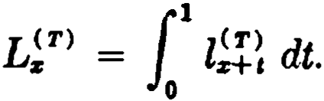
where (14.9)

This function is analogous to the ·central death rate mz in the mor- tality table. ·
The central rate of decrement from cause ( k ) is
d !.I:>

m k) -
- =
·
Lz
(14.10)

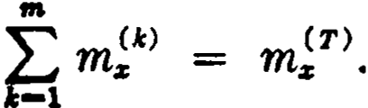
It is evident that (14.11)

In order to evaluate m!1:>, it is convenient to assume that the total decrement at each age is unifonnly distributed over the year of age. This assumption is equivalent to the approximation
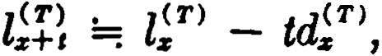 o < t < l ( 14.12)
whence

274 MULTIPLE-DECREMENT TABLES [CH. 14
L;T ) = f l;!! dt =; { (lt> - td?)) dt

= l;T ) _ ! T)
0

(14.13)

We then have

d(lc )
. z
z<T ) - 1.d(T ) ,
z 2 z

(14.14)

From this it follows that m;1c> can be cxpressed in terms of proba­ bilities of decrement as
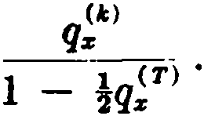 (14.15)
The experience obtained from a body of lives subject to severa! causes of decrement is often summarized in the form of central rates, and it becomes important to have a method for constructing the multiple-decrement table when the central rates of decrement are given for each cause.
From (14.13), we have z!TJ =; L!T> + i d!T> . Then

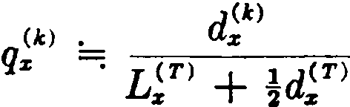
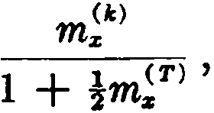
(14.16)

and similarly

( T ) • 1 - !m;T )
Pz =: 1 +!m?> .

(14.17)

Formula (14.17) can be used to build up the l;T> column of the multiple-decrement table, and the total decrement d! T> at each age
can then be distributed in proportion to the various central rates
m!1cJ

(k )
dlc ) = d( T ) , mz
- z ( T ) •
mz

- Forces of decrement
In a multiplc-dccremcnt table, the total force of decrement at age x is defined a's

SEC. 4] FORCES OF DECREMENT 275

(T)
(T) }' 11,qz
=
JJ.z 1m h
1'-+0

(14.18a)

1 dl;T )
- l?). dx
d log l;T )
dx

(14.18b)

(14.18c )

This function represen ts thc force of decrement from all causes combined, and is mathematically the same kind of f unction as the force of mortality in a sing1c-dcrement mortality tab]e. The follow­ ing relations may be derived in the same way as in Chapter l :

z?) = zf >e-f: µiT > d y
"p;T) = e-f:+""V> d11 = e-f:" H{ d t .

(14.19)

(14.20)

In order to define the forces of decrement for each of the in­ dividual causes, we first introduce the new functions
00
l (k) .,1(k) k
z = k-1 , = 1, 2, ·· · , m. (14.21a )
It will be seen that z?> represents the number of live8 at age x that will eventually be removed by cause (k). We now seek to define a force of decrement µ.< k> for each cause ( k ) such that

z<T ) <k> dy - z<k>
100
., µ,, - z '

k = 1, 2, ···, m. (14.21b)

z

Differentiating with respect to x, we find

( T l (k)
- dl :k )

whence
-lz µz - dx ,
(k) 1 dl!k )
JJ.z - zt> . dx .

(14.22)

This is taken as the definition of µ?>. It is important to observe
that the denominator in (14.22 ) is not z?> but l!T> . We now have
d 11

(k) - zCT) (A:) dt
z - z+tJJ.rl t
o
z

(14.23)

and
"q(k)
( " (T) (A:) dt
= J •Pz JJ.z+i •
0

(14.24)

276 MULTIPLE-DECREMENT TABLM [CH. 14

A simple relationship exists between the total force T> and the individual forces µ.;k> . Since
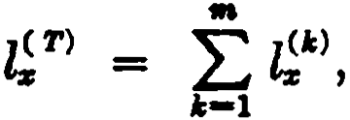
it follows from (14.18b) and (14.22 ) that
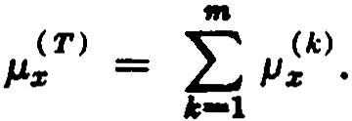 (14.25)
Thus, the total force of decremcnt is equal to the sum of the severa! partial forces.
An important distinction between forces of decrement and prob­ abilities of decrement should be noted. The probability functions involve a certain interval of time during which the body of lives is being depleted by all the causes of decrement. Hence, the number of lives which drop out in the interval on account of cause (k ) is not independent of the magnitude of the decrements due to the compet­ ing causes. The greater the effect of these other forces, the fewer will be the decrements on account of cause (k ), and the smaller will be the value of the probability of decrement from this cause. The probability values for the various causes thus 'depend on one another, and probabilities of decrement must be regarded as de­ pendent probabilities in any situation in which several causes are combined.
This may be seen mathematically by writing the probability of decrement from cause (k ) as
q(k) - 1 ( T\ (k) dt
% - tP% µz+,
o
and substituting for ,p; T> from (14.20) :
1 t
1
q( k ) - e-fo .uU:l da (k) dt
% - µz+ , .
o
In this form, it is clear that the probability of decrement for any individual cause (k ) depends upon the forces of decrement for aU the causes.
On the other hand, the function k> , being an instantaneous rate of decrement, is not based upon any time interval, and is not af­ fected by the operation of competing causes. The forces of decre-

SEC. 5) THE ASSOCIATED SINGLE-DECREMENT TABLES 277

ment for the various causes are thercfore independent functious, in contrast to the probabilities of decrement, which are dependent upon one another.
When numerical values of µ!") are needed, they can be estimated
from the multiple-decrement table by means of an approximate formula. The following three formulas may be derived under the same assumptions as formulas (1.20), (1.21), and (1.22 ) for the force of mortality µ.z :
!.- d;!i + d;k)

--: 2z?l
=; 7(d '::.1 + d?) ) - ( d;'::.2 + d; \ )
12l;T)
(14.26)

(14.27 )

µ;k ) =; zlT) ( d;" ) - !d;k ) + %2d;k ) - • • • ) (14.28)
The formulas are given in terms of d?i instead of z?> since the values of l!k> are not usually shown in the multiple-decrement table.

- The associated single-decrement tables
For each of the cam;;es in a multiple-decrement table, it is possible to define a single-decrement table which exhibits the properties of the cause in an independent form. If we have, for example, a double­ decrement table for mortality and disability, we can obtain a single­ decrement table for mortality and one for disability. Each table will be based upon its own force of decrement, which is independent of the operation of the other cause. In general, for each cause (k ), we take z<"> as the radix of an associated single-decrement table and define the functions

z;<k )
l'(k) -f
z (1: )

d11

and

qz'Ck) =
"'11
0 o
e
1 (k )
-J
1 - e ol'z+id t
(14.29)

(14.30)

These exprcssiorn; will be recognized as the standard relations which hold in any single-decrcment table. When the single cauHe of decre­ ment is death, for example, the functions z; ckJ and q;(kJ are merely the familiar lz and qz of the mortality table.
In the single-decrement table, the function q;<k> is both an annual

278 MULTIPLE-DECREMENT TABLES [CH. 14

rate and a probability of decrement. Inthe context of the multiple­ decrement table, however, q;<k> is solely a rate of decrement and must be distinguished from the probability q;k> . When several decrements are operating simultaneously, we shall scc that the ratc of decrement for a given cause is greater than the corresponding probability of decrement. In this book, the · expression raú of decre­ ment will always ref er to the function q;oi:> and will not be used as an abbreviation for central rate of decrement. The function q;<k> has often been called the absolute rate of decrement in other actuaria! literature.
Since formulas (14.29) and (14.30) cannot normally be applied directly, the values of the rate of decrement q;<k> are usually deter­ mined by approximation methods from the data given in the mul­ tiple-decrement table.
The traditional formula may be obtained from the following general argument. In a single-decrement table, when the rate of decrement for a given age is multipled by the number of lives attaining that age, the result is the number of lives which fail during the year as shown in the table; e.g., qz· lz = dz . In a mul­ tiple-decrement table, however, if the rate of decrement q;<k> is
multiplied by l! T> , the resulting number of lives exooeds the value of d!11 shown in the table, since sorne of the l! T> lives are not exposed
to cause (k) for a full year due to their removal by one of the other
causes. The number of lives which are removed during the year from other causes is d! T> - a?>, which we denote by dtk>. lf it is
assumed that these lives are exposed to cause ( k ) for one-half year on the average before exit, the loss in exposure is the equivalent of dtk> lives. Hence, in order to obtain the decrement a;"> shown in the multiple-decrement table, the rate q;<k> should be multiplie<l
by zi T> - !dtk>, which is the average exposure. We thus have
q;(k ) [l;T) -idtk) ] =; d!k )'

'(k) • d?>
whence
q% . =; zir> ._ idi-k>
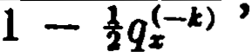q!")
( 14.31a)

( 14.31b)

where we define q!-1c> = q! T> - q!">.
For the special case of two decrements, the formulas are

SEC. 5) THE ASSOCIATED SINGLE-DECRE:\1EXT TABLES 279

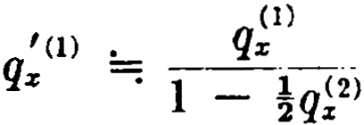
and
1t Z) • q;2)
q,: =; i - }qi1> • ( 14.32)

Other formulas can be obtained on thc basis of more formal mathematical assumptions. If we assume that each derremeut d;k> is uniformly distrihuted over the year of age, we have
l t l;'c) - t .d;">
for integral x and O < / < l.
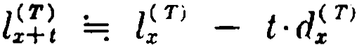
It follows that

and

dl (k )
dz+tt :-_;

¡<k )
-cz '
(14.33)

and therefore
(le) 1 dl;\ . d?)
µx+ t = - l( T) dt =; l-(T) •
x+t z+ t

( 14.34)

An approximate formula for q;o.-¡ can now be dcrived by using this assumption in formula (14.30). From (14.3a ) and (14.34) we
have
r
µ;t\ dt =; 11 ( T) d;k ) ( T) dt
O O lx - l · dz
[- :J::·log cz;T) - t·d;T' ) J:
d;k ) ( T)
- (T) log Pz .
dz
Substituting this result in (14.30), wc obtain
d?'

qz (k) ==•
1
l :_ ( ( T) )d,F'
Px ·
(14.35)

To obtain a formula for practical .use, we write the right-hand side as

1 _ ( l
and expan<l the binomial:

dA:)
- ( T) ) d .(, Tl '
qz

280 MULTIPLE-DECREMENT TABLES [CH. 14

J } d (k)
( T) + 1
d(A:) (d(1:)
J) ( ( T) )2 }

- { - aIT) ·qz "j° d T) rJ;T ) - qz - • • • •
z z z
Retaining only thc tcrms in<licated and simplifying, we have q;(/í) q A:)[1 + Hq!T) - q 1:')]
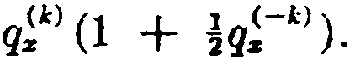 (14.36 )
FormulaH (14.:Hb) and (14.:Ui ) are easily sc<'n to he suhstan­ tin.lly equivalen t. Writing (14.:H b) as
q;(l) =: q?) (1 - qt1:) )-1
= q?) (1 + !q;-1:) + . . .),
we obtain (14.36 ) by truncating the binomial expansion.

- Construction of a multiple-decrement table from the as• sociated singlc-decrement tables
We have seen that a givcn multiple-decrement table may be resolved into a family of asso<'iated single-decrement tables. We now eonsider the inversc problcm of constructing a mult iple­ decrement table based on a given farnily of single-decremcnt tables. Let us assume that m ::;inglc-decrem.cnt tables are given, each representing a different cause of decrement, and that we wish to obtain a multiple-decrcment table embodying these m causes of decrement. The following relation holds bctween the required
parent table and the given family of tables:
µ; TJ µ;I) + µ;2) + . . . + µ m) •
Since,. from (14.20), p;TJ = e-fl C T ) d t , 1. t follows that
o µz + ,
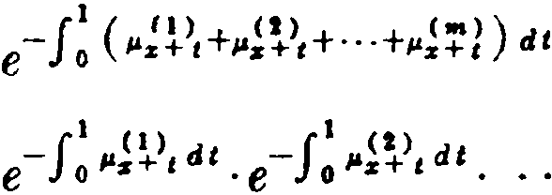
( TJ
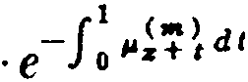
Pz
1(1) '(2) l ( m)
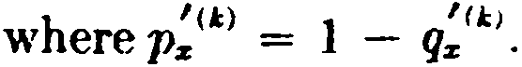
Pz ·Pz · ··· · Pz ,
(l4.:17a )

Hence,

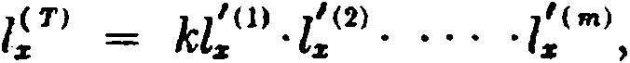
where k is a constant of proportionality.

(14.37b)

SEC. 6) COKSTRUCTION OF A l\IULTIPLE-DECREME T TABLE 281
Although (14.37b) providcs un exaet basiR for constructing l; n, thc individual decrements at each agc,
d - 11

( k ) l ( T ) (k) dt
x - x+ t µx+ t ,
o
must normally be computed by a method of approximation.
A <leviee which is particularly eonvenient for thc special casé of two decrcmcnts is based on (14.32 ). In the preseHt instancc, the values of the rates q;(I) and q;(2) are knmm from the given single­
decrement tables, and wc dcsire to find the values of the córrcspond­ ing probabilities q;0 and q;2 ) . The relations in (14.32 ) lead to thc
following system of simultaneous linear equations in q;1 and q;2l:
>

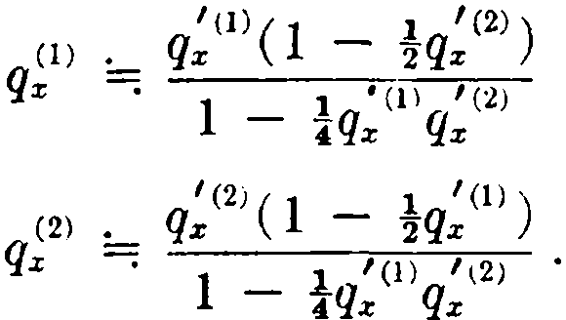
8olving, we find
(l) + lq'CI) , q(2) !.- q'O)
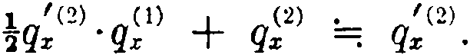
Z 2 X Z --; Z
q

(14.38)

lf d;1
>
and d?> are now eomputed as q;0 ·l; T> and q;2 > • l; TJ, the

total d;º + d?> will not always agrec with the value d; T> given by
l; Tl - z;¡l, where Z; T> has been found from the exact for­
mula (14.37b). Hence it is bctter to compute d n and d;i> by dis­ tributing the exact value of d; r> in proportion to the approximate value of q;0 and q?> from (14.: 8) ; that is, by using

(l.:)
d ( k ) qx d( T)
X = --(1) (2) • X )
qz + qx

k = 1, 2.

The extension of this mcthod to the cases of three or more decre­ ments is inconvenient since it requires thc solution of larger systems of linear equations.
Another method, which is easily applied for any number of decrements, is to translate the rates of dccrement into central rates. The central rates can be readily estimated. Since
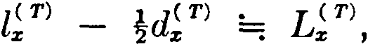

282 M'ULTIPLE-DECREME T TABLES [CH. 14

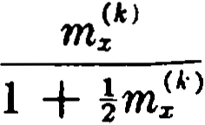
formula (14.31a ) may be written as

--: 1 ( T) .!d(k )
+
Jz 2 z

(14.39)

and solving for m;A:> ,

'(A:)
=:
m;A:) qz_....,..-
1 '<A:) •
1 -
'Iqz

(14.40)

The exact value of d; r> can then be distributed in proportion to the central rates.
It will be noted that sorne type of approximation is almost always necessary in carrying out the methods described in this chapter. For convenient reference, the basic formulas are collected in Table 9.

- The analogy with joint-life functions
The student should realize that he has already encountered a
m.athematical model of the same type as a multiple-decrement table in his study of joint-life functions. Just as l; r> represents a
number of lives subject to m causes of decrement, so the joint-life function lz1:rz···zm may be interpreted as a number of life-groups, each containing m lives, and, since the death of any one of the m lives in a group is sufficient to cause the failure of the group, we may say that the function is subject to m causes of decrement, namely the death of (x1), the death of (x2 ), ··· , the death of (xm ).
The number of failures during the year, denoted by d:r 1:rz···z"' ,
corresponds to the total decrement function d! r>.
In constructing a joint-life mortality table, we begin with a single-life table and use the relation
Similarly, the multiple-decrement table may be ·constructed from the associated single-decrement tables by using the relation
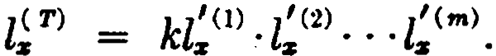
Also, corresponding to the joint-life formula

TABLE 9

THE STANDARD APPROXI MATION FORMULAS

e::
Formula for | In tenns of  q/c) | In tenns of  ,,,et>  % 1 |  | In tenns of  qz'(.I:)
Probability q">  Central rate m,.>  Rate q,f.(i) | (i)  Q:,;  (k) • qk)  m,. 1 - tqF>  (14.15)  (i)  f (k) • Q:r  Q:,; =: 1 -!q -A:>  (14.31b) | (.t)  (.t) . mz  qz -"; 1 + m T )  (14.16)  m,(.k)  1  (i)  ,c.t> . m., qz =: 1 + m.t)  1  (14.39) | For two decrementa only:  (k) • q(J,) (1 - Jq(-4:))  q:r ==: 1 - 1 r(/,) '(-k)  •Qz Qz  (14.38)  f(I,)  (k) . qz  m,. =: 1 - '<k>  }qz  (14.40)  f(k)  qz

t:r.l
r.JJ

z
ti
>
=
ti
>
't!
't!
::z:,
o
>I
i
>
j
oz
o'llJ
::z:,
oa:::
t4
>
i./l

00

284 MULTIPLE-DECREME T TABLES [CH. 14

we have the multiple-decremcnt relation
µ T) = µ.;I) + µ?) + ' . . + µ;m).
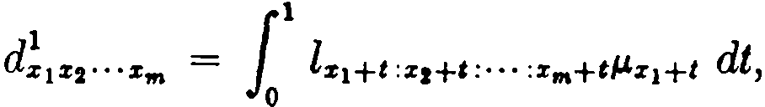
In the joint-life mortality table, it is not customary to tabulate thc numbcr of failures due to the death of a specified life. However, if it wcrc desirc<l to exprcss the number of failures in a year due to the dcath of (xi ), the formula would be
just ns thc rrumber of dccrements due to cause (1) is givcn by
1
1 {T) (1)

(1)
=
dx
l.:,+ t µx+ t dt .
0

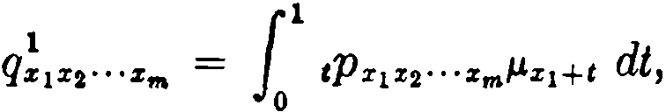
Also, the contingent probability
is analogous to the multiple-decremcnt probability
(1) 11 ( T) (1) dt

qx =

- Monetary applications
tPx µx+ t •
0

The probabilities of the multiple-decrement table may be com­ bined with compound interest functions to produce monetary values in accordance with the usual principles. The process 1s facilitated by the definition of special commutation functions.

Let vrl; T) = D; Tl · and

O()

" D( T ) - N( T)
x+ t -
L,_¡ X '
t -0

Then the present value at age x of a series of annual payments of 1 continuing as long as (x ) remains in the body of lives defined by the multiple-decrement table may be expressed as
N;T>
(T) .
Dx
Let v:r+1d?) = C;k ) and I:,-o C;t\ = M?). Then the present
00
value at age x of a payment of 1 to be made 3t the end of the year

SEC. 8] MONETARY APPLICATIONS 285
in which (x ) leaves the body of lives as a result of cause ( k ) is given by

A<t> =
(A:)
_z_
M

z D T) .

If this benefit is payable immediately instead of at the end of the year, we have
- (k}
.J <k> = M z
% D;T )

with the usual approximation M;kl =: M kl .
ó
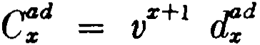
Life insurance policies of ten include a provision for an additional payment · in the event of accidental death. The theoretical model for evaluating this supplementary benefit is a double-decrement table showing the number of accidental deaths cl;d and the number of deaths from all other causes á;ad. We define
and
00
L
M!d = c:! i .
t-0

Then the present value at age x of a payment of 1 at the end of the year in which accidental death occurs is

A = Me ·
Dz
The net annual premium payable for m years for an accidental death benefit providing coverage for n years is
pi ad M - M:!"
m z: ñl = N ( T) _ N( T) •
z z+m

In practice, a special kind of approximation is often used in obtaining net premiums for the accidental death benefit. If the values of the probability of accidental dcath, q!d , are available, the construction of the <lou blc-decrcment table can be avoidcd. In place of D; T> and N ;T>, the functions Dx and N z from a standard

286 MULTIPLE-DECREMENT TABLES [CH. 14

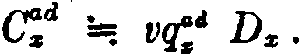
mortality table are used. The values of C:c1 are then obtained from the formula
Functions computed in this way are said to be based upon the accidental death table combined with the standard mortality table.
Special methods have been developed in two other important fields of application, pension plans and disability benefits. They will be taken up in Chapter 16.
- Notation
At the present time there is no generally accepted standard notation for multiple-decrement functions. The usual practice is to assign symbols according to the nature of the problem under con­
sideration. If the cause of decrement is withdrawal, for example, the symbol Wz may be used in place of d;10> . Mortality is normally
one of the decrements considered, and the symbol dz is of ten used for d;d> . When no confusion will arise, the superscribed parentheses
are often omitted, and symbols like Z; and el! are commonly en­
countered. In order to accustom the student to this notational flexibility, we shall frequently use alternative symbols in the fol­ lowing chapters. A few notations involving different symbols have already appeared, and others will be encountered in the exercises that follow.

References
A general treatment of multiple-decrement theory is given by Bailey and Haycocks (1946) and by Hooker and Longley-Cook (1957 ). apers which discuss the subject from a special point of view are Nesbitt and Van Eenam (1948), Bicknell and Nesbitt (1956 ), and Hickman (1964).
Greville (1948, 1954) has discussed a special type of multiple­ decrement table in which the decrements are deaths arising from different causes.
4. Methods of approximating the forces of decrement are givcn by Menge (1932).
6. The problem of this section is discussed by Gershenson (1957 ).
8. Values of the accidental death functions q:c1 and e:', based

EXERCISES 287

upon recent insurance experience, have been tabulatcd by Brodie and Kovember (1959).
EXERCISES
- Introduction; 2. Probabilities of decrement
  - Compute from Table 8
    - the probability that (26) will leave the body of lives as a result of cause (1) at age 29 last birthday;
    - the probability that (24) will attain age 26 in the body oí lives and will then lea.ve as a result of cause (2) within the succeeding 2 years.
- A two-year junior college expects t hat its students will leave in ac­ cordance with the following probabilities:

Class | Probability of
 | Academic Failure | Withdrawal for Other Causes
First year . . . . . . . . . . . . . . . . . . .  Second year . . . . . . . . . . . . . . . . . | .10  .05 | .30  .20

  - How many new students should be admitted at the beginning of each school year if 180 graduates are desired at the end of each year?
  - How many new students should be admitted at the beginning of each school year if the total enrollment then is to be 800 students?

- Central rates of decrement
  - In Table 8, estimate the value of the central rate of decrement f rom cause (2) at age 25.
  - Extend the data of Table 8 to age 30 being given that mW = .0008
and m > = .1374. Use standard approximations.
  - Suppose that for the first year following the training period of pilots the central death and withdrawal rates are a and b respectively. What is the probahility that a pilot who has just finished traini ng will still be active as a pilot at the end of the first year? Use standard approximations.

- Forces of decrement
- In a double-decrement table, it is known that µ.R = j and µ}J. = k ,
O < t < 1, where j and k are constants. Compute the exact value of ql).
- In a m ultiple-decrement table associated with a certain body of lives
2 3
there are thr<'e force¡, of decreme1t t, µ.ll , µ. > , and µ. l , w here µ."> is equal
to 3 . What is thP probability that a life aged 10 will remain
11 k (IOO - x)
in the body of lives u n til age 60? (Ans. n

288 MULTIPLE-DECREMENT TABLES [CH. 14
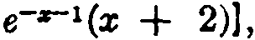
8. Given zr> = (a - x 2 )e-z and d1 = 2[e-•(x + 1) derive an exact algebraic expression for µ 0 •
>

9. Given µ;1
>
= -1 and µ;2> = 1, derive exact algebraíc expressions for
a - x
--

17'>, d,1>, and d;'l, assurning lT > = a.

- The associated single-decrement tables

- Consider the associated sing1e-decrernent tables corresponding to

Table 8. Assurning zi1
>
>
= l 2> = zr> , compute values for dl1
and d2> .

Use standard approximations.
- A body of lives is suhject to two causes of decrement. Using standard approximations, express ql) in terms of q;<o and q!T> .
- In a certain double-decrernent table involving deaths d:r: and with­ drawals w., , the decrements are dist rihuted t hroughout the year of age i n such a way as to produce the following formulas for the rates of decrement:
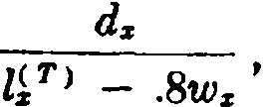
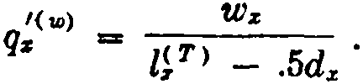

For a certain age x , lJT > = 1000, z ii = 900, and q;<"'> = .080. Find the value of q;<d>. (Ans . .022)

- Construction of a multiple-decrement table from the associated single-decrement tables
13. Two síngle-decrement tables are defiued by z;rn = a - x and z<2> = ce-z. Find expressions for zr> , d1> , and d?' in the corresponding double­ decrement table, assuming z r> = a.
14. Given q;ll = 2 .%1, q i> = 301, qiª> = 03, and q •> = 1%01, com­ pute values for d', di!> , d> , and d> , assuming l[ > = 10,000. Use standard
approxima tions.
- A company which employs a large number of fernale office workers has just constructed a service table showing the number of females who attain age x in employrnent. The workers must resign when they marry. They also withdraw for other rcasons. Tbe following values are given:
li> = 10,000, l[' = 8600, ll' = 7400. If the rate o{ marríage for each of
these ages is 10% and if the central rate of mortality for each age is 1%, calculate (using standard approximations) the number of deaths, mar­ riages, and other withdrawals for ages 20 and 21.
- If q;cl) = .080 and m2 = 3 m1 in a double-decrement table, compute
>
>
the value of qr> using standard approximations. (Ans . .286)

EXERCISES 289

- The analogy with joint-life functions
17. (a) What is the multiple-decrement analogue of the joint-life rela­ tion Pr1%•··.%tia = P%1 ·Pz1 • • • Prm ?
(b) What is the joint-life analogue of the multiple-decrement for-
c1> d l)
mula m = <T> ?
L$

- Monetary applications
- Given a double-decrement table showing decrements by death d¡a> and by disability d•> . The net annual premium at age 52 is required for a disa.bility benefit of 1 which is payable at the end of the year of disability provided that disability occurs prior to age 55.
  - Express this premium in terms of the given double-decrement f unc­ tions and interest functions.
  - Express the premium in terms of appropriate commutation func­ tions.
- An analysis of the mortality among civilians in a war combat area shows that at a certain age the rate of death resulting from war is .05 and that the central rate of death resulting from war is ten times that of death not resulting from war. Compute the net premium for a $1000 one-year term policy which would give full coverage at this age irrespective of whether death resulted from war or not. Interest is at 3 per cent.
- A mutual benefit society is being formed to offer the following bene­ fits:
- On withdrawal, return of premiums without interest.
- On death, $1000 if before retirement, none if af ter retirement.
- On retirement at age 65, a lump sum of $500 times the number of years the member has paid premiums.
Assuming that the necessary service table is available, show what com­ mutation columns you would set up to facilitate arriving at the annual premiums for the above benefits. Give the formula for the total annual net
premium P at age x assuming P' (gross premium) = (P + c) (l + k ).
21. When an accidental death table is combined with a standard mor- tality table, show that the terminal reserve 7V!":ñ] (t < m) can be expressed as
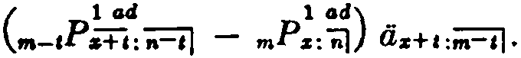

Miscellaneous problems
µ .
- Show that is equal to m"> on the assumption of a uniform dis­
tribution of decrements.
- Given the probability of death, the rate of retirement, and the central ra.te of withdrawal, find approximate formulas for the probability of withdrawal and the probability of retirement in terms of the given func­ tions.

290 MULTIPLE-DECREMENT TABLES [CH. 14

- The following is an incomplete extract f rom an employees' service table involving two causes of decrement-·death and withdrawal:

 | % | ,1r> | d"') | d d> | ' (d)  t/s
 | 20  21  22 | 10,000  9,100  8,328 | -  -  - | 41  -  - | -  .0046  -
Using standard approximations (where necessary):
  - find the values for di:>' en>' and di':' ;
(b) find the probability t hat an individual aged 20 will withdraw
within 2 years;
(e) find the central death rate at age 21;
(<l) find the rate oí withdrawal at age Zl;
(e) find the complete two-year work-life expectancy at age 20, e![-iJ .

CHAPTER 15
TABLES WITH SECONDARY DECREMENTS

l. Primary and secondary decrements
In the multiple-decrement tables discussed thus far, each life is observed only until it is removed by the operation of one of the causes of decrement. The model <loes not include the subsequent history of those lives that are removed by causes other than death. In calculating the values of certain benefits, the actuary must sometimes make assumptions about the subsequent survival of these lives. An example is the calculation of the value of a disa­ bility benefit which provides an income to the insured in the event of disability. A possible model for this situation is a double­ decrement table for mortality and disability with additional columns showing the eff ects of mortality and recovery on the lives that become disabled. In this particular table, the original body of lives is said to be subject to two primar y decrements, mortality and disability, and the disabled lives are subject to two secondar y decrements, mortality and recovery. The student will readily visualize other situations which require a model of this type.
The simplest form for such a model comprises two primary decrements and a single secondary decrement, as illustrated in Table 10. The primary decrements are death (d ) and an unspeci­ fied cause (h), and the first three columns thus constitute the usual double-decrement table. Columns (4) and (5) show the eff ects of mortality af ter the operation of cause (h ), the function (hl )z being defined as the number of lives attaining age x af ter leaving the original body of lives as a result of cause (h), and
the secondary decrement ( hd )z being defined as the number of lives dying between ages x and x + 1 af ter the operation of
cause (h). lt should not be thought that these two columns form a single-decrement table, for the function ( hl )z is subject to the increment d;A> as well as to the decrement ( hd )z . Thus the two sections of the combined table are linked by the function d;"\ which forms a decrement from l;T> and an increment to ( hl )z . The relations among these functions are

l2' ) - dcl) - d") = lt
291
(15.1)

292 TABLES WITH SECONDARY DECREMENTS
(ht)z + d!A) - (hd ):i = (hl)z+l •
[CH. 15

(15.2)

It is instructive to verify these relations for the illustrative numeri­ cal values that have been entered in Table 10.
In discussing this model, it is convenient to adopt a special terminology. We shall ref er to the lives denoted by lT> as being in state (T ) and to the (hl )z lives as being in state (h ). The lives in state (T ) are subject to the risk of death and to the risk of
transfer to state (h ), and the lives in state (h) are subject only to the risk of death. lt is assumed in this particular model that re-entry to state (T ) from state (h ) is impossible.

TABLE 10
Age s | (1) | (2) | (3) | (4) | (5)
 | ziT> | dd) | dA) | (.W)z | (ltd)s
30  31 | 32,176  29,467 | 506  494 | 2,W3  2,014 | 52,066  53,780 | 489  5Z1

The probabilities for the primary decrements take the usual form:
(d) d;">

qz = l T}

(1') d h)
qz = [ T ) •

The rates of decrement, by (14.31a), are

'(fl} • dd)
qz ::::¡ l( T) - 1.d(•)
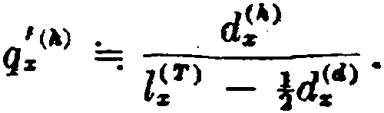
z 2 z
( 15.3a)

(15.3b)

( 15.4a)

( 15.4b)

In obtaining the rate of mortality" for lives in state (h ), which we denote by (hq )z , it must be remembered that (hl )z is subject both to the decrement (hd ):i: and to the increment d;"> . A multiple­ decrement formula must therefore be usc<l with dh> taken as a negative decrement. With this adjustment, formula (14.31a ) gives

SEC. 1] PRIMARY AND SECONDARY DECREMENTS 293

(hd) X
( hq )x =: ( hl)x + !d;h) '
( 15.5)

This result is clearly a reasonable one, for the ( hl )x lives are exposed to the risk of death for a full year and the d;h> lives are expose<l in state (h) for about one-half year on the average.
Consider the probability that a life aged x in state (T ) will
transfer to state (h ) and die before attaining age x + l. We will
denote this function by qTh). Here we wish to know how many of
the lives shown in the table as dying in state (h) between ages
x and x + 1 were in state (T ) at the beginning of that year of
age. The total number of lives dying in state (h ) at that age is ( hd )x , and this is made up of deaths among the ( hl )x lives attain­ ing age x together with the deaths occurring among the d;hl Jives which transferred to state (h ) during the yeB.r. It is these latter deaths to which the probability q;Th) refers. The rate 9f mortalit y for lives in state (h ) is (hq )z , and the number of <lca ths during the year among the ( hl)x lives is given by ( hl )x · ( hq )x . It follows that the number of deaths among thc d;hl lives is
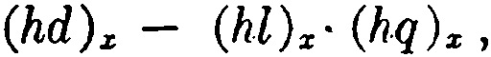
and the required probability is therefore
( Th) ( hd ) x - ( hl ) x· ( hq) x
w) .
q:z; = ( 15.G )
There is an alternative approach to the value of q;ThJ . ThP probability that a life aged (x ) in state (T ) will tramiÍer to ta te ( h ) within one year and then die beforc the end of that year may be expresscd as
( Th) 11 ( T ) (h) ( h ) dt

q:,; =
i Px µz+ t ' l-t q x H ,
0

where µ11> is the force of decrement for cause (h ). Using the Bal­ ducci hypothcsis,
1-t ( hq )x+ t =: (1 - l ) · ( hq )x ,
and assuming a uniforrn distribution of primary dccremcn ts ¡.;o th nt
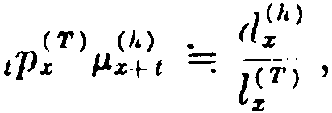

294 TABLES WITH SECONDARY DECREMENTS [CH. 15

we have

q;2'h) =: [

1 d(h)
() ' (1 - t ) • ( hq )s dt

O lz
dh)
= !·w) .( hq )z
= !·qh) · (hq )z , (15.7 )
The result appears reasonable, since q"> is the probability of transfer to state (h), and the lives entering state (h) are then
subject to the risk of death for approximately half a year on the average before attaining age x + 1.
Although (15.6) is an exact formula and (15.7 ) an approxi­ mation if (hq )z I is known, in practice (hq ):z: must be estimated from (15.5 ), so that both formulas produce an approximate resul t. lt can easily be demonstrated that the substitution of (15.5) for (hq )z leads to the same algebraic result in both (15.6 ) and (15.7 ).
Consider next the probability p;T h> that a life aged x in state (T ) will be in state (h ) upon attaining age x + l. Of the (hl ) 2 +1 lives in state (h ) at age x + 1, (hl ) 2 • (hp )2 have been in that
state for the entire past year, where ( hp )z = 1 - (hq)z . The remaining lives, (hl ):i:+ 1 - (hl)z· ( hp )z , must have attained age
x + 1 in statc (h ) af ter having been i n state (T ) at age :r , and
it follows that the requircd probability is
( Th) ( hl) x+t - ( hl) x· ( hp) ;r;
Pz = W> ( 15.8)
Thc formula may also be <lerivcd by noting that
( Th) (h) ( Th)
Pz = (15.U )
qz - qz
and substituting for qTh> from (15.6). If we substitute for q;Th>
from (15.7 ), the alternative formula

is obtained.
Pz( Th) :--: qz(h)[l _ !2 (hq )z]
(15.10 )

The probability that a life (x ) in state (1' ) will attain age
x + n in statc (h ) may be expressed as

SEC. 2] DISABILITY AND MORTALITY 29.

(Th) ( hl ) x+n - ( hl ) x·n ( hp) x
n Pz = lT ) (15.11)
by an obvious extension of formula (15.8). Here thc function
n ( hp )z is given by
n (hp )x = ( hp )x · ( hp )z+l " · ' ' • (hp )z+n-1
[1 - ( hq )x][l - ( hq )x+d ···
[1 - ( hq )x+n-d • (15.12 ) A number of other functions can be similarly expressed. For ('X­
ample, the symbol n q?h> denotes the probability that a life aged .r in state (T ) will die in state ( h ) between ages x + n and x + n + 1,
1
and
( Th) (hd) x+n - ( hl) x· n¡ ( hq)x
w)
n i qx = ( 15.13)

wherc ,., ( hq )x = ,, ( hp )x - n +l ( hp )x .
( I.1.14 )

In the sections that follow, we shall consi<ler two spccific real iza­ tions of the model of Table 10. Each of these will be discused in terms of its own characteristic notation. It is thercfore importan t for the student to understand the sense of each of the basic formu­ las derived abovc without regard to thc particular symbols i n which it happens to be cxpressed.
- Disability and mortality
In Table 11, the two primary decremcnts are disabili ty and mortality, and the secondary decrcment is mortality among the disabled lives. This table, known as a eombined disability and mortality table, is the model that was used in the calcula­ tions for the older forms of disability benefits included in life insurance policies. Payments were made only for disability which was permanent as wcll as total, so that no recoveries were assumed to occur. More recent practice involves a differcnt model, which we shall discuss in the next chapter.
In the combincd disability and mortality table, the symbol l':' is used for the original body of lives, the active livcs. The dec­ rements from death and from disabi]ity are denoted by <1:1 and

296 TA BLES ,v1TH SECONDARY DECREMENTS [CH. 15

by iz respectively. The disabled lives attaining age x are denoted by z!i and th e death:-:; among the disabled lives by d!i . \Ve thus have

r: - - Íz = li
z!i + iz - d!i = l!_!.1 •
(15.15)
(15.16)

The letters a and i uscd a::; superscripts in these symbols are suggested by the terms active and invalid. When used to distin­ guish the l:¡; and d:i: functions of the combined disability and mortality tal>le, as above, these letters are always repeated-aa and ii. When they are used as a superscript with probability, annuity, and insurance functions, a special convention is ob-

TABLE 11
SECTION OF COMBI NED DISABILITY A NO MORTALITY TABLE
 |  |  |  |  | (3) | (4) | (5)
1 (1) ! (2)
1 |  | /ºzª |  | a:a | Í,: | ¡ii | 4'
20 |  | 92,483 |  | 686 | 53 | 154 | 37
21 |  | 91,744 |  | 684 | 52 | 170 | 38
22 |  | 91, 008 |  | 683 | 52 | 184 | 38
23 |  | 90, 273 |  | 682 | 51 | 198 | 38
24 |  | 89, 540 |  | 681 | 51 | 211 | 38

scrved. In such cases, when there is a double superscript, as in pª and a:i, the first letter indicates the present tate and the sccond lettcr specifies a f utu rc state. For example, p°: represcnts the proh­
1
Age .x
z
1
1
ability that a life now active will be alive and active one year later; and a:i is thc prcscnt vulue of an annuity which is payable whcn
a life now active becomcs disabled. When there is a single super­ script, thc f uturc statc is not specificd. Thus, q: represents the
probabili ty that a life now active will die within one year, whether active or disabled.
In the case of q!,there is only one decrement operating, and the
symbol represents both the probability and the rate of mortality among the disahkd lives. The function q; is the counterpart
of the rate ( hq )x in the general model of Section l.
Formulas for thc basic proba bil itics may be w ritten. in terms of the comhined disubility an<l mortality functions. Each one

SEC. 2) DISABILITY AND l\lORTALITY 297

listed below corresponds to a formula derived in the preceding section. Instead of repeating the derivation in each case, we shall i ndica.te at the lef t the number of the analogous general fornrnla.
The probability that an active life aged x will die while active within a year is
( 15.3a) 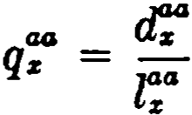 ( 15.17)
The probability that an active life aged x will her.orne disabled within a year is
( 15.3b ) 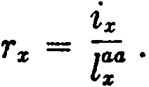 (15.18)
Note the use of the special symbol "r" for the probability of dis­ ability.
r:
The rate of disability for age :i: is dcnoted by and

' 2:i;
( 15.4b )
r. =; lªª - .! .flª .
:i: 2ti2:

For the rate of mortality arnong disabled lives, we have
( 15.19)

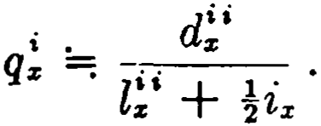
( 15.5) ( 15.20 )

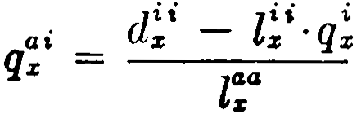
The probability that an active life aged x will die disabled within one year is

( 15.6 ) ( 15.21)

or

(15.7 )

ai . 1 i
q;c :::=; 2 · q%
z:ª .

= }rx· q! . ( 15.22 )

The probability that an active lif e aged x will be alive and disabled
at age x + 1 is
( 15.8) 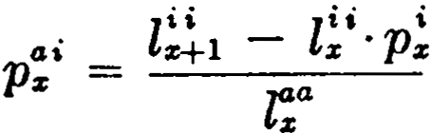 (15.23)
or

298 TABLES WITH SECONDARY DECREMENTS [CH. 15

(15.10) 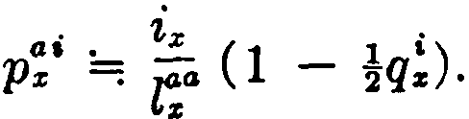 ( 15.24)
The probability that an active life agcd x will be alive and disabled at age x + n is

(15.11) ai
nPx
l! n - l!'·np! (15.25)
l!ª

The probability that an active life now aged x will die <lisabled in thc (n + 1)-th year from now is
(15.13) 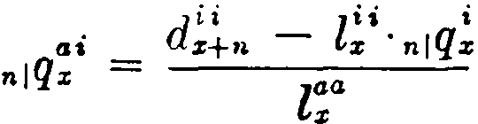 (15.26 )
:Many other probabilities may be formulated in terms of those listed above. For example, lct us obtain the probability that an
active lifc agcd x will becomc disabled bcfore attaining agc x + l
and will die beforc attaining agc .-r + 2. TlH'Sc ronditiorn; are satisficd if the life bc<'omes disabled an<l die bPforc ugc x + 1, thc chance of whirh is q\or if thc lifc bceomes disabled and sur­ vives to agc x + 1 an<l thcn <líes beforc age :r + 2, the chance of
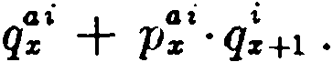
which is p i·q!+1 . The required probability is thus given by
This probability may also be cxpressc<l füi thc probability of bc­ coming disabled bcforc agc x + 1, which is rx , minus thc prob­ ability of bccoming disahled bcfore agc x + l and thcn survivi11g to agc x + 2, which is p:¡·p!+1 . Thus an alternative formulation is
ai i
Tx - P x ' Pz+l •
The two expressions are clearly equivalent sincc p:i + q:i = rx .
- Marriage and Ínortality
As a second application, ,ve shall ronsi<lcr a fcw probabilities from a combined marriagc and mortality table, a typical scction of which is shown in Table 12. Thc <lcfinitions of the 8ymbols uscd will be obvious from the column hcadings of the table.
For a married man, the ratc of mortality, (mq):i , is ohtained from

SEC. 3) l\IARRIAGE AND MORTALITY 299
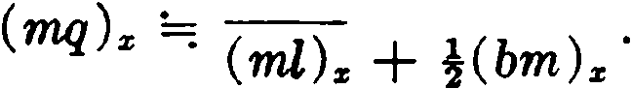(md) z

Let us use Table 12 to evaluate the probability that a bachelor aged 33 will attain age 34 as a bachelor and then die a married man before attaining age 35. The probability of attaining age 34
as a bachelor is given by [:!/:,and the probability that a bachelor
aged 34 will die a married man before age 35 is approximately

TABLE 12
ExTRACT FROM CoMBINED MARRIAGE AND MORTALITY TABLE FOR MALE LIVES
 | Age  z | Bachelors living (bl)., | Bachelors dying (bd)z | Bachelors marrying (bm)z | 1 M,nli;v,ingm'"  (ml):r | Married men dying (md):r
 | 33 | 51,002 | 376 | 4,335 | 29,711 | 207
 | 34 | 46,291 | 345 | 4,027 | 33,839 | 240
 | 35  36 | 41,919  37,826 | 320  - | 3,773 | 37,626 | 273
 |  |  |  | - | 41,126  1 1 |  | -

H bm{ )rru¡ h4. The required probability is then the product of these two expressions, or
i( bm) M • ( m<j ) 34
( bl )aa
In cvaluating this expression, we first compute
240
( mq )a4 =: 33,839 + !(4,027) = ·0067·
Then thc requircd probability is
!(4,027)(.0067) = 0003
51,002 . .
The student may show that this probability can also be computed from the expression
( md )at - ( ml)w ( rru¡)a,
( bl )aa

300 TABLES WITH SECONDARY DECREMENTS {CH. 15

As a second example, let us find the probability that a bachelor aged 34 will be alive and married at age 36. This will be recognized as analogous to the probability 2p!"M of Section 1, and, recalling the reasoning which underlies formula (15.11), we may write
(ml)as - (ml}an(mp)N
( bl )a,
where 2 (mp)a. = [1 - (mq)a.Hl - (mq)a¡).
- Monetary applications
The combined disability and mortality table can be used to evaluate benefits payable in the event of total and pennanent disability. As an example, suppose that we require the present value of an annuity benefit which is to become payable to an ac­ tive life now aged x in the event of disability. Let the benefit consist of a payment of 1 at the end of each year if the insured is then surviving and disabled. The present value may be expressed as

GO
aGsi = LJ V t ,P•s•
1-0
t l, - l!'·,p!
00 • • • • •
LJ V ·-----
1-0 r.

from (15.25)

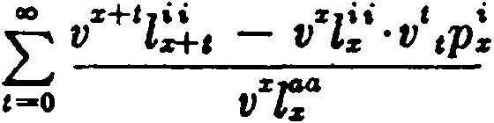

where
N!· - n!··a!
D";
D!i = v:rl!i and D:4 = vsz:4,

( 15.27)

00
N!i L,-o D!.t ,'
ao
and LJ 1 .
,-o V 1P •
It will be scen that a! represents thc present value of an annuity­ due payable to a disable<l life aged x.
If a net annual prcmium is required for thc abovc benefit, it will be payable only while the insured remains an active life.

SEC. 4] 1\IONETARY APPLJCATIO!'\S 301
The present value of an annuity of 1 payable to (x ) while active is

a•.z40 =
00
LJ V
"'°' t aa

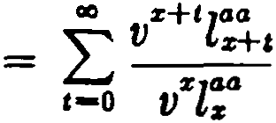
,-o
tPz

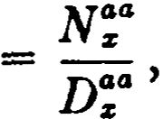
( 15.28)
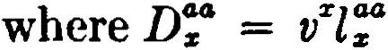

00
L
and Na;' = D:+, •
t-o
Then the net annual premium corresponding to the net single premm· m azai 1·s
a:i = N!i - D!i ·a!
a°: N':
We consider next an example using the combined marriage and mortality table. Let us determine the net single premium for an insurance of 1 for a bachelor aged x , the insurance to be pay­ able at the end of the year of death provided that the insured dies a married man. We first require an expression for the proba­
bility that a bachelor aged x will die a married man in the (t + 1)-th
year from now. This is analogous to the probability n q;T h> of
1
Section 1, and recalling formula (15.13 ), we write
bm ( md )z+t - C mOz· ,1 ( mq t
t jqz = ( bl) X ,
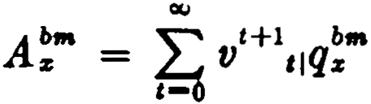
Denoting the required net single premium by A!"', we now have
= 'E, vt+l ( md )z+t - (mO:r ·,1( mq )z
,-o (bl) %
= LooV z+t+l ( md ) z+t - V :r ( ml ) :r ' V t+l ti ( mq )%
,-o vz( bl ) z
(mM ) z - ( mD ) z • (mA ) z
( bD) z

302 TABLES WITH SECONDARY DECREMENTS [CH. 15

where (mM )s = L v"-t+1(md):i:+i ,
•
C-0
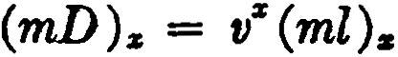 and 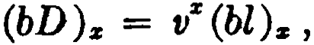
ao
and ( mA )s = L VH1,1 ( mq )s .
,-o
The function (mA ).i: will be recognized as the net single premium for a whole lif e insurance for a married man aged x. As before, the formulation of the benefit has been simplified by the introduction of special commutation functions.
It can be seen from the simple examples above that a table with secondary decrements is not a particularly convenient model for computation. The construction of such a table requires the careful compilation of extensive data, and the evaluation of in­ surance and annuity functions depends upon the availability of various special commutation functions. In the case of benefits which are based on more than one secondary decrement, the mathe­ matical analysis becomes even more complex. In the next chapter, we shall examine an altemative model which has proved more con­ venient in certain applications.
References
2. Hunter and Phillips (1932) discuss the methods of ron­ structing a combined disability and mortality table.
3. The combined marriage and mortality table is treated briefly by Spurgeon (1932) and by Hooker and Longley-Cook (1957 ).

EXERCISES
(Use standard approximations where necessary.)

l. Primary and secondary decrements
l. Evaluate q["> from Table 10
(a) using (15.6), ·
(b) using (15.7).
- Give an expression for the probability that a life aged 30 in state (T) will attain age 31 in state (h) and will then die before attaining age 32.
- Compute the entries for age 32 in Table 10 being given qf = .020 and
qW = .060, and being also given that the rate oí mortality at age 32 for
lives in state (h) is the same as for lives at that age in state (T).

EXERCISES 303

1
1
- Find an exact expression for ,p!r>µ; t· 1-1(hp),.+t dt in terll'lS of func­ tions based on the model oí Table 10.
- Disability and mortali ty
  - Show that p ¡< r,. < r; .
  - Obtain a formula for evaluating p: from the combined disability and
mortality table.
  - From the given data find tt:: , d!! ,and lf ; , assuming lf! = O.

"  15  . 16 | 96,285  95,550
 |  | 57  56 | .267  .254

  - Which of the following expressions are exactly equivalent to each other?
(a) q;¡+ p;'·q +1
(b) r,. - p '·P!+i
el!' + d!t1
(e) l:°

(d) fo ,p:'· +' d t,
2
where ,,.!is the force of morta.lity a.mong disabled Iives.
- Marriage and mortality
  - Using Ta.ble 12, find numerical values for the following:
    - the rate of mortality for married men aged 33;
    - the probability that a man, who at age 33 is married, will be alive at age 34;
    - the probability that a. man, who is a bachelor at age 33, will be alive at a.ge 34.
  - For the model of Table 12, let the forces of mortality and marriage among bachelors be denoted by µCM> and µ.<bm> respectively and the rate oí death among married men by qC"'>. Write a definite integral for the prob­ ability that a man who is now a baehelor aged 34 will die within 2 years.
  - Given the following data for each of a.ges 57 to 59 inclusive: the rate of marriage for spinsters,
the rate of death for married women, the central rate oí death for spinsters.

304 TABLES WITH SECONDARY DECREMENTS [CH. 15

Taking (ml) n to be O, describe how the combined marriage and mortality table may be completed for ages 57 to 59.

-'· Monetary applications

· JI!• - D!'·A!

  - Define t.he symbols and show that A:' =
D,0,0
  - Find an expression for evaluating a:cc:.J> , the present value to an active life (x) of a disability income of 1 per annum for life if disability occurs within n years.
  - Assume that the combined marriage and mortality table of Exercise 11 is available. Given the value of ª'° and the rate of interest i,and assuming
that no spinsters marry af ter agc 60 and that after age 60 spinsters experi­ ence the same mortality as married women, develop an expression for the net annual premium, payable to age 60 or to prior marriage or death, for an insurance of 1payable upon marri1:1,ge a.id also upon death (either mar­ ried or a spinster) of a spinster now aged 57, with the proviso that the in­ surance will be doubled if death occurs while a spinster.

Miscellaneous prohlems
  - Find the probability that an employee now aged 40 of the company whose experience is shown in the follow ing table will die between the ages of 41 and 42, upon the assumption that the rate of mortality is the same among lives that have withdrawn as among those still in service. Indicate but do not perf orm the numerical work.

Age s | ,¡ | ,. | ••
40  41 | 10,000  8,634 | 76  80 | 1,290  1,268

  - (a) Given the rates oí death and disability among active lives and the rates of death among disabled lives, explain how you would construct a combined disability and mortality table, assuming no recoveries from dis­ ability.
(b) Develop a formula, based on the table in (a), for the net annual
premium payable by a. lif e aged x while active for a policy providing a pay­ ment of $10 upon death while .active, $5 upon becoming disabled, $1 at the end of each yea.r after becoming disable<l, and $5 upon death while disabled. Assume ali claim payments are made a.t the end of the policy year. Express your answer in terms of suitably defined cornrnutation columna.

CHAPrER 16

A GENERALIZED MODEL

l. Description of the model
We consider further the problem of calculating the present value of benefits which become payable when an individual life, subject to several causes of decrement, is transferred, through the operation of one of these causes, to a specified state g. We shall of ten be concemed with benefits which consist either partly or
·wholly of annuity payments to be made while the insured is in state g. As we have seen in Chapter 15, the required value can be obtained if the multiple-decrement table is extended in a natural way to show the secondary decrements from state g. We now develop an altemative model, somewhat simpler in conception, which is often more convenient to use in practice.
The model requires the following basic elements:
l. A multiple-decrement table which measures the risk of transfer to state g. In this table, we shall use f;to refer to the
original body of lives and gs to denote the transfers to state g.
- A rate of interest i for use with the multiple-decrement table.
- A table of present values of annuities for lives in state g, computed at an appropriate rate of interest, which is not neces­ sarily the same as i. These values are based on the probabilities of continuance in state g, where continuance may depend on survival only, or on sorne additional condition as well, such as the continuation of disability. The form of annuity is determincd by the particular application, and standard notational devices
are used to distinguish the different types, as, for example, a!
and ci! .
Using these three elements, it is easy to express thc net single premium for annuity payments to be received in state g. Suppose that a continuous life annuity of 1 per annum is payable while (x ) is in state g, provided that entrance into state g occurs before age y . Assuming that the annuity becomes payable at the moment of entrance to statc g, we can write the net single premium as
305

306 A GENERALIZED MODEL [CH. 16
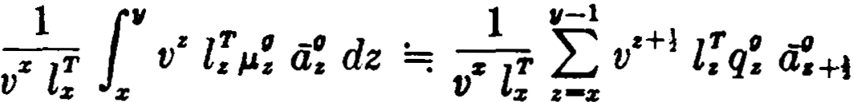

= _1_ •+! g. -ti .

(16.1)

:r l" L..., V
V :r •-:r
ª•+l

The only functions required for the evaluation of (16.1) are those given by the three elements described above.
As usual, the calculation of the value of the benefits is easier if commutation functions are available. We shall use the following basic functions, derived from the given multiple-decrement table:

D; = vx l; and D; = % (D; + D +i)
C!= vz+i Yx . and C! = (1 + i)1 C!.
(16.2)
(16.3)

Note that b; and C: , as defined above, are approximations for

lz+l D; dz and
1:r+l
v• l; dz
µ:

% z

respectively.
A special feature of this model is the use of weighted values of
C and D, distinguished by a prefixed superscript:

'D; = F x· D; and '[); = Fx· D'I
'e: = F:r ·C! and 'C!= F:r·C: ,
(16.4)
(16.5)

where Fx is a function of x on which the required monetary values depend. For example, if Fs = a!+1 , the function 'C!= C!·0:+1 is
a natural one.to use in finding the present value of a life annuity with first annual payment at the end of the year of transfer to state g.
The weight function Fs takes on many different forms in the applications, and we shall usually replace the superscript F by a symbol which will suggest the nature of the particular function
being used. For example, when F z is sorne form of annuity function, the symbol ªC! may be used in place of 'C!.
It should b noted that the exact form of annuity used in ªC:
depends on the application involved, and this symbol, like all other symbols involving weight functions, must always be defined specifirally.

SEC. 1] DESCRIPTION OF THE MODEL 307

Other commutation functions are defined in the usual way by summation. From D; and ñ; , we obtain N; ,Ñ; , S; , and S; ;
and from C!and C: , we obtain M! , M! , R! , and fl: . The corre­
sponding weighted functions are defined in the same way; for example,
CIO CID
L
'M! = I:'C: and 'R! = 'M! .
Returning to the net premium expression in (16.1 ), we can introduce commutation functions as follows:
1 a,-1
-""' •+I ,,,
LJ g, ª•+i
zlf' V
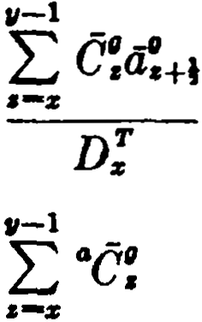
V z e-z

- D;
where

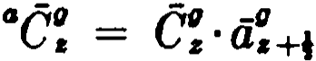
ª..M! - ªM:
D; ( 16.6)
In certain applications, such as the one just described, the benefits are payable only if transfer to state g occurs prior to a specified age y. It is then convenient to tabulate the values of the summation of the C' functions up to age y only,
:Ec:.
11-l
When this is done, the resulting values are distinguished by a prefixed suhscript with the M' function:

11-1
e:
,,M! = ¿ = M! - M! .
•-z

(16.7)

This convention may be used with any of the fortfls of the M'
function. The premium in (16.6), for example, can be expressed as

308 A GEXERALJZED MODEL [CH. 16

- Pension plans
As a first application of the general model described above, we consider the methods used in calculating the values of benefits and contributions for the participants in a pension plan. The participants in such a plan are usually employees who share a common status, either in the service of a particular crnployer or industry, or as members of a union organization. The plan may provide benefits upon dísability, withdrawal, and death, in addi­ tion to the pcnsion benefits at retirement. The cost of the plan may be sharcd by the participants and the employer (or other sponsor ), or it may be borne entirely by the sponsor without contributions from the participants.
The methods to be discussed here can be used in making periodic estimates, in the aggregate, of the value of the future benefits and contributions for all participants in the plan. These figures are used in estimating the aggregate costs and for other purposes. Although the values of the contributions and the benefits of thc plan as a whole are the sum of these values for each individual participant, the individual results are normally not of intercst in themselves.
There are wide variations in the provisions of pension plans currently in force, and we shall develop formulas for only a few typicl situations. In practice, these formulas will often be modified because of special features in a particular plan.
A common type of multiple-decrement table used in pension plan calculations incJudes four modes of decrement: mortality, disability, withdrawal, retirement. The following notation will be used:
l; is the number of lives attaining age x in service;
d z is the number dying in service in the year following attain­ ment of age x ;
i: is the numbcr becoming disabled in service in the year follow­
ing attainmcnt of age x ;
wz is the number withdrawing from servic>e in the year following attainment of age x ;

SEC. 2} PENSION PLANS 309

rz is the number retiring from service in the year following attain­ ment of age x1
•
Then l;+l = l; - d:z - Íz - Wz - rz .
Since sorne of the decrements, especially withdrawal, may change rapidly as length of service increases, it is sometimes advisable to use a select service table, but this is normally justifiable only when the number of participants is large. The development of formulas on a select basis presents no addjtional difficulties in the theory and will not be considered here.
In writing the formulas for retirement benefits, we shall use the general notation of Section 1 with the unspecified decrement
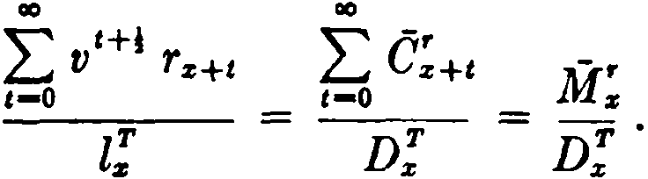
g replaced by the retirement decrement r . For example, the present value at age x of a payment of 1 at the moment of retirement is evaluated as

(16.8)

The present value at age x of a payment at the moment of retire­ ment of 1for each completed year of service from age x to retire­ ment is evaluated as

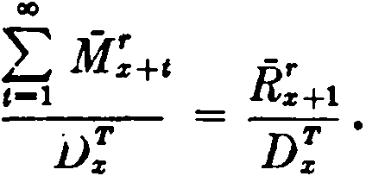
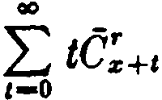( 16.9)
D;
It should be remembered that retirements will generally occur only within a certain range of ages. lf the service table shows non­
zero values of rz only for y x z, then e; = O for all x < y
and all x > z. The summations in formulas like (16.8) and (16.9) will not necessarily include a very large number of terms.
In sorne plans, it may not be realistic to assume that the retire­ ments ·are spread uniformly over the year. It may be provided, for example, that all retirements at age 65 occur at either the
beginning or the end of the year of age. Then v' would not be a
1 The symbol r% has been used in Cha.pter 15 to denote the proba.bility of disability. In the present cha.pter, it will a.lwa.ys be used in the sense of
the definition a.hove. ·we sha.11 use r; in Section 9 as the ra.te of disa.bility,
but this should ca.use no conf usion.

310 A GENERALIZED MODEL [CH. 16

suitable factor for age 65, and an appropriate modification should be introduced.
Retirement benefits are generally in the form of life annuities. In evaluating such benefits, it is convenient to use the annuity value for retired lives as a weight function. If we define
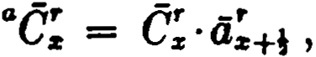 (16.10)
the present value at age x of a continuous annuity of 1 commencing at retirement may be evaluated as
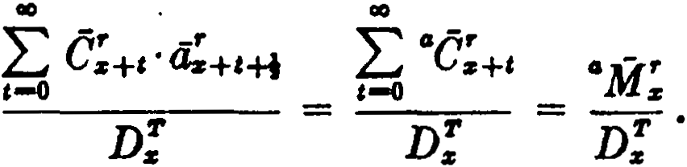
Other kinds of annuities may be used as weights in (16.10), de­ pending on the nature of the benefit. For example, if the life annuity payments were guaranteed for five years, it would be appropriate to define ª as
é; ·a: +t:il .
Pension plans may also provide annuity payments in the event of disability. These benefits may be evaluated in the same way by defining

and
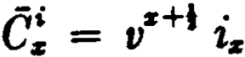 (16.11).
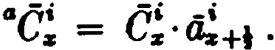
(16.12)

- Pension benefits based on salary
The amount of the pension benefit to be received by a partici­ pant often depends on his compensation, and it is important to have a means of estimating future changes in compensation. This is provided by a salary scale function, either continuous or discrete, depending on whether salary changes are recognized immediately or on sorne fixed date ee.ch year. For simplicity, the definitions below assume a discrete salary scale function.
We shall use the following salary functions, defined for integral ve.lues of x and y:
(TPS):i is total actual salary for service prior to atte.inment of age x;

SEC. 3] PENSION BENEFITS BASED ON' SALARY 311

(A S).s is actual salary for service during the year following attainment of age x ;
(ES) 11 is estimated salary for service during the year following attainment of age y ;
811 is a salary scale function such that
( ES ) 11 = :( AS ):r , Y > x ;
(ES)11 :;;;J is estimated average annual salary . for service during the m years preceding the occurrence, in the year follow­ ing attainment of age y, of a decrementa} event (retire­ ment, disability, etc.) ;
mZ 11 is a salary scale function such that
( ES ),.,:;;;¡ = f11 (AS):r, y x + m.
Then
Since m is generally a constant for any one plan, the subscript
m in mZ11 is of tan suppressed.
The magnitude of a particular value of 811 , or of Z11 , is not in itself significant, any more than is a value of l:r without reference to the radix of the table. It is the ratio of these values that is important, as
for y > x, or for y x + m.
In practice, separate salary scale functions may be required for the male and the female participants, or for the salaried and the hourly-rated participants. The tenn "salary scale function" is a general one and is used for ali types of compensation. In what follows, we shall confine ourselves to a discussion of salary only, but it is to be understood that the same methods can be applied to other fonns of compensation.
In evaluating pension benefits based on salary, we shall use the salary scale functions as weights in computing commutation functions:

312 A GENERALIZED MODEL (CH. 16

8D; = Sz D;
8C; = S:i: G;
811C; = Sz .ªC; = e;.S:,; "+t
Zac; = Z:i:··é; = c; .z:,: a;+i ·
(16.13a)
(lü.13b)
(16.14)
(16.15)

The weighting of the function e; by the product of two functions of x is indicated here by a prefixed superscript consisting of two letters.
Consider a plan providing an annual retirement pension of k % of one year's salary at the rate of pay in the year of retirement The present value at age x is
CID
I:s:i:+t e;+, a;+t+i
.01 k( AS )z _,-_o ----=-­
Ss D';

I: s"cr
ao
= .01 k( AS ):z: ,-\ Tz +t = .01 k( A8 ):z:

8
(16.16 )
:M.f .

D:i: Ds
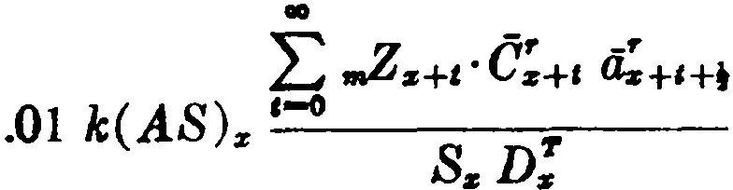
If the pension is based on the m-year final average salary, the present value is

CID
Z•c-r

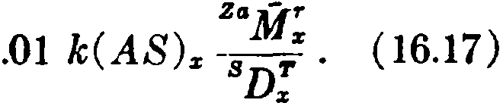
L.,¡ z+&
,-°s
.01 k ( AS ):i: 'I'
Ds
Note that this formula cannot, as it stands, be applied to lives within m years of the earliest possible retirement age, since .Zs+i has not been defined for t < m. An appropriate definition can be made in any specific case; this would take account not only of
any actual salary paid before attainment of age x but also of the fact that for tirements before age x + m there may be less than
m years of salary to average.
Most pension plans give sorne recognition to length oí service (or, alternatively, length of participation in the plan ) in deter-

SEC. 3] PENSION BENEFITS BASED ON SALARY 313
mining the pension benefit. Consider a plan providing, for each year of service at retirement, an annual retirement pension of k % of annual salary at the rate of pay applicable in the year of retirement. If an employee at age x has n years of past service (n is not necessarily an integer here), the present value of the portion of the benefit arising from past service is

.01 k·n( AS )z ";,
Dz
(16.18)

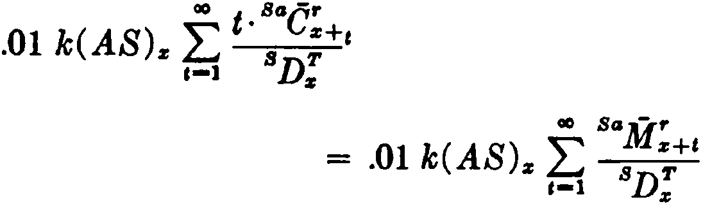
and the present value of the portion arising from future servicP. (assuming credit only for completed years of future service) is

= .01 k( AS )z

8:R=:1 .
Dz

(16.19)

If, instead of giving credit only for completed years of future service, the plan provides that fractional portions of a year are counted as well, there will be, on the average, an additional half­ year's credit at retirement. This can be taken into account by modifying the formula for future service benefits to
¡¿sa - r sa -r

.01 k( AS ):i 72 M
Dz
R:i+i .
(16.20)

It should be noted that when past service is combined with future service the number of completed years of total service is not necessarily equal to the number of completed years of past service plus the number of completed years of future service. Moreover, the addition of a half-year's credit to both past service and future service does not necessarily give the best approximation to total service with fractional years of service considered. In any calcula­ tion in which past service and future service are combined, care must be taken to use appropriate methods.
If pension benefits are based on aggregate salary during service rather than on final salary, the nature oí the problem of evaluating

314 A GENERALIZED MODEL [CH. 16

pension benefits is altered considerably. A benefit based on aggrc­ gate salary is somctimes called a career average pension, since the
- pension formula may be expressed either as k % of aggregate salary, or as k % of average annual salary during service multiplied by the number of years of servicc.
For the present value at age x of the portion of the benefit related to past service, we have simply

.01 k ( TPS )z " ';.
Dz
( 16.21)

The present value at age x of the portion of the benefit related to future service will be developed in several steps.
First, we write an expression for the present value at agc x
of the benefit arising from salary during the year following attain­ ment of age x + l, assuming for the moment that retirement occurs during the year following attainment of age x + t + n. We also
assume temporarily that therc is no credit for salary during the fraction of a year immediately preceding the date of retirement. Hence the prcsent value is
.01 k( AS ) ·8z+a • ªC;+t+•
z Sz D; '
where the only values of n to be considered are those 1. Summing this expression from n = 1 to the end of the table, we obtain the present value, without regard to date of retircmcnt, of all benefits arising from :salary during the year following attainment of age
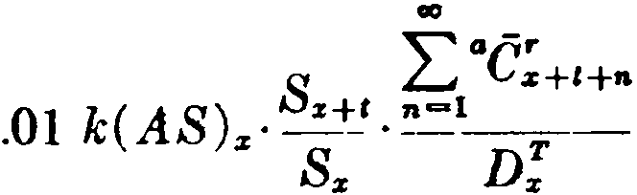
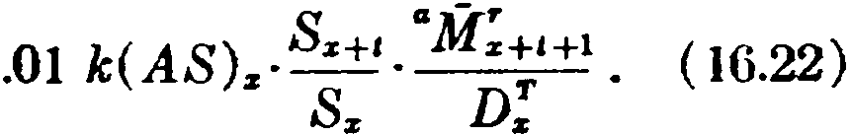
X + t :

If we define

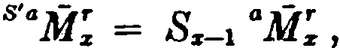
the formula becomes

(16.23)

SEC. 3) PENSION BENEFITS BASED ON SALARY 315

.01 k( AS )s 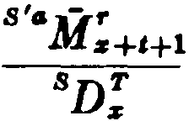 ( 16.24)
We now disregard the temporary assumption used in deriving (16.24) and make an adjustment to take account of the credit for salary during the fraction of a year immediately preceding the date of retirement. Assuming that retirement will occur, on the average, half-way through the year, the adjustment tenn is
.01 k ( AS ) ·Ss+t _!Cié;+, = .01 k( AS ) .!sºé;+t
s Ss D; z 8D; '
and adding this expression to (16.24) we have

.01 k ( AS )s lªªC;+t s+:'caM;+t+l .
Dx

( 16.25)

This represents the value of only that portion of the benefit arising from salary during the year following attainment of age x + t.
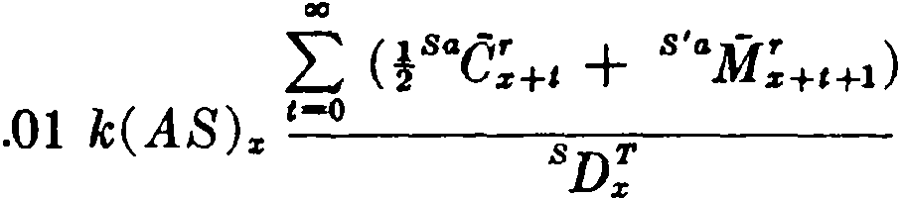
We now obtain the present value of the entire benefit attribut­ able to future service as

= .01 k( AS ). tª"M;. tR:+1 .

( 16.26 )

In defining commutation symbols for this benefit, we have in­ trodued the device of a weight function applied to the values of M.
When this is done, a prime is shown with the prefixed superscript. In the symbol S'aM; , it is to be understood from the superscribed S' a that á; has been weighted with an annuity function and that the resulting ªM; has been weighted with a salary function. The
fact that the salary function has a subscript one age lower than that of ª.M; is important in the application, but this is a matter of
definition, and the same notation could be used even if this were not so.
It should be kept in mind that the notation used in this chapter is far from standardized and is not always the same as the notation

316 A GENERALIZED MODEL [CH. 16

used elsewhere in the literature. ·For example, sorne authors use the symbol e;ª where we use ªG; and reserve the use of the bar
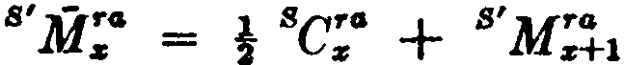
over a function for definitions like the following:

00
= L,-Jo

B'M- ra
z+c .

These special definitions are designed to simplify the writing of expressions like (16.25) and (16.26).
- Participants' contributions
Participants' contributions to a pension plan are usually either a flat amount per year or a percentage of compensation. The con­ tributions are usually made by payroll deduction. There are wide variations in payroll practices as to frequency of payment, and it is convenient to assume that the contributions are received con­ tinuously.
On this assumption, the present value at age x of a unit to be
contributed during the year following attainment of age x + t is
- 7'
Dz, . The present value of a unit to be contributed during each
Ds
year of future service is
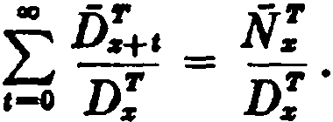 (16.27)
The present value at age x of a contribution of C % of salary during the year following attainment of a.ge x + t is
.OlC(AS) Sz+t .ñ;+e
n:
s Sz
or
fs, ,
B -'I'
.OlC( AS )s
D.
where Bn:is defined as ssn:. Then the present value of all such
contributions over the period of future service is
± :Ñ .

.OIC( AS )z sp:t = .OIC( AS ).
,-o D. Ds

(16.28)

SEC. 4] PARTICIPANTS' CONTRIBUTIONS 317

Plans requiring contributions by participants frequently pro­ vide, on death or withdrawal before retirement, for a refund of the participant's contributions with interest. Consider a plan requiring
contributions of C % of eamings, and providing on withdrawal a refund of contributions with interest at rate J. We discuss here the case where j is different from the basic rate i. The case where j = i is included ac;: an exercise for the student.
The pref' . nt value at age x of the benefit arising from contribu­ tions duri g the year following attainment of age x + t , assuming
for the m<•rnent that withdrawal Ol!curs during the year following attainment of age x + t + n (n 1) is
.OIC( AS ) Sx+t (1 + ')n C.:'+t+n
:r Sx J D; .
The factor (1 + j) n in this expression is appropriate under the further assumption that interest is crcdited from the moment of contribution to the moment of withdrawal. The present value can then be written
C1 (1 + '):r+t+n c-'°
.OlC( AS ) Oz+t J x+e+n
z S x ( 1 + j )x+t D';

where we define
.OlC( AS )x Sx+t ;é:+t +n , ( 16.29)
(1 + jY,:+t S D;

;e: = c1 + j t e:.

If we sum (16.29) over n for n ) 1 and add one-half the cor­ responding amount for n = O (sinee on the average only one-half year's contributions are made in the year of withdrawal), we obtain
the present value, without regard to thc date of withdrawal, of all benefits arising from contributions during the year following attain­
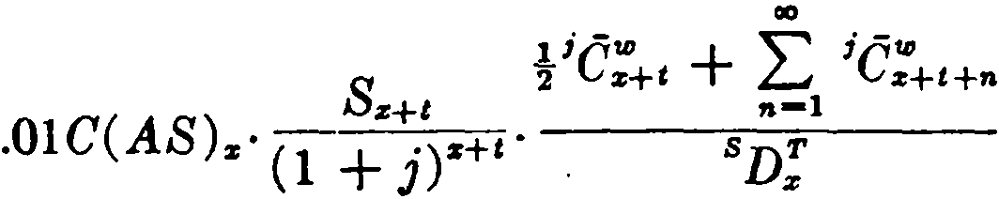
ment of age x + t:

(16.30)

In this expression, we note that

( l +Sx+t z+t ' ;C-'°

= sz+t C'° = se':+·

j ) z+t
z+t - •

318 A GENERALIZED MODEL [CH. 16

a.nd

S:s+: ;e.+- = s.H i]J• s•;M"

(1 + j) z:+t ;-:1 •-r• •• ( 1 + j)ttC •+Hl = z+Hl ,
where we define2

s•;M- • = Ss-1 ;M- •
(1 + j)-·· • .
With these substitutions, (16.30) becomes

(16.31)

.OIC( AS ). ,se:+, t s;;M:+t+i . (16.32)
D.
Finally, we obtain the pre.sent value of the entire benefit attrib­ utable to future contributions by summing (16.32) from t = O to
the end of the table, obtaining
.OlC( AS ). lªM: B+:'jR:+i . (16.33)
D.
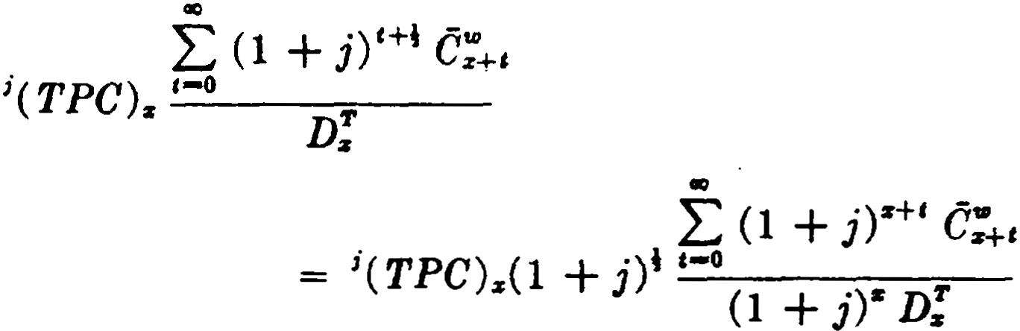
Turning now to the present value of the benefit attributable to past contributions, we require the accumulation of such contribu­ tions with interest to age x at rate j. We denote this accumulation by \TPC) • . Such an accumulation is normally maintained as a nmning total in the administrative records of the plan. The pre.sent value at age x of the benefit attributable to past contributions is then
I: ;e:+,
= ;( TPC) (1 + i·)t_e-o __
ao
ª (1 + j)ª D;
1 Consistency would suggest a more complicated symbol to exprese the
function defined in (16.31). For convenience, we are simply using a super•
scribed S" to indicate that the function 1M: is being weighted here in a
specia.l way.

SEC. 5) DISABILITY BENEFITS 319

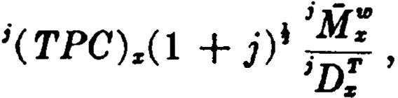 (16.34)
where (1 + iY D; . (16.35)
- Disability benefits
We consider now a second application of the general model of Section l. This relates to the type of disability insurance which is offered as a supplementary benefit, of ten on an optional basis, in individual life insurance policies.
The disability clauses in current use provide a benefit for total and permanent disability. For the purpose of defining such dis­ ability, total disability which has been continuous for a period specified in the policy is presumed to be pennanent. This period is known as the waiting period and is usually six months.
The most common benefit consists of waiver during the con­ tinuanee of disability of the premiums for the life insurance policy which contains the disability clause. Premiums are usually waived retroactively to the beginning of the waiting period. Ko benefits are payable unless disability begins before sorne expiry age, usually 60 or 65. Sorne companies also offer a monthly income benefit, payable from the end of the waiting period. In the case of endow­ ment policies, the disability income is usually payable only until the maturity date. In other cases, it is payable during the con­ tinuance of disability, either for life or up to sorne specified age.
Similar benefits are provided by individual health insurance policies, and the formulas discussed below can be adapted to this type of coverage as well.
We shall use the notation of Section 1 with z; replaced by Z:ª
and the contingency g taken as the contingency i of total disability of at least m months' duration (where m months is the waiting period). We assume that is represents the number of lives that
become disabled between ages x and x + l and remain disabled
for m months.
In order to evaluate annuity benefits commencing at the end of the waiting period, we shall use disabled life annuities of the fonns
áis+U +m/12 and ás+tJ +m/12 :ñ] • The first of these represents the present value at age x + + m/12 of a continuous annuity, payable dur­
ing the continuance of disability, to a life who entered state i at age

320 A GENERALIZED MODEL [CH. 16
x + (used as the average age at disability of those who be­
come disabled between ages x and x + 1). It is thus the present
value at the end of the waiting period of an annuity with payments beginning at that time. The annuity terminates at recovery or prior death. Because of the high rab: s of recovery in the early months following the end of the m months waiting period, select annuity values are used.
It is of interest to note that the equation

i m/12 i _¡
=
m/12 1ácz+U V m/12Pcz+!I acz+tl +in/12 ,

where m/12Pz+U represents the probability that a life just entering state i at age x + H will remain disabled for m months, reduces
to
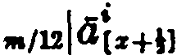
m/12 _¡
V acz+tl +in/12
since, by the dcfinition of the contingency i,
1n112P1z+tl = l.
In the formulas that follow, we shall use y to denote the age at which the disability coverage expires. It is not required that the waiting period be completed before age y, but only that the initial date of disability occur before age y. The expiry age y should also be distinguished from the age at which any benefits cease, which will be denoted by u. A disability clause may provide, for example,
that the coverage expires at age 60 (y = 60) and the benefits cease at age 65 (u = 65).
The simplest benefit to evaluate is a lump sum payment of 1 at the end of the m months waiting period. We approximate the net single premium at age x on the assumption that disability occurs in the middle of the policy year:
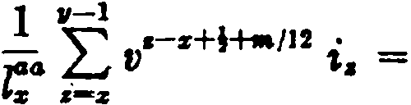
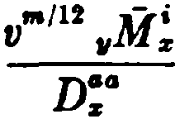
v"'/12 I:e:
.-1
•-z (16.36)

where we define 11M! as in (16.7 ).
If the benefit is a continuous life annuity of 1per annum payable

SEC. 5} DISABILITY BENEFITS 321
beginning a.t the end of the wa.iting period and thereafter during continuance of disability, the net single premium is
·
,n/12 -¡ i
1 •-1 L.J V C• O[•+il +-/12

1" L.J v•-+t i•,·•IH 14ci,+¡J =_•-z
D_ _

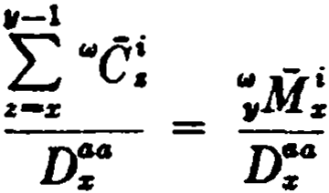
·- z
(16.37 )

where
s = s . V acs+lJ +"'/12 · (16.38)

In (16.38) it is convenient to absorb the factor v"''12 into the weight function. Hence v"" 112 does not appear explicitly in (16.37) as it does in (16.36), where no weight function is involved.
wc-· e-· a/12 _¡
lf the benefit is a continuous annuity of 1 per annum payable beginning at · the end of the waiting period and thereafter during
continuance of disability, but not beyond age u, u > y, the net
single premium is

( 16.39)

where we define

s = s' V U.(s+lJ +a/12 : u-s-- •
·e-· e-¡ a/12 ;:Í a+ml
12

(16.40)

If u y, (16.39) ornes

The symbol in the numerator of this last expression is generally written as •.M!;that is,

u-1
.M- ,_ "' •ñi
·¿-_,·¡
z - 'vs •

(16.41)

The definitions of (16.38) and (16.40) depart somewhat from the general plan described in Section 1. Instead of using a super-

322 A GENERALIZED MODEL [CH. 16

scribed a to indicate that the weight function involves an · annuity, we use the superscript w to indicate that it involves a life annuity and the superscript u to indicate that it involves a temporary annuity ceasing at age u. The reason for this departure is that disability commutation functions are -required for many values of u, and it is desirable to have a convenient means of distinguishing them.
- Income benefits
Life insurance policies which off er disability income benefits usually provide payments of $5 or $10 per month for each thousand dollars of face amount. The net single premium for a monthly in­ come of $10 commencing at the end of the waiting period in the event of disability prior to age y and payable for life during con­ tinuance of disability is

11-l
= ·-
120 '"' ,11 e-¡ "i(12>
L.J v z ac,+t1 +m112
120 ,-s+t . ..i(ll)
JG• L.J v i.·...112la1,+u

(16.42)

'-:r r-:r
D!"

We can rewrite this expression in terms of the commutation func­ tions used in (16.36) and (16.37). Since the functions of (16.37 ) involve continuous annuities, we must make an adjustment for the monthly payments specified in (16.42). From the formulas
a!12) =; Os - 14
and 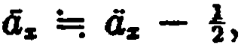
we he.ve -(1%) :.... ;: + 1L
-: U.z 724, (16.43)
and we can make a substitution in (16.42) based on this relation. We then ha.ve
,-1
120 ''°' •/11 C-¡( -' + 1L )
L.J v • ªl•+U +-/12 724
D":

120( !+ i4 ,rm.M!)
u:

(16.44)

The payment period for premiums for the disa.bility incomé

SEC. 7] WAIVER OF PREMIUM BENEFITS 323

benefit is the same as that for premiums for the basic life insurance policy, except tha.t disa.bility income premiums cease upon the occurrence of a. qua.lifying disability or upon the attainment of age y. When the policy is an ordinary life policy, the net annual premium for the disability income is
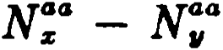
120(.M!+ Í4 v"'112 .M!)
11 (16.45)
When the policy is an n-payment life policy, the net annual pre­ mium is the same as (16.45) if x + n y, and the denominator is changed to N:ª - .N;" if x + n < y.
Endowment policies usually provide that the disability income
will cease upon maturity of the endowment. If the endowment matures at age x + n, the corresponding formulas are
120(:r+M!+ %4 v"'112 .M!)
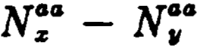
11 for x + n > y ( 16.46a)

and

120(:r+nlit + %4 v"' 112 :r+nM!)
N:ª - N,. for x + n y. ( 16.46b)

These formulas assume that the monthly temporary annuity can be evaluated as a continuous temporary annuity with an additive adjustment of 4, exactly as the monthly life annuity is evaluated in (16.43). The student will recognize that a further small adjust­ ment would be made if the standard approximation for a tem­ porary annuity were used.
- Waiver of premium benefits
When a waiver of premium provision is included in a life in­ surance policy, it provides for waiving premiums for the policy during the continuance of disability. The benefit is thus similar to a disability income benefit for the amount of premium being waived. In order to avoid consideration of the many different fractional premium arrangements which are encountered in prac­ tice, it is customary to assume that the premiums being waived are payable continuously. With this assumption, it is possible to

324 A GEERALIZED IODEL [CH. 16

use the symbol "C without adjustment. lndeed, it is for this reason that "C!is defined in tenns of a continuous disabled life annuity, the waiver benefit being a more common type of dis­
ability benefit than the income benefit.
For an n-payment policy, the net annual premium to provide the waiver of a unit of premium from the end of the waiting period
18

and
s+;.i\f!
N':' - N':¡4 for x + n > y ( 16.47a)

N':' - N:+,.
for x + n Y , (16.47b)

assuming that such net annual premium ceases upon the occur­ rence of a qualifying disability or upon the attainment of age y.
A further adjustment must be added when the waiver benefit is made retroactive to the beginning of the waiting period. In this case, any premiums paid during the waiting period are refunded at the end of the waiting period if the insured remains disabled. Under the assumption of continuous premium payments, the retroactive feature is thus equivalent to a lump sum payment of the total premium for m months. The net annual premium for this additional benefit (on a unit premium basis) is

lm2
,,.,12 Mi
V II z

and
NO:- - N':¡4 for x + n > y (16.48a )
lm2 V,,.112 z+nMi
z

No;' - N 11
for x + n y. (16.48b)

These expressions are added to the corresponding (16.47 ) formulas.
- Disability _reserves
Reserves for disability benefits are of two kinds, active life reserves and disabled life reserves. As the name implies, the active life reserve is the present value of future disability benefits less the present value of future disability premiums, both calculated

SEC. 8] DISABILITY RESERVES 325

on the assumption that the insured is not disabled. Similarly, the disabled life reserve is the present value of future disability bene­ fits, calculated on the assumption that the insured has already incurred a qualifying disability.
To illustrate the active life reserve, we consider an n-payment life policy issued at age x with a disability clause providing waiver of premium and a disability income for life of $10 per month in the event of disability prior to age y. It will be assumed that x + n is greater than y.
Taking first the income portion of the benefit, we denote the net annual disability premium per dollar of annual income benefits
by P; . The active life reserve at the end of t years (t < y - x ) is

120 [ M!+t + 2 Vm/l
2
Jli\f !+t r ..sa J, (16.49a )

Da.o. - Px ·ax+t = u-x-t l
x+t

Turning now to the waiver benefit, we assume that the amount of annual premium to be waived is P. Denoting the net annual disability premium per unit of annual premium waived by P!, we can write the active life reserve at the end of t years (t < y - x ) as
z+n - i m m112 - i J
+
p 11Mx+1 12 V r,Mx+t - pW . ..aa • (1G.49b)

[ n::,
1
x U.r:+t :y-x-t

Active life terminal reserves can also be obtained from a formula analogous to the insurance formula
,Vz = ( Pz+t - Pz ) llx+t •
In this fonn, the active life reserves shown above may be written
(16.50a)
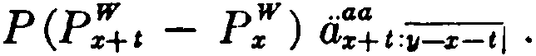
and (16.50b)
There are no special problems involved in obtaining the second type of disability reserve, the disabled life reserve. The amount of premium waived or income paid is multiplied by thc appropriate disabled life annuity value, taking acrount of agc at initial date of disability, duration, and terminal age for the annuity.

326 A GENERALIZED MODEL [CH. 16

- Special methods used in current disability practice
The general model on which the preceding disabi]ity formulas are based requires a double-decrement table for the active lives. In current practice, it is customary to use values of D:i and N:i
from an existing standard mortality table in place of D':and N:°'
wherever they occur in the formulas above. Similarly, the active life annuity values in these formulas are replaced by the corre­ sponding annuities based on the standard mortality table. Al­ though this may appear to be a rather crude practica! expedient, it has been found that only a slight distortion is produced in the resulting monetary values.
When the double-decrement table is eliminated in this way, the function i:,: is unavailable and special methods must be used to obtain values of é; . Modern disability investigations produce
values of the rate of disability r , and é!can then be obtained
from the following development, which makes liberal use of ap­ proximations:

and hence
' . i:e
Tz =: l':' - 1d';4
Íz =: r; ( Z:ª - !ª ).

Consistent with the assumptions just described for D!", we can write

Hence

e; = vz+\ i:e
•=: Vz+4 lz+t Tz'
=: Dz r;.

Thus we can calculate values of é! using the function D:i based on the standard mortality table.
These special methods are not fully standardized. In using published volmes of disability functions, the student should be careful to note the specifications for the functions. It is also im­ portant to be aware of the notation being used, which may differ from that developed in this chapter.

REFERENCES 327

References
  - A basic reference for the pension plan material in this chapter is the paper by Noback (1950). Note, however, that Noback's notation differs in many respects from that used in this chapter.
Many pension plans provide benefits to the widow of a partici­ pant. The evaluation of widows' benefits has been treated by Niessen (1949, 1963).
  - A survey of the actuaria! techniques connected with salary scale mathematics is given by Marples (1962 ).
5. Our discussion of disability benefits relates to the type of coverage offered as a supplementary benefit with life insurance policies. The notation and the formulas used when disability benefits are provided by individual health insurance policies are treated in the book by Bartleson (1963).
The details of the calculation of disabled life annuity values may be seen in Cueto (1954).
9. The nature of the approximation involved in replacing D':
by Dz: is discussed by Phillips (1929).
The methods used in the 1952 Disability Study are described in the Report of the Committee on Disability and Douhle In­ demnity, published in the Society of Actuaries' 1952 Reports of Mortality and Morbidity Experience. They are also discussed by Cueto (1954).
EXERCISES

l. Description of the model
l. Consider the example in the text, with net single premium given by
(16.6).
(a} What change should be made in the definition of "C! if the annuity
benefit is to be payable monthly with first payment at the time oí transfer to state g?
(b} Define a similar commutation function for the case where the annuity is to be paya.ble quarterly with first payment at the end oí the policy year oí transfer to state g.
(e} Write the net single premium for the benefit in (b) using a function of the type defined in (16.7).
- The function 11M! , where y is fixed, is tabulated for values of x. It is desired to obtain values of ,M! , where z is a fixed age less than y. Show
that
.M! = 11M! - 11M! , z < y.

328 A GENERALIZED MODEL [CH. 16
- Using •e: as defined in the text, obtain an approximating expl'888ion
for

Z. Pension plana
JH (:,: -?n)v•z; ,.:a:
H
dz.

- For a given age x (lesa than 65), the probability of retirement q:+, -
.002 (t + 1) for ali t . Show that
,Ji; = .002 v1[S; - s[. - (65 - x) N].
- lf an employee aged x retires or becomes permanently disabled within the next year, he will receive an annual life income of $4000. Find the net single premium for this one year's coverage, assuming that the income is payable on a continuous basis and given the following:
D; = 1000, 06; = 160, i:r: = 1.5r:r: , á!+t = -t . (Ans. $716.80)
- How should (16.8) be modified if the plan provides that participants (entering the plan at age x) who are still in service at the end of 65 - z years must retire at that time?

- Pension benefits based on salary
  - A salary scale f unction has the property that S,, = (1 + i)":r: S:r: . Find an expresaion for .Z u in terms of S:r: and f unctions involving interest only.
  - A pension plan provides a retirement income of of the five-year final average salary. For an employee now aged x (where x is not within five years of the earliest retirement age) who is earning $10,000 per year, express the present value of this benefit in terms of commutation functions.
  - Express in terms of commutation functions the present value of the following benefits for an employee hired at age x :
    - a retirement pension equal to 2% of annual salary at the rate of pay applicable in the year of retirement for ea.ch of the 6.rst 20
completed years of service, plus 1% of such salary for each of the following 10 completed years of service; and
    - a disability pension equal to $100 a year for each completed year of service, such pension not to exceed $3,000 a year.
- Participants' contributions
- To what does s"ifl:+1 reduce if j = i?
- To what does (16.34) reduce if j = i?
- A pension plan requires contributions by members of 3% of salary. It provides on withdrawal a return of contributions with interest at rate j. An employee now aged 40 has a monthly salary of $500. Give an expression in terms of commutation functions for each of the following:
  - the present value of the withdrawal benefit arising from contribu­ tions in the year of age 50 to 51;
  - the total present value of the withdrawal benefi.t.

EXERCISES 329

- Disahility benefits
- For each of the following disability benefits, payable in the event oí disability prior to a.ge 60, find the net single prerniurn at age 35 in terrns oí elernentary f unctions and also in terms oí commutation f unctions:
  - a payment of $100 at the end of a four rnonths waiting period;
(b) a continuous disabled life annuity of $1000 per year, comrnencing at the end of a 6 months waiting period;
{e) a continuous disabled life annuity oí $2000 per year, commencing at the end of a 3 rnonths waiting period and payable up to a.ge 65.

- lncome benefits
- In deriving formulas (16.46a) and (16.46b), the following approxima­ tion is used:
°-'li•(+UtJ)+m/11::a:+•-·--¡"¡"-", •=! ª_c,•+tl+m/12::i:+n-•--'¡"¡"-'I+ k ' where k = 214 .
What would be the expression for k on the basis of the standard approxima­ tions?
- Find, in terms of comrnutation functions, the net annual premmm at a.ge 30 for a disability income benefit of $10 per rnonth issued as a rider with a 20-year endowrnent policy. The waiting period is 6 months, and the disability income cea.ses upon rnaturity of the endowrnent.
- For the benefit described in exercise 15, find the net annual premium at a.ge 45 if disability rnust occur before age 60.

- Waiver oí premium benefits
  - A disability waiver of premium benefi.t included in an ordinary life policy issued at age 30 provides for waiver of premiums falling due af ter a six month waiting period and during continued disability, but only if disability occurs before age 55. Premiums falling due during the waiting period are waived retroactively. If the gross annual prernium to be waived is $100, find the net annual premium for the waiver of premium benefit.
  - For the benefit described in exercise 17, find the net annual premium ií the benefit is included:
    - in a 15-pa.yment 25-year endowment issued at a.ge 35;
(b) in a 30-payment life policy issued at a.ge 45.
- Disahility reserves

  - Write formulas for the active life reserves corresponding to (16.49a) and (16.49b) for the case where x + n < y and t < n.
  - If the reserve given by (16.49a) is denoted by 120 ,V! , show that
1+1V! = (,V! + P! )u , - tk!+c + H4 v•112 k!+c),
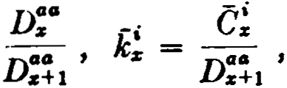
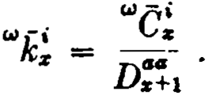
where

and

330 A GENERALIZED MODEL [CH. 16

Miseellaneous problems

  - A pension plan provides at retirement an annual pension of of one year's salary at the rate of pay in the year of retirement plus, for ea.ch completed year of service at retirement, 1% of m-year final average salary. The pension is paid on a ti.ve years certain and life thereaf ter basis. The
employee contributes 2% of each year's salary. Employee contributions cease af ter 30 years even if the employee has not retired. lf the employee terminates or dies prior to retirement, the accumulation of his contributions at rate of interest j is returned. What is the present value of ali future
benefits for an employee hired at age x at an annual salary of $5,000?
  - A disability rider, attached at issue to an ordinary life policy on (x), provides the following benefits if (x) becomes totally disabled before age y and remains disabled during a waiting period of 6 months:
    - a monthly income commencing at the end of the waiting period and payable for life during continued disability;
    - waiver of the life insurance premiums f alling due on or af ter the initial date of disability and during continued disability.
Find the amount of the monthly income and the amount of the annual premium to be waived (assumed payable continuously) if the net annua) premium for the disability rider is
1720 M!+ 200 v111M!
N!• - N;9

APPENDICES

APPENDIX I
TABLE A
The Commissioners 1968 Standard Ordinary (1968 CSO) M ort.ality Table M ale Lis
s | ,. | ,. | 1000g.
o  1 | 10,000,000  9,929,a)() | 70,800  17,475 | 7.08  1.76
2 | 9,911,725 | 15,066 | 1.52
3 | 9,896,659 | 14,449 | 1.46
4 | 9,882,210 | 13,835 | 1.40
5 | 9,868,375 | 13,322 | 1.35
6 | 9,855,053 | 12,812 | 1.30
7 | 9,842,241 | 12,401 | 1.26
8 | 9,829,840 | 12,091 | 1.23
9 | 9,817,749 | 11,879 | 1.21
10 · | 9,805,870 | 11,865 | 1.21
11 | 9,794,005 | 12,047 | 1.23
12 | 9,781,958 | 12,326 | 1.26
13 | 9,769,633 | 12,896 | 1.32
14 | 9,756,737 | 13,562 | 1.39
15- | 9,743,175 | 14,225 | 1.46
16 | 9,728,950 | 14,983 | 1.54
17 | 9,713,967 | 15,737 | 1.62
18 | 9,698,230 | 16,390 | 1.69
19 | 9,681,840 | 16,846 | 1.74
20 | 9,664,994 | 17,300 | 1.79
21 | 9,647,694 | 17,666 | 1.83
22 | 9,630,039 | 17,912 | 1.86
23 | 9,612,127 | 18,167 | 1.89
24 | 9,593,960 | 18,324 | 1.91
,gs | 9,575,636 | 18,481 | 1.93
26 | 9,557,155 | 18,732 | 1.96
27  28  29 | 9,538,423  9,619,442  9,500,118 | 18,981  19,324  19,760 | 1.99  2.03  2.08
30 | 9,480,358 | 20,193 | 2.13
31- | 9,460,166 | 20,718 | 2.19
-32  33  34 | 9,439,447  9,418,208  9,396,358 | 21,239  21,850  22,551 | 2.26  2.32  2.40

333

1968 CBO M0:talit11 Tal>le--ConUnued
Ma.k Lia

s | Is | 4z | lOOOfa
35 | 9,373,7 | 23,528 | 2.51
36 | 9,300,279 | 24,685 | 2.64
37 | 9,325,594 | 26,112 | 2.
38 | 9,299,482 | 27,991 | 3.01
39 | 9,271,491 | 30,132 | 3.25
40 | 9,241,359 | 32,622 | 3.53
41 | 9,208,737 | 35,362 | 3.84
42 | 9,173,375 | 38,253 | 4.17
43 | 9,135,122 | •tl,382 | 4.53
44 | 9,093,740 | 44,741 | 4.92
45 | 9,048,999 | 48,412 | 5.35
 | 9,000,Mrl | 52,473 | 5.83
47 | 8,948,114 | 56,910 | 6.36
48 | 8,891, | 61,794 | 6.95
49 | 8,829,410 | 67,104 | 7.60
50 | 8,762,306 | 72,902 | 8.32
51 | 8,689,404 | 79,160 | 9.11
52 | 8,610,244 | 85,758 | 9.96
53 | 8,524,486 | 92,832 | 10.89
54 | 8,431,654 | 100,337 | 11.90
 | 8,331,317 | 108,307 | 13.00
56 | 8,223,010 | 116,849 | 14.21
57 | 8,106,161 | 125,970 | 15.54
58 | 7,980,191 | 135,663 | 17.00
59 | 7,844,528 | 145,830 | 18.59
60 | 7,698,698 | 156,592 | 20.34
61 | 7,542,106 | 167,736 | 22.24
4 | 7,374,370 | 179,271 | 24.31
63' | 7,195,099 | 191,174 | 26.57
64· | 7,003,925 | 203,394 | 29.04
' 65- | 6,800,531 | 215,917 | 31.75
66. | 6,SS.,614 | 228,749 | 34.74
67 | 6,355,865 | 241,777 | 38.04
68 | 6,114,088 | 254,835 | 41.68
69 | 5,859,253 | 267,241 | 45.61
70 | 5,592,012' | 278,426 | 49.79
71 | 5,313,586 | 2frl,731 | 54.15
72 | 5,025,855 | 294,766 | 58.65
73 | 4,731,089 | 299,289 | 63.26
74 | 4,431,800 | 301,894 | 68.12
334

TABLE A 335
1968 eso MOTtalit11 Table-Continued
M al.e Lives
 | s | ,. | l | 'ª | lOOOfa
 | 75  Je  77  78  79 | 4,129,906  3,826,895  3,5Z3,881  3,2'n ,8M  2,922,055 | 303,011  303,014  301,997  299,829  295,683 . |  | 73.37  79.18  85.70  93.06  101.19
 | 80 | 2,626.,372 | 288,848 |  | 109.98
 | 81 | 2,337,524: | 278,983 |  | 119.35
 | 82 | 2,058,SU | 265,902 |  | 129.17
 | ·83 | 1,792,639 | 249,858 |  | 139.38
 | M | 1,542,781 | ZJl,433 |  | 150.01
 | 85 | 1,311,348 | 211,311 |  | 161.14
 | 86 | 1,100,037 | 190,108 |  | 172.82
 |  | 909,929 | 168,455 |  | 185.13
 | 88 | 741,474 | 146,997 |  | 198.25
 | 89 | 594,477 | 126,303 |  | 212.46
 | 90  91 | {68,174 .  361,365 - | 106,  88,813 |  | 228.14  245.77
 | 92 | 272,562 | 72,480 |  | 265.93
 | 93 | 2AJ0,072· | 57,881 |  | 289.30
 | 94,I | 142,19!. | 45,026 |  | 316.66
 | 95' |  | 34,128 |  | 351.24
 | 96 |  | 25,250 |  | {00.56
 | 97 | 37,7 | 18,456 |  | 488.42
 | 98 |  | 12,916 |  | 668.15
 | 99 | 6,415 | 6,415 |  | 1000.00

336 APPENDIX I

COMMUTATION CQLUMNS
1958 eso 3%
Male Lives
• | D. | Ns | s• | -•  o
o | 10,000,000.0 | 288,963,016.7 | 6,979,643,888.8
1 | 9,640,000.0 | 278,963,016.7 | 6,690,680,872.1 | 1
2 | 9,342,751.4 | 269,323,016.7 | ,411, 717,855.4 | 2
3 | 9,056,844.9 | 259,9 ,265.3 | 6,142,394,838.7 | 3
4 | 8,780,215.6 | 250,923,420.4 | 5,882,414,573.4 | 4
5 | 8,512,546.9 | 242,143,.8 | 5,631,491,153.0 | 5
6 | 8,253,451.8 | 233,630,657.9 | 5,389,347,948.2 | 6
7 | 8,002,642.6 | 225,377,206.1 | 5,155,717,290.3 | 7
8 | 7,759,766.4 | 21?,374,563.5 | 4,930,340,084.2 | 8
9 | 7,524,487.1 | 209,614,797.1 | 4,712,965,520.7 | 9
10 | 7,296,488.1 | ro2,090,310.0 | 4,503,350,723.6 | 10
11  12 | 7,075,397.6  6,860,868.5 | 194,793,821.9  187,718,424.3 | _4,301,260,413.6 4,106,466,591.7 | 11  12
13 | 6,652,644.7 | 180,857,555.8 | 3,918,748,167.4 | 13
14 | 6,450,352.6 | 174,,911.l | 3,737,890,611.6 | 14
15 | 6,253,773.3 | 167,754,558.5 | 3,563,685,700.5 | 15
16  17  18  19 | 6,062,760.0  5,877,109.8  5,696,688.0  5,521,418.1 | 161,500,785.2  155,438,025.2  149,560,915.4  143,864,227.4 | 3,395,931,142.0  3,234,430,356.8  3,078,992,331.6  2,929,431,416.2 | 16  17  18  19
20  21  22 | 5,351,272.8 ó, 186,111.0 5,025,845.1 | 138,342,809.3  132,991,536.5  127,805,425.5 | 2,785,567,188.8  2,647,224,379.5  2,514,232,843.0 | 20  21  22
23  24 | 4,870,385.5  4,719,592.6 | 122,779,580.4  117,909,194.9 | 2,386,427,417.5  2,263,647,837.1 | 23  24
25  26  27  28  29 | 4,573,377.1  4,431,602.-i  4,294,093.7  4,160,726.8  4,031,340.5 | 113,189,602.3  108,616,225.2  104,184,622.8  99,890,529.1  95,729,802.3 | 2,145,738,642.2  2,032,549,039.9  1,923,932,814.7  1,819,748,191.9  1,719,857,662.8 | 25  26  27  28  29
30  31  32  33  34 | 3,905,782.0  3,783,944.4  3,665,686.8  3,550,911.6  3,439,488.9 | 91,698,461.8  87,792,679.8  84,008,735.4  80,343,048.6  76,792,137.0 | 1,624,127,860.5  1,532,429,398.7  1,444,636,718.9  1,360,627,983.5  1,280,284,934.9 | 30  31  32  33  34

-

COMMUTATION COLUMNS 337
1958 eso 3% Ma.Ie Lives

X | Ds | Ns | Ss | X
35  36 | 3,331,295.4  3,226,149.5 | 73,352,648.1  70,021,352.7 | 1,203,492,797.9  1,130,140,149.8 | 35  36
37  38 | 3,123,914.9  3,024,434.7 | 66,795,203.2  63,671,288.3 | 1,060,118 ,797.1  993,323,593.9 | 37  38
39 | 2,927,506.2 | 60,646,853.6 | 929,652,305.6 | 39
40  41 | 2,833,001.8  2,740,778.0 | 57,719,347.4  54,886,345.6 | 869,005,452.0  811,286,104 .6 | 40  41
42 | 2,650,731.3 | 52,145,567.6 | 756,399,759.0 | 42
43 | 2,562,794.0 | 49,494,836.3 | 704,254,191.4 | 43
44 | 2,476,878.2 | 46,932,042.3 | 654,759,355.1 | 44
45  46  47 | 2,392,904.8  2,310,779.5  2,230,395.8 | 44,455,164.1  42,062,259.3  39,751,479.8 | 607,827,312 .8  563,372,148.7  521,309,889.4 | 45  46  47
48 | 2,151,660.7 | 37,521,084.0 | 481,558,409.6 | 48
49 | 2,074,472.4 | 35,369,423.3 | 444,037,325.6 | 49
50  51  52  53 | 1,998,744.0  1,924,383.0  1,851,312.7  1,779,488.9 | 33,294,950.9  31,296, .9  29,371,823.9  27,520,511.2 | 408,667,902.3  375,372,951.4  344,076,744.5  314,704,920.6 | 50  51  52  53
54 | 1,708,844.9 | 25,741,022.3 | 287,184,409.4 | 54
55  56  57  58  59 | 1,639,329.7  1,570,891.7  1,503,465 .3  1,436,991.7  1,371,420.2 | 24,032,177.4  22,392,847.7  20,821,956.0  19,318,490.7  17,881,499.0 | 261,443,387.1  237 ,411,209.7  215,018,362.0  194,196,406.0  174,877,915.3 | 55  56  57  58  59
60  61  62  63  64 | 1,306,723.8  1,242,859.2  1,179,823.4  1,117,613.4  1,066,231.5 | 16,510,078.8  15,203,355.0  13,960,495.8  12,780,672.4  11,663,059.0 | 156,996,416.3  140,486,337.5  125,282,982.5  111,322 ,486.7  98,541,814 .3 | 60  61  62  63  64
65  66  67  68 | 995,687.8  935,994.9  877,163.6  819,219.7 | 10,606,827.5  9,611,139.7  8,675,144 .8  7,797,981.2 | 86,878,755.3  76,271,927.8  66,660,788.1  57,985,643.3 | 65  66  67  68
69 | 762,208.4 | 6,978,761.5 | 50,187,662.1 | 69

338 APPENDIX 1
1958 eso 3%
MaJe Lives

s | Ds | Ns | s. | s
70 | 706,256.4 | 6,216,553.1 | 43, 208,900.6 | 70
71 | 651,545.5 | 5,510,296.7 | 36,992,347.5 | 71
72 | 598,314.8 | 4,858,751.2 | 31,482,050.8 | 72
73 | 546,819 .2 | 4,260,436.4 | 26,623,299.6 | 73
74 | 497,308.1 | 3,713,617.2 | 22,362,863.2 | 74
75 | 449,933.5 | 3,216,309.1 | 18,649,246.0 | 75
76 | 404,778.5 | 2,766,375.6 | 15,432,936.9 | 76
77 | 361,872 .0 | 2,361,597.1 | 12,666,561.3 | 77
78 | 321,222.8 | 1,999,725.1 | 10,a<K,964.2 | 78
79 | 282,844.4 | 1,678,502.3 | 8,305,239.1 | 79
80 | 246,818.8 | 1,395,657.9 | 6,626,736.8 | 80
81 | 213,275.5 | 1,148,839.1 | 5,231,078.9 | 81
82 | 182,350.6 | 935,563.6 | 4,082,239.8 | 82
83 | 154,171.2 | 753,213.0 | 3,146,676.2 | 83
84 | 128,818.2 | 599,041.8 | 2,393,463.2 | 84
85 | 106,305.0 | 470,223.6 | 1,794,421 .4 | 85
86 | 86,577.7 | 363,918.6 | 1,324,197.8 | 86
87 | 69,529.5 | 277,340.9 | 960,279.2 | 87
88 | 55,007.3 | :l>7,811.4 | 682,938.3 | 88
89 | 42,817.6 | 152,804.1 | 475,126.9 | 89
90 | 32,738.4 | 109,986.5 | 322,322.8 | 90
91 | 2i,533.4 | 77,248.1 | 212,336.3 | 91
92 | 17,964.9 | 52,714.7 | 135,088.2 | 92
93 | 12,fl>3 .4 | 34,749.8 | 82,373.5 | 93
94 | 8,834 .3 | 21,946.4 | 47,623.7 | 94
95 | 5,861.0 | 13,112.1 | 25,677.3 | 95
96 | 3,691.7 | 7,251.J | 12,565.2 | 96
97 | 2,148.5 | 3,559.4 | 5,314 .1 | 97
98 | 1,067.1 | 1,410.9 | 1,754.7 | 98
99 . | 343.8 | 343.8 | 343.8 | 99

COMMUTATION COLUMNS 339
1958 eso 3%
Male Lives

" | c. | JI. | R. | "
o  1  2  3  4 | 68,737.864  16,471.864  13,787.524  12,837.749  11,934.192 | 1,583,601.456  1,514,863.592  1,498,391.728  1,484,604.ro4  1,471,766.455 | 85,672,418.432  84,088,816.976  82,573,953.384  81,075,561.656  79,590,957.452 | o  1  2  3  4
5  6  7  8  9 | 11,156.965  10,417.328  9,789.464  9,266.74.5  8,839.092 | 1,459,832.263  1,448,675.298  1,438,257.970  1,428,468.506  1,419,)1.761 | 78,119,190.997  76,659,358.734  75,210,683.436  73,772,425.466  72,343,956.960 | 5  6  7  8  9
10  11  12 | 8,571.528  8,449.523  8,392.725 | 1,410,362.669  1,401,791.141  1,393,341.618 | 70,924,755.199  69,514,392.630  68,112,601.389 | 10  11  12
13 | 8,525.775 | 1,384,948.893 | 66,719,259.771 | 13
14 | 8,704.932 | 1,376,423.118 | 65,334,310.878 | 14
15  16  17  18  19 | 8,864.550  9,064.961  9,243.829  9,346.988  9,327.222 | 1,367,718.186  1,358,853.636  1,349,788.675  1,340,544.846  1,331,197.858 | 63,957,887.760  62,590,169.574  61,ZU,315.938  59,881,527.263  58,540,982.417 | 15  16  17  18  19
20 | 9,299.603 | 1,321,870.636 | 57,,784.559 | 20
21 | 9,214.012 | 1,312,571.033 | 55,887,913.923 | 21
22 | 9,075.863 | 1,303,357.021 | 54,575,342.890 | 22
23  24 | 8,936.960  8,751.644 | 1,294,281.158  1,285,344.198 | 53,Z71, 985.869  51,977,704.711 | 23  24
25  26 | 8,569.542  8,432.941 | 1,276,592.554  1,268,023.012 | 50,692,360.513  49,415,767.959 | 25  26
27  28 | 8,296.154  8,.069 | 1,259,590.071  1,251,293.917 | 48,147,744.947  46·,888,154.876 | 27  28
29 | 8, 140.858 | 1,243.093.848 | 45,636,860 .959 | 29
30 | 8,076.941 | 1,234,952.990 | 44,393,767.11,1 | 30
31 | 8,045.567 | 1,226,876.049 | 43,158,814.121 | 31
32  33 | 8,007.661  7,998.081 | 1,218 ,830.482  1,210,82'l.821 | 41,931,938.072  40,713,107.590 | 32  33
34 | 8,014.251 | 1,202,824.740 | 39,502,284.769 | 34

340 APPIJNDIX I
1968 eso 3%
Male Livee
• | c. | "· | Rz | s
35 | 8,117.923 | 1,194,810.489 | 38,299,460.029 | 35
36 | 8,269.0M | 1,186,692.566 | 37,104,649.MO | 36
37  38  39 | 8,492.306  8,838.268  9,237.171 | 1,178,423.512  1,169,931.?JJ7  1,161,092.949 | 35,917,956.974  34,739,533.462  33,669,602.256 | 37  38  39
40  41  42  43  44 | ·9,709.221  10,218.176  10,731.609  11,271.289  11,831.248 | 1,151,855.778  1,142,146.557  1,131,928.381  1,121,196 .772  1,109,925.483 | 32,408,509.306  31,256,653.528  30,114,506.971  28,982,578.590  27,861,381.818 | ..o  41  42  43  44
45  46  47 | 12,429.129  13,079.355  13,772.152 | 1,098,094.235  1,085,665.106  1,072,585.751 | 26,751,456.335  25,653,362.100  24,567,696.994 | 45  46  47
48  49 | 14,518.518  15,306.897 | J ,058,813.599  1,044,295 .081 | 23,495,111.243  22,436,297.644 | 48  49
50  51  52 | 16,145.109  17,020.413  17,902.007 | 1,028,988.184  1,012,843.075  995,822.662 | 21,392,002.563  20,363,014.379  19,350,171.304 | 50  51  52
53 | 18,814.279 | 977,920.655 | 18,354,348.642 | 53
54 | 19,743.028 | 959,106.376 | 17,376,427.987 | 54
55  56  57  58  59 | 20;690.546  21,672.210  22,683.398  23,717.295  24,752.177 | 939,363.348  918,672.802  897,000.592  874,317.194  850,599.899 | 16,417,321.611  15,477,958.263  14,559,285 .461  13,662,284.869  12,787,967.675 | 55  56  57  58  59
60  61  62  63  64 | 25,tlM.703  26,836.036  27,846.132  28,830.119  29,779.577 | 825,847.722  ,043.019  773,206.983  745,360.851  716,530.732 | 11,937,367.776  11,111,5.054  10,311,477.035  9,538,270.052  8,792,909.1 | 60  61  62  63  64
65  66  67  68  69 | 30,692:340  31,569.313  32,395.427  33,150.537  33,751.833 | 686,751.155  656,058.815  624,480.502  592,094.075  558,943.538 | 8,076,378.469  7,389,627.314  6,733,568.499  6,109,078.997  5,516,984.92'2 | 65  66  67  68  69

COMMUTATION COLUMNS 341
1958 eso 3%
Male Livea
" -  70  71 | c. | J/a | Ra | "
 | 34,140.262  34,253.619 | 525,191.705  491,051.443 | 4,958,041.384  4,432,849.679 | 70  71
72  73  74 | 34,069.048  33,584.287  32,889.905 | 466,797.824  422,728.776  389,144.489 | 3,941,798.236  3,485,000.412  3,.062,271.636 | 72  73  74
75  76  77  78  79 | 32,050.095  31,116.905  30,109.191  29,022.371  27,787.431 | 356,254.684  324,ID4.489  293,087.584  262,978.393  233,956.022 | 2,673,127.147  2,316,872.563  1,992,668.074  1,699,580.490  1,436,602.097 | 75  76  77  78  79
80  81  82  83  84 | 26,354.463  24,712 .992  22,868.200  20,862.501  18,761.225 | 206,168 .591  179,814.128  155,101.136  132,232.936  111,370.435 | 1,202,646.075  996,477.484  816,663.356  661,662.220  529,329 .284 | 80  81  82  83  84
85  86  87  88  89 | 16,631.093  14,526.529  12,497.068  10,587.550  8,832.090 | 92,609.210  75,978.117  61,451.588  48,954.520  38,366.970 | 417,958.849  325,349.639  249,371.522  187,919.934  138,965.414 | 85  86  87  88  89
90  91  92  93  94 | 7,251.375  5,853.988  4,638.273  3,596.142  2,715.983 | 29,534.880  22,283.505  16,429.517  11,791.244  8,195.102 | 100,598.444  71,063.564  48,780.059  32,350.542  20,559.298 | 90  91  92  93  94
95  96  97  98  99 | 1,998.652  1,436.657  1,018.801  692.218  333.791 | 5,479.119  3,480.467  2,044.810  1,026.009  333.791 | 12,364.196  6,885.077  3,404.610  1,369.800  333.791 | 95  96  97  98  99

-

342 APPENDIX 1

N tt 8inol11 PremiumB
1958 eso 3%
Male Lives

s | lOOOAa | Ma | ._
o | 158.360 15 | 28.896 30 | 27.046 89
1  2 | 157.143 53  160.13 | 28.938 07  28.826 95 | 'Zl.212 26  27.094 00
3 | 163.920 68 | 28.705 39 | 26.958 78
4 | 167.623 04 | 28.578 28 | 26.815 84
5 | 171.491 83 | 28.445 45 | 26.664 98
6 | 175.523 57 | 28.307 02 | 26.506 50
7 | 179.722 88 | 28.162 85 | 26.340 17
8 | 184.086 53 | 28.013 03 | 26.166 32
9 | 188.611 10 | 27.857 69 | 25.985 23
10 | 193.293 36 | 27.696 93 | 25.797 22
11 | 198.121 89 | 27.531 15 | 25.603 10
12 | 203.085 31 | 27.360 74 | 25.403 68
13 | 208.180 20 | 27.185 81 | 25.199 30
14 | 213.387 27 | 27.007 04 | 24.991 25
15 | 218.702 ff1 | 26.824 53 | 24.779 88
16 | 224.131 19 | 26.638 16 | 24.565 00
17 | 229.668 79 | 26.448 04 | 24.346 94
18 | 235.320 04 | 26.254 01 | 24.125 52
19 | 241.097 09 | 26.055 67 | 23.900 06
20 | 247.019 86 | 25 .852 32 | 23.669 44
21 | 253.093 51 | 25.643 79 | 23.433 41
22 | 200.330 92 | 25.429 64 | 23.191 29
23 | 265.745 12 | 25. 42 | 22.942 38
24 | 272.342 19 | 24.982 92 | 22.686 40
25 | 279.135 64 | 24.749 68 | 22.422 65
26 | 286.131 94 | 24.509 47 | 22.150 83
27 | 293.330 83 | 24.262 31 | 21.871 09
28 | 300.739 26 | 24.007 95 | 21.583 13
29 | 308.357 44 | 23.746 39 | 21.287 04
30 | 316.185 85 | . 23.477 62 | 20.982 94
31 | 324.232 05 | 23 .201 37 | 20.670 49
32  33 | 332.497 17 340.989 29 | 22.917 60  22.626 03 | 20.349 73 20.0W 12
34 | 349.710 31 | 22.326 61 | 19.681 85

NET SINGLE PREMIUMS 343
1958 eso 3%
Male Lives
:& | 1000.ds | iiz | lizz
35 | 3.58.662 43 | 22.019 26 | 19.334 92
36 | 367.835 58 | 21.704 31 | 18.980 05
37 | 377.226 51 | 21.381 89 | 18.617 57
38 | 386.826 41 | 21.052 29 | 18.248 10
39 | 396.615 03 | 20.716 22 | 17.872 96
40 | 406.584 91 | 20.373 92 | 17.492 68
41 | 416.723 48 | 20.025 83 | 17.108 07
42 | 4Z7.024 94 | 19.672 14 | 16.719 55
43 | 437.490 01 | 19.312 84 | 16.326 98
44 | 448.114 68 | 18.948 06 | 15.930 80
45 | 458.895 91 | 18.577 91 | 15.531 24
46 | 469.826 35 | 18.202 63 | 15.128 60
47 | 480.894 80 | 17.822 61 | 14.723 70
48 | 492.091 34 | 17.438 20 | 14.316 95
49 | 503.402 74 | 17.049 84 | 13.909 10
50 | 514.817 40 | 16.657 94 | 13.500 77
51 | 526.320 94 | 16.262 98 | 13.092 74
52 | 537.900 84 | 15.865 40 | 12.685 64
53 | 549.551 42 | 15.465 40 | 12.Z79 59
54 | 561.260 05 | 15.063 40 | 11.875 20
55 | 573.016 73 | 14.659 76 | 11.472 90
56 | 584.809 76 | 14.254 86 | 11.073 11
57 | 596.622 08 | 13.849 31 | 10.676 59
58 | 608.435 80 | 13.443 70 | 10.284 05
59 | 620.232 88 | 13.038 67 | 9.896 17
60 | 631.998 68 | 12.634 71 | 9.513 44
61 | 643.711 71 | 12.232 56 | 9.136 78
62 | 655.358 24 | 11.832 70 | 8.766 52
63 | 666.921 90 | 11.435 68 | 8.403 12
M | 678.384 17 | 11.042 14 | 8.047 12
65 | 689.725 39 | 10.652 76 | 7.699 24
66 | 700.921 36 | 10.268 37 | 7.360 15
67 | 711.941 88 | 9.890 00 | 7..030 96
68 | 722.753 71 | 9.518 79 | 6.712 87
69 | 733.321 15 | 9.155 98 | 6.407 22

344 APPJCNDIX I
t9S8 eso 3%
Male Livea
,r | 1000.A.s | l.s | la
70 | 7 .627 53 | 8.800 12 | 6.114 48
71 | 753.671 76 | 8.457 27 | 5.834 4't
72 | 763.474 05 | 8.120 73 | 5.565 96
73 | 773.068 64 | 7.791 31 | 5.307 21
74 | 782.501 81 | 7.467 44 | 5.055 88
75  76 | 791.793 86  800.942 96 | 7.148 41 6.834 29 | 4.810 63  4.571 12
77  78 | 809.920 59  818.679 10 | 6.526 06  6.225 35 | 4.338 03  4.112 94
79 | 827.154 51 | 5.934 37 | 3.898 08
80 | 835.303 43 | 5.654 59 | 3.694 98
81  82 | 843.107 29  850.565 54 | 5.386 64  5.130 58 | 3.504 23  3.325 ffl
83 | 857.701 93 | 4.885 56 | 3.159 04
84 | 864.555 12 | 4.650 29 | 3.002 44
85  86  g¡ | 871.165 14  877.571 44  883.820 36 | 4.423 34  4.203 38 3.988 82 | 2.854 76  2.714 85  2.581 45
88 | 889.964 06 | 3.777 89 | 2.453 11
89 | 896.056 06 | 3.568 72 | 2.328 40
90 | 902.147 94 | 3.359 56 | 2.206 08
91 | 908.292 57 | 3.148 69 | 2.085 14
92  93 | 914.534 29 920.946 31 | 2.934 32  2.714 11 | 1.964 79  1.844 15
94 | 927.645 88 | 2.484 23 | l.721 41
95 | 934.843 71 | 2.237 18 | 1.591 28
96 | 942.781 65 | 1.964 16 | 1.446 08
97 | 951.738 42 | 1.656 69 | 1.281 26
98  99 | 961.492 83 970.887 14 | 1.322 18  1.000 00 | 1.106 92  1.000 00

1948 CSO Table
Table of Uniform Senioril y 1
Di6erencc of A¡c | Addition to Youngu Ag, | DiBcrcncc of A¡c | Addition to Youn¡cr Age
1  2 | .512  1.046 | 41  42 | 33.720  34 .699
3  4  5 | 1.603  2.183  2.785 | 43  44  45 | 35.679  36.661  37.645
6 | 3.409 | 46 | 38.630
7 | 4.055 | 47 | 39.617
8 | 4.721 | 48 | 40.604
9 | 5.407 | 49 | 41.593
10 | 6.113 | 50 | 42.582
11 | 6.837 | 51 | 43.573
12 | 7.580 | 52 | 44.564
13 | 8.340 | 53 | 45.556
14 | 9.116 | 54 | 46.549.
15 | 9.907 | 55 | 47.543
16 | 10.714 | 56 | 48.537
17 | 11.534 | 57 | 49.531
18 | 12.368 | 58 | ó0.526
19 | 13.214 | 59 | 51.522
20 | 14.072 | 60 | 52.517
21 | 14.940 | 61 | 53.514
22 | 15.819 | 62 | 54.510
ZJ | 16.707 | 63 | 55.507
24 | 17.604 | 64 | 56.504
25 | 18.509 | 65 | 57.502
26 | 19.422 | 66 | 58.499
'Z1 | 20.342 | 67 | 59.497
28 | 21.268 | 68 | 60.495
29 | 22.201 | 69 | 61.493
30 | 23.139 | 70 | 62.491
31 | 24.082 | 71 | 63.490
32 | 25.030 | 72 | 64.489
33 | 25.982 | 73 | 65.487
34 | 26.938 | 74 | 66.486
35 | 'n.898 | 75 | 67.485
36 | 28.862
37 | 29.828
38 | 30.797
39 | 31.769
40 | 32.744
1 Based on 10110 e = .04. Produces approximate values for joint two-lif e functions.
345

346 APPENDIX I

TABLE B
Lif-e 1'able for White Malea: Uniud States , 1969-61

J: | fa | Is | 4s | L. | Ta | ;. | J:
o | .02592 | 100,000 | 2,592 | 97,764 | 6,754,846 | 67.55 | o
1 | .00153 | 97,408 | 149 | 97,334 | 6,657,082 | 68.34 | 1
2 | .00101 | 97,259 | 99 | 97,210 | 6,559,748 | 67.45 | 2
3 | .00081 | 97,160 | 78 | 97,121 | 6,462,538 | 66.51 | 3
4 | .00069 | 97,082 | 67 | 97,048 | 6,365,417 | 65.57 | 4
5 | .00062 | 97,015 | 60 | 96,985 | 6,268,369 | 64.61 | 5
6 | ..00057 | 96,955 | 55 | 96,927 | 6,171,384 | 63.65 | 6
7 | .00053 | 96,900 | 52 | 96,874 | 6,074,457 | 62.69 | 7
8 | .00049 | 96,848 | 47 | 96,825 | 5,977,583 | 61.72 | 8
9 | .00045 | 96,801 | 43 | 96,779 | 5,880,758 | 60.75 | 9
10 | .00042 | 96,758 | 40 | 96,738 | 5,783,979 | 59.78 | 10
11 | .00042 | 96,718 | 40 | 96,698 | 5,687,241 | 58.80 | 11
12 | .00047 | 96,678 | 46 | 96,655 | 5,590,543 | 57.83 | 12
13 | .00059 | 96,632 | 56 | 96,604 | 5,493,888 | 56.85 | 13
14 | .00075 | 96,576 | 73 | 96,539 | 5,397,284 | 55.89 | 14
15 | .00093 | 96,503 | 90 | 96,458 | 5,300,745 | 54.93 | 15
16 | .00111 | 96,413 | 107 | 96,359 | 5,204,287 | 53.98 | 16
17 | .00126 | 96,306 | 121 | 96,246 | 5,107,928 | 53.04 | 17
18 | .00139 | 96,185 | 134 | 96,118 | 5,011,682 | 52.10 | 18
19 | .00149 | 96,051 | 143 | 95,979 | 4,915,564 | 51.18 | 19
20 | .00159 | 95,908 | 153 | 95,831 | 4,819,585 | 50. 25 | 20
21 | .00169 | 95,755 | 162 | 95,674 | 4,723,754 | 49.33 | 21
22 | . .00174 | 95,593 | 167 | 95,509 | 4,628,080 | 48.41 | 22
23 | .00172 | 95,426 | 163 | 95,345 | 4,532,571 | 47.50 | 23
24 | .00165 | 95,263 | 157 | 95,184 | 4,437,226 | 46.58 | 24
25 | .00156 | 95,106 | 149 | 95,032 | 4,342,042 | 45.65 | 25
26 | .00149 | 94,957 | 141 | 94,887 | 4,247,010 | 44.73 | 26
27 | .00145 | 94,816 | 137 | 94,747 | 4,152,123 | 43.79 | 27
28  29 | .00145  .001.49 | 94,679  94,542 | 137  141 | 94,611.  94,471 | 4,057,376  3,962,765 | 42.85  41.92 | 28  29
30  31  32  33  34 | .00156  .00163  . 00171  .00181  .00193 | 94,401  94,254  94,100  93,939  93,769 | 147  154  161  170  180 | 94,327  94,177  94,020  93,855  93,679 | 3,868,294  3,773,967  3,679,790  3,585,770  3,491,915 | 40.98  40.04  39.10  38.17  37.24 | 30  31  32  33  34

U. 8. Life Tabk-Continued
% | f:, | la: | 4z La:  1 |  | Ts | e:, | s
35 | .00 | 93,589 | 194 | 93,491 | 3,398,236 | 36.31 | 35
36 | .00225 | 93,395 | 210 | 93,290 | 3,304,745 | 35.38 | 36
37 | .00246 | 93,185 | 229 | 93,070 | 3,211,455 | 34.46 | 37
38 | .00270 | 92,956 | 251 | 92,800 | 3,118,385 | 33.55 | 38
39 | .00299 | 92,705 | 278 | 92,566 | 3,025,555 | 32.64 | 39
40 | .00332 | 92,427 | 306 | 92,274 | 2,932,989 | 31.73 | 40
41 | .00368 | 92,121 | 339 | 91,952 | 2,840,715 | 30.84 | 41
42 | .00409 | 91,782 | 376 | 91,594 | 2,748,763 | 29.95 | 42
43 | .00454 | 91,406 | 415 | 91,198 | 2,657,169 | 29.07 | 43
44 | .00504 | 90,991 | 458 | 90,762 | 2,565,971 | 28.20 | 44
45 | .00558 | 90,533 | 505 | 90,280 | 2,475,209 | 27.34 | 45
46 | .00617 | 90,028 | 556 | 89,751 | 2,384,929 | 26.49 | 46
47 | .00686 | 89,472 | 613 | 89,165 | 2,295,178 | 25.65 | 47
48 | .00766 | 88,859 | 681 | 88,519 | 2,206,013 | 24.83 | 48
49 | .00856 | 88,178 | 754 | 87,801 | 2,117,494 | 24.01 | 49
50 | .00955 | 87,424 | 835 | 87,007 | 2,029,693 | 23.22 | 50
51 | .01058 | 86,589 | 916 | 86,131 | 1,942,686 | 22.44 | 51
52 | .01162 | 85,673 | 995 | 85,176 | 1,856,555 | 21.67 | 52
53 | .01264 | 84,678 | 1,071 | 84,142 | 1,771,379 | 20.92 | 53
54 | .01368 | 83,607 | 1,144 | 83,035 | 1,687,237 | 20.18 | 54
55 | .01475 | 82,463 | 1,216 | 81,855 | 1,604,202 | 19.45 | 55
56 | .01593 | 81,247 | 1,295 | 80,599 | 1,522,347 | 18.74 | 56
57 | .01730 | 79,952 | 1,383 | 79,261 | 1,441,748 | 18.03 | 57
58 | .01891 | 78,569 | 1,486 | 77,826 | 1,362,487 | 17.34 | 58
59 | .02074 | 77,083 | 1,598 | 76,284 | 1,284,661 | 16.67 | 59
60 | .02271 | 75,485 | 1,714 | 74,628 | 1,208,377 | 16.01 | 60
61 | .02476 | 73,771 | 1,827 | 72,858 | 1,133,749 | 15.37 | 61
62 | .02690 | 71,944 | 1,935 | 70,976 | 1,060,891 | 14.75 | 62
63 | .02912 | 70,009 | 2,039 | 68,990 | 989,915 | 14.14 | 63
64 | .03143 | 67,970 | 2,136 | 66,902 | 920,925 | 13.55 | 64
65 | .03389 | 65,834 | 2,231 | 64,718 | 854,023 | 12.97 | 65
66 | .03652 | 63,603 | .2,323 | 62,441 | 789,305 | 12.41 | 66
67 | .03930 | 61,280 | 2,409 | 60,076 | 726,864 | 11.86 | 67
68 | .04225 | 58,871 | 2,487 | 57,627 | 666,788 | 11.33 | 68
69 | .04538 | 56,384 | 2,559 | 55,105 | 609,161 | 10.80 | 69
70 | .04871 | 53,825 | 2,621 | 52,514 | 554,056 | 10.29 | 70
71 | .05230 | 51,204 | 2,678 | 49,865 | 501,542 | 9.80 | 71
72 | .05623 | 48,526 | 2,729 | 47,161 | 451,677 | 9.31 | 72
73  74 | .06060  .06542 | 45,797  43,022 | 2,775  2,815 | 44,410  41,615 | 404,516  360,106 | 8.83  8.37 | 73  74
347

U. S. Lije Tabntinued

-
s | q,, | ,. | 4,, | L,, | T,, | •.• | s  -
75  76 | .07066  .07636 | 40,  37,366 | 2,sn 2,853 | 38,786  35,940 | 318,491  279,705 | 7.92  7.49 | 75  76
77 | .0821' 1 | 34,513 | 2,855 | 33,086 | 243,765 | 7.06 | 77
78 | .08986 | 31,658 | 2,844 | 30,236 | 210,679 | 6.65 | 78
79 | .09788 | 28,814' | 2,821 | 27,403 | 1,«3 | 6.26 | 79
 | .10732 | 25,993 | 2,789 | 24,599 | 153,040 | 5.89
81 | .11799 | 23, | 2,738 | 21,835 | 128,441 | 5.M | 81
82 | .12895 | 20,466 | 2,639 | 19,146 | 106,606 | 5.21 | 82
83 | .13920 | 17,827 | 2,482 | 16,586 | 87,460 | 4.91 | 83
84 | .14861 | 15,345 | 2,280 | 14,205 | 70,874 | 4.62 | 84
85 | .16039 | 13,065 | 2,096 | 12,017 | 56,669 | 4.34 | 85
86 | .17303 | 10,969 | 1,898 | 10,020 | 44,652 | 4.07 | 86
87 | .18665 | 9,071 | 1,693 | 8,2'25 | 34,632 | 3.82 | 87
88 | .20194 | 7,378 | 1,490 | 6,633 | 26,407 | 3.58 | 88
89 | .21877 | 5,888 | 1,288 | 5,244 | 19,774 | 3.36 | 89
90 | .23601 | 4,600 | 1,086 | 4,058 | 14,530 | 3.16 | 90
91 | .25289 | 3,514 | 888 | 3,070 | 10,472 | 2.98 | 91
92 | .26973 | 2,626 | 709 | 2,271 | 7,402 | 2.82 | 92
93 | .28612 | 1,917 | 548 | 1,643 | 5,131 | 2.68 | 93
94 | .30128 | 1,369 | 413 | 1,163 | 3,488 | 2.55 | 94
95 | .31416 | 956 | 300 |  | 2,325 | 2.43 | 95
96 | .32915 | 656 | 216 | 548 | 1,519 | 2.32 | 96
97  98  99 | .34450  .36018  137616 | 440  288  185 | 152  103  70 | 364  237  150 | 971  607  370 | 2.21  2.10  2.01 | 97  98  99
100  101  102  103  104 | .39242  .40891  .42562  .44250  .45951 | 115  70  41  24  13 | 45  29  17  11  6 | 92  56  32  19  10 | 220  128  72  40  21 | 1.91  1·.83  1.75  1.67  1.60 | 100  101  102  103  104
105 | .47662 | 7 | 3 | 6 | 11 | 1.53 | 105
106  107  108  109 | .49378  .51095  .52810  .54519 | 4  2  1  o | 2  1  1  o | 2  2  o  1 | 5  3  1  1 | 1.46  1.40  1.35  1.29 | 106  107  108  109

At the oldest ages, where the av&ilable data are scanty and unreliable, the life table functions have been adjusted in a special way. The student will note that the usual mathematical relationshipe do not hold consistently at the end of the table.

APPENDIX II
DERIVATIVES OF ACTUARIAL FUNCTIONS

l. dl. = -lJJ,. See (1.9).
dx

2. d log z. = -µ:,e

See (1.10).

3. a7,Pixs = ,P:c (P.:c - l":cH )

See Exercise 11(d ) in Chapter 1.
4· a,ps = -ePJl.:c H
Tt
See Exercise 11(e) in Chapter 1.

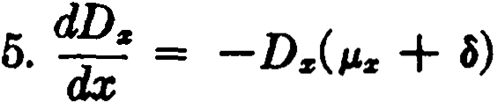
See (2.17).

6. d :c = -D. See (2.36).
7. ':t; = a:c( µ. + a) - 1 = µ.z<i,s - Á s . See (2.37).
8. ·= -v(Ia):c
See (2.48).
9. d ·= -µJ):,
See Exercise lO{a) in Chapter 3.
d.A. -
= +
10. dx A.( µ. a ) - P.:c

See Exercise 10(b) in Cha.pter 3.
- dt:c = -v(IA ).
See Exercise 15(a) in Chapter 3.
349

350 APPENDIX II

- dLs = -d. See pe.ge 170.
dx

- dTs = -l dx
11
See page 170.

- dYs = -Ts See pe.ge 170.
dx
15. ':;= p.,,As - 1
See Exercise 1in Chapter 8.

16• O
in

A
=
p.,,. -

l
-'l.sr

Write lzw = 1·,'f>ZII dt.

Then
-- 1·a,p- dt
az o az
1.,p. t
= a,pz d
o az
= 1•cPw • ,pz{ µ:,: - P.s+i) dt

= P.1/f/ -
a4a. _ -1
ai
17. = µ.- - A

l
-'l.sw •

See Exercise 19 in Chapter 11.
18. inIs = ,,-.,. - A-1
Q

See Exercise 5(a) in Chapter 13.

l. w = 100
ANSWERS TO THE EXERCISES
CHAPTER 1

3. (a) s (x ) = %8 (98 - x )
x21a

4. (d) s( x ) = 1 -
25
5. lo = | 100,000 | do = 505
l1 = | 99,495 | d1 = 515
l2 = | 98,980 | = 525
6. lo = | 10,000 | do = 110
l1 = | 9,890 | d1 = 49
Z2 = | 9,841 | d2 = 30

, w = 125

65,834
7
· (a) 93,589
(b) 1 - (a)
2,136
(e) 93 589
J

( d) 82,463 - 65,834
93,589
(e) 1 - (d)
- /J:i: = -log s - 2x log w - c:i: log g log e
- lz = k (lOO - x )
12. 1 - .992 e-,03

17· (a) 41 ( 149 )
95,106
e b) H90,533 + 00,02s)
92,427
351

352 ANSWERS [CH. 2

835
(e) 87,424 - (835)
18 k

· 1 - 2k
- log e
- A = -log s
Á
+
23. k( l Bcs )-Blocc

H = -2 log w

B = -log c·log g

24_ lraoJ +4-l'°
l¡IO]+I

941,143 - 934,572
25· (ª ) 941,143
( b) 942,001 - 934,572
942,001
26. (a) nP1sJ > nP:
(b) q:> q; > qf.1
(e) = µ: > µ;
27. (a) a1ql47J
(b) 111,qo
(e) d12"11+2

28. q.. =
,
s
1 - e-Jol "•+, ,, = 1
- e-
n.-1"• ,•..

30. q;s < 2q..

CHAPTER 2
10. 1 [120(N40 - N '°) - 55( D,o - D¡o))
Dro

1
(b) D. (Ss - Ss+r& - nNs+,a )

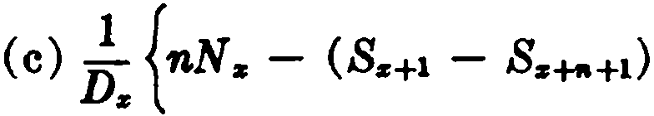
CH. 2) ANSWERS 353
1
- m [nD.- (N +1-N.....+,)I}
16. Dz [N z + .l(Sz+l - S:+a) - l.5N:+u1
1
17. Dz [lOON:+1 + 300S:+2 - 700S.i:+7 + 400S:+1ol
1
1
18. Dz [hN, - k( SH1 - Sv+n+1) - ( h - nk )NHn ]

D: [hN, + k( Sr+1 - S,+n)]
1
20. - (]á )z
21. ( b) (Ia)! fo - ![(a!i% - a:6" ) - i(a!6" - 2a!t% +a:6")]
26. (a) •1 ªn
(b) 120 d hi
(e) 2·11,,aW
C tl) 144(¡<12>aH2 >
(e) 1111oáto

27. (a) DN•
[IOJ
( b) N,,. - Nu + %( Do - Du)
Da,
(e) N S5 }D•
(d) N .,,, - iDn
Da

(e) Su Nu

354 ANSWERS (CH. 3
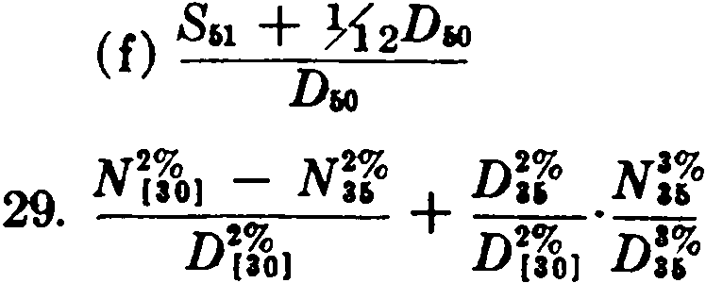
30. log (1 + k )
log e
CIIA.PTER 3
3. v20 ( l z - lz+20) + M z+20
lz Dz
6. P = 1, Q = l +. i , R =
i i
11. i" = 1 + i - 1
e
1
12. D.o ( 2M 40 - M&r, )

100
+ +
13. Do (Co 2( R1 - Rt,) 40M21]

1000
+ +
14. Df¡(J ( M.o 3R41 - 7R.6 4R.g)

15. (b) -v( lA)z
4 "'-z-1
and M{z] + t = L CczJ +r + L Cz+r .
r-t r-6
"'-z-1
and M z+t = c%-ti" .
L
r-t
(1+;) ( M.. - M,.) + D,.
19. (a) D.,

(b) lOMao - ( Ru - Ru)
D.,

CH. 4] ANSWERS

(e) R46 M'°
(1+ i) (R,. - fM..)
(d) Dar,

- (a) M ar,-¡; M eo
25

(b) R'° - Ru - 5MM
Deo
(e) Rs - !Ms - Rs"i;z - ( n - })Mz+n
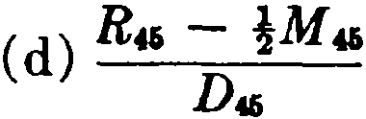
- (a) No.
1
+ +
- D [dñ](Mz - M z+e ) ci";¡Dz+c N z+t+nl
n z
i - a .Cz
24
• t,2 D:i:
355

2_ (a) N,1 - Ne1
Nao - Nar,
CHAPTER 4

( b) N,1 - Nu
Nao - N11 - Rao + Rar, + 5M co
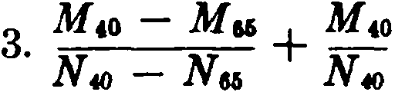
<"'> :..,_ ,Pz:'ñ]
z:ñl -;
6• e P
m - 1 1
+
1 - 27n( Pz:tJ d )

7. Limit is P:i: .
11. (b) P =-ll.z.+n
s;¡
12. .vn (1 - Zz+n )
az:ñ] lz

356 A.NSWERS [CH. 5

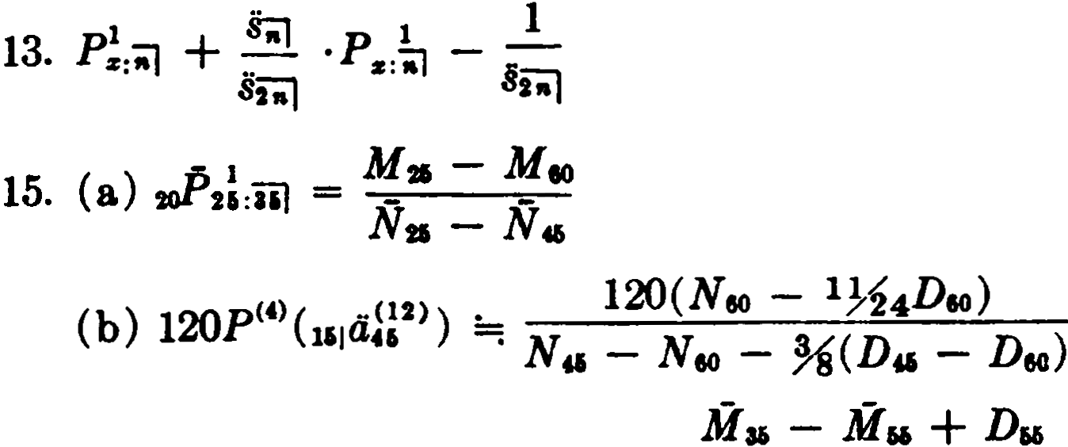1121
(e) uJ> U3i:20] ) =: Nu _ Na -14(D16 - Da) - ,(Mu - Ma)
or - M- D
+
1121 - • Mu M

1oP ( A 31:ioJ ) Nu - Na - 1
M ao - M r,o + Dr,o
16. (a) (1 - 7-4d )( Nao - N.o)
( b) Ru - R.o - 15M,o
N» - N-,
(e) M.
( N:r. - N 10) - HM. - M.+10)
Mu
21. p = sM¡¡D11 + N 1i
22_ a'iJD•+• + N:r.+•+•
N. - N11 - ( R. - R•+• - nM.+11)
CHAPTER 5
4a(G" - D )- t(.M" - M.)

1. (a) ., {M.o - M¡¡ + Da - P(N.o - N'°)}
where p = Mao - M11 + D11
N., - Nr,o
(b) _!_ {.Ma - M" - P( N. - Nu) I
Du

3. (1+;),V!,;¡+ ,V..
where
P = M. - Mu
Nto - Na

4. _l_ {.P.(N. - N.+,> - ( M. - M.H)}
D,
for t n

CH. 5) ANSWERS 357

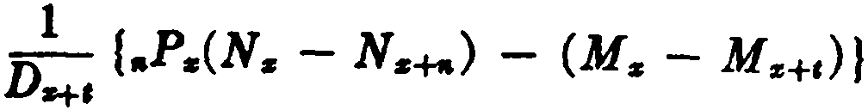 for t > n
Q. (b) 11V61:ioJ - ,Vu:iol
1 - ,Va:ioJ
14_ ( ,R. - 1)(1 + i)
P:r+a + h.z+e
16. .0604, .0600, .0607, .0607.
17 ( ) vi ( m - 1 1(•))
. a , s:il 1+ ps:;;J
(b) !V. + l·1:P "'1 ·,V!:il
(e) c Ys:i]
(d) e Y:r:-;J + l ·l :ñl ·e V :iil
18. (a) %- 1:vc,01 + - 1 Vc,01 + %·10Pc'°1
{b) % - 1:Vc'°1 + ·1 Vr'°1
+ %·1oP\! 1(%·1Vc!o1:'íol + -1Vc!o1:Io¡)
(e) %·1:vc'°J + - 1:Vc.01
+!·1oPfü1 ( ·1Vc!o1:10) + ·eV ,!01 :10) ) + ·1oP !h1
19. $242.38, $262.57, $255.84, $257.56.
24. .0108.
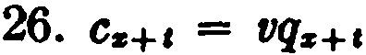
27. -M.+-
28. PN.
33. 10V10 < 10Va'o < 10V',o < 10V,o

360 p = 1 + ( 1 + ")•+2o(M'
i :,:
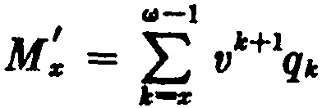
8ioJ
- M's+20 )

P =:

1
a=i
vso,

1
P :io)
+
where

358 A.N8WKBS (CH. 6

38. 3% %.
40. (a) Pj{ z+i - M z+11 + Dz+n
N z+I - N z+11
41. 2

1 - (d - h) d:t + le
l. ( . \..
1 - 1 f z:,i¡
CHAPTER G

2. .9a!D,[1000 (1 + )( M, - M,+.) +!OOOD<+• + 5D,
+ 2.5(N,+1 - N,+.) J

(1 + h )az - m;: l
3. -
k
1 - -
100
4. p = M z + c(l + k )Rz
N z - (I + k ) Rz
7.· aDz + {jNz+l - M z
s. 3 -
4az:ñ=il
11. QF = 5g;
fjF = 5M ü - 4M .,,
N a - Na
12. acora - Cz = fjcom. - 11Pz+1
Re- _ 0 ;-;i + 1tP,,.-Cu
13
• r,, - 1f.l H:201 _
dn:101
acom = fjcom - (nP• - C21)
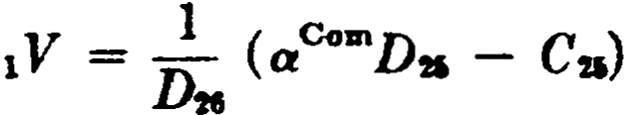

CH. 6) ANSWERS 359

1V = _!_ [aComDu + (JCom(N"' - Nn) - ( Mu - M12)]
Dn
uV = A,o:íl
l6. pA = A + .25P: + .02 where P: = z + .02
a - .4 ax - .65
18. (iCV = A'°:ioj - 1oPat¡¡¡' ª'°=il
12CV = A41:iJ
20. Net CV = 2000[Ao:i1 - ¡3com 069:sJ] - 100

Pure endowment =
where

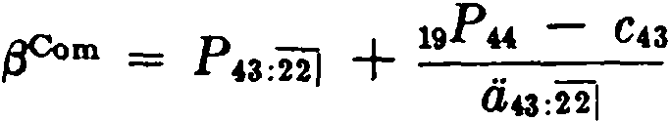
( net CV ) - 1900A 9:6J
1
A69:ij

21. (') p 'd t = M (C - L)D+40D

1 a1 -up amoun

Pure endowment
M
40 - 46 tó

E = ( C - L )D40 - (1 - L )( M 40 - M46)
D41,
(ii) Retrospective reserve
= (C _ L ) D,o _ ( 1 _ L ) M ,o - M 43
Du D43
. D46 ( ) M43 - M 46
= +
Prospect1ve reserve E D 1 - L D
43 43

where E is the pure endowment given in (i ).
1200M x+n + 3Nz

y,.Com (19Pz+l C:,:) .. _
(a) ,V - ,v = .. _
23. llz:30J ªz+t:3o-tl
Com (19pz+l - C.r) ..
= .. _
(b) e V - t V O.z+t :66-x-t J
az:66-xl

360 ANSWEBS (CH. 7

24. V. = J>.N_.__N_,, _ M. - M,,
D,, D,,
Paid-up reserve = ,.P. N• - N•+1 - M• - M,,
D"' D11
Difference is · 0 N•+e - N,
mi • D,,
13,500D60
27
. 108ao1Dao -( Nto - Nto)
CHAPTER 7
l. d,, + f ( k - t} v' ,p11µ,,+c dt
=; NÍt + i + (1 .i)I [(k + t)( M, - M.+,)

- ( R,, - R11 +1: - kM11 +1) ]
3 N <l•>l - (R<r•>l - Rs<+•)a+. - nM s+c+11}
. (1 - r )( N. - N s+, ) - (R. - Rz+, - tM•+c+• )
d§D" + Nn + c[R. - Ru - ( 65 - x)M16]
6
. N. - N.,, - (1 + k )[Rz - Ru - (65 - x )MuJ
where the gross premium equals (1 + k ) times the net premium plus c.
10. .%
M .,, - M 67 + 1.5 v8 D•1
ll. N N + · D
40 -¡7 ªil i7
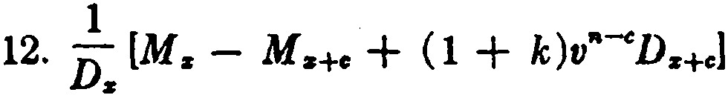
where e is the greatest integer for which 1 + k (1 + i) -
1

13. N _
N (M.- M..... + ( 1 + k )v' '-D.-tca1

s s+r

14· N. - N..... + D..... ·ü -1 - (1 + k )( R. - R..... - aM.....)
11

CH. 8] ANSWERS

where P' = ( l + k )P + c
and a is the greatest integer for which
l 2v"-ª - Pit ,.-0¡ a[P (l + k ) + e]
! -1 _ 20 - -1 _ -1 _
+
16. ( Az : I6j - V ' l6'/:1J a¡¡(A z:20/ - Á.r:I6j)

1 1 (12) (12)
+
18. - -[IOOOA.r:iol 120(aioJ - a.r :"ioJ ))
O.r:iol
19. A =: K ( N z:1 + %Dz + M,:)
361

D. - (1 + 100
)
[M.- %( R. - R,+1))

100 -1 _ 20 _ Dz+lO - 1
+
20. ( A.r:tol - V 1<1b) lOOaio] -n:- Az+lO :IOj

ak,e + (
n-o [)z
1 k )V gz; D-
+ +

21. 13
z+a
8.r:a} + ti;=;¡
where a is the greatest integer for which

s;::;i _k_
4.r:al 1 + Uz
CHAPTER 8
2. (a) lz {b) Lz (e) Tz (d) Tz (e) T:,; (f) Yz
3. (a) Tz - Tz+.. - nl:ie+,.
(b) Y:ie
{e) Tz+n
4. fflz :s:: 1 for all X
5. .015
2
7. 2w - 2x - 1
8. 2.48, 2.98
9. w - x
2

362 ANSWERS [CH. 8

12. (a) (x - y )ls
(b) T:s - Tz = lz f!:s:i=i}
( x - Y) l:s + Ts - T. _ +
( ) A
C ls - X - y "s:'i=il

13. (a) 20(lao - l¡o)
(b) Tao - Tto - 20ll0
lao - l50
300
14. (a) -¡; ( T20 - .lTu - .045Tao - .855Teo)

( b) -30¡;0 (.045lao)

(e) Ti;; ( .855Teo)
300

15 ( ) lOOOl.,
. a Tao - Tw; - Tao - }Te.
( b) lOOO(l., - la - leo - Jl66)
Tao - TN - Teo - !T"

16. (a)
5-0¡0;-0 ( Tu - T )

( b ) 50,000 lu (20 + e21:üi )
16
lo

(e) 750, Z. ea

(d) 250,ooo (l21 - lea)
lo
- (a) Yz - Yz+" - nTz+n
(b) Yz - Y:s+11 - Y:s+• + Y:s+•+n
- (a) x + 2( Yz - Y:s+,J - nTz+tt
T:s - T:s+"
( b) X + 2( Yz - Yz+,. - nT,,+.) - n lz+11
2
Ts - Ts+n - 1Uz+tt

CH. 9)
ANSWERS
363

2 Yo - Yao - 30T.,
- To - TJO
22. 30 + T - T,,. - 20l¡o
l., - liO
23. (a) 1 - n
75
( b) 1 - IJ.z
1,1Jz

24. 8000, 16
25. 2400 lso - 3200 lao + 100 Tr,o - 140 Tro
+ 40 Tso + 2 Yeo - 4Y10 + 2Y,o
CHAPTER 9
l. (a) nPz ·"p"
(b) flPz + flpJI - 2,.p:,:' nP11
(e) ,.,pz + ,.p,, - ,.ps·,.,p11
{d) 1 - nPz·,.,p,,
(e) 1 - ,.,ps·,.,p,,
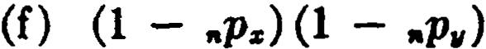
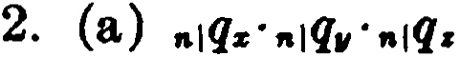

(b) (1 - ,.,¡q:,: )(1 - fl,q,,)(l - ,.,q.)
(e) 1 - (b)
5. (a) dSJI = ls¡¡ - lz+l:11+1
(b) l-' zt1 = P.z + P.11
(e ) Correct.
(d ) qSJI = q:,: + q., - q:,:·q,,
8. (a) 2 (P.z - J'z+,>
(b) 2/Jz H - 1

364 AN8WEB8 [CH. 10
15. t = log (1 + kc") - log (1 + k )
log e
where t = w - x and n = y -,x
17. a, = Ozi,:;=.]
22. ev+2 , where e• = CS + C"
CHAPTER 10
l. qz + q,, - qzi,
2. (a) ci., + á:, + + á, - Ovz - 4'°1f - áw,
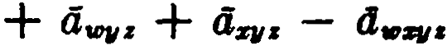

( b) A!:;i + A!:;i - A;;:;;i
<lz:ñl + :ñj - d•:ii'J
3. nlqz + nlqll - ,.lqz· nlqll
No
4. ,a¡az + ,a¡Oi, - n!Ozi,
6. au < ª1D1D < ª" < ª11 < < <in
11. :ii] + aao :2oJ - au :ao :20]
12. 21110u + 20,aao - u¡au:ao
13. a;¡ + az + 0i, - aZlf - Oa :i] - Oi,:'i] + OsN:.J
15. (a) nPZj¡ + nPu + ,.p.,, - 2,.pzi,,
(b) nPz + nP11 + ,.p 2 - 2 ( npq + ,ap:,, + nP11• ) + 3,.pz¡;,
L6. Exactly 2 of the 4 lives will survive for t years. 17• ª'°Zlf + atDU + ªWJ/Z + ªZl/1 - 4a»Zl(.S
20. 1 - d (<iwz + iiw11 + <lu,z + dz11 + dzz + d11z - 2c.i.,ZI/ - 2dv;u
- 2<iw11.z - 2az,, + ªª··}

CH. 11) ANSWERS 365
22. (a) 1 - 5 (,.pz )4 + 4 (,.pa:}6
(b) [1 + 4 (11-IPz - 11Pa: )][l 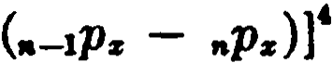
27. }tiz :nl + ía..:;;¡ + _%aZJ1:;¡
28. H (a,o + az + a11 + a. + ª"'ZJI + a10u + a..,. + ªZJI•>
ÜIAPTER 11
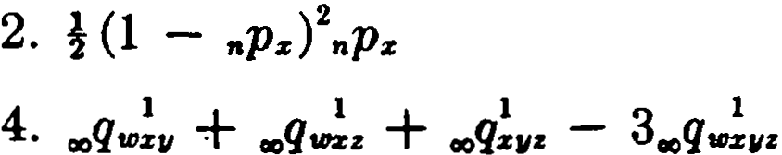
6. (b) (x ) is older than (y )
13. A,.,! + A!11 + A!. - 2(.A. 11 + .AID!.+ .J!...) + 3.J,.,!...
14. Insurance payable upon death of (y ) before (x ) within n
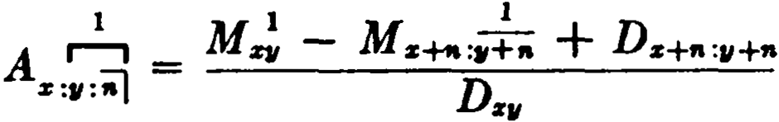
years, or at end of n years if both are surviving.
15. .25.A,o :liO + .001Cl4o :,o
20. A!:iiz =: -1 (ªz-l: - Pz·<iz+l:)
2 Ps-1
22. If all 3 Jives are surviving;
2
Az+ l :a,+t :s+I - P·dz+l :a,+t:s+t
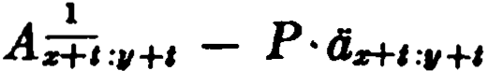
If only (x ) and (y ) are surviving:
If only (x ) and (z ) are surviving:

1
Az+t :s+t - P' tiz+t :sH
I,OOOMa :,o + 10,000.Mlli:,1o --- lOO( R11}1 - R..:l1)
23.

N" ='°

866 ANSW.ERS {CH. 12

Dffllt
26. D. •-P• d•+-=•+•-"

- A¡o
-

- l
- Á¡o :IO :IOj

-1
- AZII
Dstt
- D.
-
( Az+,.
- 1
- Áz+11:r, )

-1 D. - 1
+
Aio:i] D., A u:ao
29.
1 D. - 1
1.075 - D., A u:10
30. }24
31. 1·tv' ,pq l't,+, Áz+c dt
10 -1 -1 -1 -1
+
32. V ( As :ií - 10P11 A. :11+10 - 10Ps Á z :z+lO 10P11, As :11+10:.r+IO)
CJuPTER 12
l. (a) 1·(1 - tP' v) •Pzw• l'z+, dt
(b) 111q!,,, - q.!_.
6. Both are incorrect. Should be

1o•Ve ,P-,,.P.z+,

- 1
A;:¡:;:z+l:l/+I dt

or 1.1,q. ,ptfffl

- 1 +

- 1
) dt

o V ( µz+, A;:¡:¡:,,+C l't,+c A v+c:z+,

7. 2.A! . or
1

8. (a) 4.,
(b) d.,.,,
A;;.,
1
- 1

9. (a) {' (1 - ,p..),p,,..1o1s+,· :,+1 dt
(b) (l - ¡.p,.),,p..,[J.' (1 - ,P,+10l,P.+11 ,._....,..,
(,P,+10 - c+IP,+10) dt

CH. 13) ANSWERS 367

10. (a)

ao
0 ( 1 - ,P10) ,fho 1.&20+a< ,pao - aopao) dt
l
+ 1'° (1 - ,pao ) cP20 µ,,o+c( ,p10 - &0P10) dt
+ 140

(1 - aoPao) ,p20 1.&20+,( ,P10 - &0P10) dt
ªº

-1 _ D40:u. -1 - 1 - 1
+ +
11. Aa&:30:101 D- ( A'6:40:40 An:40:&0 - Au:40:40:&0)
30:16
14. 1.l(a + b)
1 - 1.lc
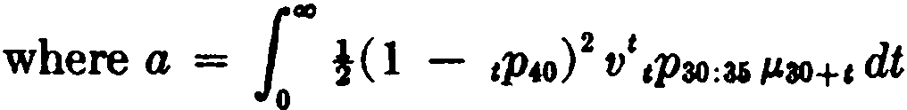

b = .75

00
!(1 - ,p40 ) V 1Pao:a6
1
2 t
0

- l
µai+1Á ao+t

:i1 dt

00
1
e = !(l - ,p40) 2 t/H,pa¡ l'li+c º c+aPao dt
15. 200,000 [ Az - % (A :i:i, + Azd + Au)
+% (A :i:i,d + Á:i:i,e ) + % (Azde - Á:i:i,ci.)]
CIIAPTER 13
2. (a) ªz + a,, - ª:1:11 - azz - U.,,z + ª:zvz
3. Share of (x ) : a:z - !azv - %a:zz + %azvz

368 ANSWERS [CH. 13
Share of (y): - !.- }asi, + ªQ•
Share of (z): a. - %a•• - ia.,, + %ass,.11
4. fº v' ,p.(1 - ,p;.) dt

7. (a) Dn:" ( az+n:•-" I - ªz+•=•=•-•I )
(b) ª•=i'I + D .az+n:w:-111
8. (a) ª•lw + dñ] ·Az!

(b) ªil - ª•=ñl
+ V"aw - DDs.t-.• ªz+n :I'

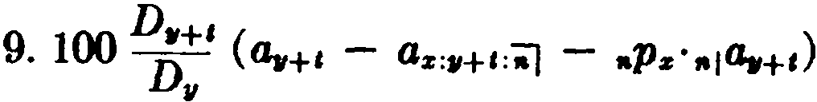
10. (a) az + a;i - a.i::i'J - Oza, - :í.l + Ozw:i.]

(b) ª11
3 D.+•:tt•
- ª%11:;;¡ 8 Dz11
+

13. All alive: ª•+I - ª•+•=•+I - Oi,+1: z+I + ª•+•=w+t :.e+I
(x) dead: ª•+1 - llw+•= •+I
(y ) dead: az+I - az+l:1+1
(x ) and (y ) dead: ª•+'

,¡en> .Á + ..

•• (12) ..:1(12)
DDw+n -(12)

(12) -, - 1fl-tt1lUzw -
+
16. ,il z:iiij -+nlOz 11
dz:-] dq:iiij

reducing upon the death of the beneficiary to
(12) - . (12)
+ -+•Iª•
d11 • Az:iiij
az:i,+n :-1

ª•=-1

CH. 14] ANSWERS 369
is. fu·v',p;.. ,q!u, dt

1·V 1
o
1p..
J.'+itP:A, + 1PA+• - ,p •=11+e ) dt

20. %( a., - ª:iw + "'ªz)2 + H "'ªza,
.935 - nAq
where (z) is husband and ( y ) is wife

21. 360 (dio :ao :sj - á,:10 :ao :8] - dio :ao :36 :sl + á¡:10 :ao :36 :il
+ (l¡:ao :ÜI - Ói :80 :36:iil ) + 240 (a¡:iil - a.:36 :ii]
+ á10:sj - dio:36:8] )

22. P = _
I (5.0.m0>0) (D,D,+20 t1c12> )

az.+6:a, :80-zl ªiol 11
az+6111+20
5000 (D,rt-26 ..c 12> ) •
V = .. D P'
6 (12) az+lOli,+26 - 010 :r,+6:H-z!
ª201 r,+6

324
l. (a) 721,013
( b) 80,385 + 74,117
901,020
ÜIAPTER 14

2. (a) 400
(b) 500 3 86,632
' 764,486
4. lt = 4:35,457
d > = 326
d > = 55,964
5 1 - l( a + b )
·1 + !(a + b)
6. j !k (1 - e-UH>]

370 ANSWEB8 [CH. 14

8. ,.i!l) - 2x
- a - x2
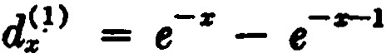
9. z!.,.> = (a - x )e-z
d;2 > = e-:r (a - x - 1) - e--1 ( a - x - 2)
10. 315; 92,777
2 ('I')
11. - q:u> ·q;o> if (14.31b) is used.
2 - qz
Answer is diff erent if (14.36) is used.
13. Same a.s Exercise 9. 14. 3,520; 80; 120; 280.
15. X d!cl) ti!•) d "')
20 | 93 | 979 | 328
21 | 80 | 842 | 278

17•
(8.)
Pz( f')
= Pz (1) ·Pz'(2) ' ··
'<•>
Pz

1 = d!1:r1·••za fflz 1z1..,z..
1
( b)

LZJ S!"º Z..
i
1
where L:ii 1 z 1...z. =

la1+e:z,+e:..·:s...+' dt

(i) 2 (i) 1 (i)
+ +
( ) vd12 v du v du.
18
- a z¡r> + vl¡r> + v2zr)
MW - MW
(b) Ne"> Nc r>
H - H

19. $53.26.
20. p = c( l + k )R!•> + 1000M;4> + 500(65 - x )D¡>
N!'°> - N¡¡l - (1 + k )R •>

23 q(w) == m
l. (cl)](l
- - 'lqz
[l

.l. '(r)]
- ,¡q:;i

• z • z 1 +!m!•) - q;<r>m;•>

CH. 15] ANSWJDBS 371
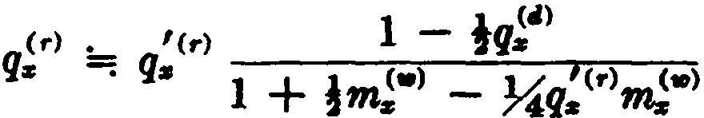
24. (a) 859, 732, 40
( ) 1,591
b 10,000

(e) 8 4 or 9 7 depending on formula used
:

(d) 732
9,080
(e) 1.83

CIIAPTER 15
l. .0003.

2. p!:"> .(hq)11 z<) {d >[1 - +(hq)ao1(hq)ail
ªº
3. zff > = 26,959; dW = 539; d:> = 1,618; (hl)u = 55,267;
(hd)n = 1,156
4. p!"l>, formula (15.8)
1 .
+
6. p: C- [1 i.s( 1 - q )) or

p•. = 'f}: [",,.z_+l + l"
.z+i
l H •1
- •
P.1

7. 7Zl, 20, 85
8. (a) and (b)
ro1
9
·(a} 29,711 +!·4,335
(b) 1 - (a)
376 + 4,335·(a}
2
(e) 1 ----- or
51,002

372 AN8WEll8 [CH. 16

1 { 46,291 + 33,839 - 29,711(1 - (a)]}
,
O r (bl)14+a ( Od) + (hl) (M) )

1 ·J
0
(bl)M 1'14+, l'l'+I ·2-,qu+1 dt

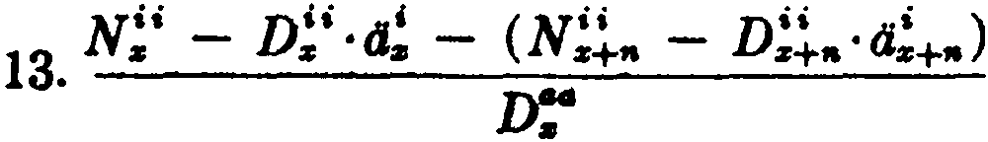

2
L
v1+1[2(3d)67+1 + ( sm),1+1 + ( mdh1+11
,-o
14. + v1[2(3Z)eo + ( ml)eo](l - diieo)
2 ;;_ _

15 1
·[ - 10,000

v'( s011+1
,-o
:E
6
t(1,200J[s,634 - (1,268)]

16. ( b) lOM:° + 5Af:+ (N!¡- D!'·a!) + 5(M!' - D!'·A!)
N:'

CHAPTER 16
1· (ª) •m _ v""•g ...r:1<12> = fff .A,<U>
\.,• - • "'•+l \.,• ua+I
(b) ·e: = v•+lg,·¡¡4:¡y = 0!·1,a!í'¡
(e):DM"!, where •e: is defined as in ( b).
•

3. L"
s-20
( x - 19.- i)v:r+tg:r·d!+t

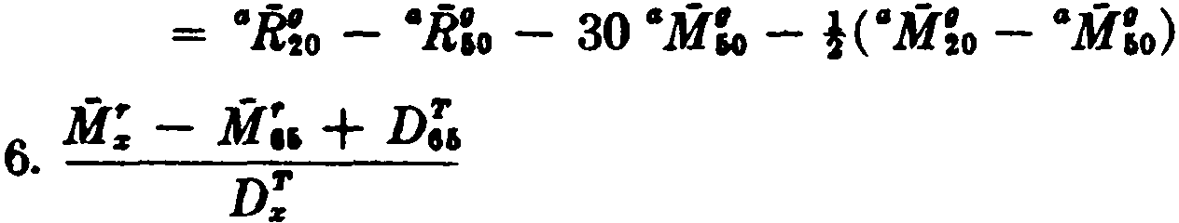i )C;,
M; - M;, + ( I +
or
D

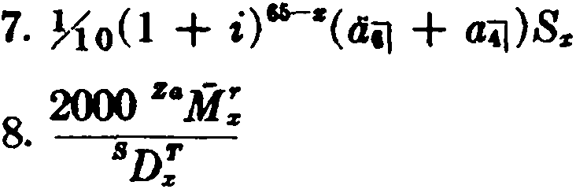

CH. 16] ANSWERS 373

9 .Ol(AS)A 2
80R;+l -
8ªR:+2l -
8ºR;+3l )

' SDxT
+ lOO( ªR!+1 - ".R!+31)

D;
- t,-o ( sz+t Vz+t Htn-1 Wz+t+n)
ao
L W:i:+t

- '( TPC )z
l:i:

12. (a) 180(!sC B" iM;1)
D,o
( b ) 180(!8.M:o + s" ;R:1 )
8Dro
100 69 100 l :11i

13. (a)
z:
L vz-34l i =
z-as z
DV S(:µY.L u

1000 611 z-34 • _,: lOOOtoM;s
L
(b) l"" V tz ·Ocz+t J+t = Daa
35 z-35 15

2000 .i-34t • _,
( )
C l"" LJ V tz·q1,+tl+t:64t-zl
36 z-36

2000:tMilí
D;:
14. (1 - v',pÍ,+11 +•'")

('°M], + v1..M!,)
15. 120 aa aa
Nao - Nso
where t = x + n - z -6 +m-
12

120(666oM- io +
V eoM,6

24
1 l - i )
16. N::- N:
50( 2 .M;o + v46&M"!o )
17.
N; - N:

374 ANSWl:R8 [CB. 16
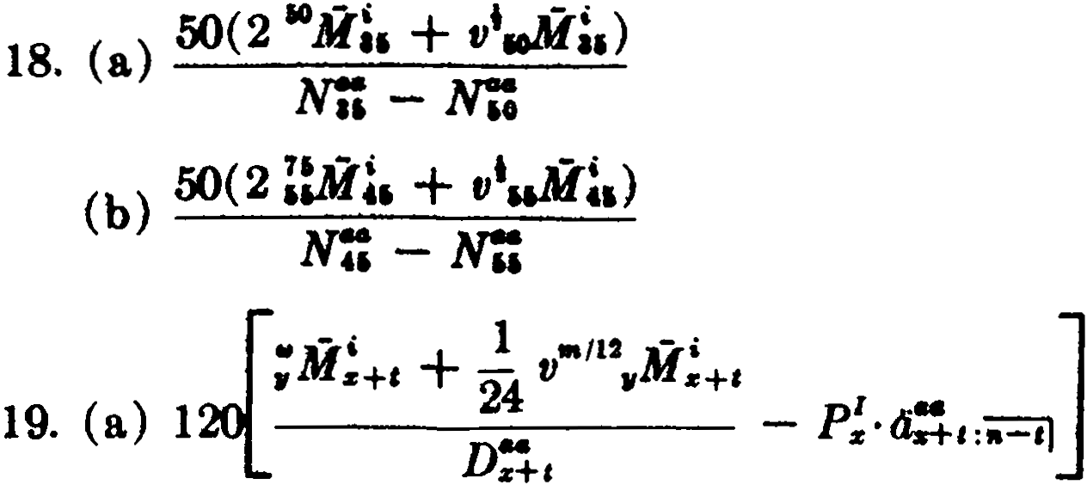
s+11M- , m •112 M- , ]
s+t 12 V s+• s+c
+

(b) {
.. - P!' ,:ii="i'J
Ds+,

21. The present value is equa.l to the sum of the four expressions below:

(1)

where

( 2)
•
E S:r+c C:+, (ªil + .,a:+a+t )
1000 '---º-----------=-------
SJ);

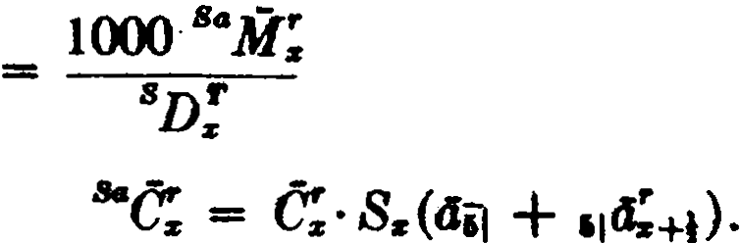
IIO
L
50 ,-1 t·..Zs+i é"rl,(a¡¡ + ,,a:.t,+¡)
SJ);
50 S•ñ:+1
ªD!

where .rae; is defined analogously to &ac; in (1).
25 L UªC:+, + S" jM:+1+1 )
H
,-o

(3)

=
ªD;
l( ªM: - ªM:.+ao ) + ( ª";R:+1 - s";R:+ai )
25
ªD/'

( 4) Se.me as (3) with the superscrihed w replaced by d in the commuta.tion symbols.
22. $120, $280.

BIBLIOGRAPHY
Allen, J. M. (1907) : On the Rela.tion between the Theories of Compound lnterest and Life Contingencies, J IA 41.
Bailey, W. G. and Haycocks, 11. W. (1946) : Sorne Theoretical Aspects of M ultiple DecreTM nt Tables, Consta.ble, Edinburgh.
Baillie, D. C. (1951): The Equation of Equilibrium, TSA 3.
Bartleson, E. L. (1963) : Health Insumnce Provided through Individual Policies, 8ociety of Actuaries, Chicago.
Baughman, C. B. (1965) : Sorne Instances of the Superiority of Geometric Methods over Arithmetic Methods of Interpolation and Extrapolation, TSA 17.
Bergstresser, R. L. (1941) : Formulas for Continuous-Income Policies,
RAI A 30.
Bicknell, W. S. and Nesbitt, C. J. (1956): Premiums and Reserves in Multi­ ple Decrement Theory, TSA 8.
Bizley, M. T. L. (1957): Probabilit y, Cambridge University Press. Boermeester, J. M. (1956) : Frequency Distribution of Mortality Costs,
TSA 8.
Brillinger, D. R. (1961) : A Justification of Sorne Common Laws of Mor­ tality, TSA 13.
Brodie, N. and November, W. J. (1959): A New Table for Accidental Death Benefits, TSA 11.
Chapman, F. ·P. (1943) : Adjusted Premium Surrender Values, TASA 44. Cody, D. D. (1948) : Family Income Formulas Assuming Uniform Distribu­
tion of Deaths, TASA 49.
Cueto, Manuel R. (1954) : Monetary Values for Ordinary Disability Bene­ fits, Based on Period 2 of the 1952 Intercompa.ny Study of the Society's Committee, with 2í% lnterest, TSA 6.
Da.vidson, J. C. and Birkenshaw, J. T. (1958): The Preparation of lnterim
Accounting Statements Using Electronic Da.ta. Processing Equipment,
TSA 10.
Dona.Id, D. W. A. (1956): Compound Interest and Annuities-Certain, 2nd ed., Cambridge University Press.
Elston, J. S. (1923) : Survey of Mathema.tical Formulas that Ha.ve Been Used to Express a Law of Mortality, RAI A 12.
Eva.ns, A. W. (1925) : On the Calculation of Contingent Assurances and the Compound Survivorship Annuity when Ma.keham's Law Holds, J IA 56. Eva.ns, A. W '1929) : A Method of Approximating to Increasing Annuities,
J IA 60.
Eva.ns, A. W. J931): On the Relationship between Life Annuities at Dif ­ ferent Rates of Interest, J IA 62.
Fassel, E. G. (1930): Insurance for Fa.ce Amount or Reserve if Orea.ter,
RAI A 19.
Freeman, H. (1960): Finite Differences for Actuarial Students , Cambridge University Press.
375

376 BIBLIOGRAPHY

Froberg, C.-E. (1965) : Numerical Anal ysis , Addison-Wesley, Reading,
Mass.
G. J. L. and S. E. M . (1910) : Practical Hints to Students on the Application of the Formula for Integration by Parts to Life Contingency Problems, J I A 44.
Gershenson, H. (1951) : Reserves by Different Mortality Tables, TSA 3. Gershenson, H. (1957) : Review of Hooker and Longley-Cook (1957), TSA 9,
p. 459.
Gershenson, H. (1961) : Measurement of M ortality, Society of Actuaries, Chicago.
Gold, M. L. a.nd Wilson, D. T. (1963) : Payment of Cash Value in Addition to Face Amount, TSA 15.
Gompertz, B. (1825) : On the N ature of the Function Expressive of the Law of Human Mortality I Philosophical Transactions , Royal Society of London.
Ora.ce, W. L. a.nd Nesbitt, C. J. (1950): On Average Age at Death Problems,
TSA 2.
Greville, T. N . E. (1948) : Mortality Tables Ana.lyzed by Cause of Dea.th ,
RAI A 37.
Oreville, T. N. E. (1954) : On the Formula for the L-Function in a Special Mortality Table Eliminating a Given Cause of Death, TSA 6.
Oreville, T. N. E. (1956) : Laws of Mortality which Satisfy a Uniform Seniority Principie, J IA 82.
Oroeschell, C. G. and Snell , W. M. (1951) : Valuation of Reversionary In­ terests Involving Two or More Lives for Federal Ta.x Purposes, TSA 3. Ha.hn, J. W. (1946) : Actuaria.! Note: Insura.nce for Face Amount or Mi ni­
mum Caah Value if Orea.ter, RAI A 35.
Heckman, J . F., Jr. (1946) : Commissioners 1941 Standard Ordinary Mor­ tality Table for Joint Lives, RAI A 35.
Hickma.n, J. C. (1964) : A Statistical Approach to Premiums a.nd Reserves in Multiple Decrement Theory, TSA 16.
Hooker, P. F. and Longley-Cook, L. H. (1953): Life and Other Contingencies ,
vol. 1, Cambridge University Press.
Hooker, P. F. and Longley-Cook, L. H. (1957) : Lije and Other Contingencies ,
vol. 2, Cambridge Universíty Press.
Hume, A . S. and Stott, W. (1906): On the Calculation of Conti ngent As­ surance Premiums when Makeham 's Law Holds, J I A 39.
Hummel, T. J. and Stedman, J. A. (1958) : Cash Va.lues and Reduced Paid-up
Insurance, TSA 10.
Hunter, A. and Phillips, J. T. (1932) : Disabilit y Benefits in Life Insurance Policies , (Actuaria! Studies No. 5), 2d ed.
Jenkins, W. A. (1943): An Analysis of Self -Selection among Annuitants, including Comparisons wíth Selection among Insured Lives, TASA 44.
Jones, W . R. (1930) : Notes on the Computation oí Joint-Life Annuitie by
the Single-Life Method when Makeham's Law Holds, RAI A 19.
Kineke, F. D. (1938): A New Annuity Table, TASA 39.

BIBLIOGRAPHY 377

King, G. (1902) : lnstitut of Actuariu' Text Book , Part 11, 2d ed., Charles and Edwin Layton, London.
Lever, E. H. (1920): On Obtaining Values of Life Annuities at Isolated Ratea of Interest, J IA 52.
Lidstone, G. J. (1893): On the Approximate Calculation of the Values of lncreasing Annuities a.nd Insurances, J IA 31.
Lidstone, G. J. (1905): Changes in Pure Premium Policy Values Consequent upon Variations in the Rate of Interest or Rate of Morta.lity, J IA 39.
Linton, M. A. (1919) : Analysis of the Endowment Premium, TASA 20. Lotka, A. J. (1956) : Elements of Mathematical Biology, Dover Publications,
New York.
Makeham, W. M. (1860): On the Law of Mortality, and the Construction of Annuity Tables, J IA 8.
Makeham, W. M. (1889): On the Further Development of Gompertz 's Law,
J IA 28.
Marples, William F. (1962) : Salary Sea.les, TSA 14.
Marshall, E. L. (1933): Payment of Reserve in Addition to Face Amount as a Death Benefit, RAIA 22.
Menge, W. O. (1932): Forces of Decrement in a Multiple-Decrement Table,
RAI A 21.
Menge, W. O. (1935) : lncreasing or Decreasing Annuities and Assurances,
RAI A 24.
Menge, W. O. (1936): Preliminary Term Valuation Methods, RAI A 25. Menge, W. O. (1946): Commissioners Reserve Valuation Method, RAJ A 35. Menge, W. O. and Fischer, C. H. (1965) : The M athematics o/ Lije lnsurance ,
Macmillan, New York.
Mereu, J. A. (1961) :Sorne Ohservations on Actuaria} Approximations, TSA
13.
Mereu, J. A. (1962) :Annuity Values Directly from the Makeham Constants,
TSA 14.
Mereu, J. A. (1963): The Mathematical Forces Operating on Reserves, TSA
15.
Myers, R. J. and Bayo, F. (1964): United States Life Tables for 1959-61,
TSA 16.
Nesbitt , C. J. and Van Eenam, M. L. (1948) : Rate Functions and Their Role in Actuarial Mathematics, RAJ A 37.
Nesbitt, C. J. and Van Eenam, M. L. (1952) : Insurance for Fa.ce Amount or Paid-up Insurance Amount if Greater, TSA 4.
Niessen, A. M. (1949) : A Revised American Remarriage Table, RAI A 38.
Niessen, A. M. (1963) : Commutation Functions and Net Single Premiums for Widows' Monthly Benefits, TSA 15.
Noback, J. C. (1950) : The Valuation of Self -lnsured Retirement Plans, TSA
2.
Nowlin, P. W. and Greville, T. N. E. (1956): Payment of Reserve in Addi­ tion to Fa.ce Amount, TSA 8.
Phillips, J. T. (1929) : Sorne Practical Problems in a Disability Investiga­
tion, TAS A 30.

378 BIBLIOGRAPHY

Rasor, E. A. and Greville, T. N . E. (1962): Complete Annuities, TSA 4. Rasor, E. A. and Myers, R. J. (1952): Valuation of the Shares in a Share­
and-Share-Alike Last Survivor Annuity, TSA 4.
Sarason, H. M. (1960) :A Layman's Explanation of the Expectancy Annuity,
TSA 12.
Sarnoff , P. E. (1958) : The Valuation of the Family Policy, TSA 10.
Smith, F. C. {1948): The Force of Mortality Function, TM American Jlatltematical M onthl11, May 1948.
Smith, F. C. (1961): Commi88ioners Reserves and Minimum Cash Values Ueing Continuous Functions, TSA 13.
Smith, F. C. (1964): A General Treatment of lnsurance for Faee Amount
plus Reserve or Cash Value, TSA 16.
Smith, T. C. and Griffin, F. L., Jr. (1952): Work Life Expectancy as a Meas­
ure of Damages, TSA 4.
Spiegelman, M. (1955) : Introduction to Demogra phy, Society of Actuaries, Chicago.
Spurgeon, E. F. (1932): Lije Contingencies, 3rd ed., Cambridge University
Press.
Thompeon, J. S. (1934): Select and Ultimate Mortality, Proceedings of the Tenth Intemational Congrus of Actuariu, vol. 2.
Thompson, J. S. (1941): The Commissioners 1941 Standard Ordinary Mor­ tality Table, TASA 42.
Veit, K. P. (1964): Stationary Population Methods, TSA 16.
Walker, C. N. and Lewis, W. E. (1949): A Valuation Method for Retirement lnoome Endowment Policies after Life Contingencies Have Ceased, TSA l.
Weck, F. A. (1947): The Mortality Rate and Ita Derivation from Actual Experience, RAJ A 36.
White, R. P. and Greville, T. N. E. (1959): On Computing the Probability that Exactly k of n lndependent Events Will Occur, TSA 11.
Williamson, W. R. (1942): Selection, TASA 43.
Wolfenden, H. H. (1942) : The Fundamental Principlu of M athematical
Statistics, Macmillan, Toronto.
Zwinggi, E. (1945): Versicrungsmathematik , Verlag Birkhauser, Basel.

INDEX TO NOTATION

(The number indicates the page upon which the symbol first
appears.)
l. Symbols introduced in Part I, Single-Life Functions
"I -> 46
Az | 66
Az | 69
A!m> | 68
Az:"ñl | 66
Áz:nl | 69
A!:nJ | 65

N (tn)
47

-1
Az:ñ"J
l
"'ªz
nl•ªz 41
nl•ªz 42
Cz GG
éz 72
69 ,CV z 140

Az:nl 67 Cz
n l Á z 66
136

nlÁz 72 Dz 37
Dz 49
az 39 (DA )!:ñJ 73
az 41 (Da )z:nl 52
ax 48 (Da)z:"ñJ 53
dz 166 <•> 61

az<m)
45 (Dd )z:n]
dz 8
a;"'> | 47
et"'> | 157
az:ñJ | 40
llz:ñJ | 42
az:nj | 50
(m)  az:nj | 46
az:nl | 47
naz | .59
nl az | 41
n jClz | 42

nEz 37

ez 173
éz 173

ez:ñj
173

.. (m)
¡1¡a-·z
z:"ñ] 174
F z 185
nFz 161
"Fz 167
42 Gz 185

n ldz 50 (IA )z 72
379

380 INDEX TO NOTATION

Pz:ril
(IA )z | 73 | Pz | 81
(]A)z | 75 | Í'z | 84
([ <"'>A )z | 74 | P;"'> | 84
(['"'>A )z | 75 | p•l | 88
(IA )!:a1 | 73 | P "'I | 89
(l,;¡A )z | 73 | P: | 140
( fa )z | 51 | ,Pz | 82
( Jii )z | 52 | tP •) | 87
( Já)z | 54 | pl•I  t z | 90
(la)z | 55 | p z:';l | 81
( la)! "'> 53 |  | l•I | 90
(]'"'>a )-> 54 |  | ,Pz:"il | 82
(Ja)z:;;J 52 <•> |  |  | 93
( I ii )z :-;J 61 P!:.J |  |  | 81
(ln1a)z 52 |  | pi(•) | 84
K z 107 |  | iP!:.i | 82
1
kz | 116 P (.,,L:) 83
kz | 116 P (Az ) 84
tkz | 99 ,P( Az ) 83

,Pz:iiJ

z:al

P:a: :.J 81
,k: 99 P[(IA )sl 93
Ls 170 ,P(,.¡iis) 83
iP(m) (.¡iiz ) 84
l: 8
M s 66 Ps 9
M z 72 •Pz 9
M!*> 155 q:;r 9

m:ir
172 .qz 9
•lqz 9

l':s 13 ,.¡ ..qz 9
Ns 40 Rz 72
Ñ:ir 49 R:ir 73
N!•> 154 R!•> 154

INDEX TO NOTATION 381
Ss 51 V •I 127
sª 55 ,Vs:ñl 97
s(x ) 3 ,Vs:ñJ 127
(91)
8:i::i¡ | 43 | ,V:i::il | 127
8:i::ñ] | 43 | ,V!:-;;i  1(91) | 97
T:i | 170 ,V:i::iiJ 127
U:i | 'V (.A:,:) 98
Ü:i | 116 ,V (A:i :nl ) 99
nU:i: | 43
,V:i | 97 :v (111a:i ) 98
,Vz | 108

116 ,V(A:i ) 113
t V (a111z ) 260
y(WI) 108 ,W:i 142
:wz

' z
y(WI) 109
143

yt•J 109 ,Wz:"1 143
' :i:
' :i:
:v:i: 97 Y:i 170
II. Symbols introduced in Part Il, Multi-Life Functions
1
192 | A:i : | 242
203 | A!uz | 233
213 | 1!11, | 234

Á:i:1z1···z,,.
1
Ázi:,i]
A-
ZI/
Á:i::nl 222 -a 234
A%JIZ
Au:;; 216 - 1 233
Áii:z
Aio:i:: 216 - 2
234
Ázi:•
A'°z:11• 213 - 1

r
A:i:1:i:1···:i:,,.
220
Áiv:z 233
- 1 248

A!11 232 Aztt•
1

1!11 232
A-sv•1 248
1

A!11
233 A:11121 252

1!11 233 1
249

11A!11
A!.,. :ñi | 232
-1  A%Jl :nl | 232
A!,=ñl | 235

234
- 1
Awzi,z 1
- 8
249
AIOZI/Z
1 2
AIOZI/ Z 249
- 4
12

382 INDEX TO NOTATION
Á10x 14, 249 O.,:ñ]lz 259
-,1 2  A10 z11•  1 | 252 | 0.,,¡in  l10z
- 2  Áiñ:11• | 252 | -1
1 |  | -2
 |  | 0.,sf z

256
265
262

0.,,¡z

Oz1z1···z,.. 192 -2
zlw
263
264

áZfl•
192 1
-2:1
264
a Z 11zl10

ª"=" 215
_, 1

ªioz= 213
O(z)(11:nJ> 216
ª<z:-;J > <•I > | 216 | Cz¡zs·..zm
O(z:-;J) (11 :iiil> | 217 | Cz1zs···z,,.
<l;i:-;J | 222 | C!11
Oz:11 :nj | 222 | C!1z2···z,,.

222 | -1  Cz 1zs···z,,. | 240
220 | Dz1z2·•·z,,. | 194
220 | Dz1zs···z,,. | 203

Oobe :z11z
a10:1:11z l ti
21
264

194
203
235
240.

2
·
ª

(1)

Oz11 s
llw
2 223

193
dz1z1···z 111  ez, | 192
lu | 206
lzw | 350
lz1z1 ···z•:;;i | 231
( IA )ID%Jfl | 193
ku | 208
lz,zs ···z111 | 193
M!11 | 235
M!1z1···z,,. | 240
/.&z¡Zl"'Z111 | 194
 | 213
P!., | 237

:z11z
a.,¡z 255
ª•l z 256
lz
(t11)  f z | 256
a!"') . | 257
ª !) | 261
n0111 z | 259
n ¡O..,¡z | 259
OnJ!z | 258
(•)  a,;¡ l z | 259
011f z :n] | 259
Oa,f z:n] | 266

(4)
Oz:"1111 | 266
a,1z11 | 255
a,,iw | 265

l z 256 P;;:,;i 222
1

INDEX TO NOTATION
383

P!:
P!11z
p (a11í z ) P (Oi,z1z) P (Oi",""i¡z)
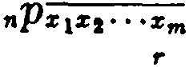Pz1zs···z,,. nPz1zs···zm

nPz1z2 • • •Zm
[r)
nPz1z1• • •z,,.
237
237
260
260
260
193
192
210
217
217
2
nqz;¡
2
111qzv
l
nqz11z
1
nq :z .
nq!:;z
2
flqZI/Z
11q ?11z
1
2
nqiy:z
3
nqZ'I/Z
2
IJDqZJIZ
1
226
226
227
227
227
227
227
228
227
246

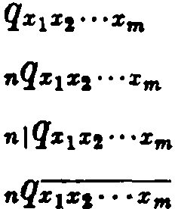

nlqZJZt·. •Zm
1
qZI/
1
nqz11
1
ot:,qZJI
1
nlq:i:11
193
192
192
211
211
226
226
226
226
2
IJDqVIZI/Z
2
1JDq'IDZ1/Z
1
3
ot:,q'IIIZJIZ
1 2
1
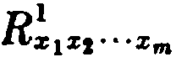
oDqVI :z11z
241
252
248
252
240
208
243

m.Symbols introduced in Part m, Multiple-Decrement Functions

A:'
A!"'
A;k>
A-czk>
(AS )z

a..zcaa azcai
aza(i:n) )
a!
a!
285
307
285
285
311

301
296
304
305
305
a..zi
_¡
az+l
- i
alz+H +m/12
- i
alz+!l +m/12:nl
_¡
ffl/12la (z+IJ
..i (12)
m/121a1z+tl
a:,.+1
ás+t:61
a?>
(bD)x
300
310
319
319
320
322
310

310
284
301

384 INDEX TO NOTATION

e: 306
(bd )x | 299
(bl )1. | 299
( bm )x | 299
c:d | 285

D?> | 284
<!;ª | 295
<l:' | 285
<!;ad | 285
d;i | 296
et! | 286
d;k> | 271

e: 306
ªC! 306
ºC! 307 d;-k> 278
FC! 306 d!T ) 271
Fe: 306 d!1x1·" Xm 284
e! 310 (ES) 11 311

ªC! 310 (ES)
uc! 321
11 :;;;¡ 311

"'C! 321
Fx 306

C;1c> 284 g;c 305
e: 309 ( hd ):e 291
ªe; 310 ( hl )x 291
se; 312 " ( hp ):e 295
sae: 312 ( hq )x 292
Zae; 312 n( ( hq ):e 295
e;ª 316 ix 296

e: 317
k!
;e: 317
329

se: 317 "'k; 329

DªX ª
300
L;T> 273

D!i 300 r;a 295
D; 306 z;i 296
ñ; 306 l!"> 275
'D; 306 z:<1c> 277
'ñ; 306 l; 286
;D; 319 l;T) 271
sn: 312 M': 285
sn: 316 M! 307

INDEX TO NOTATION 385
N; 307
M! | 307
11M! | 307
4.M! | 307
:M: | 308
FM! | 307
11M; | 320
"M; | 321
:Aí! | 321

N-zr 307
8 - T
Nz 316
N;T> 284
P! 325
P:' 325
l ad

mPx :ñ"I
Px
285

:it 321
44 296

SaM; 312
M ;t> 284 |  | a.i  Pz | 297
M ;t> 285 |  | a.i  nPx | 298
M: | 309 | i  nPz | 298
ªM: | 310 | i  mmPt.r+tJ | 320

Px'<"> 280

S'ªM: 314 ( T) 272
Pz

ZaM; 312
S' M;ª 316
'M': 318
S" jir: 318
nPz 272
( Th) 294
Pz
( T)
( Thl
nPz 295
qz4 296

(A:) 273 a.a. 297
mz Qz

m;T ) 273
qazd 285
Qz
(mA)z | 301 | ai | 297
(mD)z | 301 | ai | 298
(md)z | 299 | ,¡q:,": "' | 301
(ml)z | ·299 | qzi | 296
(mM)z | 301 (k) 271
n (mp )z | 300 qz(-A:) 278
(mq)s | 298 q:;'i:(A:) 277

,.¡qz

qz
CI (mq)s 301 qT) 273
q('I') 272
(A:) 275
JJ.z n :ii:
(Tl)

JJ.i 275
(T)
qz 293
(Tl) 295

N:ª 301 nlqz
N;; 300 R! 307

386 INDEX TO NOTATION
R! 307 s: 307
F fl: 307 s,, 311
fez 309 ;(TPC )z 318
&fl; 313 (TPS)z 310
S'afl; 315
44
S'fl;4 316 U.i: 329
S" jR ': | 318 | ,V! | 329
rz (disabílity ) | 297 | , Vzl : " | 289
rz (pensions) | 309 | W:i | 286
Tz' 297 |  | Z,, | 311
s: 307 |  | ..zJI | 311

INDEX

Accidental death benefit, 285, 286
Adjusted premium method, 139-
142
Aggregate mortality tables, 28 Amount at risk, net, 106 Annuity, life
cash ref und, 150--155
complete, 157, 158
continuous, 48-50, 54, 55
decreasing, 52, 53
deferred, 41, 46-48
due, 41, 42
forborne, 43
immediate, 41
increasing, 51-55
instalment refund, 156
joint-life, 192, 195
last-survivor, 212
paya.ble m times a year, 4H8 reversionary, 255-265
select, 44, 45
single-life; 37-60
temporary, 40, 46-48
varying, 50--55
with term-certain, 155-157
Annuity-due, 41, 42
forborne, 43
payable m times a year, 48
varying, 52, 53 Apportionable premium, 88-9Q
Attained age valuation method,
117
Average a.ges in stationary popula­ tion, 179-185
Balducci hypothesis, 20 Canadian reserve valuation
method, 138
Cash refund annuity, 150-155
Cash value, 139-142
Central rate
of death, 172, 173
of decrement, 273, 274

387
Combined disability and mor­ tality table, 295--298, 300, 301 Combined marriage and mortality
table, 298-302
Commissioners reserve val uation method, 137, 138
Commutation f unctions accidental death benefits, 28.5
annuities, 37, 40, 49, 51, 59, 154,
155
contingent insura.nces, 235
continuous, 49, 55, 72, 73
disability benefits, 320, 321, 326
insurances, 66, 72, 73
joint-life, 194, 203
multiple-decrement8, 284, 285,
300-302, 306, 307
pension pis.ns, 309, 310, 312, 314-
319
Complete annuity, 157, 158
Compound contingent f unctions, 246-251
Compound reversionary annuity, 262-264
Contingent insurance, 232-240 annual premiums for, 237-240 compound, 248, 249, 251
reserves, 237, 238
with Gompertz's law, 236
with Makeham's law, 236 Contingent probability, 225-232
  - compound, 246-251
with Gompertz's law, 230, 231
with Makeham's law, 231, 232
Continuous instalment8, 260-262 Continuous life annuity, 48-50,
54, 55
Continuous premium, 87
Cost of insurance, accumulated, 99
ha.sed upon net amount of risk,
106
Death-rate
annual, q:ie ,9, 12

388

Death-rat .e-Continued central, mz , 172, 173 instantaneous, P.z , 13-24
Decreasing lífe annuity, 52, 53 Decreasing term insurance, 73 Decremen t
cen tral rate of , 273, 274
force of , 274-Z'/7
primary and secondary, 291
probability of , 271-273
Deferred ínsurance, 66
Deferred life annuity, 41, 46-48
De Moivre's law, 20, 21, 59
Disability and mortality ta.ble, combined, 295-298
Disability benefits, 295-298, 319-
326
combined disability and mor- tality table, 295-298
income benefit, 319, 322, 323
reserves, 324, 325
waiting period, 319
waiver of premium, 319, 323, 324

Endowment
analysis of premium, 90-92
insurance, 66, 67, 69
net annual premium, 81
net single premium, 66, 67, 69
pure, 37-39, 81
Expectation of life, 173-175
Expenses, 132, 133
Extended insurance, 143, 144

Fackler reserve accumula.tion for- mula, 115, 116
Family income benefit, 160-164
Forborne life annuity, 43 Force of decrement, 274-277 Force of mortali ty, 12-24, 194
approximate formulas for, 17-20
at select ages, 28
effect of constant change in, 57
joint-life, 194
with uniform distribution of deaths, 19
Fractional premium, 83-90
INDEX

apportionable, 88-90
con tinuous, 87
instalmen t, 88
true, 83--87
Full preliminary term reserves,
135, 136
Gompertz's la.w, 21-23
with contingent f unctions, 230,
231, 236
with joint-life f unctions, 201-203
Gross premiums, 133 ·

Illinois reserve valuation method H7 ,
Immediate life annuity, 41 Increasing life annuity, 51-55 · · Increasing insurance, 72-75
Instalment premium, 88 Instalment refund annuity, 156 Insura.nce
compound contingent; 248, 249,
251
contingent, 232-240
cost of , accumulated, 99, 106
decreasing term, 73
deferred, 66
endowment, 66, 67, t9, 81
extended, 143, 144
increasing, 72-75
joint-life, 192, 195
last-survivor, 213
ordinary life, 82
paid-up, 142, 143
term, 65, 69, 81
va.rying, 72-75
whole life, 66, 68, 69, 81
Interna.tional Actuaria) Notation, 29
J oin t-and-survivor f unctions, 210
Joint-life functions, 191-205
Last-survivor f unctions, 210-213
Law of uniform seniority
with Gompertz's law, 202, 203
with Makeham's law, 199-201
Laws of mortality, 20-24

INDEX 389

de Moivre's, 20, 21
Gompertz's, 21-23
Makeham 's, 2'2-24
Makeham's second, 34
Lidstone's Theorem, 118-121 Life annuity (see Annuity) Life esta.te, 68
Life expecta.ncy, 173-175
Life insurance (see Insurance) Life ta.ble, 8
Loading, 133
Loan clause, 142
Longest lífe f unctions, 210
Makeha.m's Ia.w, 22-24, 59
effect of cha.nge in the consta.q, 58
with contingent functions, 231,
232, 236
with joint-life f unctions, 195--201 Makeham's second la.w, 34 Marria.ge · and morta.Iity ta.ble,
combined, 298-300
· Modified reserve systems, 133-138 Ca.na.dia.n va.luation method, 138 Commissioners valuation
method, 137, 138
full preliminary term, 135, 136 Illinois valuation method, 147 modified prelimina.ry term, 137,
138
New Jersey valua.tion method,
147
Mortality
central rate of , 172, 173
force of, 12-24
laws of, 20-24
ra.te of , 9, 12
Mortality table, 7-28
e.ggrega te, 28
as sta.tionary population, 176- 185
as survivorship group, 175, 176
select, 24-28
select a.nd ultima.te, 25-28 ultima.te, 28
Multiple-decrement table, 271-287

with secondary decrements, 291-
302
Net a.mount a.t risk, 106 Net annual premium, _81-93 Net single premium, 38, 65
New Jersey reserve valua.tion method, 147
Nonforfeiture va.lues, 139-144
cash va.lue, 139-142
extended insura.nce, 143, 144
pa.id-up insura.nce, 142, 143 Notation
accidental dea.th benefit, 285, 286
annuities, 58, 59
combined disability and mor­ ta.lity, 295--298, 300, 301
combined ma.rriage and mor­ ta.lity, 298-302
compound contingent functions,
251, 252
contingen t f unctions, 240
disability benefits, 319-322
insurances, 75--76
joint-life f unctÍons, 203 last-survivor f unctions, 221 mortality f unctions, 29, 30
multiple-decrement functions, 286
net annua.l premiums, 92
pension plans, 308, 309
probabilities, 29, 30
reserves, 124, 125
reversionary annuities, 264
sala.ry sea.le functions, 310, 311
Paid-up insurance, 142, 143
Pension plans, 308-319
benefits ha.sed on salary, 310-316
general model, 308-310
partici pan ts' contributions, 316-
319
Popula.tion, sta.tionary, 176-185
Prelimina.ry term valuation, 135-
1
Premium
adjusted, 139-142
apportionable, 88-90

390 INDEX

Premium- Continued con t inuons, 87 fractional, 83-90
gross, 133
instalment, 88
net annual, 81-93
net single, 38, 65
payable m times a year, 83-90
true fractional, 83-87 Primary decremen t, 291 Probn.bility
compound con tingent, 246-251
contingent, 225-232
joint-life, 191-193
last-survivor, 210-212
t>f decrement , 271-273
single-life, 3-7, 9-12, 14, 15, ·18-
20. 27
Prospect i ve reserve formulas, 97,
98t.
Pnre e11dowme11t 37-39, 81

Radix, 8
Rate . . lbsolute, 278
anhual death-rate, 9, 12
cen t ral de.ath:-rate, 172, 173
  - ·cent ral, of decremént ; 273, 274
of decrement, 278
of mort ality, 9, 12
Reserve
Jt, fractiona.l 'dnration, 110-113
corp.ingen t insurance, 237, 238
coiil)1nuous, 113-115
con Úrtúous instalmen t poi icy, 262·.,. . ·
disa.biHty -, 324, 325
Fackler accumulalion formula,
115, 116
f ull preliminary term, 135, 136
i nitial, lU ·
l;_c,t-survH,oi -. mean, 110 -· ·· · ·
modified, 1 -
negatfve, 1; 04'
net level, 96-125
on policies with fractional premiums, 108-110
prospective formulas, 97, 98
retrospective formulas, 98-104
reversionary annuity, 260
terminal, 98
Retirement income policy, 158-160
Retrospective reserve formulas,
98-104
Retrospective valuation method,
116, 117
Reversionary annuities, 255--265
Salary sea.les, 310-316
S;,c_ondary decrement, 291
SÍect and ultimate tables, 25-28 Select mortality tables, 24-28 Select period, 24
Sta.tionary population, 176-185
Surrender charge, 139 .
Survival füitction, 3
Survivorship group, 175--176
Tempore.ry life annuity, 40,36-48
Term insurance, 65, 69
decreing, 73
True fractional premium, 83-87
Ul tima.te mortality table, 28
Unifqrm distribution of deat.hs, 19, 20, 70
Uniform seniority, la'V 9f ,. 199-203
Val uation methods, 116,,:117 attained age, 117 ····;
retrospective, 116, 117··
Variations in interest and mor- tality
effect on a.nnuity values, 55-.58
effect on reserves, 118-123
Varying insuraces, 72-75.
Varying life annuities, S0-55
0Waiver of premium benefit, 319,
<823, 324
Whole life insuran.ce, 66, 68, 69, 81

